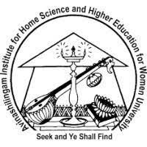

Avinashilingam Institute for Home Science and Higher Education for Women
Deemed to be University Estd. u/s 3 of UGC Act 1956, Category A by MHRD (now MoE)
Re-accredited with 'A++' Grade by NAAC.CGPA 3.65/4, Category I by UGC
Coimbatore-641 043, Tamil Nadu, India

“SIXTH SHORT TERM CAPACITY BUILDING PROGRAMME FOR THE YEAR 2024-2025”

ON
“ARTIFICIAL INTELLIGENCE IN ALLIED AND HEALTH CARE SCIENCES ”

ORGANISED BY

AIU – Avinashilingam Institute – Academic and Administrative Development Centre (AIU-AI-AADC) & Centre for Machine Learning and Intelligence (CMLI) & School of Allied and Healthcare Sciences

DATE: 19.08.2024 to 23.08.2024
MODE : Blended

Avinashilingam Institute for Home Science and Higher Education for Women
Deemed to be University Estd. u/s 3 of UGC Act 1956, Category A by MHRD (now MoE)
Re-accredited with 'A++' Grade by NAAC.CGPA 3.65/4, Category I by UGC
Coimbatore-641 043, Tamil Nadu, India

DAY 1: (19.08.2024)
Artificial Intelligence (AI) is rapidly reshaping the landscape of health care, offering unprecedented opportunities to enhance diagnosis, treatment, patient care, and operational efficiency. AIU – Avinashilingam Institute – Academic and Administrative Development Centre (AIU-AI-AADC) & Centre for Machine Learning and Intelligence (CMLI) & School of Allied and Healthcare Sciences jointly organized Sixth Short Term Capacity Building Program for the year 2024 on “Artificial Intelligence in Allied and Healthcare Sciences”. This capacity building program explores the profound impact of AI in healthcare, highlighting its benefits, challenges, and ethical implications. This program is designed for faculty members and research scholars from related disciplines of Higher education institutions, Health care administrators, medical professionals, clinical instructors and practitioners. Around 63 participants benefitted from this capacity building program worldwide.

Program gracefully started with receiving the Guest Speaker formally and Tamilthai Vaazhthu, prayer song sung by Allied and Health care sciences students.
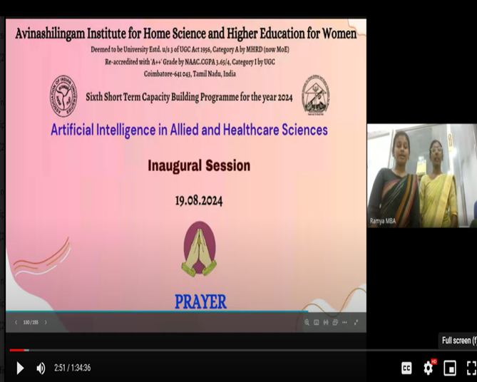
PRAYER SONG – STUDENTS OF AHS

Dr.K.Ramya, Nodal officer, Academic and Administrative Development Centre of Avinashilingam Institute (AIU-AI-AADC) welcomed Guest Speakers formally and greeted the gathering with her soulful speech and welcomed everyone with her insightful thoughts. She delivered introductory remarks on AI and its application in academics.
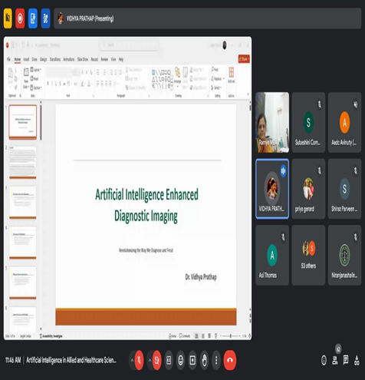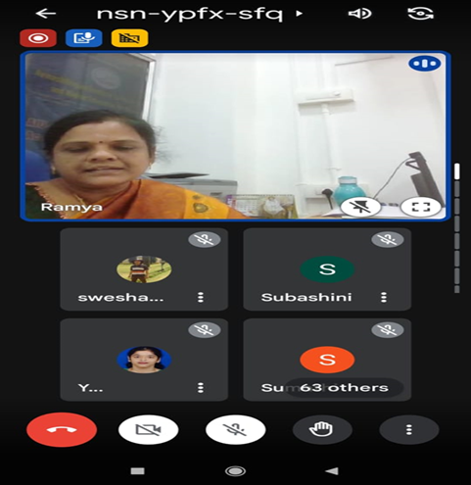
WELCOME ADDRESS
Dr.K.Ramya, Nodal officer(AIU-AI-AADC)

Mrs.Uma Devi .A, Program Co-ordinator, Co-ordinator –School of Allied and Health Care Sciences felicitated the participants, highlighted the objectives of the five day capacity building program and introduced the Eminent Guest Speakers by her enthusiastic Phrases
EVENT BRIEFING
Mrs.Uma Devi .A, Co-ordinator School of AHS
.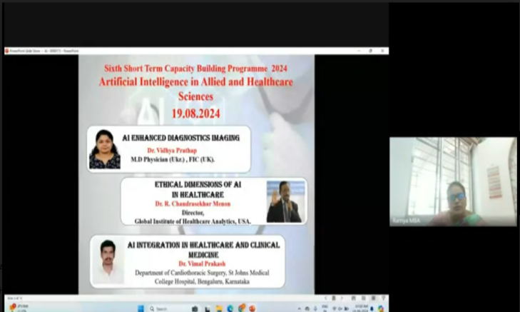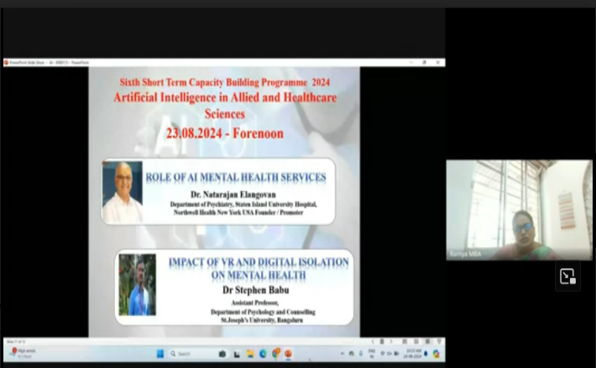

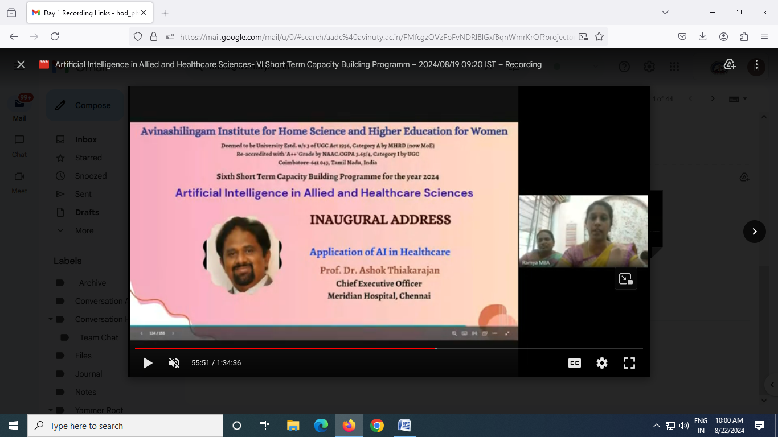
MASTER OF CEREMONY
Mrs.Ramya. P, Assistant Professor,
Department of Physician Assistant, AHS

- Highlighted the importance and evolution of AI among Health Care
- Introduced the speakers with brief profile and their successful contributions in various aspects of Health Care.
- Importance of the seminar for Health care professionals was insisted well.
Dr. H. Indu, Registrar i/c,Avinashilingam Institute for Home Science and Higher Education for Women delivered Presidential address and shared a brief knowledge on Health and its various aspects and impact of the current innovations of AI in Health Care.
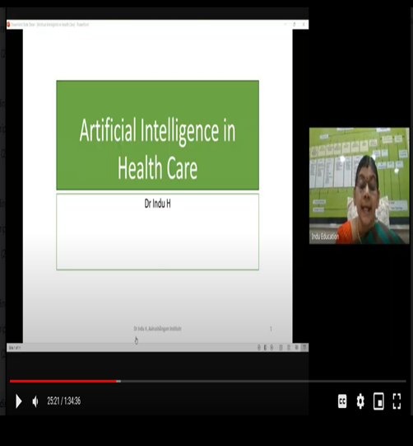
PRESIDENTIAL ADDRESS
Dr. H. Indu,Registrar i/c.

Session-I :Inaugural Address :
Speaker: Prof. Dr. Ashok Thiakarajan, Chief Executive Officer, Meridian Hospital, Chennai.
Topic: APPLICATION OF AI IN HEALTHCARE.
- The seminar session started with self introduction of the guest speaker, History of AI, role of AI in various health sectors. The speaker presented a very crispy and brief presentation with insightful knowledge.
- Secondly, Guest speaker shared his experience in Oncology unit regarding new technology in AI, Harvesting of Cancer cell lines, Analysing of Gene sequences, designing the dosage of Drugs, Telemedicine as a innovative tool and environmental impact in handling Bio medical waste.
- The session ended with interactive question answer session with active participation from all the members.

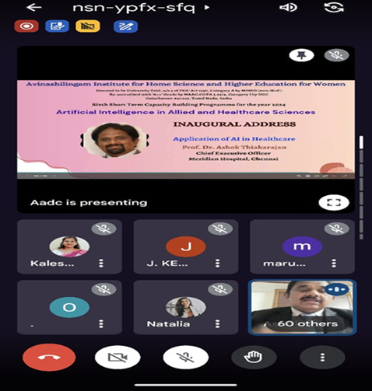
INAUGURALADDRESS
Prof. Dr. Ashok Thiakarajan

Vote of Thanks :
Dr.P.Subashini, Program Co-ordinator, Co-ordinator, Centre for Machine Learning and Intelligence, Professor of computer science, Avinashilingam Institute for Home Science and Higher Education for Women presented the Vote of Thanks.
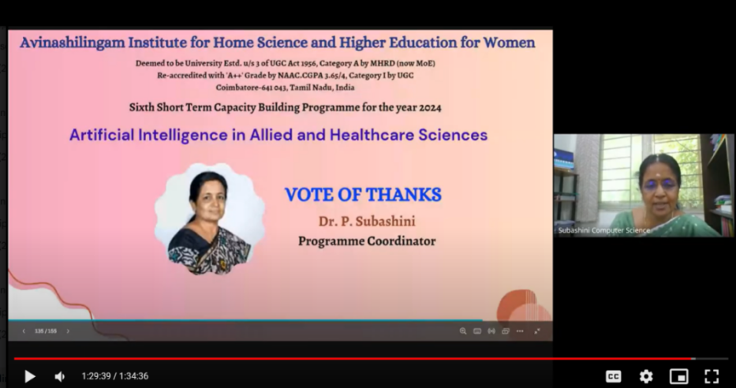
VOTE OF THANKS
Dr.P.Subashini, Program Co-ordiantor, CMLI

Seminar Session-II :
Speaker: Prof. Dr. Vidhya Prathap,MD,FIC,DMO,General Medicine,UK.
Topic: AI ENHANCED DIAGNOSTICS IMAGING.
- The seminar session started off with the introduction of the guest speaker
- Prof. Dr. Vidhya Prathap described elaborately on the Evolution of Diagnosis, and the implications of using AI tools for predicting potential health issues for early diagnosis
- Guest speaker shared his experience in Diagnostic tools regarding new technology in AI, Predictive Analysis.
- She completed her session with elaborated insight in AI and its applications and Domain in Diagnostic tools.

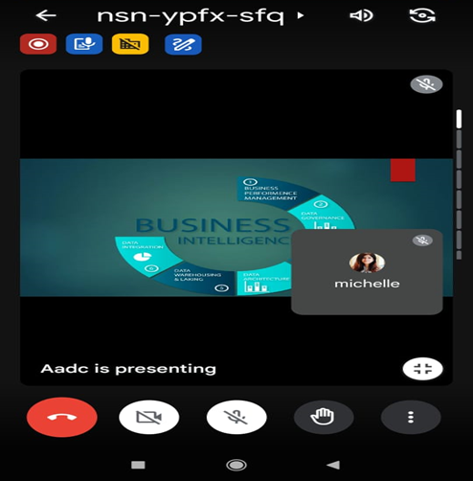
SESSION-II
Prof. Dr. Vidhya Prathap

Lunch Break : 1 pm to 2 pm
Seminar Session-III :
Speaker: Dr.R.Chandrasekar Menon,Director,Global Institute of Healthcare Analytics,USA
Topic: ETHICAL DIMESIONS OF AI IN HEALTH CARE.
- With the brief introduction of the Guest speaker profile, the session started off. He spoke on evolution of AI, the importance of Customer Journey mapping, optimising touch points for enhanced experiences, business Intelligence, Data architecture, Data convenience, Data Integration.
- Secondly, Guest speaker shared his experience about use of AI in the Emergency Department, in all aspects like Triage, Investigation, Documentation and Disposition.
- He completed his session with importance of Privacy and data protection , elaborated insight in AI and its applications in Ethical Dimensions.
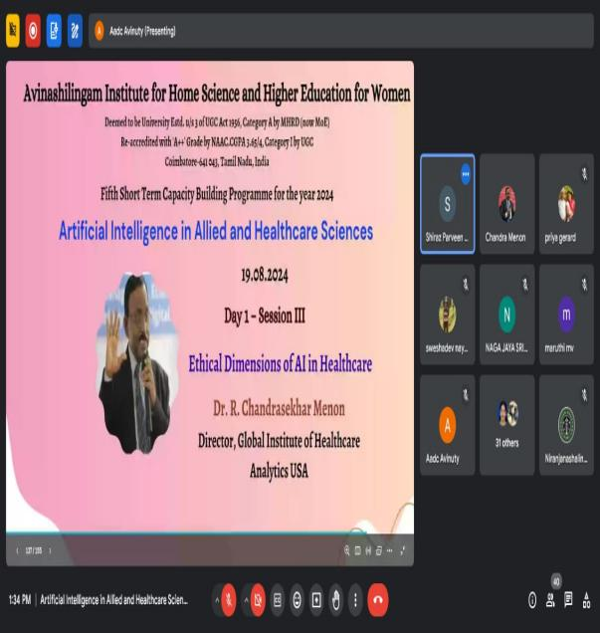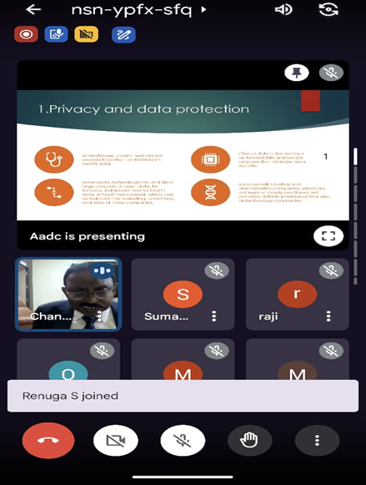
SESSION-III
Dr. R. Chandrasekar Menon

Seminar Session-IV :
Speaker: Dr.Vimal Prakash.P,M.B.B.S,Resident in CardioThoracic Vascular Surgery,St Johns Medical College Hospital,Bengaluru,Karnataka.
Topic: AI IN HEALTH CARE AND CLINICAL MEDICINE .
- The seminar session started with the introduction of Guest speaker. The speaker discussed the importance of AI in clinical medicine, application of AI in disease identification, Personalised treatment, Robotic Surgery, clinical trial research.
- Guest speaker shared his experience about use of AI tools like Embrace 2,Da Vinci Robot, Human Supervision with AI, Treatment Design.
- He completed his session with Privacy Future Health Care in AI , finally he stated Whoever saves one life, saves the world entire.
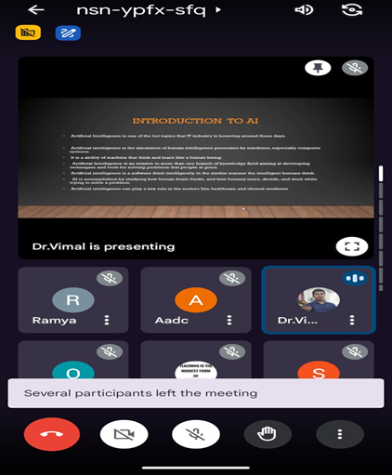
SESSION–IV
Dr.Vimal Prakash.P

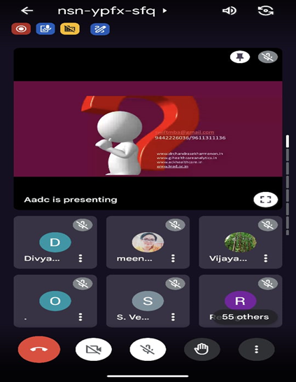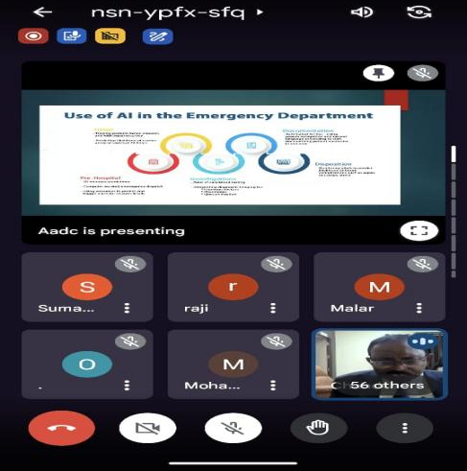
OPEN DISCUSSION

The Seminar was really helpful and opened insightful thoughts among participants on the importance of Artificial Intelligence and its impact on future of healthcare. It was a more of interactive session with highly experienced Guest speakers in emerging field. Google form shared to all participants to obtain feedback and post test also has been collected.
Day I Session Program ended with humble tribute to nation by singing National Anthem.
With the need for AI in health care professionals increasing, AI is in demand now more than ever. Artificial Intelligence is one of the hot topics that IT industry is hovering around these days. Artificial intelligence is the simulation of human intelligence processes by machines, especially computer systems. It is a ability of machine that think and learn like a human being.
Artificial intelligence is a software think intelligently, in the similar manner the intelligent humans think. AI is accomplished by studying how human brain thinks, and how humans learn, decide, and work while trying to solve a problem. Artificial intelligence can play a key role in the sectors like healthcare and clinical medicine.AI have been referred to as the pluripotent stem cells of health professions because of its versatility and adaptability. The seminar will serve as a foundation for further discussions, research, and awareness campaigns in Health Care Sectors.
DAY 2: (20.08.2024)
Session 1: Future Trends In Ai and Physiotherapy: Insights Into Upcoming Innovations -Dr.Zeeshan Ali, Associate Professor of physiology, Krupanidhi college of physiotherapy
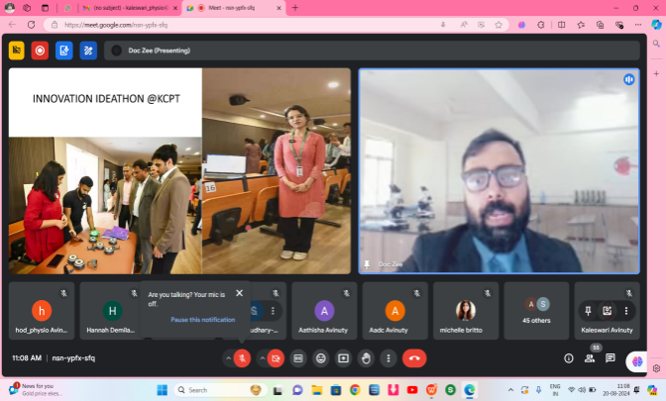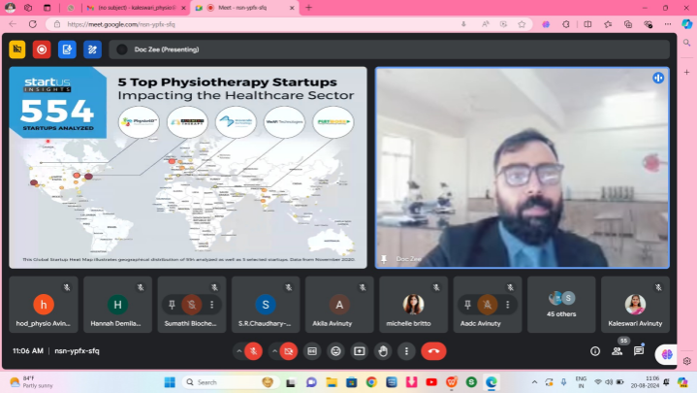

Dr. Zeeshan Ali, Associate Professor of physiology, Krupanidhi College of physiotherapy was the resource person. He facilitated the participants on “FUTURE TRENDS IN AI AND PHYSIOTHERAPY: INSIGHTS INTO UPCOMING INNOVATIONS”. He commenced the presentation by clarifying the concept of artificial intelligence within the domains of physiotherapy and healthcare. He thoroughly articulated the obstacles associated with the application of AI in healthcare and the burgeoning technologies. Attendees were informed about ethical considerations and innovative methodologies that can capitalize on these technologies. Furthermore, the presenter provided an overview of the latest advancements utilizing AI and exhibited video demonstrations to illustrate these applications.

Session 2: - Future Of Digital Healthcare In Rural India Physiotherapy Approach- Dr.Richa Singh , Founder of Perfect Bounce.

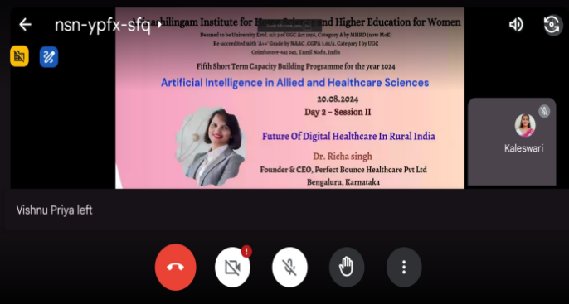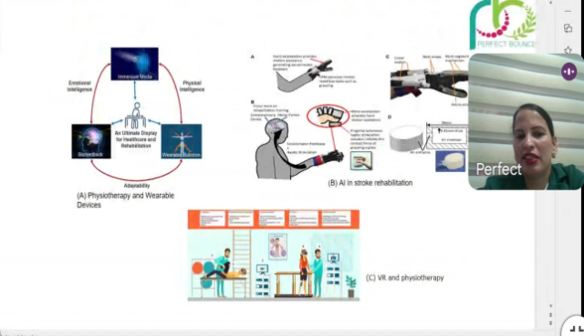

Dr.Richa Singh, founder of perfect bounce was the resource person. She facilitated the participants on “Future of Digital Healthcare in Rural India Physiotherapy Approach”. She commenced the presentation by clarifying the concept of transforming the methodologies employed in the management of healthcare. She elaborated on the digital tools available and provided a succinct overview of tele-consultation and tele-rehabilitation. The speaker imparted insights regarding the utilization of digital applications and virtual reality within the realm of urban healthcare. She conducted training programs encompassing monitoring and evaluation alongside practical training methodologies.

Session 3 : AI Enabled Wearable diagnostic devices- Dr. S. Venkata Lakshmi ,Professor and head of the Department of Artificial Intelligence and data sciences, Sri Krishna College of Engineering and technology, Coimbatore.

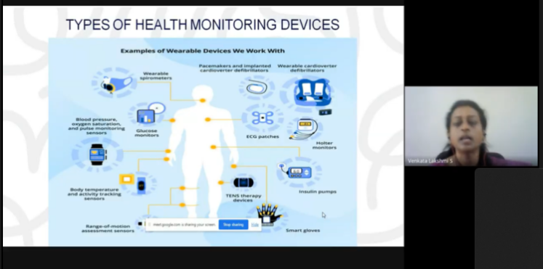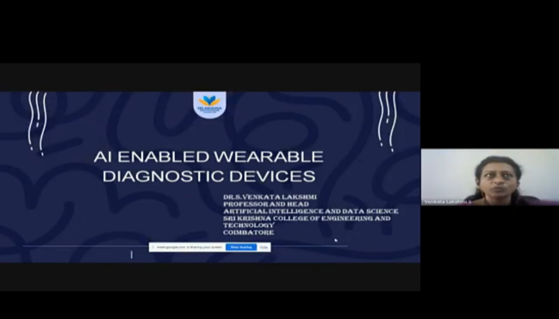
Dr. S. Venkata Lakshmi, Professor and head of the Department of Artificial Intelligence and data sciences, Sri Krishna College of Engineering and technology, Coimbatore. He facilitated the participants on “AI Enabled Wearable diagnostic devices”. She commenced the presentation by clarifying the notion of artificial intelligence (AI) integration within diagnostic devices utilized in the healthcare sector. He articulated the impediments associated with the implementation of AI in healthcare, as well as the emergence of novel technologies. She augments the existing knowledge base in the domain of AI and delineates sophisticated concepts. She succinctly discussed Google Lens and its advanced functionalities, explicating its application within the healthcare industry.
Session 4 : AI BASED HEALTHCARE FOR ELDERLY AND DIABETIC PEOPLE- Dr. V. Sampath Kumar sir (Dean Research-Christ College of Engineering, CEO- SR Assistive Technologies Pvt Ltd and Founder Director at Saines Agro Tech Pvt Ltd.
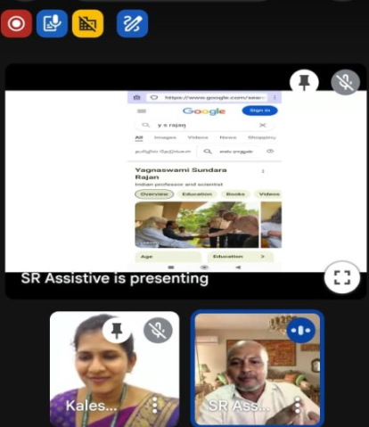
Dr. V. Sampath Kumar, Dean of Research at Christ College of Engineering and a Founding Director of Saines Agro Tech .He commenced the presentation by clarifying the concept of artificial intelligence within the healthcare domain. He elaborated on the enhanced advantages of artificial intelligence for the elderly and individuals with diabetes. In his session, he expounded upon the sources and facilitated the provision of high-quality care for individuals through the utilization of artificial intelligence. He disseminated and guaranteed the understanding and benefits of artificial intelligence in healthcare, particularly concerning the elderly demographic and individuals with diabetes.
DAY 3: (21.08.2024)
Session: I
Speaker: Dr. Kalpa Negiloni, Clinical Research, AI&ML – Remidio, Bangalore.
Topic: AI IN OPTOMETRY.
- The seminar session was started with self introduction of the guest speaker, role of AI in eye care research, it was a crispy and brief presentation with interactive powerpoint presentation.
- Guest speaker shared the development of digital health and AI applications in eye health. She also shared her experiences as part of the research development cycle for AI in Diabetic Retinopathy.
- She delivers the application of AI in the evaluation of Posterior segment of eye, Binocular Vision disorders, refractive errors.
- She explains comprehensive Fundus Image based screening using AI.

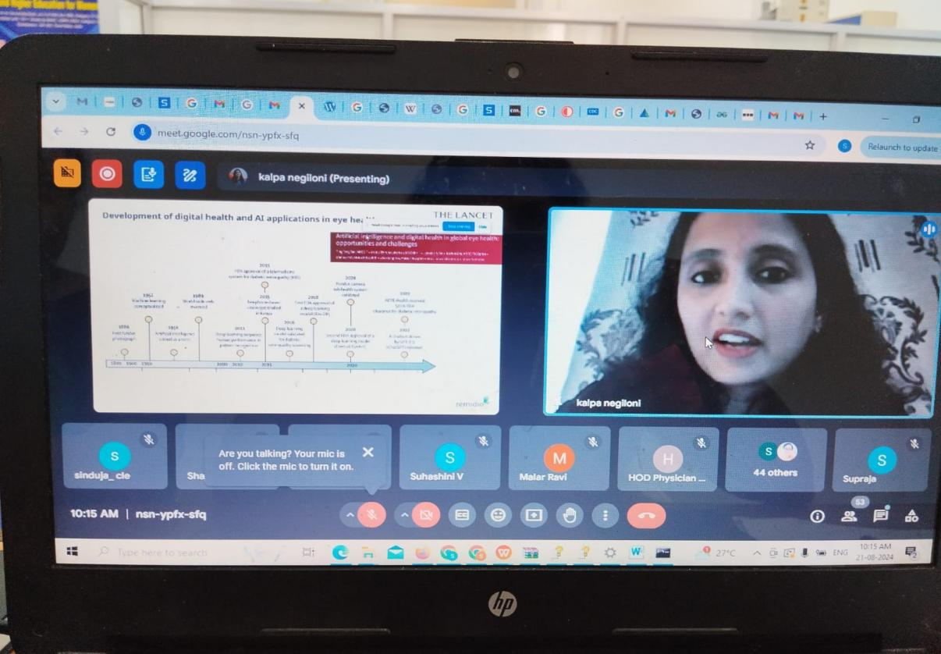
Session: II
Speaker: Prof. Dr.Vivek Suganthan. R Assistant Professor,
SRM University, Kattankullathur, Chennai.
Topic: AI POWERED DIAGNOSTIC TOOLS FOR EYE DISEASES.
- The seminar session was started with enveloping the profile of the guest speaker, Evolution of Diagnostic tools for evaluating various ocular condition with brief and interactive powerpoint presentation.
- He explained in detail the identification of Diabetic Retinopathy using AI enhanced fundus images. He described about the AI tools like Retmarker DR, Eye Art, Bosch DR softwares used for screening and evaluating Diabetic Retinopathy.
- He describes about the AI based virtual reality and augumented reality in visual field analysis.
- He concludes his presentation by explaining the Challenges in AI, video documentation references about the involvement of AI in eye.
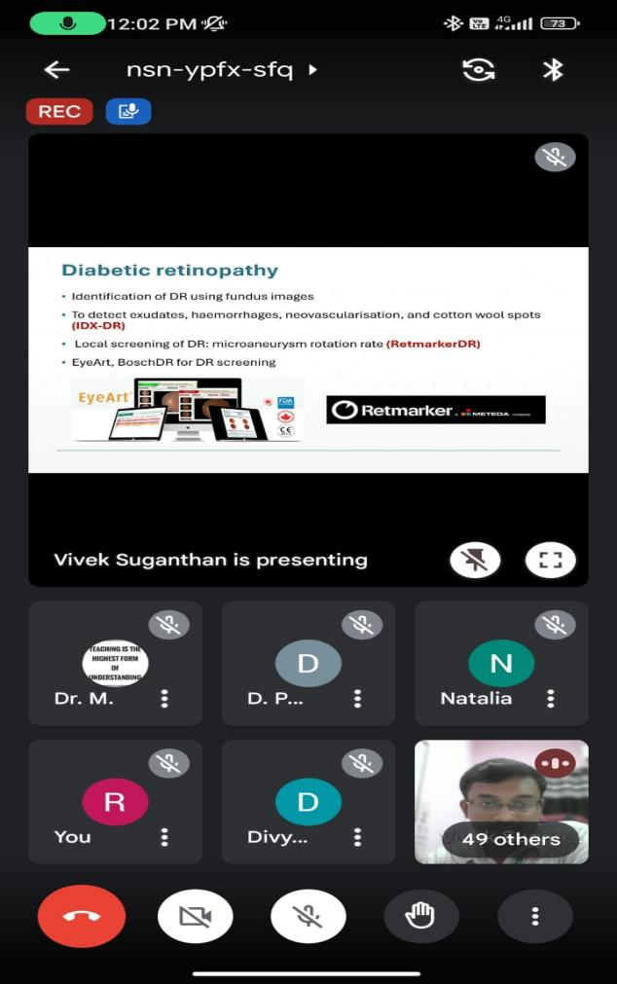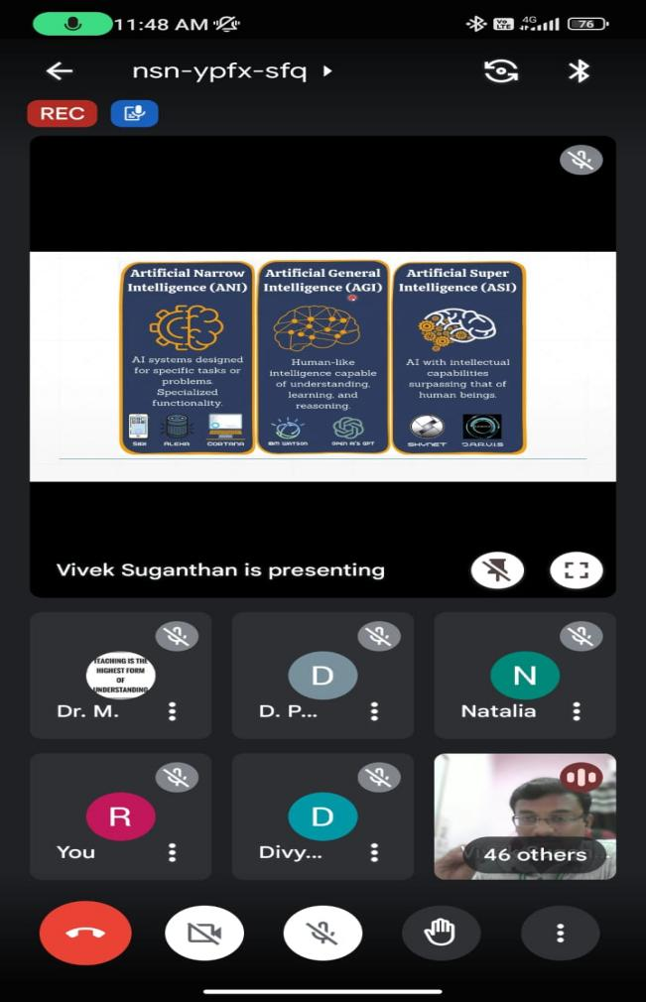
Lunch Break : 1 pm to 2 pm
Session: III
Speaker: Mr. Daryl Newsome, Vice President,
Association of BritishDispensing Opticians (ABDO), UK.
Topic: AI IN DISPENSING OPTICS.
- The seminar session was initiated with the biography of the guest speaker. He described the Personalised Progressive lens design using AI made by IOT.
- He described about his personal experience Optain eyetelligence AI technology that detect the systemic disorders using retinal photograph.
- Guest speaker shared his experience about use of AI in Tele optometry, Lens surfacing/glazing which stores the shapes of frames as digital memory.
- He completed his session with elaborated insight on AI GPT – 40 – PLAUD NOTE and its applications in Ethical Dimensions.
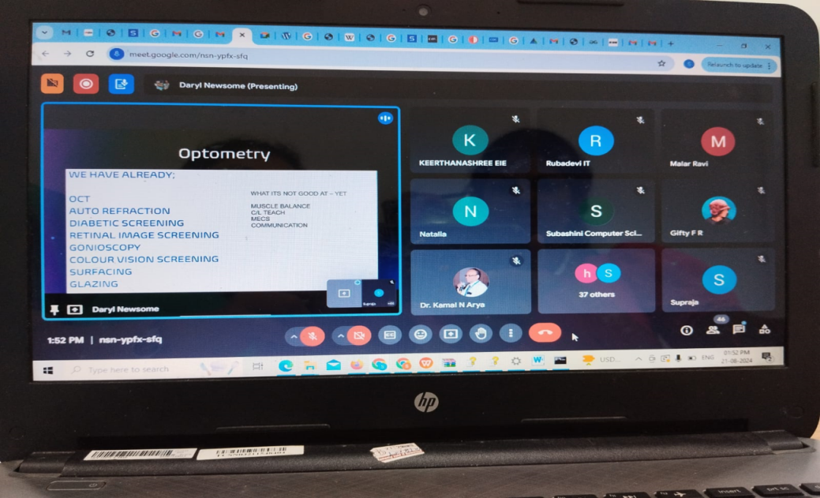
Session: IV
Speaker: Ms. Maanasi Mahalingam, Doctoral Research,
University of Western Australia, Australia
Topic: AI IN GLAUCOMA.
- The seminar session was sparkled with the biography of the guest speaker. The session started on a lively note with the speaker posing few questions on facts about AI with the participants. She deliverd a lecture on Introduction of AI in Glaucoma, model & metrics used for evaluation.
- She explains the comparison between Deep learning & Machine learning models used in Glaucoma evaluation.
- She delivers AI enhanced technology used for glaucoma evaluation, screening, diagnosis, predictive analysis, personalized treatment options and outcomes.
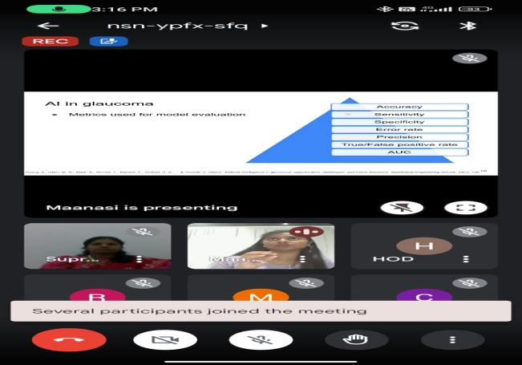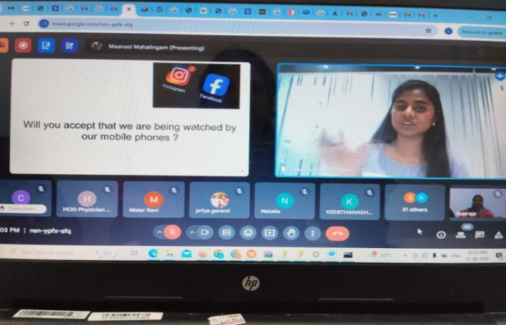

DAY 4: (22.08.2024)
Session - I
Speaker: Dr. Lalitha Raja, Asssitant Professor, CAS in Linguistics, Annamalai University, Chidambaram.
Topic: APPLICATION OF AI IN BREAKING SPEECH AND LANGUAGE BARRIERS
The seminar session started with self - introduction followed by explaining the communication disorders, breaking the barriers during evaluation and therapy.
Secondly, Guest speaker shared her knowledge on AI tools specifically on Speech Recognition Software, Language Processing Tools, AAC Devices, Interactive Language Learning Platforms, wearable AI Devices and AI in Telet therapy. She shared several Learning AI tool links which is offers significant benefits to BASLP students, enhancing their ability to diagnose, treat, and manage speech and hearing disorders.
And she concluded with AI is a tool that supports only users purposes and it is not substitute for the human intelligence. The applications of AI still evolving which helps in future.
After the session the participants actively interacted with the speaker, for their queries.
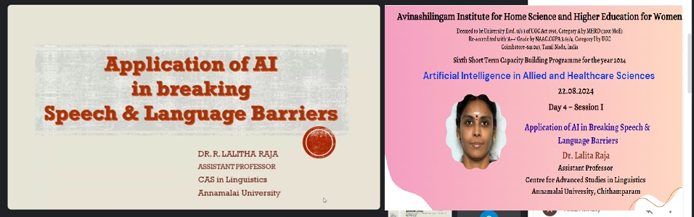

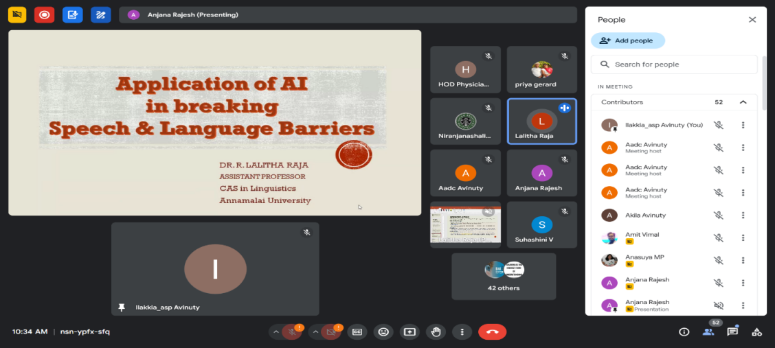
Session - II
Speaker: Dr.Sunderasan, Prof. in Audiologist and Speech Language Pathologist, Head of the Department, Department of BASLP, Holy Cross, Trichy.
Topic: APPLICATION OF AI TECHNOLOGY IN DIAGNOSTICS AUDIOLOGY.
The seminar session started with self - introduction followed by overview AI based diagnostics techniques that are transforming audiology by leveraging machine learning algorithms to analysis audiometric data, patterns and to predict outcomes.
He also talked about the AI based techniques in diagnostic audiology such as, automated hearing threshold estimation AI powered Oto - acoustic Emissions, Machine learning for tinnitus diagnosis, AI assisted Vestibular disorder identification. And he also explained challenges in traditional audiometry, traditional tympanogram versus AI automated hearing threshold, automated tympanogram. He also explained about AI in Immittance Audiometry which is used worldwide for long period.
And he concluded with future advancements of AI in Cochlear Implants, predictive modelling for Hearing loss and also in personalized sound therapy.

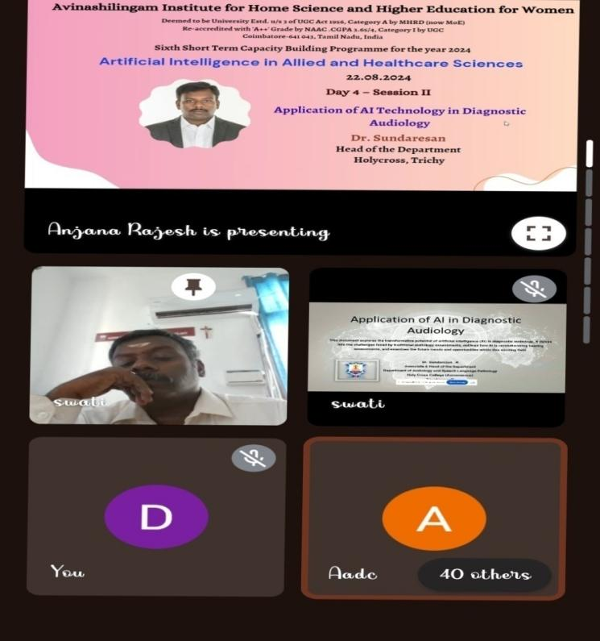
Session - III
Speaker: Ms. Sindusha Chandran, Assistant Professor in Speech and Sciences, COE, CSLS & CSD.
Topic: ARTIFICIAL INTELLIGENCE IN ARTICULATION
The seminar session started with self - introduction followed by explaining various modules to improve speech in articulation disorders. Modules such as WordPop, Speech Worm , Whack – A – Mole, and so on. Were very informative and interesting.
Also she explained about the Spokeit, Say it Now which will stimulate the language and articulation of the child and also described about the therapy apps which used AI technology.
She also explained about the web based application Isi – Speech Training System which is designed to improve speech and auditory skills for hearing impaired individuals. She concluded with remarks on AI modules that are meant to enhance and support the therapy guided by the speech language pathologist, but never going to replace it.
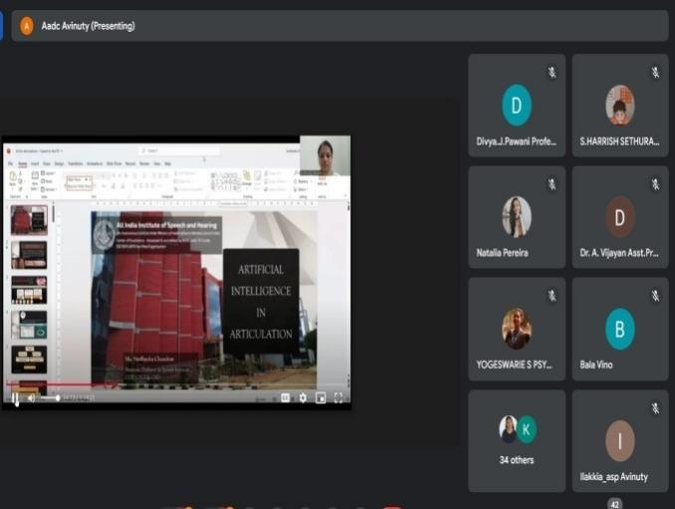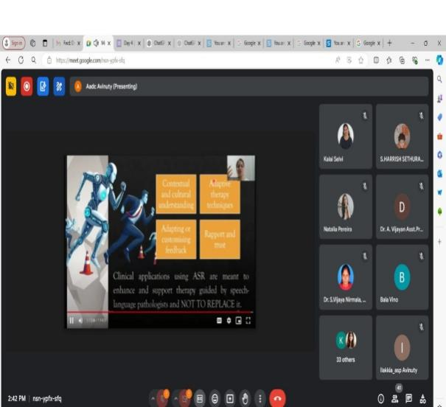
Session - IV
Speaker: Ms. Ashwini P Rao, Clinical Audiologist, Cochlear, South Zone, Bengaluru

Topic: AI Technology in Cochlear Implant Sound Processing
The Seminar Session Started with self – Introduction and followed by she explaining early years modules of Cochlear implantable devices and innovators.
Guest Speaker also spoken about the various technologies in cochlear implants which is currently available. The speaker also mention how technology can help during surgery such as insertion of electrodes, the speed of the insertion and depth of the placement. The technology can be used during intra OP & NRT measures.
Speaker also explained about the latest technology available in sound processing like NRA. Signal Enhancing Technology which improves speech Intelligibility.

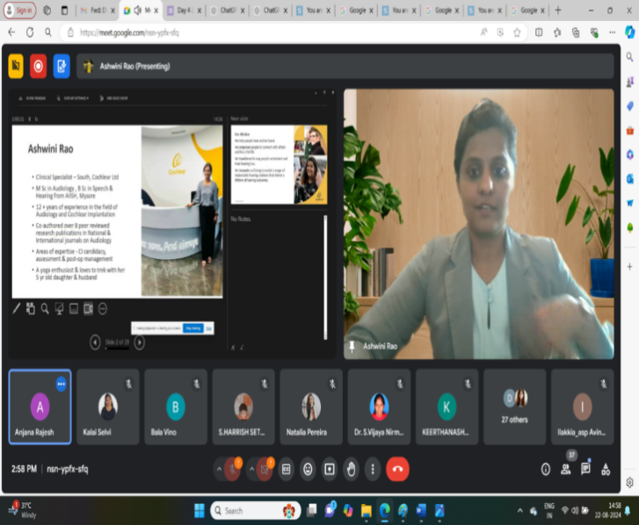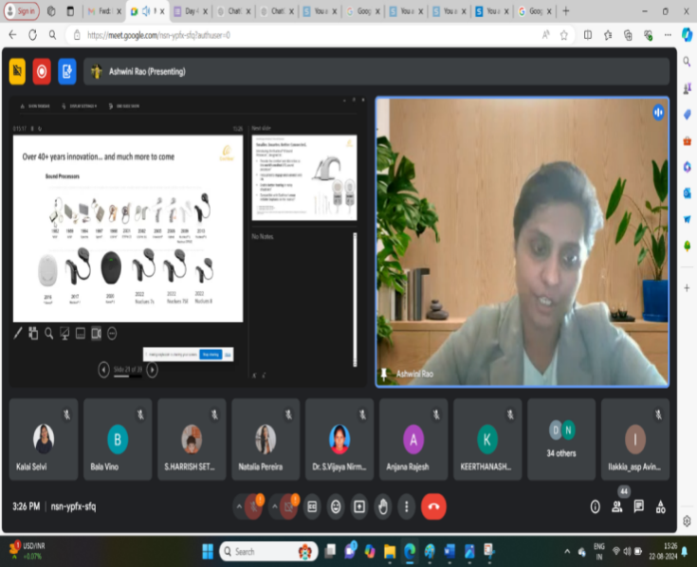
DAY 5: (23.08.2024/FN)
SESSION I
ROLE OF AI IN MENTAL HEALTHCARE
SPEAKER: Dr. J. Venkatachalam, Prof. Dept. of Psychology, Periyar University.

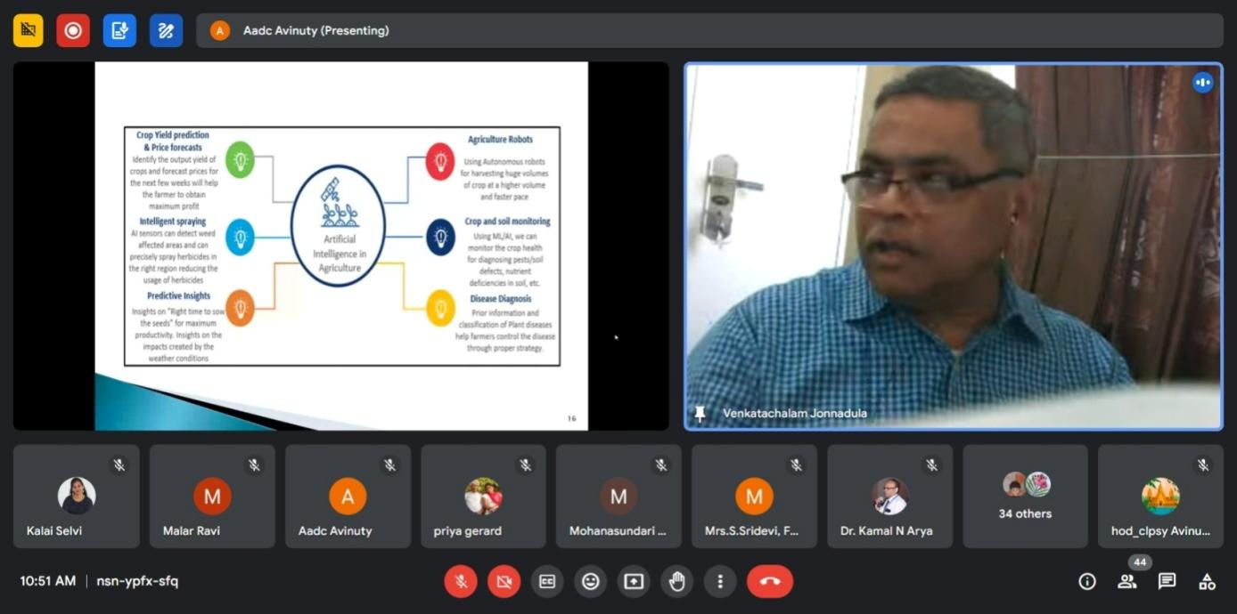
The speaker spoke on what mental health is all about and how AI is prevailing on various aspects of human life right from education, banking, retail operations, production, human resource development & agriculture. He touched upon the various technological advancements particularly in AI and how AI can shape the future of the above mentioned areas. His talk further dealt in detail about how mental health can be re-shaped in terms of diagnosis, treatment and interventions using AI Tools. He highlighted how AI would help in understanding digital interactions to identify mental health disorders and therapist/counselors can use digital histories to identify mental health issues.
SESSION II
IMPACT OF VR & DIGITAL ISOLATION ON MENTAL HEALTH
SPEAKER: Dr. A. Stephen Babu, Asst. Prof. St Joseph University, Bangalore.
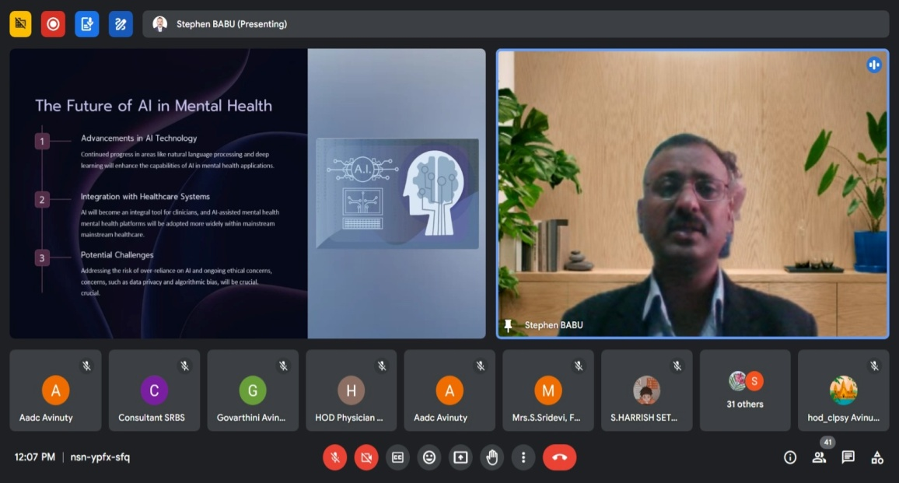

Dr. A. Stephen Babu spoke on how AI can be used to help in accessing mental health for vast population like India, were availability of mental health professionals is very low. He spoke on advantages of mental health applications in diagnosis, assisting health professionals in treatment and therapeutic strategies. He spoke on how some apps such as WOEBOT, MINDSTRONG are already supporting mental health professionals in identification. He also spoke on how AI cannot however replace a therapist but rather assists them in therapies.
DAY 5: (23.08.2024/AN)

SESSION I
AI IN Public health-Enhanced Medical Imaging Techniques.
SPEAKER: Dr.Yuvaraj.N, Associate Professor, School of Computer Science and Engineering, VIT, Vellore Tamil nadu
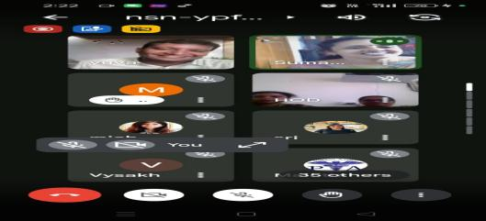
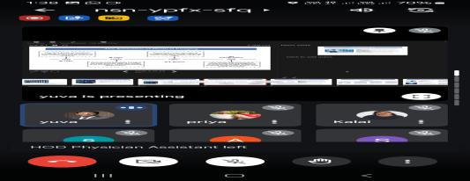

The speaker spoke on advanced algorithms to analyze medical images, identifying patterns and anomalies and its impact on faster diagnosis for improvement in accuracy and precision of result. He stressed that Medical imaging process represents Invitro diagnosis of the body to monitor health conditions in a non-invasive method. AI will be helpful for radiologists to make the results more precise and early detection and personalized treatment in medical imaging. He explored AI techniques like CNN and their real – time applications. Moreover, he shared future direction of AI growth, healthcare impact and ethical focus.
The speaker spoke on advanced algorithms to analyze medical images, identifying patterns and anomalies and its impact on faster diagnosis for improvement in accuracy and precision of result. He stressed that Medical imaging process represents Invitro diagnosis of the body to monitor health conditions in a non-invasive method. AI will be helpful for radiologists to make the results more precise and early detection and personalized treatment in medical imaging. He explored AI techniques like CNN and their real – time applications. Moreover, he shared future direction of AI growth, healthcare impact and ethical focus.
VALEDICTORY SESSION
Prayer by BASLP students, School of AHS

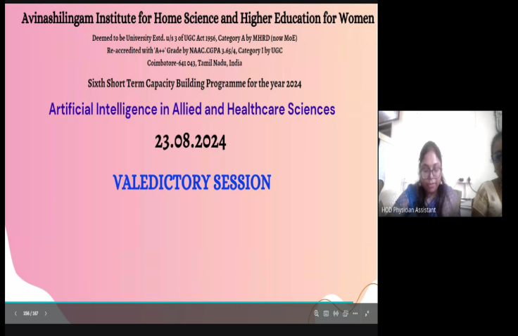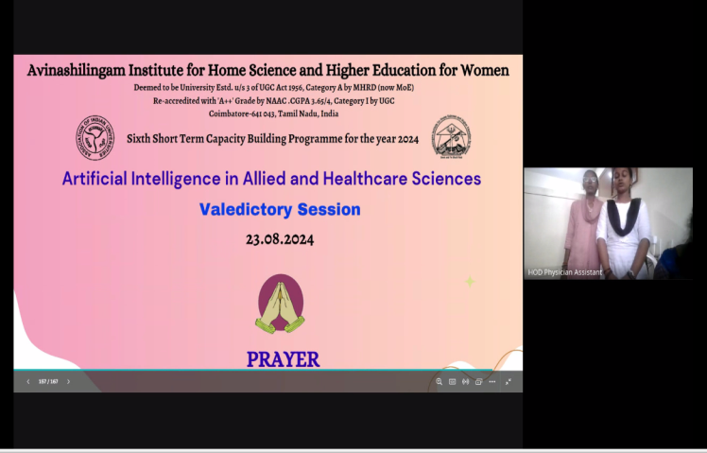

The Valedictory function started with the prayer song rendered by the students of BASLP department.

Report Presentation by
Mrs.Uma Devi.A, Coordinator and HoD,
School of AHS

Welcome address by
Mrs.Malathi.B, Assistant Professor,
Department of Physician Assistant
School of AHS

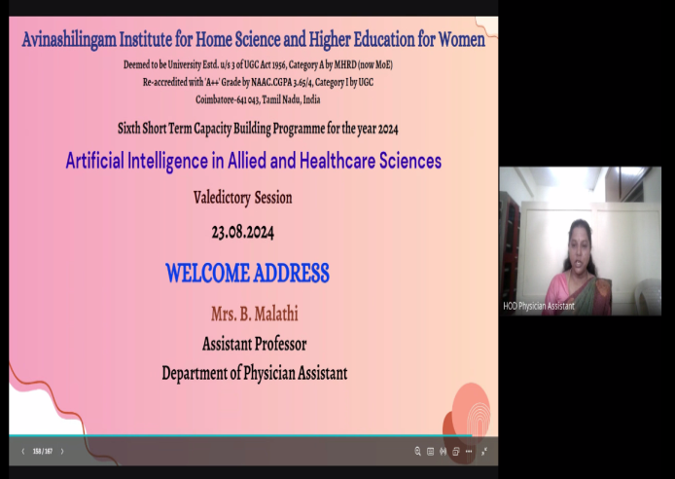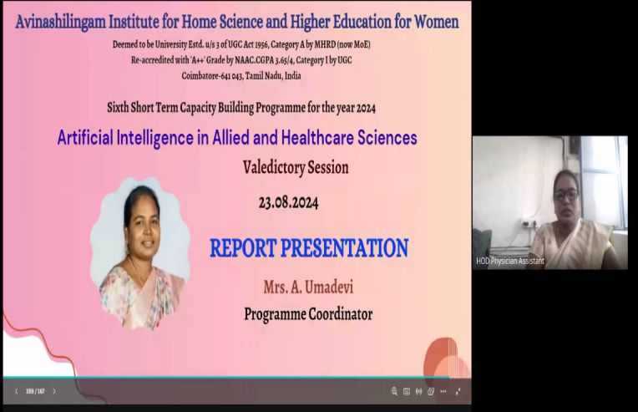
Mrs.Malathi.B, Assistant Professor, Department of Physician Assistant, School of AHS welcomed the participants and the guest speakers.
Mrs.Uma Devi.A, Coordinator and HoD, School of AHS presented a brief report of the five day Capacity building program. She presented a report on the various topics discussed by eminent speakers and elaborated on the key takeaways of each and every session.

Valedictory Address by
Dr.Sri Preethaa K.R., Assistant Professor,
School of Computer Science and Engineering
Vellore Institute of Technology

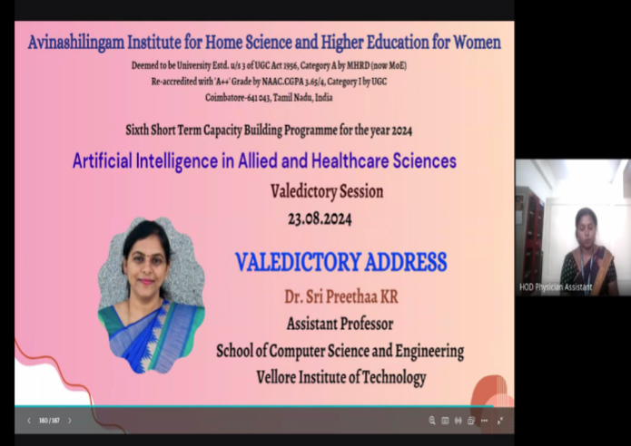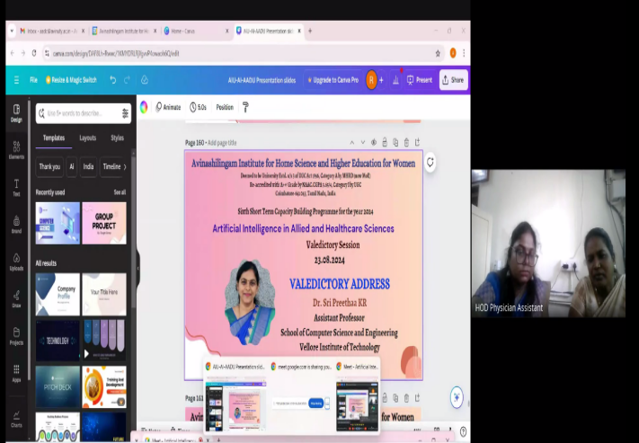

Dr. Sri Preethaa, K.R., Assistant Professor., School of Computer Science and Engineering, VIT, Vellore Tamilnadu delivered Valedictory address on the topic LEVERAGING AI IN PREDICTIVE HEALTH CARE
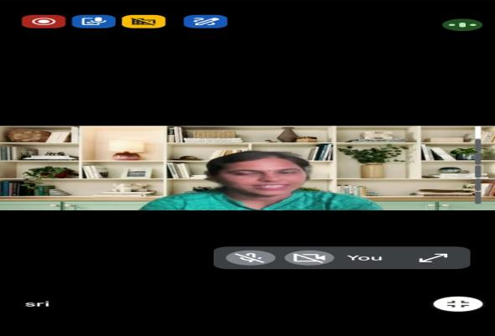
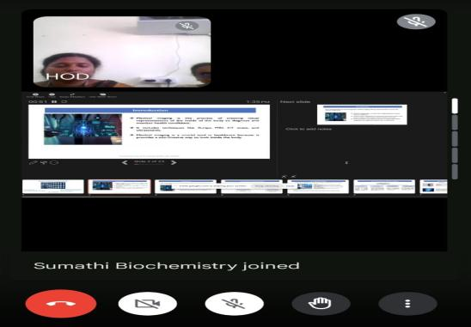

The speaker briefed about revolution driven by Artificial Intelligence from predicting diseases to personalizing treatment .she shared simulation of human intelligence in machines that are programmed to think like humans and mimic their actions .she insisted about predictive health care uses AI algorithms to analyze data and predict future health out comes enabling early intervention and personalized care and she also shared industry applications of AI in predictive health care Google”s AI model have been used to predict patient out comes. Moreover, she shared future direction of AI integration in healthcare will become more seamless leading to even greater advancements.
Vote of Thanks by
Mrs.Ramya.P, Assistant Professor,
Department of Physician Assistant
School of AHS

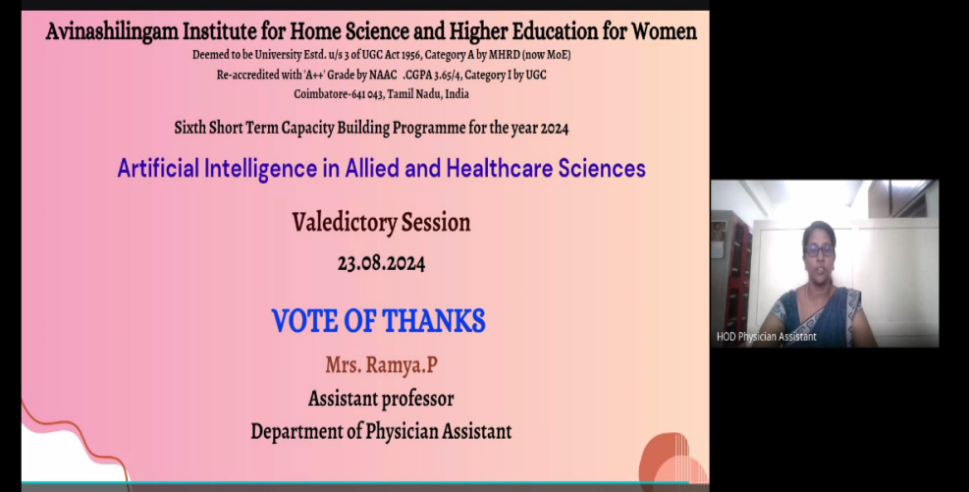
Mrs.Ramya.P, Assistant Professor,Department of Physician Assistant,School of AHS presented Vote of Thanks. She placed on record our sincere thanks to all higher authorities for their support and motivation. Our sincere gratitude to all the participants for their active involvement

National Anthem by
BASLP students, School ofAHS

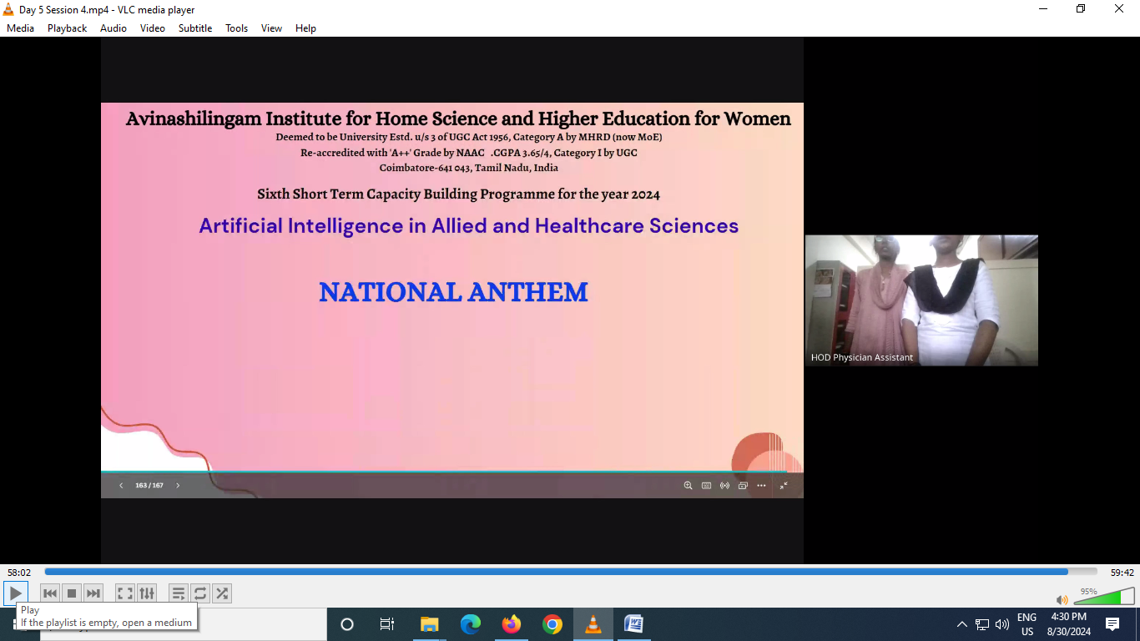
Participants List
S.No | Name | Designation | Department | Institution/ Organisation Name
1 | Ms. Michelle Britto | Research Scholar | Department of Food, Nutrition Dietetics | College of Home Science Nirmala Niketan
2 | Dr. JASPER JEMIMA. G D | Assistant Professor | ECONOMICS | Vistas Deemed University
3 | Dr. NADIMPALLI NAGA JAYA SRINIKHITA | Research Scholar | PHYSIOTHERAPY | SRM College of Physiotherapy, Kattankulathur,  Chennai.
4 | Dr. S.VIJAYA NIRMALA | Reader | Oral pathology and microbiology | Sri Ramachandra Dental college &Hospital,Chennai
5 | Dr. Sharada T Rajan | Professor | Oral Pathology | Sri Ramachandra Dental College and Hospital,Chennai
6 | Dr. Mohamed Suhail S | Medical Officer | Clinical Operations | Qurocare
7 | Mrs. S.SRIDEVI | Associate Professor | DEPARTMENT OF CARDIOPULMONARY PHYSIOTHERAPY | Sri Ramachandra Dental College & Hospital, Chennai
8 | Mrs. ANGELINE RAJAN | Assistant Professor | Sri Ramachandra Faculty of Physiotherapy | SRIHER
9 | Dr. DHILIPHAN KUMAR M | Associate Professor | Management Studies | Velammal College of Engineering and Technology (Autonomous) Madurai
10 | Ms. Annu | Assistant Professor | Information Technology | M.O.P VAISHNAV COLLEGE FOR WOMEN
11 | Mrs. KEZIA ANGELINE J | Research Scholar (Full-time) | School of Public Health | SRM Institute Of Science & Technology in Kattankolathur, Chengalpattu
12 | Dr. Divya Sundaram | Assistant Professor | Psychology | CHRIST (Deemed to be University)
13 | Ms. Shakthi Roshini G | Teaching Assistant | Hospital Administration | PSG College of Arts & Science, Coimbatore.
14 | Mrs. Vishnu Priya T M | Assistant professor | Physiotherapy | Sathyabama institute for science and technology
15 | Dr. SEEMA RAMESH CHAUDHARY | Associate Professor | Computer Science & Engineering | Maharashtra Institute of Technology (MIT), Chhatrapati Sambhajinagar, Maharashtra
16 | Mrs. P.SUMATHI | Research Scholar | ZOOLOGY | THE MADURA COLLEGE, MADURAI
17 | Mrs. Asi Thomas | Lecturer | Biochemistry | Ganga college of Nursing
18 | Mr. RAJAN N.D. | Advisor to School of Rehabilitation and Behavioral Sciences | Rehabilitation and Behavioral Sciences | Vinayaka Mission's Research Foundation- Deemed to be University
19 | Dr. Renuga S | Project Technical support III | Oralpathology | Sri Ramachandra Dental college
20 | Dr. R. Rajeswari | Consultant- Research | Oralpathology | Sri Ramachandra Dental college
21 | Mrs. Hema Latha J | Physician Assistant | Orthopedics | Ganga Hospital
22 | Ms. Safira Sahana Rehman | Faculty | Optometry | Inlife Institute of Vision Science and Management
23 | Dr. MEENAKSHI BATRA, PhD, FELLOW (ACOT) | LECTURER (OCCUPATIONAL THERAPY) | OCCUPATIONAL THERAPY | Deendayal Upadhyaya National Institute for Persons with Physical Disabilities (PDUNIPPD), New Delhi.
24 | Dr. R. Yamuna | Assistant Professor | Zoology | PSGR Krishnammal College for Women
25 | Dr. P. SUSHEELA | Associate Professor and Head | Zoology | PSGR KRISHNAMMAL COLLEGE FOR WOMEN
26 | Dr. S Yogeswarie | Assistant Professor | Psychology | CHRIST (Deemed to be University), Bangalore
27 | Mrs. N.INDHU | ASSISTANT PROFESSOR | ELECTRONICS AND INSTRUMENTATION ENGINEERING | KONGU ENGINEERING COLLEGE
28 | Mrs. T.KEERTHANASHREE | ASSISTANT PROFESSOR | ELECTRONICS AND INSTRUMENTATION ENGINEERING | KONGU ENGINEERING COLLEGE
29 | Dr. M.Suguna Devakumari | Assistant Professor | Agriculture | Karunya Institute of Technology and Sciences, Coimbatore
30 | Ms. OLUWATOMISIN MERCY ARO-GORDON | MBBS Student | Medical School | American University of Barbados
31 | Ms. Demilade Hannah ADESINA | MSc Student in Epidemiology | Epidemiology and Medical Statistics | University of Ibadan
32 | Mrs. Kalaiselvi Sivabalan | Research Scholar | Computer Science (Life science integrated research) | Sathyabama Institute of Science and Technology
33 | Dr. Sumathi.S | Professor of Biochemistry | Biochemistry Biotechnology and Bioinformatics | Avinashilingam Institute for Home Science and Higher Education for Women
34 | Dr. Kamal Narayan Arya | Lecturer (Occupational therapy) | Occupational therapy | Pt. Deendayal Upadhyaya National Institute for Persons with Physical Disabilities, New Delhi
35 | Mrs. Cathrine . S | Associate Professor | Physiotherapy | RVS College of Physiotherapy
36 | Dr. Amit Kumar Vimal | Demonstrator PO | Prosthetics and Orthotics | Pt. Deendayal Upadhyaya National Institute for Persons with Physical Disabilities, New Delhi
37 | Mrs. Mahalakshmi.S | Assistant professor | Physiotherapy | RVS College of Physiotherapy
38 | Ms. Smita Nayak | Demonstrator(P&O) | Prosthetics and Orthotics | Pt. Deendayal Upadhyaya National Institute For Persons with Physical Disabilities, New Delhi
39 | Mrs. Divya J Pawani | Professor | Physiotherapy | RVS College of Physiotherapy
40 | Mrs. Niranjana Shalini. R | Assistant Professor | Physician Assistant | Avinashilingam Institute for Home Science and Higher Education for Women
41 | Mr. Syed Aneef Ahmed | Graduate | B.tech-Biotechnology | Dr. M.G.R. Educational And Research Institute university
42 | Mr. S. Harrish Sethuram | Graduate | B.Tech - BIOTECHNOLOGY | Dr. M.G.R. Educational and Research Institute
43 | Mrs. G. Rubadevi | Assistant Professor | Information Technology | PSGR KRISHNAMMAL COLLEGE FOR WOMEN
44 | Mr. Sweshadev Nayak. | Associate Professor | Physiotherapy | RVS College of Physiotherapy
45 | Mrs. G.N.K. Parameswari | Associate Professor | Community Health Nursing | Vijay Marie College of Nursing
46 | Dr.R.VENDHAN | Professor | Education | -
47 | Ms. Suhashini V | Pediatric physiotherapist | Department of Pediatric physiotherapy | Snowdrop Therapy Centre, Bangalore
48 | Dr. PRACHI RAJ MEENA | LECTURER | PHYSIOTHERAPY | PANDIT DEENDAYAL UPADHYAYA NATIONAL INSTITUTE FOR THE PERSONS WITH PHYSICAL DISABILITIES
49 | Dr. RAJ KUMAR MEENA | Professor & Principal | PHYSIOTHERAPY | KAILASH INSTITUTE OF NURSING AND PARAMEDICAL SCIENCES
50 | Dr. A Vijayan | Assistant professor | Microbiology | FAHS SRM IST trichy
51 | Mrs. Malarvizhi Ravi | Asst. Professor | Home Science | Bharathidasan Government College for Women, Puducherry
52 | Mr. MARUTHI M V | Research Scholar | Commerce | Bangalore University
53 | Dr. M. DEVENDRA | PROFESSOR & PRINCIPAL | TOURISM AND HOSPITALITY MANAGEMENT | MAHARISHI INSTITUTE OF MASTER MANAGEMENT
54 | Mrs. Anasuya Mani MP | Assistant Professor | Pharmacology | Jain School of Allied Healthcare and Sciences
55 | Mrs. Swapna. C | Assistant professor | Allied and Health care Services | Avinashilingam Institute for Home Science and Higher Education for Women
56 | Mrs. Preeta Singh | Assistant Professor | Department of BASLP | Avinashilingam Institute for Home Science and Higher Education for Women
57 | Ms. Mohana Sundari S.B | Teaching Assistant | Optometry | Avinashilingam Institute for Home Science and Higher Education for Women
58 | Dr. Gifty F R | Chief Dentist | Department of Dentistry | Sacred heart hospital, Kumbakonam
59 | Dr. Anoop Aggarwal | Senior Physiotherapist | Physiotherapy Department | Pandit Deendayal Upadhyay National institute for person with physical disabilities (Divyangjan)
60 | Mrs. Ilakkia N | Assistant professor | Audiology and speech language pathology | Avinashilingam Institute for home science and higher education for women
61 | Dr. D. PRADEEPA | Associate Professor | Biochemistry | Dr. N.G.P. Arts and Science College
62 | Dr. Gowri S | Professor and Head | Biochemistry | Dr.N.G.P. Arts and Science college
63 | Ms. Natalia Pereira | Head of Training & Quality | NutraSciences | Reework- Shamrock Pharma

Sample Certificate

