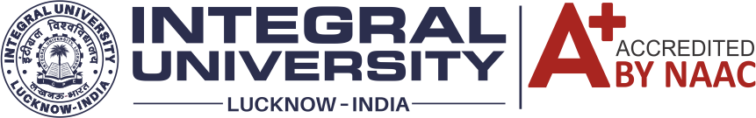
Subject: A Detailed Report on One-Month Faculty Development Programme
The Faculty of Law, Integral University, is pleased to formally conclude its One-month Faculty Development Programme on "Integration of Intellectual Property Rights (IPR) Principles into Teaching, Research and Professional Activities" being conducted from 2nd September 2024 to 30th September 2024 in collaboration with the Association of Indian Universities (AIU), New Delhi and Human Resource Development Centre (HRDC), Integral University, Lucknow.
The event has witnessed an enthusiastic participation of faculty members, advocates, and research scholars from various institutions, creating a vibrant atmosphere for intellectual exchange and collaborative learning for the field of IPR and professional activities.
The Total no. of registrations for the program reached an impressive 101 participants, signifying the strong interest and enthusiasm within the academic and legal communities to engage with the topics addressed during the FDP.
This One Month Faculty Development Program commenced on September 2nd, 2024, with an inspiring inaugural session. The event was graced by the esteemed presence of Dr. Pawan Kumar Pandey [Deputy Registrar of Trademarks, Govt. of India, Mumbai] His presence added a distinguished touch to the beginning of this enriching program, setting the stage for a month filled with insightful discussions and collaborative learning.
The FDP 2024, comprising of a total of 23 technical sessions, was organized into Four modules, each addressing different aspects of the theme. These sessions were meticulously designed to provide participants with a comprehensive understanding of the subject matter, covering various contemporary issues and challenges in the fields of intellectual property rights, teaching, research, and professional activities.
The Resource persons for the technical sessions included distinguished individuals from all over the country, such as
- Prof. Dr. Gigimon V.S., director, Amity law school, Mumbai
- Dr. Jayram Raghunath, Dean, School of Law, G.D. Goenka University
- Prof. (Dr.) Asghar Ali Ansari, Jaipur National University
- Dr. Mohd. Nizam Ashraf Khan, Head of IPR Cell, GD Goenka, Gurugram
- Dr. Manwendra K. Tiwari Associate Professor, Dharmashastra National Law University Jabalpur
- Dr. Upankar Chutia, Alliance School of Law, Alliance University, Bangalore.
- Prof. (Dr.) Girjesh Shukla, Himachal Pradesh National Law University, Shimla
- Adv. Nidhi Sharma, Advocate on Record, Supreme Court of India
- Adv. Shivendu Gaur , Advocate on Record, Supreme Court of India

Their insights and experiences added immense value to the program.

Moreover, to evaluate the academic performance of participants, quizzes were conducted every Saturday, allowing them to apply their knowledge and engage actively in the learning process. Feedback forms after each technical session provided an opportunity for participants to share their perspectives and suggestions for improvement.
To ensure wider dissemination of knowledge, all technical sessions were streamed live and are now accessible on the Faculty of Law's YouTube channel at https://youtube.com/@lawfacultyintegral, allowing participants to revisit the sessions and share the knowledge with their peers.
The month-long journey of the Faculty Development Program culminated on September 30th, 2024, with an Online Valedictory Session. The occasion was honoured by the presence of Prof. (Dr.) R.L. Raina [Vice-chancellor, Jaipur National University, Rajasthan], who served as the Chief Guest for the event. His presence and insights at the valedictory session symbolized the successful completion of the program and the shared commitment to advancing knowledge in the fields of IPR and professional realm.
The distinguished leadership of the FDP included:
- Conveners:
Prof. Dr. Naseem Ahmed, Dean, Faculty of Law, Integral University
Dr. Seema Siddiqui, Head, Faculty of Law, Integral University
- Advisory Members
Dr. Mirza Juned Beg, Assistant Professor, Faculty of Law, Integral University
Dr. Sadaf Khan. Assistant Professor, Faculty of Law, Integral University
- Programme Coordinators
Dr. Tulika Singh, Assistant Professor, Faculty of Law, Integral University
Mr. Mohd. Ubais Ansari, Assistant Professor, Faculty of Law, Integral University
The core committee responsible for hosting the technical sessions comprised all the professors of the Faculty of Law, Integral University, who ensured the academic rigor and quality of the program.
In addition, student conveners played a pivotal role in the success of the FDP:
- Sharik Husain, B.B.A.LL.B- 3rd Year, Faculty of Law, Integral University, Lucknow.
- Minhum Zaidi ,B.B.A.LL.B- 3rd Year, Faculty of Law, Integral University.
- Khubaib Rehman, B.B.A.LL.B- 3rd Year, Faculty of Law, Integral University.
The technical sessions for the FDP were as Follows

Module -1
Theme - Importance of intellectual property protection in academia and research
S. No. | Date | TOPIC | Moderators Name | Name of the Resource Person
1 | 02/09/24 | Importance of IPR protection: Academia and Research. | Dr Sadaf Khan  (Member of Advisory Committee) | Adv. Nidhi Sharma, AOR, Supreme Court of India
2 | 03/09/24 | Basics of IP: Educating researchers, students, and academic staff. | Dr Nidhi Singh Arora  (Member of Core Committee) | Prof. (Dr.) Gigimon V.S.  Professor of Law & Director, Amity Law School, Mumbai
3 | 04/09/24 | IPR and reputation enhancement of Academic Institutions | Dr Manzoor Khan  (Member of Core Committee) | Dr. Prateek Deol  Associate Professor, SRM University, Sonipat, Haryana
4 | 05/09/24 | Legal frameworks: Governance of intellectual property rights in academia | Mr Ashraf Azmi  (Member of Core Committee) | Adv. Shivendu Gaur  Advocate on Record, Supreme Court of India
5 | 06/09/24 | Integration of IPR in academia and professional Development programs | Ms Reshma Hayat  (Member of Core Committee) | Prof. (Dr.) Snober S. Mir  Head, Department of Biosciences, Integral University, Lucknow
6 | 07/09/24 | Innovation and Entrepreneurship: IPR principles in academic settings | Dr Mirza Juned Beg  (Member of Advisory Committee) | Adv. Rimjhim Mathur  Founder, Rimjhim & Associates, Leading IP Attorney, Rajasthan High Court

Module – 2
Theme - Integration of IPR knowledge in academic and professional activities
S. No. | Date | Time | Topic/Session | Moderator Name | Name of the Resource Person
1 | 09/09/24 | 2:30 to 4:30 PM | Best practices in academia: Negotiation and Management of IPR | Dr Manzoor Khan  (Member of Core Committee) | Prof. (Dr.) Asghar Ali Ansari  Professor, Jaipur National Law Univerasity
2 | 10/09/24 | 2:30 to 4:30 PM | Ethical and legal dilemmas: Intellectual property in academic research | Ms Huma Khan  (Member of Core Committee) | Dr. Gulafroz Jan, Sr. Assistant Professor, Central University of Kashmir
3 | 11/09/24 | 2:30 to 4:30 PM | “Advancing International Progress through IPR Awareness, Publication and Collaborations” | Dr Sadaf Khan  (Member of Advisory Committee) | Prof. (Dr.) M.A. Khalid  Dean, Student Welfare, Integral University Lucknow
4 | 12/09/24 | 2:30 to 4:30 PM | Open access principles vs. Intellectual property rights | Mr Mohd. Ubais Ansari  (Programme Coordinator) | Dr. Mohammad Imran Khan, Assistant Professor, Aligarh Muslim University
5 | 13/09/24 | 2:30 to 4:30 PM | IPR and Collaborative Research: Influence on research endeavours | Dr Nidhi Singh Arora  (Member of Core Committee) | Prof. (Dr.) Shobha Gulati  LPU, Punjab
6 | 14/09/24 | 9:30 to 11:30 PM | Research Governance and IPR: Overview of the legal frameworks | Ms Reshma Hayat  (Member of Core Committee) | Dr. Debmita Mondal  Assistant Professor, HNLU, Raipur

Module-3
S. No. | Date | Time | Topic/Session | Moderator Name | Name of the Resource Person
1 | 17/09/24 | 2:30 to 4:30 PM | Global Comparison of IP laws: Implications on research. | Mr Ashraf Azmi  (Member of Core Committee) | Prof. (Dr.)Asma Farooq  Professor, Department of Commerce & management, Integral University Lucknow
2 | 18/09/24 | 2:30 to 4:30 PM | Commercialization of research: Scope of trademark rights in research | Dr Seema Siddiqui  (Convenor) | Dr. Prasenjit Kundu, Associate professor, RMNLU, Lucknow
3 | 19/09/24 | 2:30 to 4:30 PM | Evaluation of IP laws: Protection of research and academic creations | Dr Uzma  (Member of Core Committee) | Dr. Sufiya Ahmad, Associate professor, BBAU, Lucknow
4 | 20/09/24 | 2:30 to 4:30 PM | Research Grants and Funding: Managing Intellectual Property Rights | Dr Tulika Singh  (Programme Coordinator) | Dr. Vinay Singh Kashyap,  College of Agriculture, Navgaon, Alwar, Rajashthan
5 | 21/09/24 | 2:30 to 4:30 PM | Future trends in global IP Laws: Impact on research practices | Dr Nidhi singh Arora  (Member of Core Committee) | Dr. Upankar Chutia, Alliance School of Law, Alliance University, Banglore.
6 | 23/09/24 | 9:30 to 11:30 PM | Digital Rights Management – Research and Academic Works | Ms Huma Khan  (Member of Core Committee) | Dr. Abhishek Kumar Tiwari  Associate Professor, Faculty of Law, University of Lucknow
Theme - Global Perspectives on IPR: Comparing international approaches to intellectual property rights in research

Module – 4
Theme - Empowering future researchers with essential knowledge and skills in intellectual property rights
S. No. | Date | Time | Topic/Session | Moderator Name | Name of the Resource Person
1 | 24/09/24 | 2:30 to 4:30 PM | Curriculum Development: Comprehensive IPR curriculum | Dr Mirza Juned Beg  (Member of Advisory Committee) | Dr. Jayram Raghunath, Dean, School of Law, G.D. Goenka University
2 | 25/09/24 | 2:30 to 4:30 PM | Interdisciplinary Perspectives: Intersection of IPR with various disciplines | Dr Seema Siddiqui  (Convenor) | Dr. Manwendra Kumar Tewari  Associate Professor, Dharmashastra National Law University, Jabalpur
3 | 26/09/24 | 2:30 to 4:30 PM | Conflicts of interest in academic and Commercial Research | Dr Uzma  (Member of Core Committee) | Dr. Mohammad Nizam Ashraf Khan, Associate Professor &  Head of IPR Cell in GD Goenka University,
4 | 27/09/24 | 2:30 to 4:30 PM | Analysis of Case Studies: Identification and protection of IPR in research. | Dr Wasim Ahmad  (Member of Core Committee) | Ms. Sanya kapur Wadhawa, School of Law, G.D. Goenka University
5 | 28/09/24 | 9:30 to 11:30 PM | Open Educational Resources (OER) and IPR | Dr Tulika Singh (Programme Coordinator) | Prof. (Dr.) Girjesh Shukla  HPNLU, Shimla

Youtube Sessions Links
Module -1
Theme - Importance of intellectual property protection in academia and research
S. No. | TOPIC | Name of the Resource Person
1 | Importance of IPR protection: Academia and Research. | Adv. Nidhi Sharma, AOR, Supreme Court of India
Link: | https://www.youtube.com/live/2ycia-PJ3Ao?si=enNjbOX6lHAa_eZ7
2 | Basics of IP: Educating researchers, students, and academic staff. | Prof. (Dr.) Gigimon V.S.  Professor of Law & Director, Amity Law School, Mumbai
Link | https://www.youtube.com/live/mangihMn5V0?si=io0RLYQUPLuuc-Td
3 | IPR and reputation enhancement of Academic Institutions | Dr. Prateek Deol  Associate Professor, SRM University, Sonipat, Haryana
Link | https://www.youtube.com/live/HlqaQIoCmOs?si=RrIrhwZvfuN4PBP7
4 | Legal frameworks: Governance of intellectual property rights in academia | Adv. Shivendu Gaur  Advocate on Record, Supreme Court of India
Link | https://www.youtube.com/live/lyWl7OtIYXo?si=faX9oBorgOC7k5wK
5 | Integration of IPR in academia and professional Development programs | Prof. (Dr.) Snober S. Mir  Head, Department of Biosciences, Integral University, Lucknow
Link | https://www.youtube.com/live/Cs6wDxPu18Q?si=6X21V5dY1tndD0KI
6 | Innovation and Entrepreneurship: IPR principles in academic settings | Adv. Rimjhim Mathur  Founder, Rimjhim & Associates, Leading IP Attorney, Rajasthan High Court
Link | https://www.youtube.com/live/s1IygXSwDyc?si=-DNxTvR8hCdvU9cr
Module – 2
Theme - Integration of IPR knowledge in academic and professional activities
S. No. | Date | Topic/Session | Name of the Resource Person
1 | 09/09/24 | Best practices in academia: Negotiation and Management of IPR | Prof. (Dr.) Asghar Ali Ansari  Professor, Jaipur National Law Univerasity
Link: | https://www.youtube.com/live/wQ7wVwHDsN0?si=JtQc0EIfeQwQMLdO
2 | 10/09/24 | Ethical and legal dilemmas: Intellectual property in academic research | Dr. Gulafroz Jan, Sr. Assistant Professor, Central University of Kashmir
Link: | https://www.youtube.com/live/AQDmMCu0mug?si=hwznRMb_YGHFnRqn
3 | 11/09/24 | “Advancing International Progress through IPR Awareness, Publication and Collaborations” | Prof. (Dr.) M.A. Khalid  Dean, Student Welfare, Integral University Lucknow
Link: | https://www.youtube.com/live/ehyxU73KzJc?si=FEYyYEVOOX7V1njo
4 | 12/09/24 | Open access principles vs. Intellectual property rights | Dr. Mohammad Imran Khan, Assistant Professor, Aligarh Muslim University
Link: | https://www.youtube.com/live/b9OB9z6qzUU?si=nxDhZB4k9LWKZExx
5 | 13/09/24 | IPR and Collaborative Research: Influence on research endeavours | Prof. (Dr.) Shobha Gulati  LPU, Punjab
Link: | https://www.youtube.com/live/C0ApWj905Vs?si=J2aoFRhNZqssBuro
6 | 14/09/24 | Research Governance and IPR: Overview of the legal frameworks | Dr. Debmita Mondal  Assistant Professor, HNLU, Raipur
Link: | https://www.youtube.com/live/cEaJTBmidzc?si=3eiTI5cIqTg6y3iu

Module-3
Theme - Global Perspectives on IPR: Comparing international approaches to intellectual property rights in research
S. No. | Date | Topic/Session | Name of the Resource Person
1 | 17/09/24 | Global Comparison of IP laws: Implications on research. | Prof. (Dr.)Asma Farooq  Professor, Department of Commerce & management, Integral University Lucknow
Link: | https://www.youtube.com/live/ob0jxP0Vqds?si=YrlGr9xCPw0fmSwP
2 | 18/09/24 | Commercialization of research: Scope of trademark rights in research | Dr. Prasenjit Kundu, Associate professor, RMNLU, Lucknow
Link: | https://www.youtube.com/live/RQi6kUV_jFY?si=Z99WFlm1pZiPPaGc
3 | 19/09/24 | Evaluation of IP laws: Protection of research and academic creations | Dr. Sufiya Ahmad, Associate professor, BBAU, Lucknow
Link: | https://www.youtube.com/live/PPayLiK3AHA?si=dJYBaC89MNyhz_qu
4 | 20/09/24 | Research Grants and Funding: Managing Intellectual Property Rights | Dr. Vinay Singh Kashyap,  College of Agriculture, Navgaon, Alwar, Rajashthan
Link: | https://www.youtube.com/live/0iKqzqffuLw?si=xYlse1Xj9JxGMt-S
5  ] | 21/09/24 | Future trends in global IP Laws: Impact on research practices | Dr. Upankar Chutia, Alliance School of Law, Alliance University, Banglore.
Link: | https://www.youtube.com/live/2l4fE2iCz5s?si=kA5FYjXHIq9u8hM_
6 | 23/09/24 | Digital Rights Management – Research and Academic Works | Dr. Abhishek Kumar Tiwari  Associate Professor, Faculty of Law, University of Lucknow
Link: | https://www.youtube.com/live/jCOY6SAMvpU?si=aduF-57ojt-dtdmT

Module – 4
Theme - Empowering future researchers with essential knowledge and skills in intellectual property rights
S. No. | Date | Topic/Session | Name of the Resource Person
1 | 24/09/24 | Curriculum Development: Comprehensive IPR curriculum | Dr. Jayram Raghunath, Dean, School of Law, G.D. Goenka University
Link | https://www.youtube.com/live/Uh3fPsp__Jc?si=TfPXCA94FKz_bTBj
2 | 25/09/24 | Interdisciplinary Perspectives: Intersection of IPR with various disciplines | Dr. Manwendra Kumar Tewari  Associate Professor, Dharmashastra National Law University, Jabalpur
Link | https://www.youtube.com/live/-AXSN6pfJbc?si=prYXVa271_dpdr2K
3 | 26/09/24 | Conflicts of interest in academic and Commercial Research | Dr. Mohammad Nizam Ashraf Khan, Associate Professor &  Head of IPR Cell in GD Goenka University,
Link | https://www.youtube.com/live/UBqT5rP2ag4?si=QZ2IqyRxh8_cWu1L
4 | 27/09/24 | Analysis of Case Studies: Identification and protection of IPR in research. | Ms. Sanya kapur Wadhawa, School of Law, G.D. Goenka University
Link | https://www.youtube.com/live/6F6wdJC1ai4?si=PVhHDO9OrDSasXhy
5 | 28/09/24 | Open Educational Resources (OER) and IPR | Prof. (Dr.) Girjesh Shukla  HPNLU, Shimla
Link | https://www.youtube.com/live/jkGtVpi_AOc?si=GdbEoNAjBBasIbFZ

Pictures of Inaugural Session

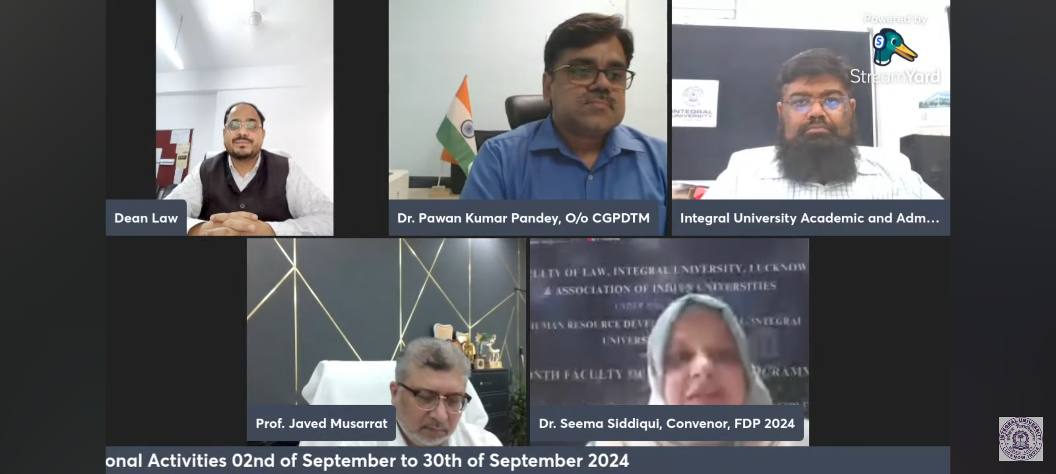
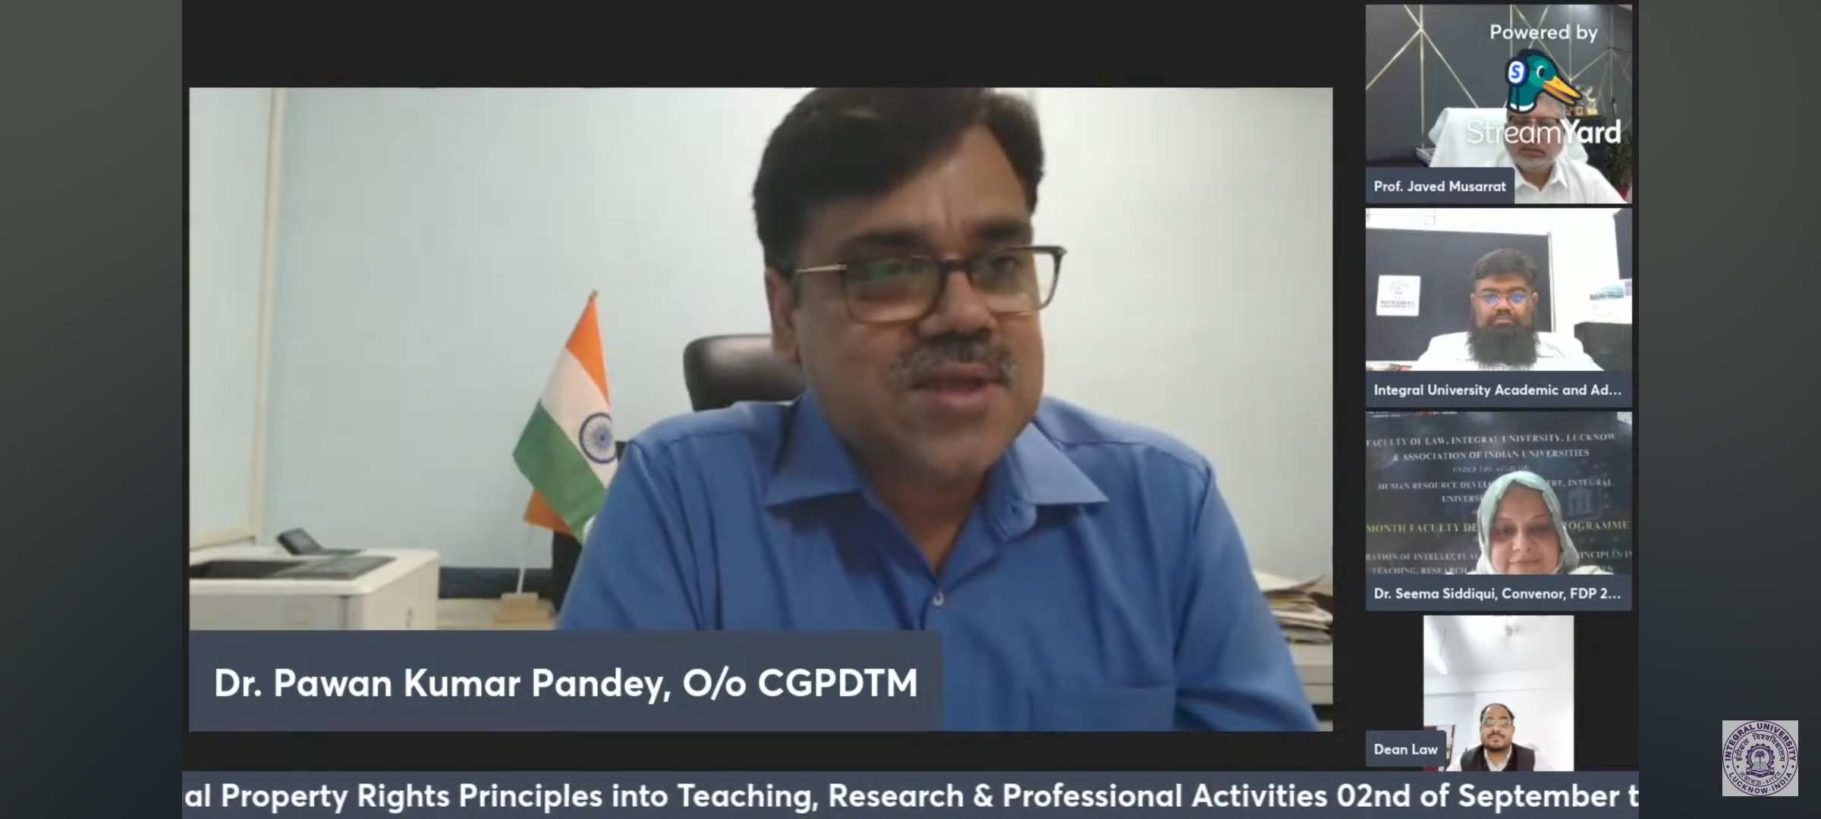

Pictures of Valedictory Session
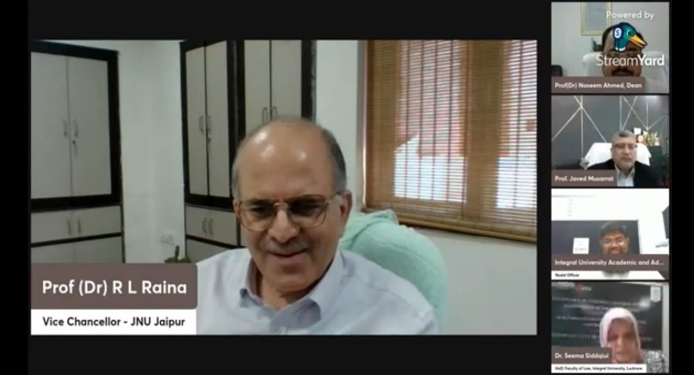
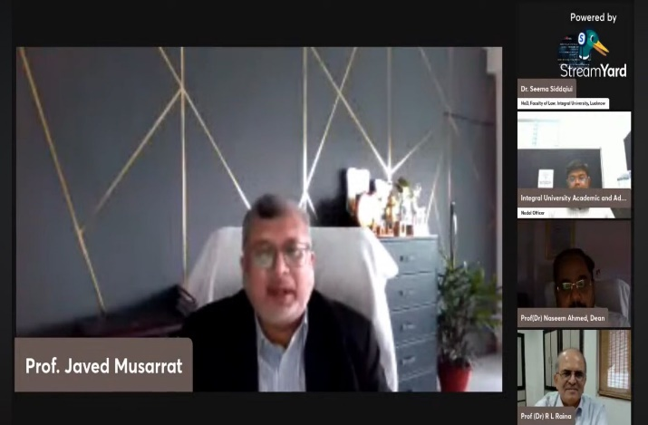

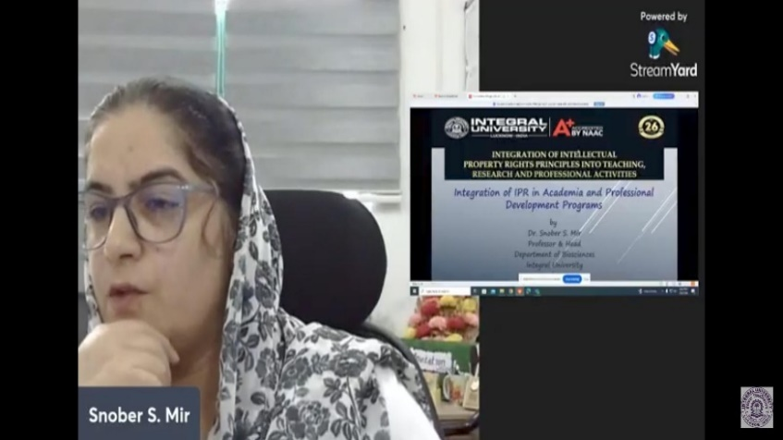
Pictures of Technical Sessions
