

AVINASHILINGAM INSTITUTE FOR HOME SCIENCE AND HIGHER EDUCATION FOR WOMEN
(Deemed to be university under category ‘A’ by MHRD,Estd. u/s 3 of UGC Act 1956) Re-accredited with ‘A++’ Grade by NAAC, Recognized by UGC under section 12B Coimbatore-641 043, Tamil Nadu, India

Report on Fifth Short-Term Capacity Building Program for the year 2024

“Artificial Intelligence Assisted Science Education”

Organized By

The AIU-AI-AADC
(Association of Indian Universities - Avinashilingam Institute Academic & Administrative Development Centre)
&
Centre for Machine Learning and Intelligence
&
School of Physical Sciences and Computational Sciences
15.07.2024 - 19.07.2024

AVINASHILINGAM INSTITUTE FOR HOME SCIENCE AND HIGHER EDUCATION FOR WOMEN
(Deemed to be university under category ‘A’ by MHRD,Estd. u/s 3 of UGC Act 1956) Re-accredited with ‘A++’ Grade by NAAC, Recognized by UGC under section 12B Coimbatore-641 043, Tamil Nadu, India

AIU-AI-AADC
Report on Fifth Short-Term Capacity Building Program

Artificial Intelligence Assisted Science Education

15.07.2024 - 19.07.2024

The AIU-AI-AADC (Association of Indian Universities - Avinashilingam Institute - Academic & Administrative Development Centre), Centre for Machine Learning and Intelligence and School of Physical Sciences and Computational Sciences jointly organized its Fifth Short-Term Capacity Building Program on Artificial Intelligence Assisted Science Educationfor 2024 from 15th July to 19th July 2024.

The program aimed to enhancethe skills, knowledge and confidence of participants in integrating AI technologies into science education and to familiarize them with AI concepts, including machine learning, natural language processing, data analytics and intelligent tutoring systems. They were also trained on techniques for using AI to support active learning, including interactive simulations and approaches in using AI to cater to diverse learning needs and styles, providing tailored support for students with varying abilities. Seventy Two from diverse institutions attended online sessions, focusing on integrating artificial intelligence tools in science education.

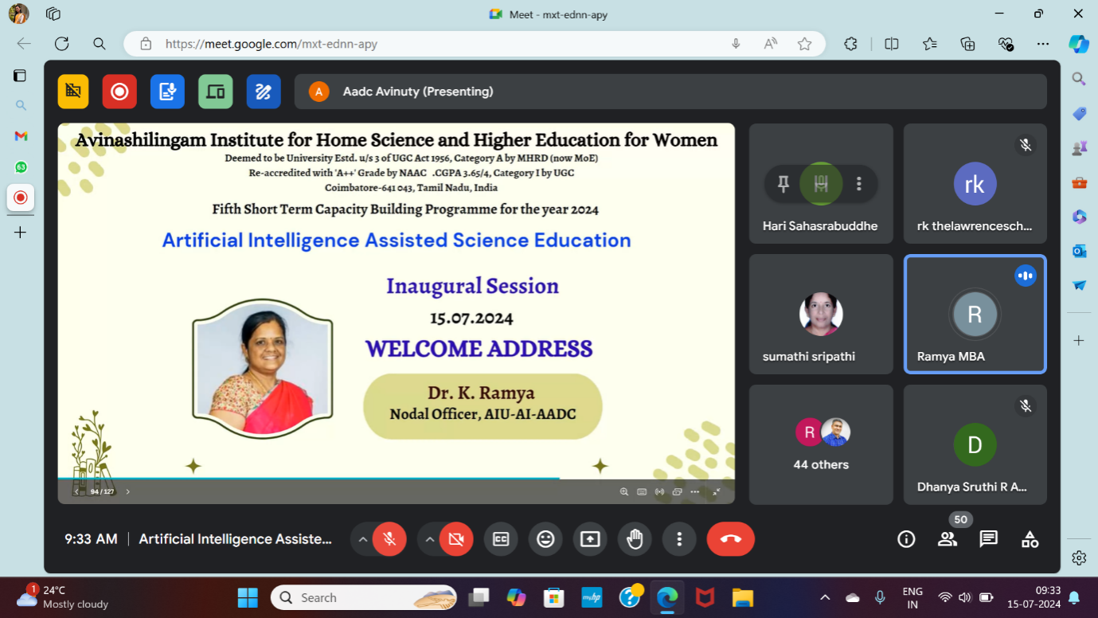

The program began with a prayer, followed by Dr. K. Ramya, Nodal Officer, AIU-AI-AADC, welcoming the gathering. The brief for the 5-day event was presented by Dr. Shubashini K Sripathi, Professor, Department of Chemistry, Avinashilingam Institute for Home Science and Higher Education for Women and Programme Coordinator.

Day 1: 15.07.2024 Session 1
Inaugural address
Dr. Hari. V. Sahasrabuddhe, Retired Professor, Kanwal Rekhi School of Information Technology, Indian Institute of Technology, Mumbai

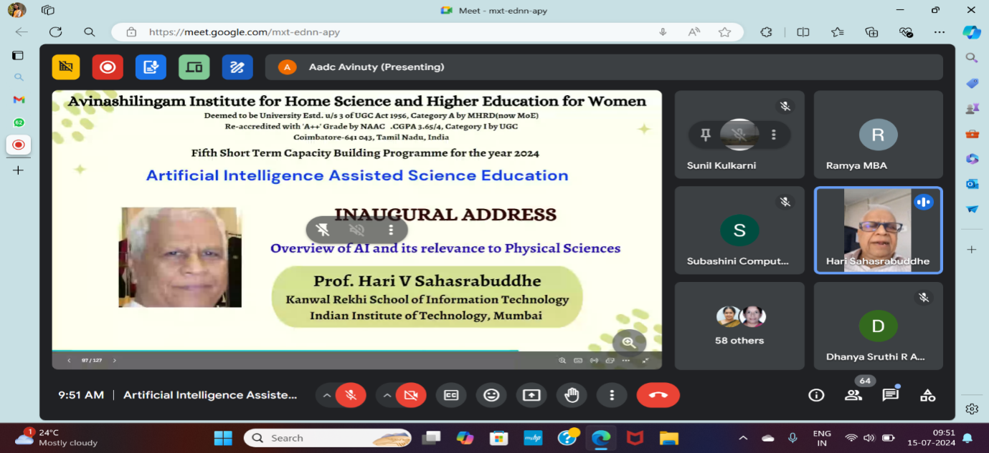

Dr. Hari. V. Sahasrabuddhe is a retired Professor of Computer science. During his talk, he talked about the awareness that people in this AI world should have and connected it to an occurrence that happened prior to Indian independence when the British gave away free samples of tea, which led to the current state of Indians being victims of tea. He emphasised on using AI precisely and warned about its fishhook. He brought out the need to use technology and AI with human intellect during the session. There were also some interesting ideas discussed during the session. Dr. Hari V. Sahasrabuddhe spoke during the workshop how learning occurs naturally in humans and how individual differences result in adaptability. The session also aided the participants' understanding of how the world is always changing and how teachers should adjust their methods to reflect these changes. Dr. Hari V. Sahasrabuddhe engaged the participants in an engaging discussion by providing numerous instances and analogies. To conclude he emphasized that the future of learning should be updated with current evolution and technologies of the world
Take away from the session:
- In his inaugural speech, Sir stated that educators must constantly learn new material and impart it to their students.

Day 1: 15.07.2024 Session 2
Significance of Machine Learning tools and languages in AI-powered education
Dr. T. Devi, Dean Research, PSG Tech
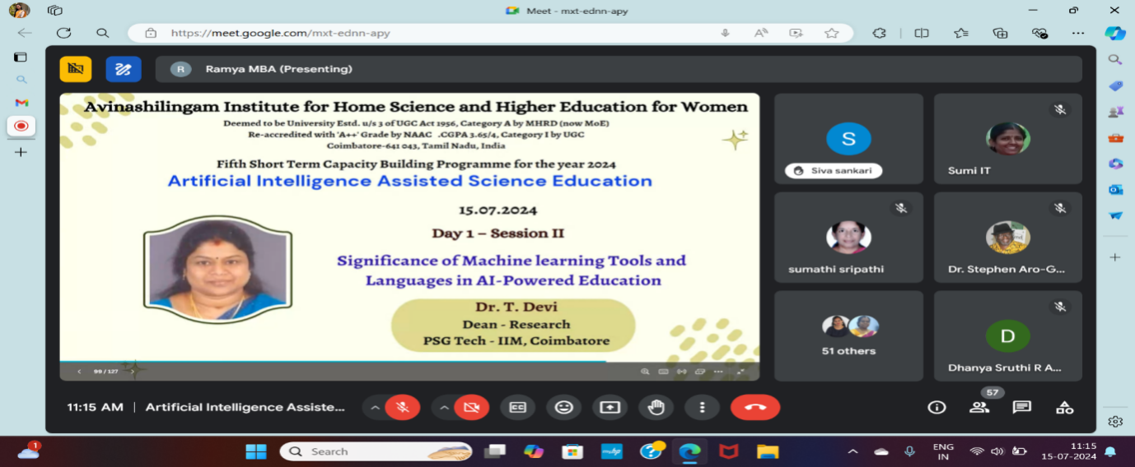

Dr. Devi highlighted on industry 4.0 and expounded on the use of transformational digital technologies to disrupt education. She gave a quick discussion of deep learning, reinforcement learning, and machine learning. She emphasized on the role of Machine Learning in AI- powered education. The expansion of acronym VUCA (volatile, uncertain, complex, and ambiguous) was briefed by her. She elaborated on popular machine learning tools and languages such as python, tensorflow, Pytorch and artificial modelling capabilities. The challenges in implementing Machine Learning in Education are data privacy, interpretability and teacher training. She also gave a briefing on upcoming developments in AI-powered schooling.
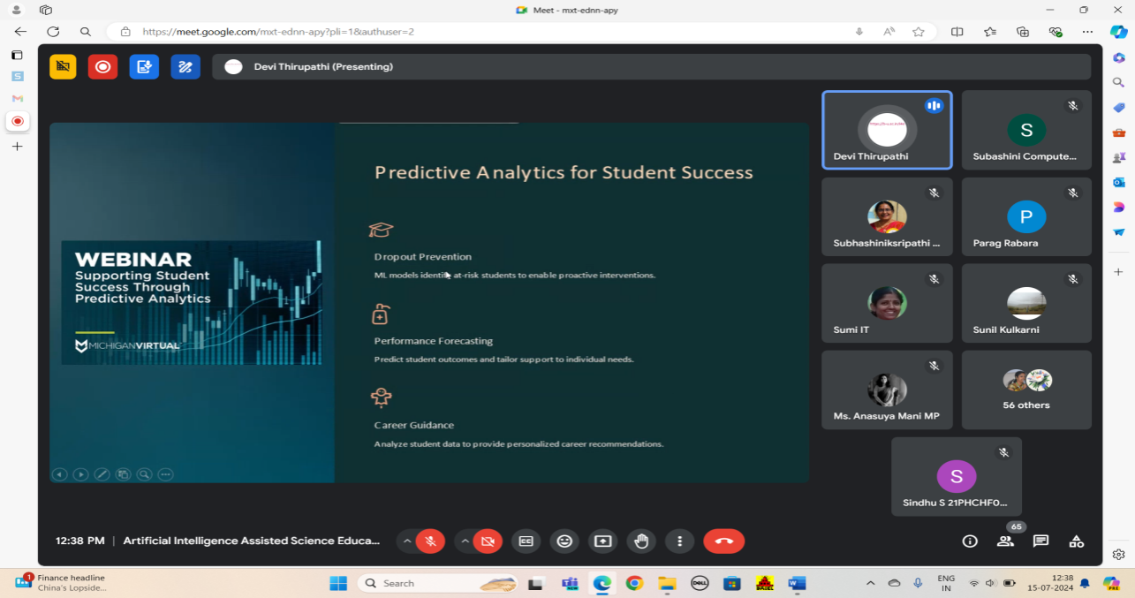

Take away from the session:
- Understanding the role of Machine Learning in AI – powered education
- Advantages of Machine Learning in education
- Art of personalized learning with Machine Learning
- Holistic approach to improve education system with Machine learning

Day 1: 15.07.2024 Session 3
Artificial Intelligence in Chemistry: Current Landscape and Future Opportunities
Dr. V. Rajapandian, Assistant Professor,
Sri Ramakrishna Mission Vidyalaya College of Arts and Science, Coimbatore
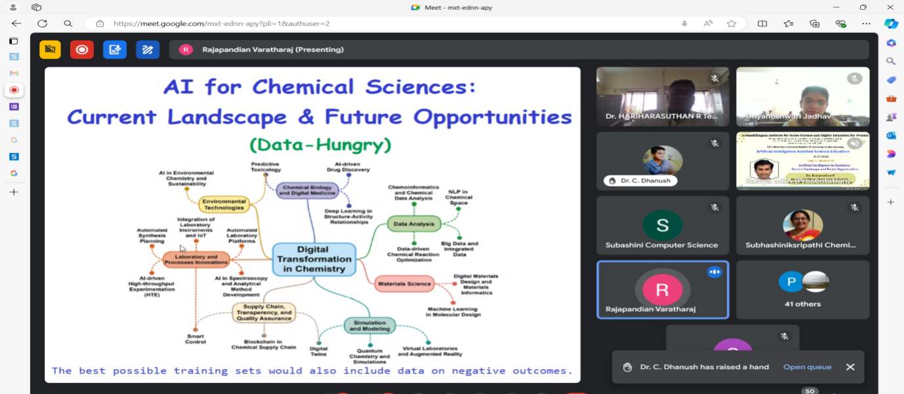
The seminar began with an engaging story from Dr. V. Rajapandian sir, which focused on the idea that in the right situation, our experiences, talents, and knowledge may be valuable, and that a person's work is valued wherever it is directed. He briefed on classical and quantum mechanical methods in computational chemistry, explained about semiempirical, density functional and ab initio methods. He also elaborated about the evolution of 5G from 1G since the year 1979 and the evolution of AI since the year 1950. Sir explained about basics of AI, its trendsfrom 2018 to 2060 where super intelligent AI will be developed. Discussing about use AI in chemistry he spoked about the high throughput experimentation, deep learning based inverse design model for intelligent discovery of organic molecules, graph convolution neural network model for the prediction of chemical reactivity, use of deep reinforcement learning to optimize chemical reactions and future advances such as molecular editing and machine learning.
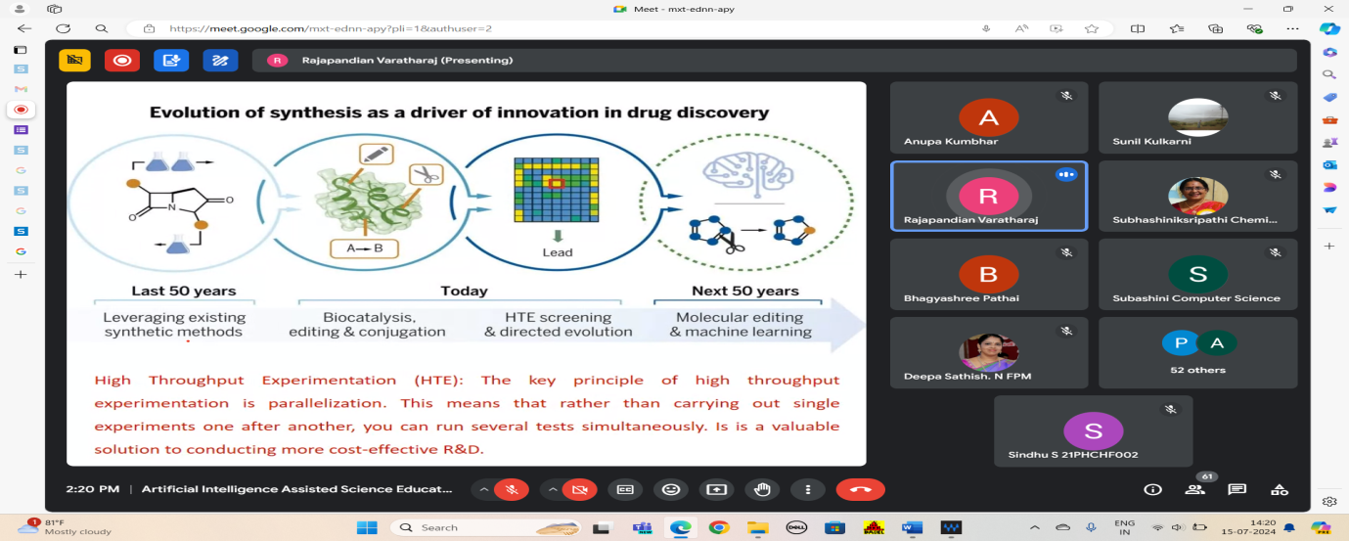

Take Away from the session:
- History of evolution of 5G
- Trends in Artificial Intelligence
- Influential AI-based technologies in chemical research
- Machine learning resources and tools
- Optimizing chemical reactions with deep learning

Day 1: 15.07.2024 Session 4
‘Intelligent tutoring Systems (ITS) and Virtual Teaching Assistants’
Dr. P. Subhashini, Professor, Avinashilingam Institute of home science and higher education for women, Coordinator, Centre for Machine Learning and Intelligence

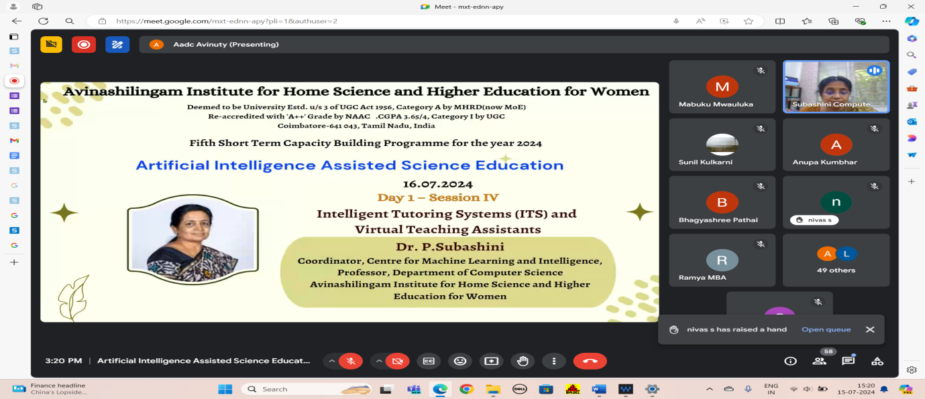

The importance of the intelligent tutoring systems (ITS) and virtual teaching assistants (VTA) was highlighted by Prof. P.Subashini. She discussed on the key components and working of ITS and benefits such as personalized learning, scalability and data-driven insights. Free and open-source intelligent tutoring systems such as ASSIStments, KaLi, AutoTutor and SMARTS were briefed by mam. She elaborated about the meaning of VTA, its functions and benefits of using it, while explaining about its working she said that VTA uses natural language processing, machine learning, automation and integration (learning management system). She stated efficiency, accessibility and enhanced learning are the benefits of a virtual teaching assistant. Jill Watson and IBM Watson tutor are examples stated by madam for virtual teaching assistant. Free VTA tools such as Edmodo, moodle, google classroom, Microsoft teams for education, canvas network, otter.ai, coursera for campus and Khan academy were also familiarized by her.

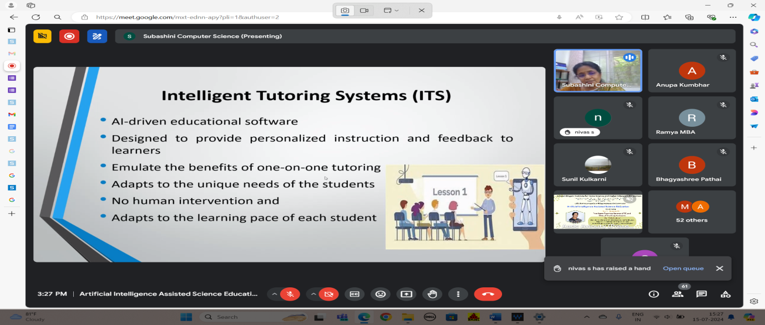

Take Away from the session:
- ITS and VTA’s revolutionizes education as they provide personalized, scalable and efficient learning solutions.
- Free and open ITS
  - ASSISTments
  - KaLi
  - AutoTutor
  - SMARTS
- Free VTAs
  - Edmodo
  - Moodle
  - Google classroom
  - Microsoft Teams for Education
  - Canvas Network
  - Otter.ai
  - Coursera for campus
  - Khan Academy

Day 2: 16.07.2024 Session 1
AI-powered platform for learning environment
Dr. Vinay, Associate Professor, Christ University, Bangalore
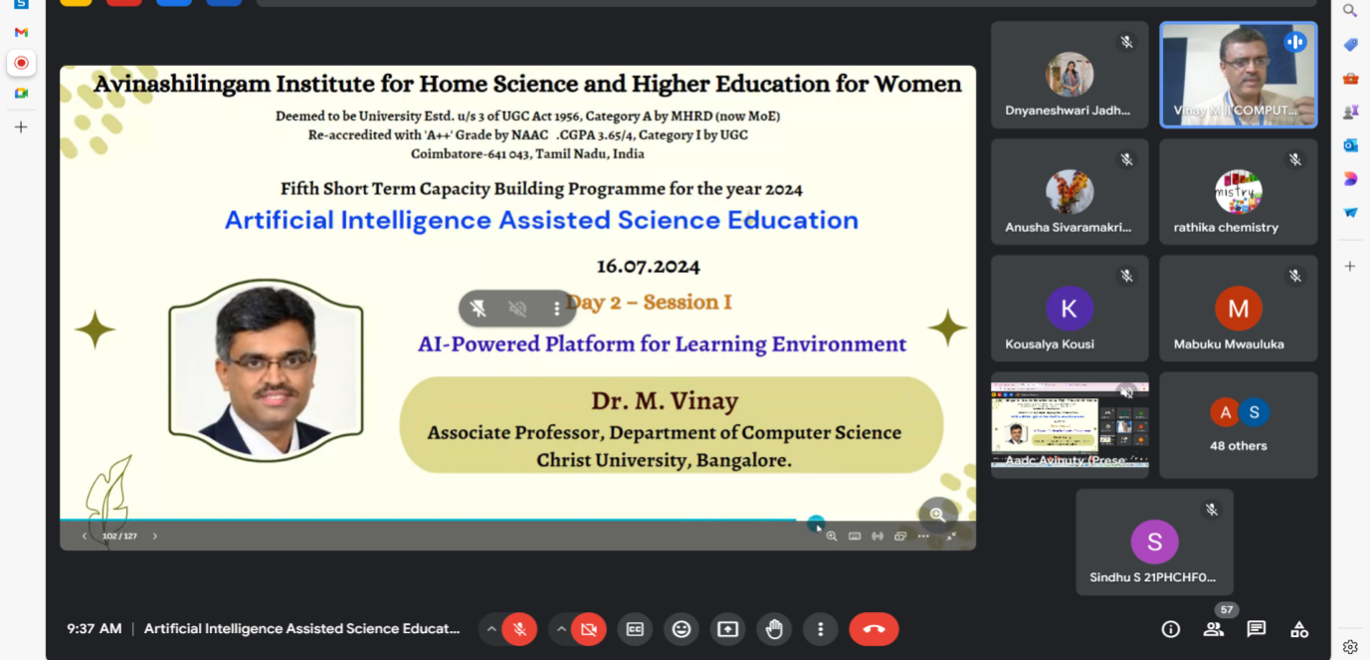

The session started with a brief explanation about artificial intelligence, machine learning and deep learning. Dr. Vinay explained on types of AI, need for AI and importance of AI in education. Evolution of AI- powered learning platforms and global AI in education market since 2016 was elaborately discussed by him. He gave an exhaustive demonstration on AI powered tools for teaching and learning such as, Gimkit, Whimsical and Genially. Dr.Vinay said by embracing AI, a teacher can create a more engaging and effective learning experience for all students.
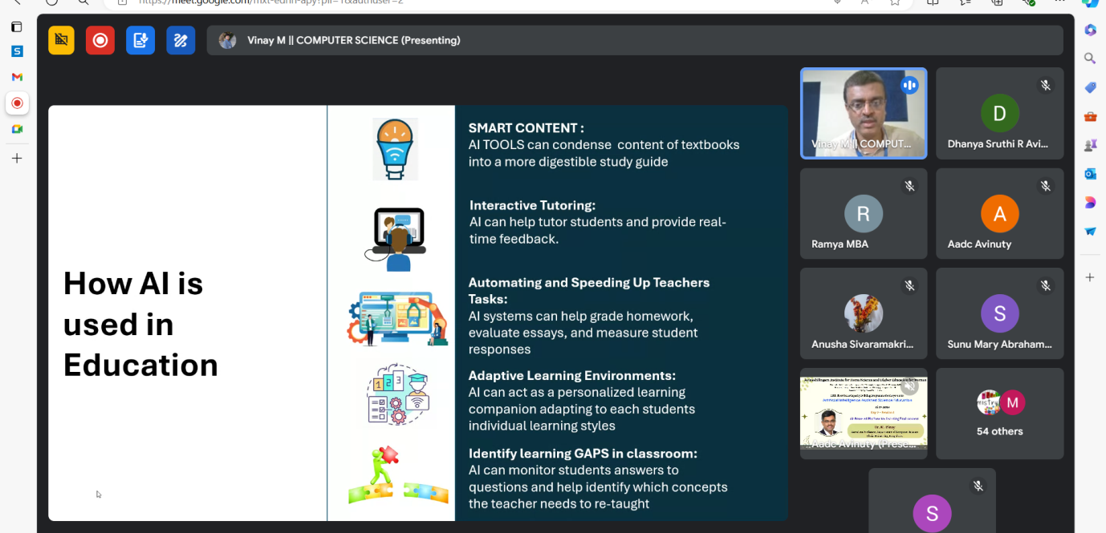

Take away from the session:
- Adaptability towards AI powered learning platforms
- AI-powered learning platforms can enhance engagement, improve student outcomes and provide valuable data-driven insights.
- Versatility in smart content creation tools for teaching using AI such as; Gameshow (quizzes), gimkit (quizzes), whimsical (images and flow chart maker), coggle.it (for mind map generation) and genially (designing pictures and templates) software.
Day 2: 16.07.2024 Session 2
Integration of AI with Moodle Learning Environment
Mrs. Elizabeth Leah George, Assistant Professor, Nagindas Khandwala College Mumbai

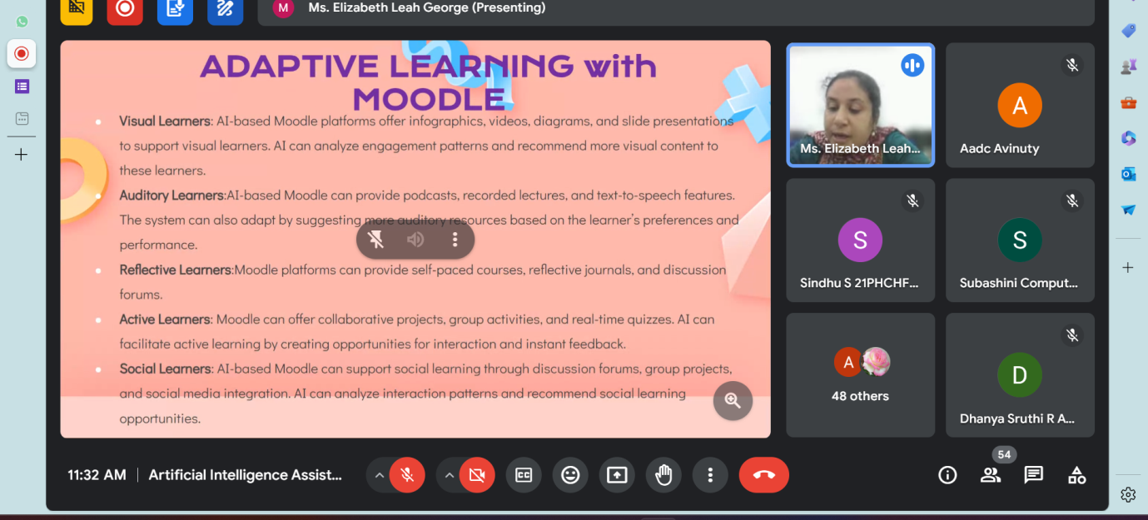
A comprehensive demonstration of Moodle e- learning platform and adaptive learning with Moodle was presented by Mrs. Elizabeth Leah George, She also discussed about hardware requirements of Moodle.
Adaptive features of Moodle explained by her are:
  - AI connector
  - Open AI ChatBlock
  - Open AI question generator
  - AI text to questions generator
  - Compilatio plagiarism and AI content detector
  - Copyleaks plagiarism and AI content detector
  - X-5- Moodle
  - IntelliBoard
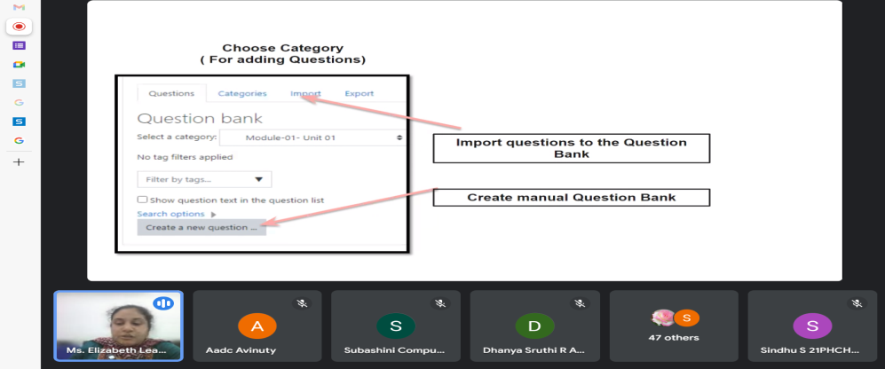
Using Moodle, an open-source learning management system (LMS) helps educators create and manage online courses. It provides a platform for teachers to upload course materials, create quizzes, assignments, and facilitate discussions through forums and chat rooms. Moodle is highly customizable, allowing users to extend its functionality with plugins and themes, making it adaptable for different educational needs, whether in schools, universities, or corporate training. Its user-friendly interface and collaborative tools help enhance the learning experience by promoting interaction between students and instructors.
Take away from the session:
- Demo of Moodle platform for adaptive learning
- Moodle tool and its features

Day 2: 16.07.2024 Session 3
‘Deep Learning and Pattern Recognition’
Dr. M. Punithavalli, Professor and Head
Department of Computer Applications, Bharathiar University

Dr. Punithavalli touched upon the basic concepts of artificial intelligence and explained about sub fields of AI such as robotics, computer vision, embedded AI, control system, natural language processing and machine learning. The speaker discussed application of AI in various fields.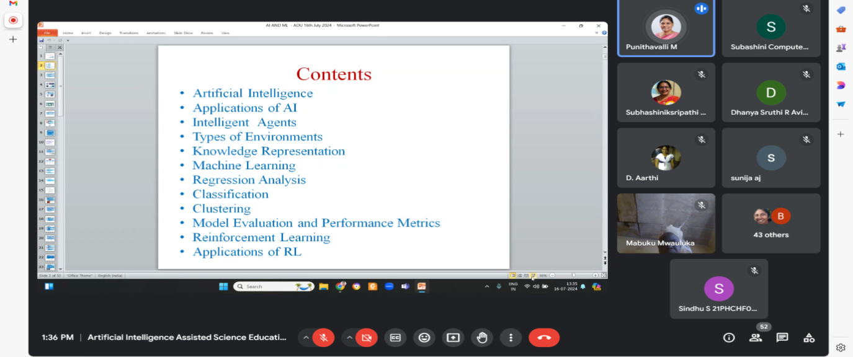

Machine learning (ML), a branch of AI was elaborately explained by the speaker by stating the steps in ML, its types: Supervised learning, unsupervised learning and reinforcement learning. Regression analysis pertaining to supervised learning was explained in detail by the speaker.
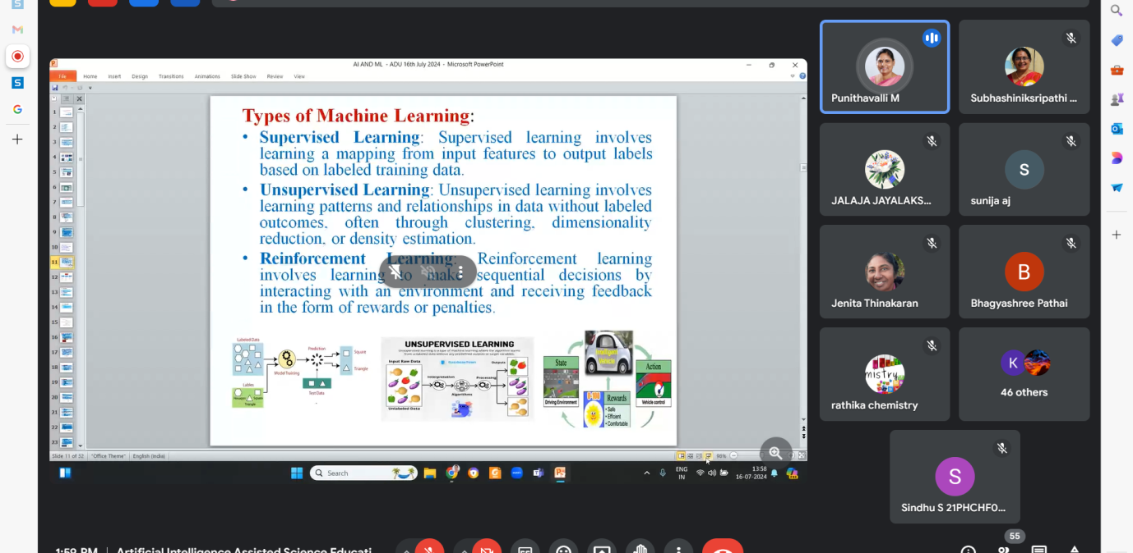

Take away from the session:
- Understanding basic concepts of Artificial Intelligence and its applications in environmental monitoring.
- Differentiating about types of Machine learning:Supervised learning, Unsupervised learning and Reinforcement learning

Day 2: 16.07.2024 Session 4
‘Virtual Reality and Augmented Reality Tools for Immersive Learning Experience in Science’
Dr. K. Thiyagu, Assistant Professor, Central University of Kerala, Kasargod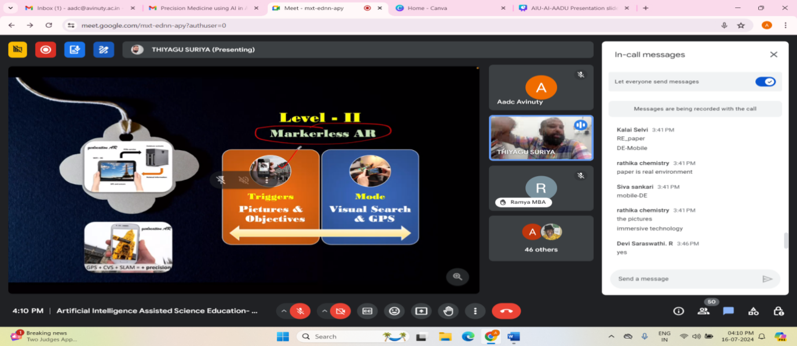

Dr Thiagu provided a demonstration of various augmented reality tools such as Animal 4D cards, AR loopa, Space craft AR and anatomy AR 4D. Explained on location-based AR, Superimposition AR, Projection based AR. He listed the applications of AR such as Quiver, elements 4D, blippar, star walk, spacecraft AR and explained that AR in education can
  - Increase content understanding
  - Aid in Long-term memory retention
  - Improve activity performance
  - Improve collaboration
  - Increase pupil motivation

Takeaway from the session:
- Understanding the importance of Augmented reality
- Introduction to various augmented reality tools

Day 3:17.07.2024 Session 1
‘AI Assisted Content Creation Tools’
Mr. Roshan Singh, Scrollwell, Noida

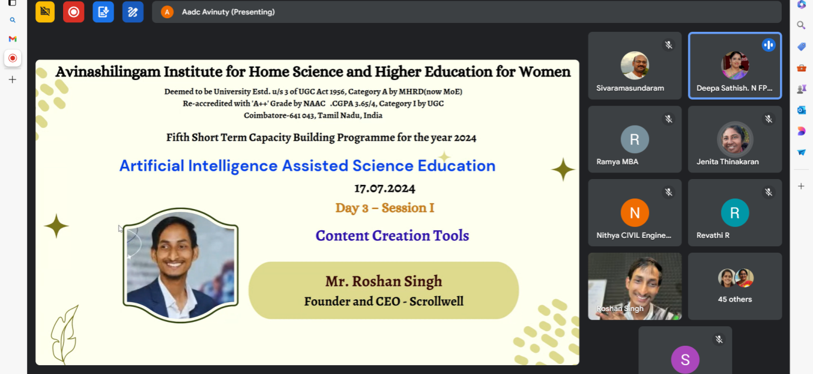

Mr. Roshan Singh of Scrollwell commenced the session by holding a quick fire round asking the attendees to mentiontheir expectations of the session and the listed the topics subjects that will be covered. Since the majority of participants requested for multiple kinds of content creation, he described a one-stop shop for content creation that focuses just on conversation chat GPT and several ways of prompting it exclusively. Additionally, he gave a thorough demonstration of AI assisted Microsoft PowerPoint, Canva, and Slides. Microsoft PowerPoint, that help users to make, customise, and present slideshows.
Canva Magic Slides design suite tool from Canva provides an easy-to-use interface for making eye-catching presentations. It offers an extensive collection of templates, graphics, and design components together with AI-driven tools that can produce slide layouts on their own. Canva is liked for its creative versatility and user-friendliness, appealing to both novices and experts alike.SlidesGo provides a range of premium and free Google Slides and PowerPoint templates. Professionally created slides from SlidesGo can be altered to meet a range of presentation requirements, from business to education. It's a useful tool for adding polished, thematic designs to presentations rapidly.In addition, Mr.Roshan provided an introduction to the Free Humanise AI text software and recommended the website "THERE'S AN AI FOR THAT" to locate the most appropriate AI solutions for our requirements.
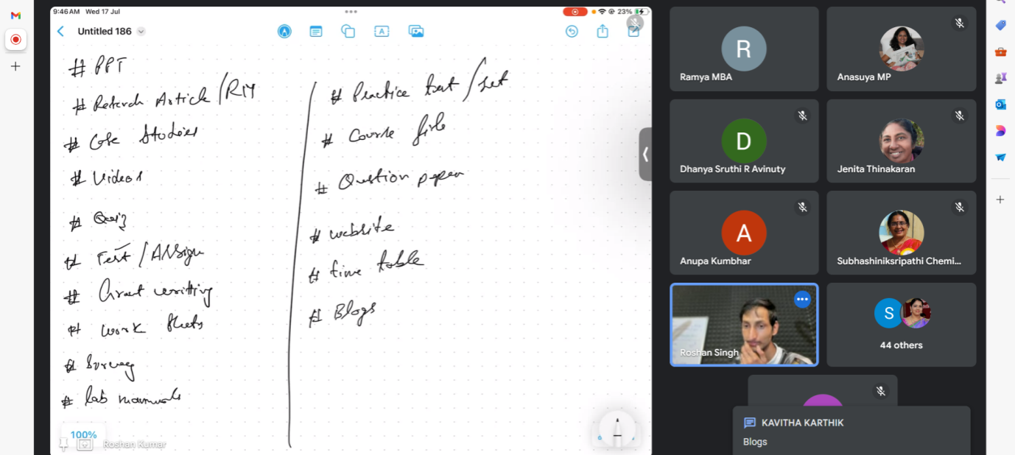
Take away from the session:
- Understanding on vast usage of ChatGPT, tips and tricks of its prompting.
- Learning to create ppt using canva, ms ppt online, which suggest slides according to the content and slides go
- Awareness about incognito mode in google chrome.

Day 3: 17.07.2024 Session 2
‘Multimedia content creation – Video and Audio Production, Image and Graphic Design’
Dr. Vinay, Associate Professor, Christ University, Bangalore
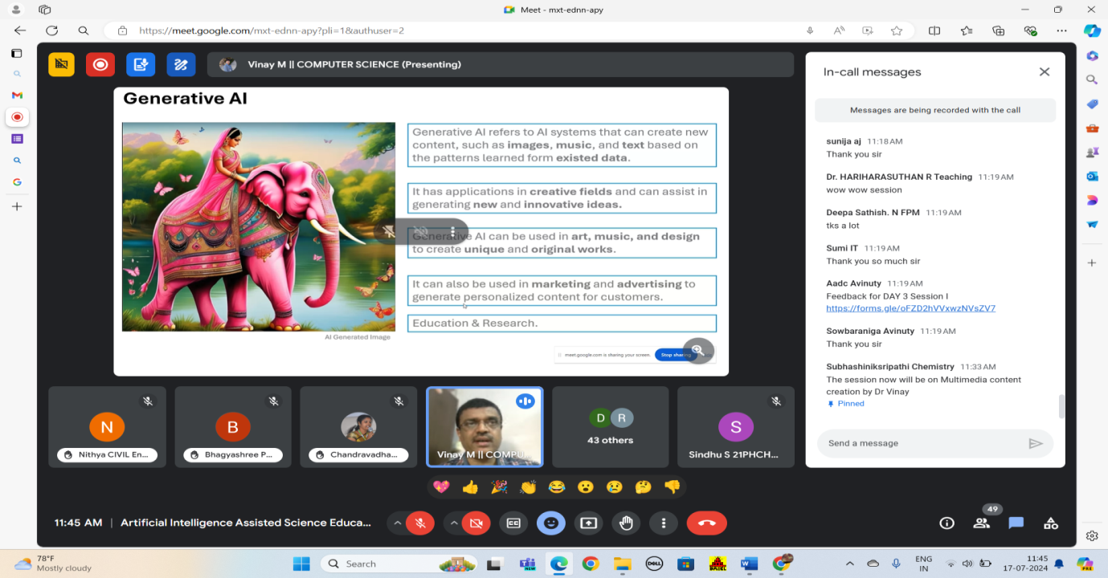

The session started with a brief introduction to generative AI. Generative AI refers to a class of artificial intelligence models that can create new data similar to the data on which they were trained. This can include text, images, music, code, and other types of content. Unlike traditional AI, which is designed to recognize patterns or make decisions based on existing data, generative AI can produce original content. Dr Vinay explained about text generation AI applications such as Claude, Gemini, Copilot and ChatGPT the advanced AI models designed for natural language understanding and generation, each with unique features and applications. The session was followed by explanation on prompting and he said that an ideal prompt should comprise of 21 words which should include:
  - Persona
  - Task
  - Context
  - Format
Further Dr Vinay gave a rapid demonstration on various audio and video generative applications. Narakeet is a tool for creating videos with text-to-speech narration; Adobe Firefly offers AI-powered creative tools for generating and editing images; Freepik provides a vast library of free and premium design resources; Pixlr is an online photo editor offering quick and advanced editing features; ElevenLabs specializes in AI-generated lifelike voice synthesis; Dubverse provides AI-powered video dubbing and subtitling; Soundraw enables AI-generated custom music compositions; Natural Reader converts text into speech for accessible reading; Designs.ai Video Maker automates video creation with AI; Elai is an AI platform for creating personalized video content; Meta AI focuses on developing advanced AI research and tools, and Miro is a collaborative online whiteboard platform for team brainstorming and planning.

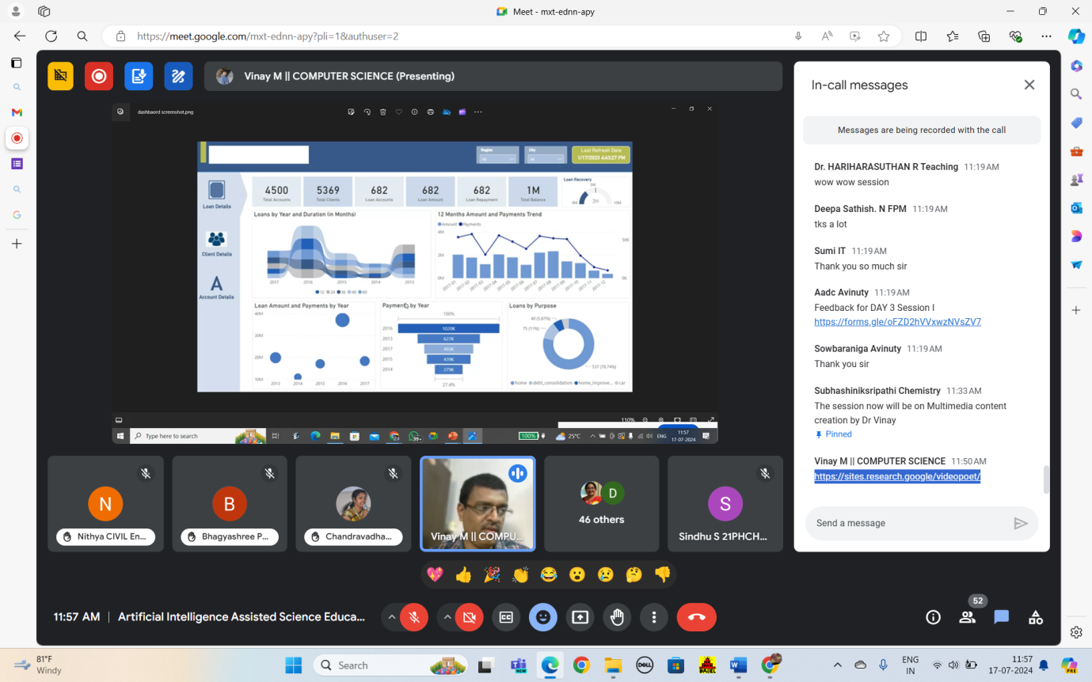

Take Away from the session:
- Aspects of generative AI
- Demonstration of generative AI platforms for creating image, audio effects and videos using adobe firefly, freepik, pixlr, IIElevenLabs, Dubverse, soundraw, natural reader, designs video maker, elai, meta- AI, narakeet and miro
- Explanation about prompt engineering

Day 3: 17.07.2024 Session 3
‘Deep Learning for Video Analytics –Science Perspectives’
Dr. P.R Hiremath, Professor, KLE Technological university, Hubballi, Karnataka
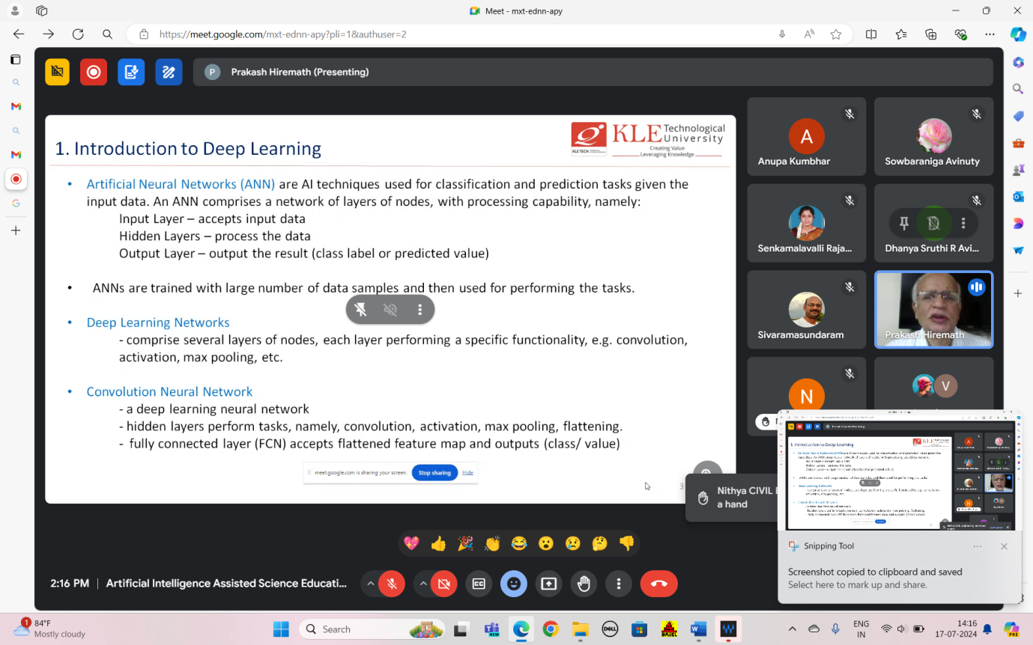

Dr. Hiremath started the session with a discussion on deep learning. He explained about generative AI models for text, image, audio generations, multi and diffusion models. Hugging face, an open-source platform for experimenting Gen AI. He elaborately discussed about the Gen AI in sports science, in sports science, generative AI is being used to enhance performance analysis, injury prevention, and training strategies. By creating simulated data, such as virtual athletes or predictive scenarios, generative AI can model complex biomechanical movements, optimize training routines, and predict potential injuries. This technology also enables the generation of personalized training programs by analysing individual athlete data, leading to more tailored and effective interventions. Additionally, generative AI helps in visualizing game strategies and outcomes, offering coaches and players new insights into performance improvements. Further in the session sir explained the differences in pixel and compressed domain, video analysis for action recognition. The theory behind human action recognition in a compressed video, stages in action identification (action recognition and data association) is clearly explained by the speaker.

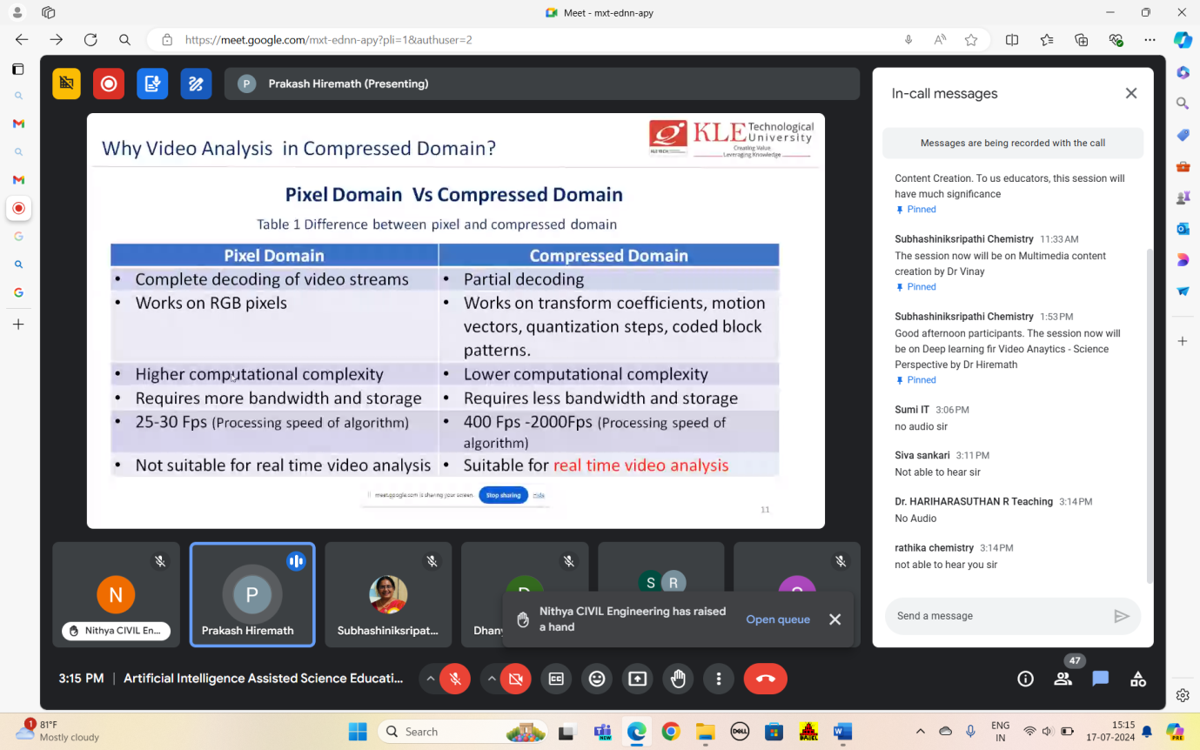

Take Away from the session:
- Understanding about Artificial neural networks-Deep learning networks-convolution networks
- Generative AI Models such as; GPT- 4, ChatGPT for text generation, DALL- E2, Stylegan2 for image generation and BigGAN for image generation, Jukedeck and Juke box for audio generation, GitHub Copilot, OpenAI Codex, Intellicode for code synthesis, Adobe firefly and MidJourney for image synthesis.
- Compressed domain in video analysis

Day 3: 17.07.2024 Session 4
‘Hands-on Training on Content Creation using AI’
Dr. K. Thiyagu, Assistant Professor, Central university of Kerala, Kasargod

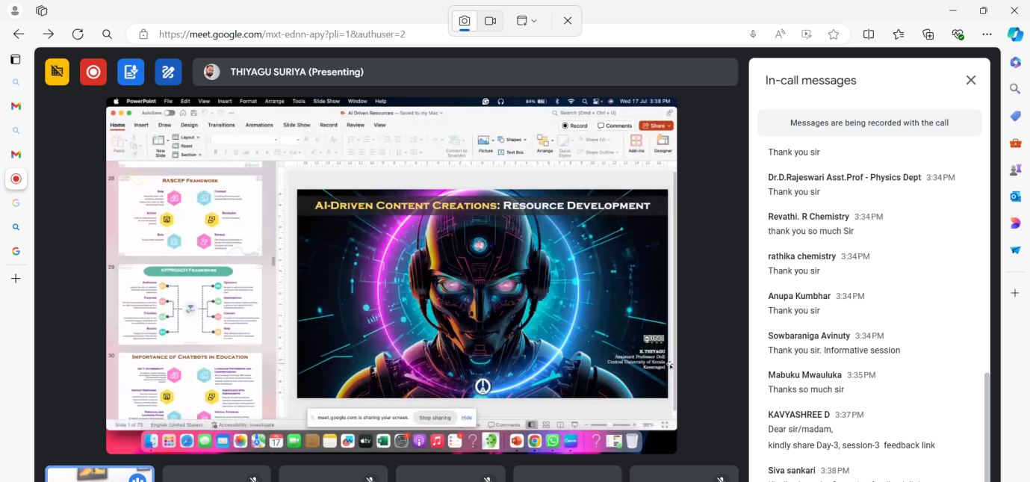

Dr. K. Thiyagu started the session by explaining generative and predictive AI and explained that its applications are the one which is used by end users. Such tools are used in text generation, image generation, music generation, video generation and speech synthesis models. Sir explained about Generative AI in the aspects of
- Text Generation – ChatGPT
- Image Generation – DALL-E
- Music Generation – MuseNet, Semiconductor
- Video Generation – VQ-VAE-2
- Speech Generation – TTS Text to Speech
He gave an eye-opening explanation on art of prompting, its types and taught the participants on how to use a prompt to get good AI generated out and explained the types of prompting as zero-shot, one-shot,few shot and chain prompting. Speaker explained the GIGO principle, which stands for "Garbage In, Garbage Out," is a concept in computing and artificial intelligence that emphasizes the importance of input quality. Sir also discussed about the RTA (Role, Task and format) and TAG (Task, action and Goal) framework in the context of AI generative tools.He emphasized many applications of AI in education (Smart content, Personalized learning, Adaptive learning, Data Accumlation. Virtual Facilitator, Automated Grader, Chat Campus, Pictoring)

Sir explained about various content creation tools such as presentation makers (Gamma App, SlidesPlot, Magic Slides, slidesgo) and demonstrated autodraw and lalamu.He elaborated on Predictive AI, AI Presentation markers such as AI boards (AutoDraw, Gamma App, Slidesgo), AI Image markers (Adobefirefly). Gamma app is a tool for creating visually appealing presentations and reports with AI-powered design suggestions, Tome app is a platform for building and sharing interactive documents and presentations with a focus on collaboration, and SlidesPilot offers AI-assisted presentation design and content generation to enhance slide creation and visual storytelling.Finally concluded with a message that Humans are Hooked but Machines are Learning, therefore humans should understand that AI is a tool and not a solution.

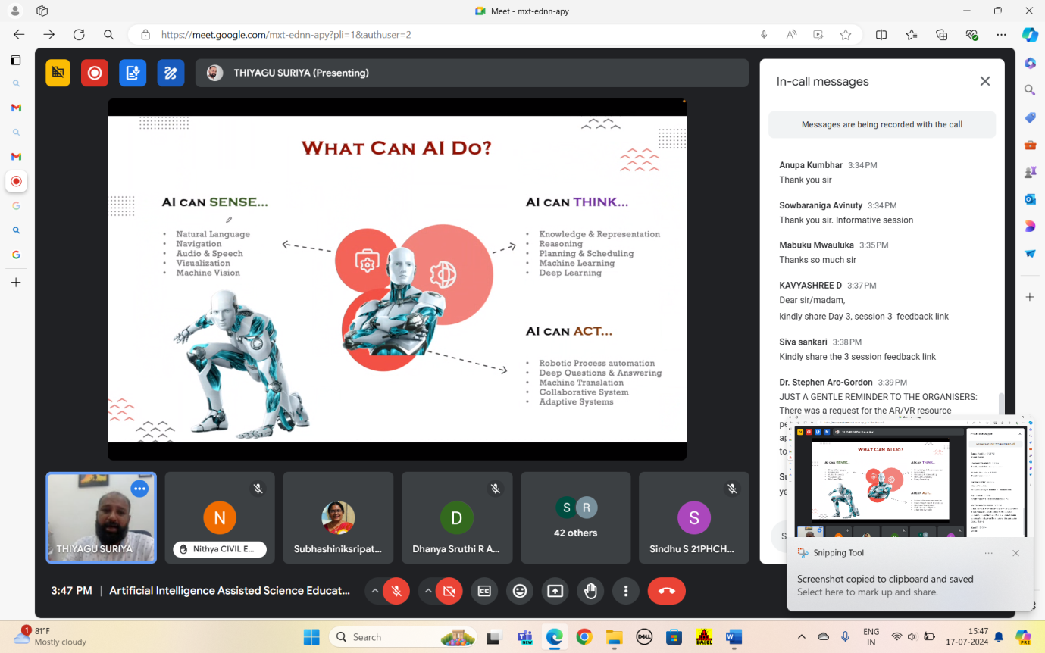
Take Away from the session:
- GIGO principle, RTA and TAG formats
- Demonstration of AI presentation makers
- Importance of prompting technique

Day 4: 18.07.2024 Session 1
‘AI Powered Feedback Tools for Language, Grammer and Plagiarism’
Dr. Kalaiselvi, Assistant Professor, Gandhigram Rural Institute, Dindigul
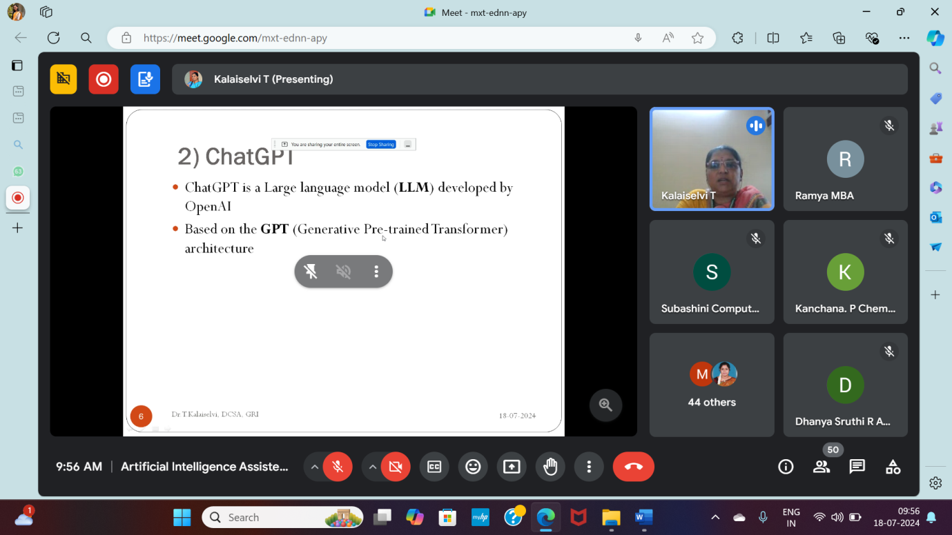

The session began with an explanation of AI-powered feedback systems by Dr. Kalaiselvi. The speaker divided the AI tools into three categories: Super intelligent AI, general purpose AI, and narrow AI. She went on to identify other resources for language, grammar, and plagiarism. Ma'am gave an explanation of the ChatGPT, including its main features, uses, and versions.

he speaker elaborately explained the key features of it as:
- Natural Language Processing
- Conversational Ability
- Task Versatility
- Code Generation and Analysis
- Language Translation
- Adaptability
- Continuous Learning
- Text Completion and Prediction
- Multi-turn Interactions
- Customizable Output

The session then continued with exhaustive explanation of language tools such as google translate, claude AI and duolingo.and duolingo. Google Translate is a tool that provides real-time translation of text and speech across multiple languages, Claude AI is a conversational AI developed to assist with a variety of tasks and answer questions, and Duolingo is a language learning app that uses gamified lessons to teach new languages and improve fluency.
Grammer checking tools like grammarly, quillbot and traude AI.Grammarly is an AI-powered writing assistant that provides grammar, punctuation, and style suggestions, QuillBot is a tool that offers advanced paraphrasing and text rewriting capabilities, and Traude AI is a conversational AI platform designed to assist with natural language understanding and generation tasks. The speaker gave an insightfull overview on plagiarism checking detectors such as Grammarly, small SEO tools, duplichecker, plagscsn, quetext and paperRater.Small SEO Tools is a suite of tools for analyzing and improving search engine optimization, Duplichecker helps detect duplicate content across the web, Plagscan provides plagiarism detection and content originality checking, Quetext offers plagiarism detection and citation support, and PaperRater combines grammar checking, plagiarism detection, and writing suggestions for academic and professional documents. Madam explained about copyscape, GPT zero and writer AI content detector. Copyscape is a tool for detecting online content duplication and plagiarism, GPTZero is designed to identify text generated by AI models, and Writer AI Content Detector helps to distinguish between human-written and AI-generated content for authenticity verification.

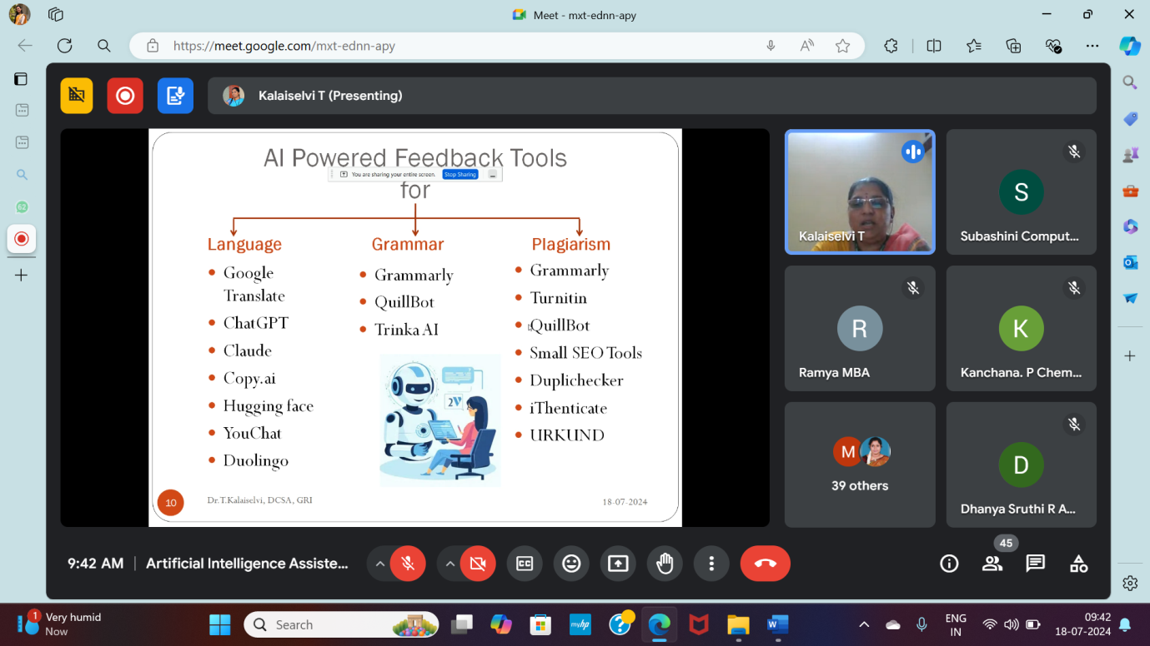

Take Away from the session:
- Explanation of ChatGPT, Claude AI, Duolingo, Grammarly, Quill Bot, Trinka AI
- In depth understanding of key features of chatGPT
- Understanding broad range of plagiarism checking tools

Day 4: 18.07.2024 Session 2
‘AI assisted Tools for Formulating Questions and Quizzes’
Dr. Suresh Shanmugasundaram, Teaching Fellow
College of Science Technocampus, Swansea University

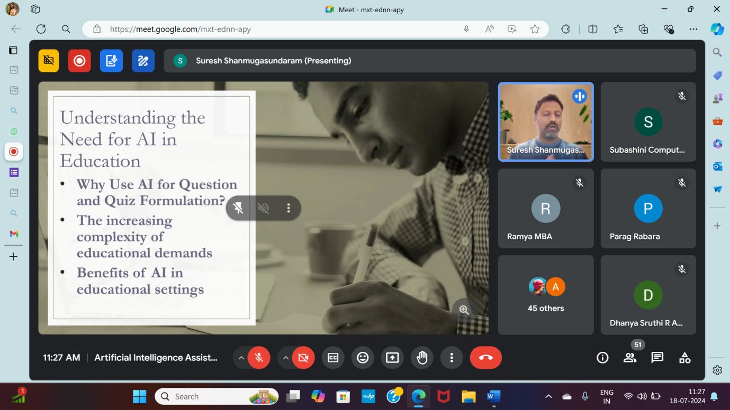

Dr. Suresh Shanmugasundaram spoke on the need for AI in education, its practical limitations and best practices. He explained about AI capabilities as data analysis, pattern recognition, natural language processing and predictive modelling. AIin education can be used for personalized learning, administrative efficiency, enhanced engagement and accessibility. The speaker while discussing about challenges in use of AI in educational setting discussed about Khan academy, Kahoot and Edulastic. Khan Academy offers a vast range of free educational resources and interactive lessons across various subjects, Kahoot provides a platform for creating and playing interactive quizzes and games for learning, and Edulastic is an online assessment tool that enables teachers to create, administer, and analyze formative and summative assessments. In case study 1, the speaker explained on how to create a recap quiz in database systems using ChatGPT, it involves generating questions and answers based on key concepts and topics from database systems, such as SQL, normalization, and schema design, to reinforce learning and assess understanding. Further discussed about creating a recap quiz using Microsoft Forms, which involves designing a set of questions to review key concepts, distributing the form to participants, and using the built-in analytics to assess understanding and gather feedback. Sir discussed certain best practices such as human oversight, using diverse prompts, supplementing with expert inputs, bias checking, following student- centric approach as needed to mitigate limitations in AI generated content. The session followed with explanation of quizlet, an online learning platform that allows users to create and study digital flashcards, practice quizzes, and other interactive study tools.

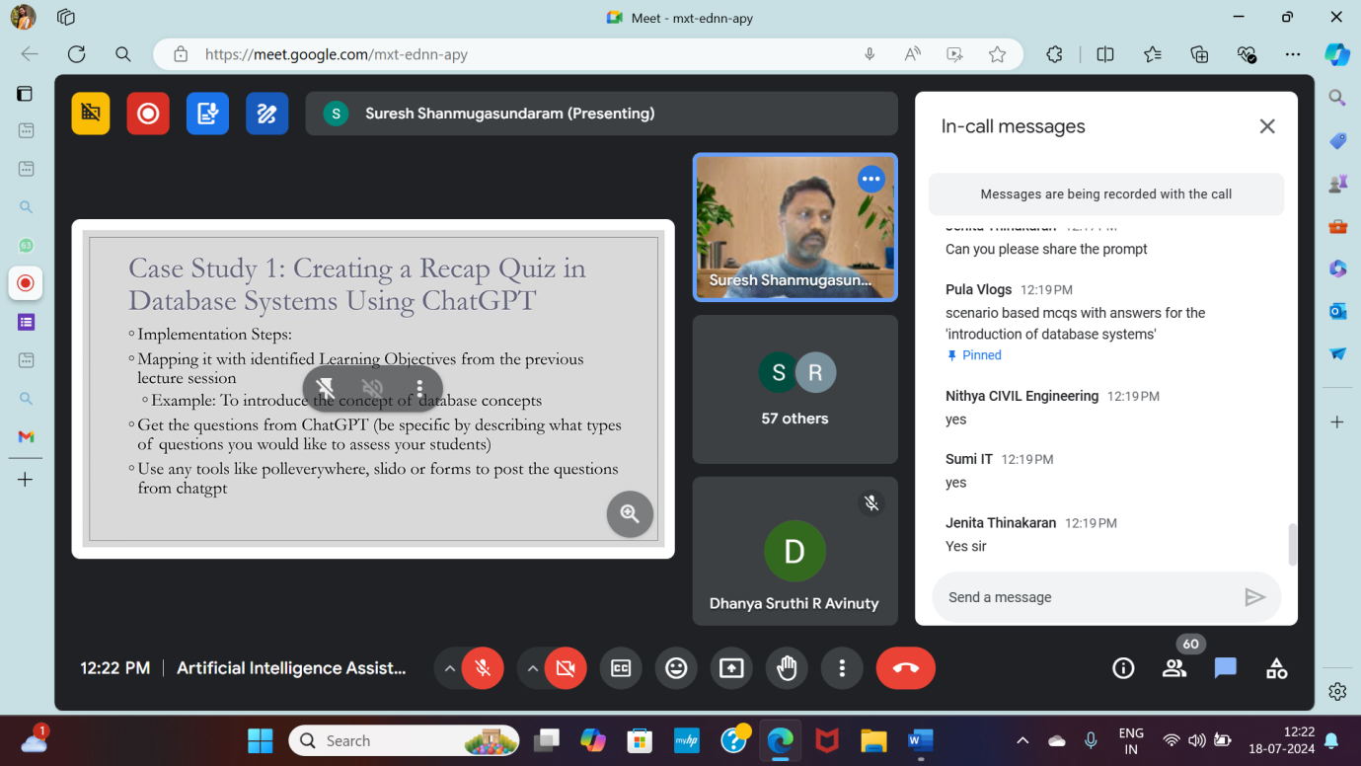

Take Away from the session:
- Understanding the importance of AI in formulating quizzes, assignments and questions and also the factors affecting the same.
- Knowledge on case studies from chatgpt about - “why recap quizzes are beneficial”
- Advantages of recap quiz using Microsoft office forms.

Day 4: 18.07.2024 Session 3
‘AI and Physical Sciences- Demonstration of Edredo’
Dr. P. Subhashini, Professor of Computer Science
Avinashilingam Institute of Home Science And Higher Education for Women.

Dr. P. Subashini demonstrated about Edredo, an adaptive learning tool, and goes over its features that are helpful for both students and teachers who wish to monitor their progress. Similar to Google Classroom, Edredo is a virtual classroom that may be hosted by businesses or educators. With its features—which include discussion boards, surveys, exams, presentations, and video content—teachers can host online classes, publish videos, and promote student participation. Among the features are an integrated writing tool, options for backing up courses, surveys, and an automated test engine that creates quizzes for students. It is also adaptable, allowing you to modify the course's default settings.

A teacher can use this application to host a course in many classrooms, and students can enrol based on how interested they are in the topic being offered. It will be possible for the instructor to publish quizzes, articles, polls, and videos. In addition, Edredo gives the instructor the ability to keep an eye on how the students are interacting with each other and the various components of the course, such as the quiz results and grades. Edredo offers live online classes in addition to enabling the posting of recordings. This seminar focused on how having lessons online helps instructors better understand how their students behave online, enabling them to customise the curriculum to suit their preferences.
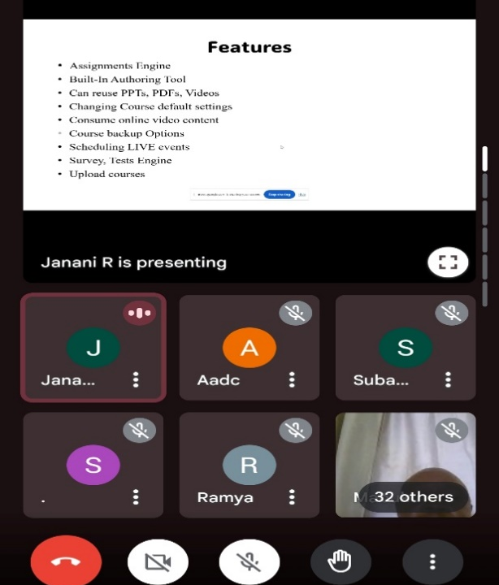

Take away from the session:
- Demo of Edredo platform for adaptive learning
- Edredo tool and its features

Day 4:18.07.2024 Session 4
‘Hands-on Experience In Creating Assignments and Quizzes Using AI Tools’
Mr. Roshan Singh, Scrollwell, Noida

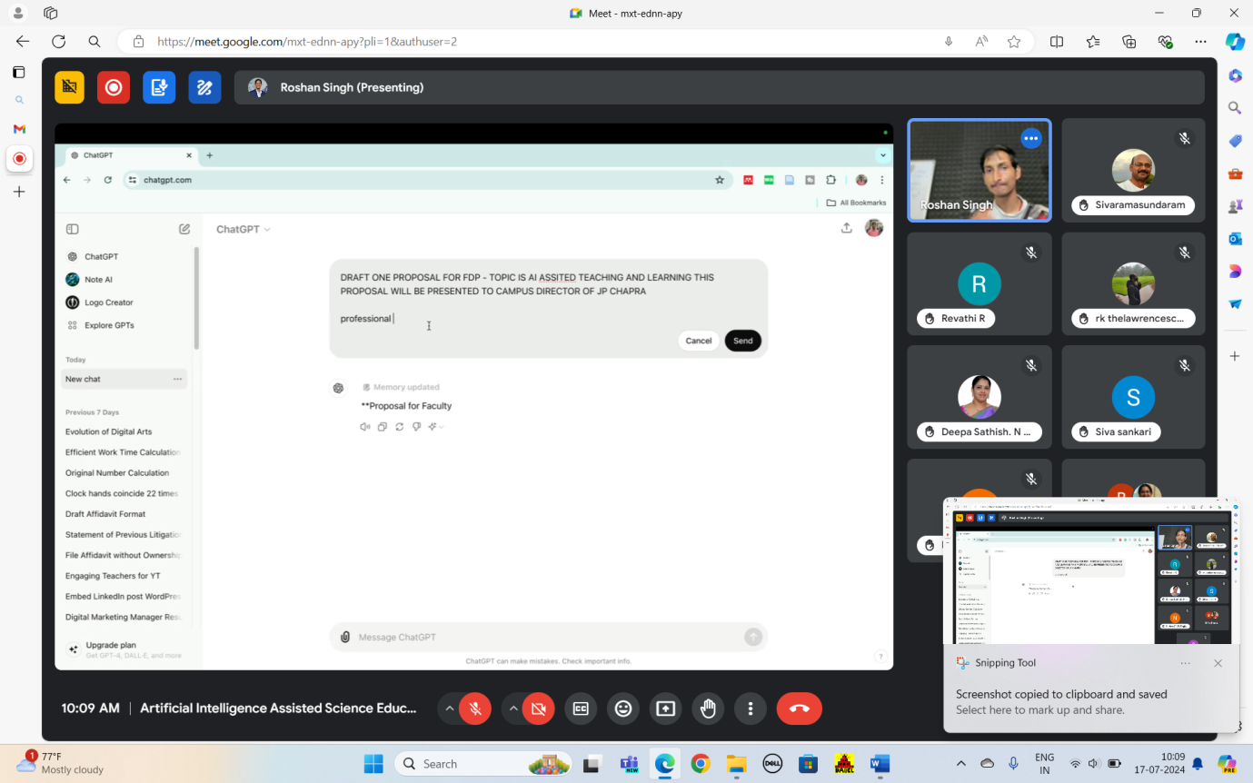

Mr.Roshan explained on creating quizzes and use of rubrics in it, Google Classroom, creating and on how managing quizzes is a streamlined process that integrates with Google Forms for efficient assessment. He also gave an insightful explanation on Pear Deck, an interactive presentation tool that integrates with Google Slides and Microsoft PowerPoint, allowing educators to create engaging and dynamic lessons. It enables real-time student participation through interactive questions, polls, and activities embedded within presentations, fostering increased engagement and understanding. Teachers can gather instant feedback and adjust their instruction based on student responses, making Pear Deck a valuable resource for enhancing classroom interaction and learning outcomes.

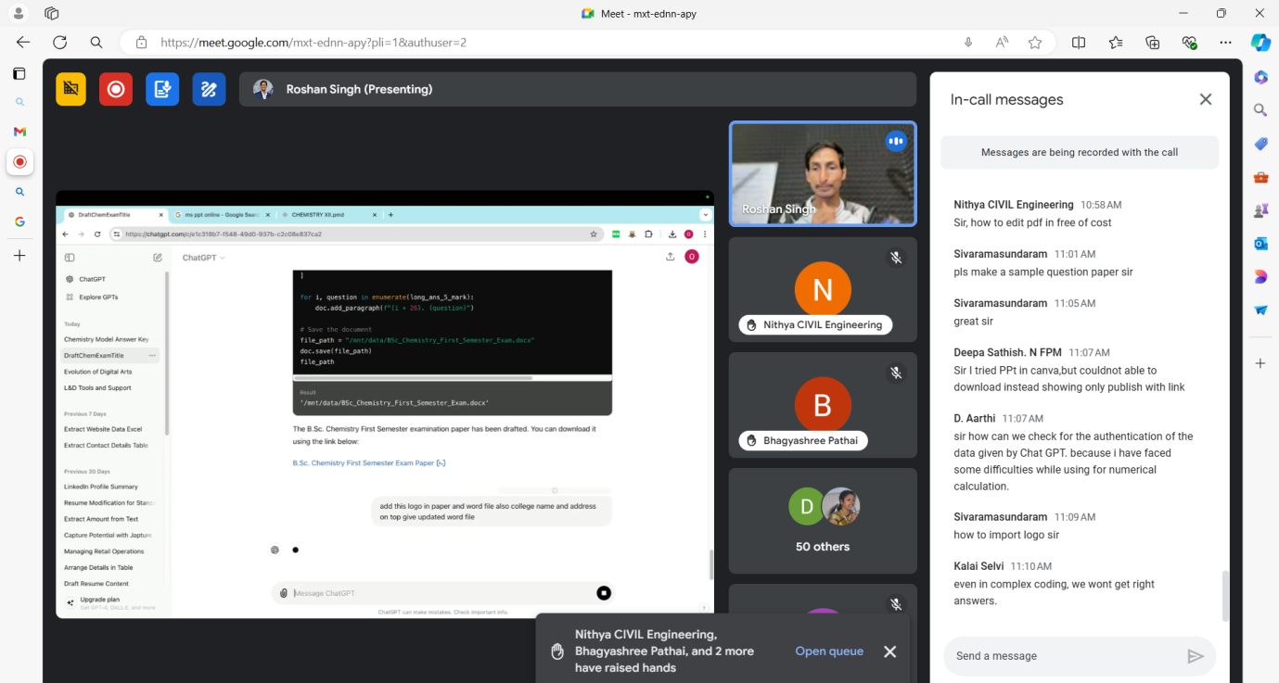

Take away from the session:
- Demonstration of creating quizzes in google classroom and creating rubrics in it.
- To assess student feedback on assignments by a teacher using google forms
- peardeck – an engaging power point presentation application for student teacher interaction.

Day 5: 19.07.2024 Session 1

‘Integrating AI Into Physical Sciences Curriculum and Ethical Considerations’
Dr. Anand Paul, Professor, Kyungpook University, South Korea

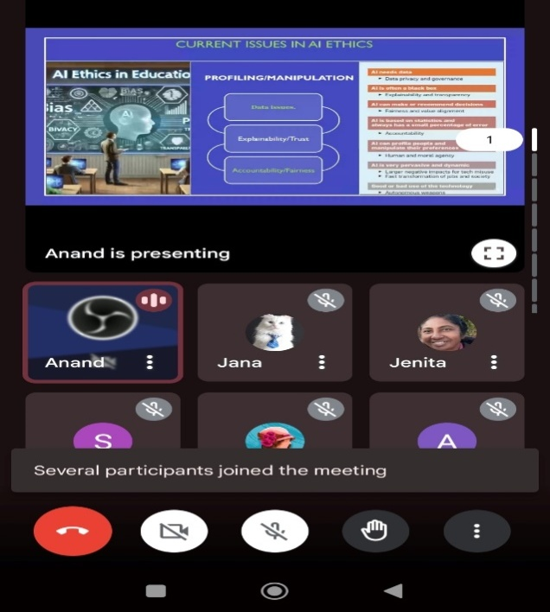

Dr. Anand Paul began the session by emphasizing the importance of, AR and VR technologies in future classrooms as they are expected to significantly enhance the learning experience for students studying physical sciences and said that these technologies offer immersive and interactive ways to explore complex concepts that are often challenging to visualize or understand through traditional methods. Example, VR can transport students to different environments or historical periods, allowing them to experience scientific phenomena firsthand. AR can overlay digital information onto the physical world, providing real-time, interactive explanations of scientific principles.
By integrating AR and VR into the curriculum, educators can create dynamic, engaging learning experiences that help students grasp abstract concepts more effectively and foster a deeper understanding of physical sciences.Sir emphazied on the thought about using AR and VR in future classrooms, which will play a great role for the stream of physical sciences.Sir also discussed the benefits of using AI in material discovery and also about the usage of robots in medicine and nuclear power plants
Sir also discussed about ethics in AI in the aspects of data privacy and transparency

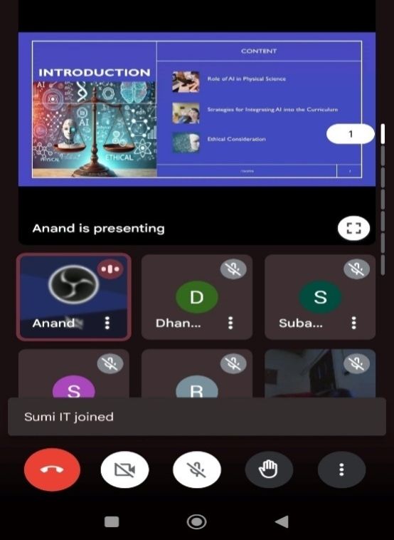

Take Away from the session:
- Importance of Augmented Reality (AR) and Virtual Reality (VR) on the future of education, especially in physical sciences
- Perspectives of ethics in AI

Day 5: 19.07.2024 Session 2
‘AI For Virtual Tutoring Assistant’
Vedha Viyas Gopalakrishanan, Co- Founder Adra Product Studio, Atlanta

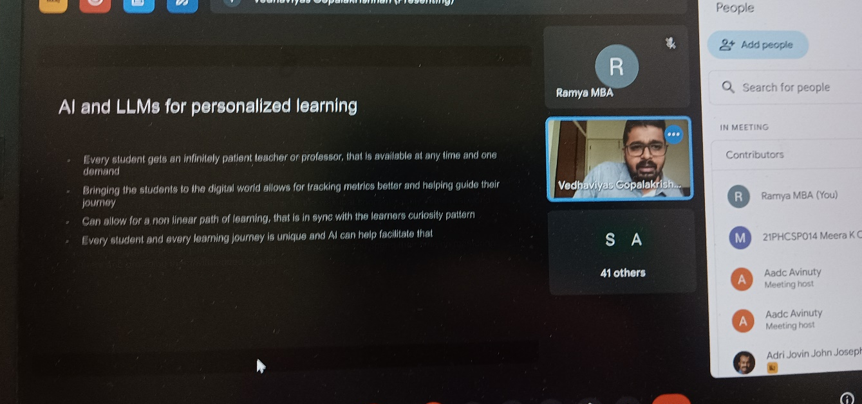

Mr. Vedha viyas started the session by explaining the importance of Personalized learning and said that it is an educational approach that tailor’s instruction, resources, and learning experiences to the individual needs, strengths, and interests of each student. The goal of it is to optimize learning outcomes by accommodating different learning styles and paces. He further explained and gave an exclusive demonstration on about prepy AI and Essence AI developed at ADRA solutions. Sir also explained about the audio tutor for students which aids in learning mathematics.

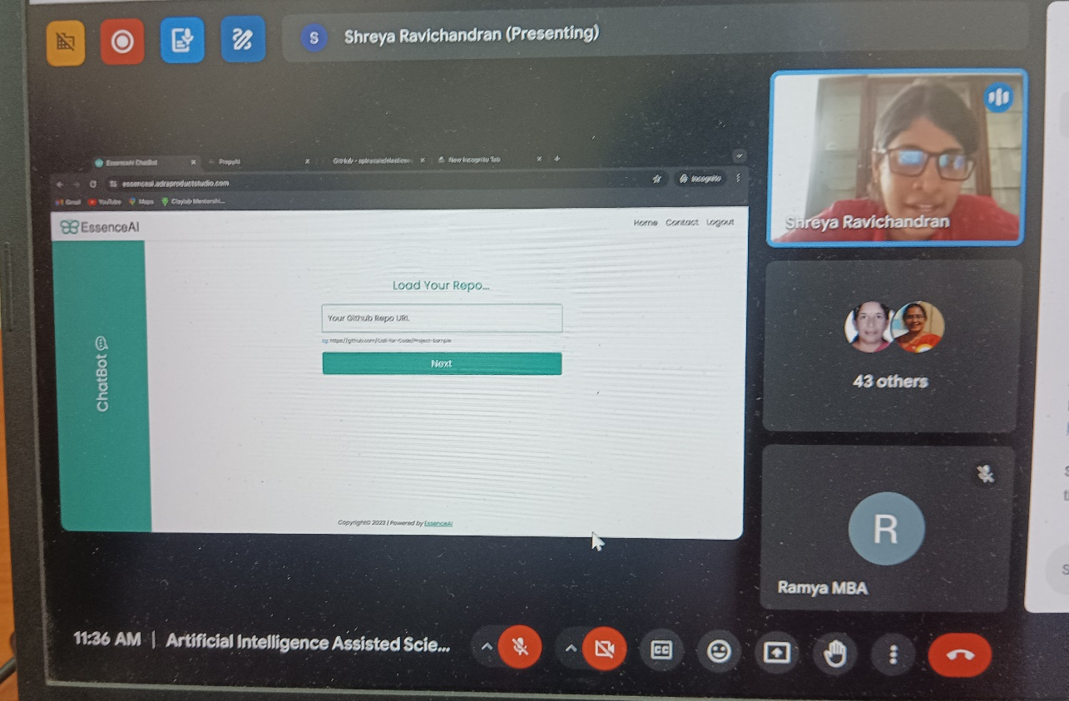

Take Away from the session:
- Perspectives and importance of personalized education
- Understanding Preppy AI and Essence AI
- Various frameworks for prompting ChatGPT for educators

Day 5: 19.07.2024 Session 3
‘Developing AI Based Lab Exercises and Projects’
Mr. Joel Prince
Founder Berachah Academy, Coimbatore

Mr. Joel explained on the background of how prompting works. Prompting in AI involves providing specific input or instructions to guide the model's response. Essentially, a prompt serves as the starting point for generating output, influencing how the model interprets and responds to a given query. LLMs, like GPT, are trained on diverse text data, enabling them to recognize patterns and contexts. When a prompt is input, the model uses these learned patterns to generate a response that aligns with the given context. The effectiveness of prompting relies on the clarity and specificity of the input, as well as the model's ability to understand and process the prompt based on its training.and he emphasized on the advancements of AI like smart homes. Sir also briefed about the works done at berachah academy.

Take Away from the session:
- Background operation of prompting
- AI smart homes
In Toto the following were the AI Tools exposed to the participants
Crafting Images | Voice Generating Tools
Canva | Narakeet
Adobe firefly | Elevenlabs
Microsoft Designer | Dubverse. AI
Pixlr | Natural Reader
FreePik | Sound draw

Text to Content Tools
ChatGPT
Canva
MS ppt online
Gamma AI
Claude
Copilot
Gemini
Quizlet
Mark map
Geninnov.com
Autodraw.com
Virbo
Steve.ai
wimsical
Genially
Anuvadini
Google vids
Coggle.it
Slides go

Augmented and Virtual  Reality Tools | Language Learning  Software
AR loopa | Duolingo
Animal 4D cards – AR | Google translate
Space craft AR | Memrise
Anatomy AR 4D | ChatBoT

Tools for Video creation
Video poet
Sora
Anthiago
Elai
Meta
Miro
Narakeet
Plagiarism Check Tools
Turnitin
Urkund
Ithenticate
Small SEO tools
Grammarly
Dupli checker
Plagscan
Quetext
PaperRater
Copyscape
Unicheck
Tools for Questions  and Quizzes | Platforms for  teaching and learning
Gimkit | Khan Academy
Gameshow | Dream Box
ChatGPT | Edulastic
Slidesgo | Edredo
Kahoot | Google classroom

Valediction

The Five-day short term capacity building programme on “Artificial Intelligence Assisted Science Education” jointly organized by the AIU-AI-AADC (Association of Indian Universities - Avinashilingam Institute - Academic & Administrative Development Centre), Centre for Machine Learning and Intelligence and School of Physical Sciences and Computational Sciences during 15-19 July in online mode culminated on the evening of 19th July 2024. Seventy Two-participants attended the programme online. Twenty sessions each of 90 minutes duration were planned and conducted with utmost punctuality and participation by all the expert resource persons. The programme brief is presented in Annexure 1. The schedule of the programme with the resource person details is presented in Annexure 2. The programme was planned and executed within a duration of 30 days (Planning of programme, inviting resource persons and participant intimation was done twenty days prior to the programme)
The valedictory meet began with a prayer song by Mrs. R. Dhanya Sruthi, Research scholar, Department of Chemistry. Mrs. S. Sindhu, Research scholar, Department of Chemistry welcomed the gathering. Dr. P. Subhashini, Professor, Department of Computer Science, Coordinator – CMLI, Avinashilingam Institute for Home Science and Higher Education for Women, Coimbatore and Programme Coordinator of this Short-term capacity building programme, delivered a warm note of greetings to the participants.
The session was followed by participant presentations of their work using AI assisted tools taught by various resource persons in the short-term capacity building programme and the coordinators reviewed the presentations. It was followed by the post assessment session when the organizers shared a questionnaire to the participants to evaluate their level of understandings of the sessions.
Dr. Shubashini K Sripathi, Professor, department of chemistry, Deputy dean school of computational and physical sciences, Avinashilingam Institute for home science and higher education for women, Coimbatore and Programme Coordinator of the short-term capacity building programme presented a brief report of this five days short-term capacity building programme.
The participants gave their valuable feedback on the conduct of the workshop and choice of resource persons. They highly appreciated the choice of topics, the resource persons, time management of the programme and were highly appreciative of the overall conduct of the programme. The overall feedback as received from the participants is presented in Annexure 3.
The valedictory session concluded with a warm note of greetings and formal vote of thanks by Dr. K. Ramya, Nodal officer, AIU-AI-AADC, Avinashilingam Institute for home science and higher education for women, Coimbatore

Annexure 1
Programme Brief
Artificial Intelligence (AI) significantly enhances education by offering personalized, efficient, and engaging learning experiences. In science education, AI's impact is transformative, addressing students' difficulties with scientific concepts and improving their understanding of how science works. AI-powered platforms provide personalized learning, interactive content, intelligent tutoring systems, enhanced assessment tools, and data-driven insights for educators. Integration with Augmented Reality (AR) and Virtual Reality (VR) creates immersive experiences, aiding comprehension of complex scientific concepts through enhanced visualization.
University science education must introduce AI tools for solving scientific problems and encourage students to contemplate AI's impact on science. Embracing AI in teaching can foster 21st-century skills, essential for future generations. AI-incorporated teaching methods support participative learning, experiential learning, and problem-solving strategies, creating effective, student-centric education.
Faculty development is crucial for implementing AI in teaching and assessment. Familiarizing educators with AI-powered platforms tailored for science education enhances personalized learning, interactive simulations, and advanced teaching tools.
AI-powered feedback tools improve learning outcomes, and AI-assisted content creation, curation, and lesson planning advance STEM education. Leveraging AI to create engaging, personalized, and effective learning experiences is essential for fully understanding scientific concepts and preparing students for future challenges.

Objectives:
1. To provide an overview of AI in STEM education and its advantages.
2. To provide an exposure to AI applications in Sciences.
3. To gain valuable insights and practical skills to effectively integrate AI in teaching and research in the physical sciences and computational sciences.

Annexure 2
Schedule of Programme and Resource Person Details
Day/Date | Session I - 9.30 to 11.00 am | Session II - 11.15 to 12.45 pm | Session III - 1.30 to 3 pm | Session IV - 3.15 to 4.45 pm
15thJul’ 2024  Monday | Overview of AI and its relevance to Physical Sciences  Inaugural Address  Prof. Hari V Sahasrabuddhe  Kanwal Rekhi School of Information Technology  Indian Institute of Technology, Mumbai  Email : hvs@it.iitb.ac.in  Mobile :897 553 8035 | Significance of Machine learning tools and languages in AI-powered education  Dr. T.Devi, Dean - Research  PSG Tech - IIM  Coimbatore  Email : tdevi5@gmail.com  Mobile : 9790004351 | Artificial Intelligence in Chemistry: Current Landscape and Future Opportunities  Dr. V.Rajapandian  Assistant Professor of Chemistry  Sri Ramakrishna Mission Vidhyalaya  Coimbatore  Email : vrajapandian@hotmail.com  Mobile :9500934166 | Intelligent tutoring systems (ITS) and Virtual Teaching Assistants  Prof. P.Subashini  Centre for Machine Learning and Intelligence  Avinashilingam University for Women  Coimbatore
16th Jul’ 2024  Tuesday | AI-powered platform for learning environment  Dr. M. Vinay, Associate Professor,  Department of Computer Science,  School of Sciences, Christ University  Bangalore.(confirmed )  E-Mail : vinay.m@christuniversity.in  Mobile: | Integration of AI with Moodle Learning environment  Mrs. Elizabeth Leah George  Assistant Professor  Nagindas Khandwala College  Mumbai  Email : elizabeth@nkc.ac.in  Mobile : 9833198228 | Machine Learning for Physical Sciences  Dr.Punithavalli  Professor and Head  Dept. of Computer Applications  Bharathiar University, Coimbatore  Email : punithavalli@buc.edu.in  Mobile : 9843281552 | Virtual Reality and Augmented Reality Tools for Immersive Learning Experience in Science  Dr. K.Thiyagu  Assistant Professor  Department of Education,  Central University of Kerala  Kasaragod, Kerala - 671 320, India  Email: thiyagusuri@gmail.com  thiyagucuk@gmail.com  Mobile: 9486812800  Invitation mailed (Google Meet link sent)
17th Jul’ 2024 Wednesday | Content creation tools - educational content writing, reporting, story-telling and creative writing, lesson plans and quizzes, Significance of AI in content curation  Mr. Roshan Singh  201301  www.scrollwell.com  Email :roshan@scrollwell.com  Mobile :70095 48243  Invitation mailed (Google Meet link sent) | Multimedia content creation - Video and Audio Production, Image and Graphic Design  Dr. M. Vinay, Associate Professor,  Department of Computer Science,  School of Sciences, Christ University  Bangalore.(confirmed )  E-Mail : vinay.m@christuniversity.in  Mobile:  Invitation mailed (Google Meet link sent) | Deep Learning for Video Analytics - in Science perspectives  Dr. P. S. Hiremath  Professor  Department of Computer Science(MCA)  KLE Technological University  BVB Campus, Hubballi-580031  Mob : +91 9480226698  Invitation mailed (Google Meet link sent)  Email : hiremathps53@yahoo.com  Mobile : 9480226698 | Hands-on Training on Content Creation Using AI  Dr. K.Thiyagu  Assistant Professor  Department of Education,  Central University of Kerala  Kasaragod, Kerala - 671 320, India  Email: thiyagusuri@gmail.com  thiyagucuk@gmail.com  Mobile: 9486812800  Invitation mailed (Google Meet link sent)
18th Jul’ 2024  Thursday | AI-Powered Feedback Tools for language, grammar and plagiarism  Dr. Kalaiselvi  Gandhigram Rural UNiversity, Dindigul  Email : kalaiselvi.gri@gmail.com  Mobile :9486362843 | AI assisted Tools for formulating questions and quizzes  Dr Suresh Shanmugasundaram  Lecturer, University of Wales,  Trinity UK  Email s.shanmugasundaram@swansea.ac.uk  Mobile | Edredo AI Tools Demonstration  Prof. P.Subashini  Centre for Machine Learning and Intelligence  Avinashilingam University for Women  Coimbatore | Hands-on experience in creating assignments and quizzes using AI Tools  Mr. Roshan Singh  Founder - Scrollwell  Block D, Sector 36, Noida. 201301  www.scrollwell.com  Email :roshan@scrollwell.com  Mobile :70095 48243  Invitation mailed (Google Meet link sent)
19th Jul’ 2024  Friday | Integrating AI into physical sciences curriculum and ethical considerations  - Prof. Anand Paul  Kyungpook University  South Korea  Email : paul.editor@gmail.com  Mobile :+82 10-7930-9696 | AI for virtual tutoring Assistant  - Mr. Vedha Viyas  Chief Technical Officer  ADRA AI Studio  Coimbatore  Email : vedha@adraproductstudio.com  Mobile : 9489634991 | Developing AI-based lab exercises and projects  Mr. Joel Prince  Founder, Berachah Academy  Coimbatore | Concluding session and feedback  Presidential and Valedictory Address  - Dr. V. Bharathi Harishankar  - Vice Chancellor  - Avinashilingam Institute for Home Science and Higher Education for Women, Coimbatore.

Annexure 2
Feedback from the Participants
Participant feedback was solicited from all the participants. The responses received are documented below:

- "The event was a resounding success! The organizers demonstrated excellent communication skills, keeping participants informed and engaged throughout. The punctuality of the sessions was impressive, with each speaker starting and ending on time.
The speakers were extremely knowledgeable and well-versed in their respective topics, providing valuable insights into the applications of Artificial Intelligence in Science Education. The presentations were very informative, interactive, and thought-provoking.
The event offered a great platform for learning, discussion, and networking. The organizers, speakers, and participants all contributed to a stimulating and enriching experience.
Overall, the event was well-organized, informative, and engaging. It exceeded expectations and provided a valuable learning experience. Kudos to Avinashilingam University for hosting such a fantastic event!"
- All sessions were organized very well. I thank organizers and nodal officer for the excellent arrangements of the speakers. We learnt many AI tools applicable for teaching learning process.
- All the session were very nicely organized, kudos to team
- Artificial intelligence (AI) and all its global technological ramifications are evolving at a very fast pace, but it appears the educational sector is slow to catch up with the emerging AI opportunities for making positive differences to the students' learning experience and the faculty's workloads. This 5-day training is therefore not only timely but also very comprehensive. Over the past five days, I have learned a lot about various evolving AI tools and platforms that should make my workload much easier and less time consuming, while also helping me deliver higher-quality teaching and scientific research solutions. The resource persons were fantastic; they brought in a great deal of AI diversity, passion, experience, and expertise. Big congratulations to the organisers; the entire programme was professionally organised and perfect, you would think that the organisers themselves were AI-assisted!!
- As a research scholar attending the 5-day seminar on AI-assisted science education, I found the experience to be profoundly enriching and intellectually stimulating. The seminar offered a comprehensive overview of the latest advancements in AI technologies and their practical applications in the field of science education.
- During the course of the FDP program, artificial intelligence-based features in the teaching learning system have raised awareness, encouraged creativity, and allowed for timely evaluation of current students. The profession improves when the facilitator uses artificial intelligence (AI) to enhance traditional ways with tools we gained from this platform, moving more and more towards online approaches. In terms of creating content, creating e-content, managing classrooms in various languages, and adding several additional options that can be edited quickly, As a result, the FDP program effectively assists in introducing fresh viewpoints to the teaching profession. Additionally, after participating in the FDP program, instructors from science disciplines can employ AI tools more efficiently.
- Entire sessions were too good.It provided advanced learning in AI
- Everything of the 5 days sessions was wonderful. Enjoyed the sessions. Good lessons taught. Thankyou for such a resourceful workshop. Organized in the perfect form. Right from the start of each day till the finish of the day's session was excellent. Words of appreciation for the perfect work done by the organizing team.
- Excellent
- Excellent
- Excellent
- Excellent sessions. Provided very valuable information for my career. Thank you Organizing committee
- Good coordination
- Good FDP
- I have learned many new concepts from this programme, many new tools were introduced, useful
- IT IS VERY ADVANCED AND USEFUL
- It was an enriching experience. The sessions were well-structured, providing comprehensive insights into integrating AI with science education. Expert speakers shared valuable knowledge and practical applications, making the content both informative and engaging. The interactive format encouraged active participation, enhancing the learning experience. Overall, the program successfully equipped participants with the necessary tools and understanding to effectively incorporate AI into educational practices, fostering innovation and advancement in science education.
- It was an excellent program organised very meticulously keeping in mind all the aspects and requirements in education. Very enriching. Learnt a lot. Now it's time to implement . Thanks a lot for this wonderful experience.
- It was an Excellent program which enriched my knowledge. i congratulate the organizing team for the successful conduct of this programme.
- It's very interesting and interactive program...
- Organized In Excellent Manner and Useful sessions
- Overall it is amazing experience learnt alotai tools kike cava adibe exrds autobdraw gamma app
- Overall it's good organizing
- Overall, all the sessions were very engaging and interactive. I personally learned a lot about Artificial intelligence, and its role in current teaching and research as well from the sessions.
- please provide your Overall Feedback about the programme in 200 words or less:
- Program was organized beautifully well manenge and subjects was to good , All invited speakers was so good and i enjoying every presentation
- Programme was organised well with a team of experts in the field of AI in education. The handson sessions helped a lot to learn the new tools. Will sure explore further with the inputs gained form the sessions and share the knowledge with my faculty colleagues to enrich the teaching and learning process
- Provided us with concrete takeaways on how we can integrate AI tools into the classrooms and resources for further exploration.
- Session was intresting, informative,we learnt many new tools in AI which can use during our teaching
Some sessions were v lively were hands on training was given which was quite beneficial for us
- Thank you all the organizers for the wonderful program
- Thank you all the organizers for the wonderful program.
- Thank you for giving me the opportunity to attend the sessions
- Thank you for the great opportunity
- Thank you to the Organizers for organizing such an informative program. Every sessions are highly informative.
- The fdp program is very informative. Every session is very useful for educators for their professional development.
- the program was designed well by engaging all discipline of audience. all could take back some new concepts with them
- The program was exceptionally well-organized, providing a comprehensive overview of how artificial intelligence can revolutionize science education. The workshops were engaging and informative, with expert facilitators who made complex concepts accessible and exciting. The hands-on sessions were particularly valuable, allowing us to apply AI tools and techniques directly to our teaching practices. The collaborative environment fostered by the organizers encouraged meaningful exchanges of ideas and experiences among participants. I now feel more confident and equipped to integrate AI into my curriculum, enhancing the learning experience for my students. This program has truly broadened my perspective on the future of education and empowered me with the skills to be at the forefront of this transformation. I highly recommend this workshop to any educator looking to innovate their teaching methods.
- The program was really awesome I gain more knowledge about the importance and significance of artificial intelligence. Thank you so much for the opportunity .
- The recent series of sessions on integrating AI into various educational and scientific domains was exceptionally informative and engaging. The presentation on "Deep Learning for Video Analytics" offered valuable insights into cutting-edge advancements and practical applications, significantly enhancing our understanding of this technology from a scientific perspective. The hands-on training on "Content Creation Using AI" was both engaging and practical, equipping participants with essential skills and innovative techniques to enhance creative workflows.
Similarly, the session on "AI-Powered Feedback Tools for Language, Grammar, and Plagiarism" was incredibly informative, demonstrating the transformative impact of these technologies on improving writing quality and maintaining academic integrity. The insights provided on "AI-Assisted Tools for Formulating Questions and Quizzes" showcased how these technologies can streamline and enhance educational content creation processes. The hands-on experience in creating assignments and quizzes using AI tools was particularly practical, offering valuable skills to efficiently develop engaging educational materials.
Finally, the presentation on "Integrating AI into the Physical Sciences Curriculum and Ethical Considerations" was thought-provoking, highlighting the educational benefits and ethical challenges of incorporating AI into academic programs. Overall, these sessions were highly beneficial, offering a comprehensive understanding of AI's potential and practical applications across various fields while emphasizing the importance of ethical considerations.
- The topic and the field choosen is the need of the present situation. Implementing and using advanced tools such as Artificial Intelligience, Machine Learning, Deep learning in Teaching learning process will be highly acceptable. This is the first in my 25 years of service to know and learn the tools for education.
- This five days program offered a comprehensive coverage of science education topics, blending foundational concepts with advanced applications effectively.
The use of AI was innovative and impactful, enhancing learning through interactive simulations and personalized learning paths.
The sessions were engaging, with hands-on activities and real-time data analysis exercises that kept us actively involved.
Resource persons demonstrated deep knowledge, effectively guiding discussions and clarifying complex concepts.
Thank you very much for this opportunity.
- This program is very useful for Me .I learnt many thing from this program. I have Realtime exposure. I have hands on training .It is really Amazing .kindly arrange one more program for us
- Ver Excellent
- Very Excellent
- Very good well organised session with brilliant speakers.
- Very informative program on application of various AI tools. Got very good learning experience on new tools with hands on teaching. My heartiest thanks to the organising team for conducting this program
- Very informative sessions. Appreciate the smooth conduct of the sessions and selection of resource persons.
- Very Interest to Ai program and plagiarism, algorithm, Practice also well
- Very useful
- Very well organised as a team work . Very good Communication to the participants . Clarifying all the doubts . Good resource persons and knowledgeable. Over all I have attended excellent and knowledgeable programme and gained knowledge. Thank you from the. Bottom of my heart
- Very well organized program. All sessions were informative and resource persons presented and explained very nicely. Learned a lot.
- We had very good session. Thank you for the organizers
- Well Organised programme conducted with all highly qualified resources person. Gain lot of knowledge about utilisation of AI in Education
- Well planned and well organised.
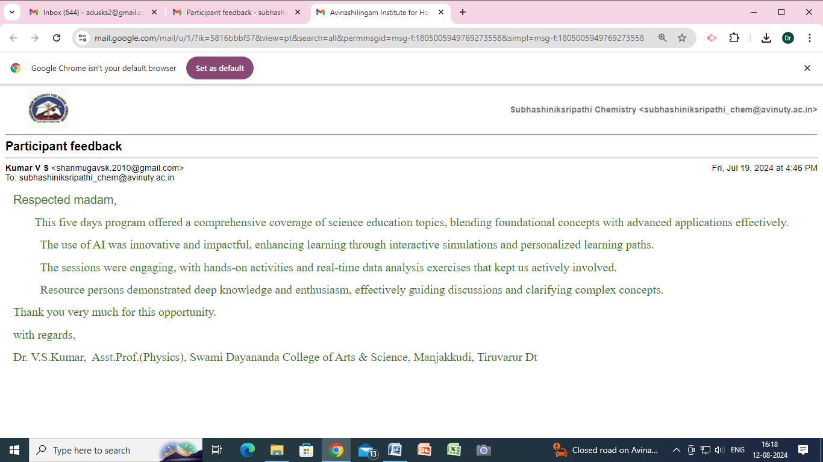
Email Feedback from a Participant

Glimpses of Feedback

“Very well organized as a team work .Very good Communication to the participants, clarifying all the doubts, Good resource persons and knowledgeable. Over all I have attended excellent and knowledgeable programme and gained knowledge. Thank you from the. Bottom of my heart”

“Beginning on the first day, every session has eminent speakers who are very effective and energetic about the subject. Fantastic and really committed organizers in all aspects for the participants, and excellent hospitality”

"The event was a resounding success! The organizers demonstrated excellent communication skills, keeping participants informed and engaged throughout. The punctuality of the sessions was impressive, with each speaker starting and ending on time”

It was an enriching experience. The sessions were well-structured, providing comprehensive insights into integrating AI with science education. Expert speakers shared valuable knowledge and practical applications, making the content both informative and engaging. The interactive format encouraged active participation, enhancing the learning experience. Overall, the program successfully equipped participants with the necessary tools and understanding to effectively incorporate AI into educational practices, fostering innovation and advancement in science education.

“This 5-day training is therefore not only timely but also very comprehensive. Over the past five days, I have learned a lot about various evolving AI tools and platforms that should make my workload much easier and less time consuming, while also helping me deliver higher-quality teaching and scientific research solutions. The resource persons were fantastic; they brought in a great deal of AI diversity, passion, experience, and expertise. Big congratulations to the organisers; the entire programme was professionally organised and perfect, you would think that the organisers themselves were AI-assisted!!”
Participants List
S.No | Name | Designation | Department | Institution/ Organisation Name
1 | Dr. KAVYASHREE. D | Associate Professor and Head | PHYSICS | ACHARYA INSTITUTE OF TECHNOLOGY
2 | Mrs. SAKHI RAMESH | TEACHER | CHEMISTRY | AL NOOR INTERNATIONAL SCHOOL, BAHRAIN
3 | Mr. BENEL DAS REYMAND | COORIDNATOR | COMMERCE | AL NOOR INTERNATIONAL SCHOOL, BAHRAIN
4 | Dr. G.Ramalingam | Assistant professor | Department of Nano science and technology | Alagappa university
5 | Dr. R.SENKAMALAVALLI | Associate Professor | Information Science and Engineering | AMC ENGINEERING COLLEGE
6 | Ms. Anjali Sankar | Assistant Professor | Department of Computer Applications | ASIET
7 | Dr. M AMUTHA SELVI | Assistant Professor | Chemistry | Avinashiligam Institute for Home Science and Higher Education for Women
8 | Mrs. SMITHA K S | Part Time PhD Scholar | Computer Science | Avinashilingam Institute for Home Science and Higher Education for Women
9 | Dr. R. Sowbaraniga | Assistant Professor | Education | Avinashilingam Institute for Home Science and Higher Education for Women
10 | Dr. S. Anitha | Assistant Professor (SS) | Physics | Avinashilingam Institute for Home Science and Higher education for women
11 | Mrs. Vinodhini.J | Research scholar | Food science and Nutrition | Avinashilingam Institute for Home Science and Higher Education for Women
12 | Mrs. Dhanya Sruthi R | Research Scholar | Chemistry | Avinashilingam Institute For Home science and higher education for women
13 | Dr. A.Sumi | Assistant Professor | Information Technology | Avinashilingam Institute for Home Science and Higher Education for Women
14 | Dr. R V LAKSHMI ALIAS ANUSHA | Ph.D | FSN | Avinashilingam Institute for Home Science and Higher Education for Women
15 | Mrs.R. Romela Elizabeth Preena | Research Scholar | Computer science | Avinashilingam Institute for Home Science and Higher Education for Women
16 | Mrs. Meera K Chandran | Research Scholar | Computer Science | Avinashilingam Institute for Home Science and Higher Education for Women
17 | Mrs. SINDHU S | Research Scholar | Chemistry | Avinashilingham Institute of home science and higher education for women
18 | Dr. M. Lakshmipriya | Assistant Professor | Physics | B. S. Abdur Rahman Crescent Institute of Science and Technology
19 | Dr. Buddhaghosh Arjun Shingade | Assistant professor | Physics | Bhawabhuti Mahavidyalaya Amagon
20 | Dr. Sumathi. K. Sripathi | Associate professor | Institute of Virtual and Distance Learning | DMI- St. Eugene University
21 | Ms.A. FATIMA MARY | Administrator | Management | DMI. St. Eugene University
22 | Dr.N.NANDAKUMAR | PROFESSOR | MECHANICAL ENGINEERING-ENGINEERING DESIGN | GOVERNMENT COLLEGE OF TECHNOLOGY
23 | Dr. Shachi Mishra | Assistant Professor | P. G. Department of Chemistry | Jai Prakash University, Chapra, Bihar
24 | Mrs. Anasuya Mani MP | Assistant Professor | Pharmacology | Jain School of Allied Healthcare and Science
25 | Ms. Dnyaneshwari Ram Jadhav | Assistant Professor | BCA/MCA | JSPM University Pune
26 | Dr. VIDHYA B | Assistant Professor | Physical Sciences | Karunya Institute of Technology and Sciences
27 | Dr. Jenita Thinakaran | Professor | Horticulture | Karunya Institute of Technology and Sciences
28 | Dr. RAJU NANDHAKUMAR | Professor | Chemistry | Karunya Institute of Technology and Sciences (deemed to be university)
29 | Dr.M.Suguna Devakumari | Assistant Professor | Agriculture | Karunya Institute of Technology and Sciences, Coimbatore
30 | Mr. MABUKU T. MWAULUKA | TEACHER | NATURAL SCIENCES | KAUNGA SECONDARY SCHOOL
31 | Dr. R.K.Kavitha | Assistant Professor III | Computer Applications | Kumaraguru College of Technology
32 | Mrs. JALAJA JAYALAKSHMI V | AP II | MCA | KUMARAGURU COLLEGE OF TECHNOLOGY
33 | Dr. K.Kalapriya | Assistant Professor III | CHEMISTRY | Kumaraguru College of Technology
34 | Ms. ANNU | Assistant Professor | Department of Information Technology | M.O.P VAISHNAV COLLEGE FOR WOMEN
35 | Dr. Sumalya Kaluva | Assistant Professor | Physics | Malla Reddy Engineering College for Women
36 | Dr. ROHIT HAZRA | ASSISTANT PROFESSOR | HUMANITIES AND SCIENCES (PHYSICS) | MALLA REDDY ENGINEERING COLLEGE FOR WOMEN
37 | Dr .Stephen Aro-Gordon | Assistant Professor | Finance & Strategy | Muscat College (Adjunct Faculty, SDMIMD)
38 | Mrs. V.SIVA SANKARI | LECTURER | PHYSICS | NACHIMUTHU POLYTECHNIC COLLEGE
39 | Mrs. RATHIKA.V.S | Lecturer | Chemistry | Nachimuthu polytechnic college
40 | Dr. NIVAS S | HOD & ASSISTANT PROFESSOR | COMPUTER SCIENCE | NIFT-TEA COLLEGE OF KNITWEAR FASHION
41 | Dr. P. KANCHANA | ASSOCIATE PROFESSOR | CHEMISTRY | PSGR KRISHNAMMAL COLLEGE FOR WOMEN
42 | Dr. R Revathi | Assistant Professor | Chemistry | PSGR Krishnammal College for Women
43 | Dr. AMIRDHA SHER GILL | PROFESSOR | PHYSICS | PSN COLLEGE OF ENGINEERING AND TECHNOLOGY
44 | Mrs. Sunu Mary Abraham | Assistant Professor | Computer Science | Rajagiri College of Social Sciences
45 | Dr. T VELUMANI | Assistant Professor | Computer Science | Rathinam College of Arts and Science,Coimbatore-21
46 | Dr. C. Dhanush | Assistant Professor | Physics | Rathinam College of Arts and Science
47 | Ms.K. Kousalya | Assistant Professor | Physics | Rathinam College of Arts and Science
48 | Mrs. Bhagyashree Ratan pathai | Asst prof | Chemistry | RKTALREJA College of arts science and commerce Ulhasnagar 3
49 | Dr.A.Chandravadhana | Associate professor | Physics (H&S) | S.A.Engineering college, Chennai-77
50 | Dr.R.HARIHARASUTHAN | PROFESSOR&HEAD | HUMANITIES&SCIENCE | S.A.ENGINEERING COLLLEGE CHENNAI-77
51 | Dr. Asha Mathew | Associate Professor | Chemistry | S.I.W.S.
52 | Mrs. Kalaiselvi Sivabalan | Research Scholar | Computer Science | Sathyabama Institute of Science and Technology
53 | Dr. Anupa Avinash Kumbhar | Professor | Department of Chemistry | Savitribai Phule Pune University
54 | Dr. R.Nithya | Associate Professor | Civil Engineering | School of Engineering, Avinashilingam Institute
55 | Dr. Parag Rabara | Associate Professor | Pharmacy | School of Pharmaceutical Sciences, Atmiya University
56 | Dr. KARTHICK KUMAR S | ASSOCIATE PROFESSOR | PHYSICS | SETHU INSTITUTE OF TECHNOLOGY
57 | Dr. Sivaramasundaram K | Associate Professor | Physics | Sethu Institute of Technology
58 | Dr. SIVABHARATHY M | PROFESSOR | PHYSICS | SETHU INSTITUTE OF TECHNOLOGY
59 | Dr. Sunil D. Kulkarni | Associate Professor | Chemistry | Sir Parashurambhau College, Pune
60 | Dr. ADRI JOVIN JJ | Professor | Infomation Technology | Sri Ramakrishna Institute of Technology, T
61 | Dr. ADB.Vinothramkumar | Research scholar | Computer science | Sri Ramakrishna mission vidhyalaya college of arts& science
62 | Ms. Aarthi D | Research Scholar | Mathematics | Sri Ramakrishna Mission Vidyalaya College of Arts and Science
63 | Dr. D. Rajeswari | Assistant Professor | Physics | SRM Institute of Science and Technology, Tiruchirappalli
64 | Dr. R. Aarthi | Assistant Professor | Physics | SRM Institute of Science and Technology,Tiruchirappalli
65 | Dr. UJWALA B | Assistant professor | Chemistry | SRM INSTITUTE OF SCIENCE AND TECHNOLOGY TIRUCHIRAPPALLI
66 | Dr. Subramanian R | Assistant Professor | Chemsitry | SRM Institute of Science and Technology, Tiruchirappalli Campus
67 | Dr. KUMAR V.S. | ASSISTANT PROFESSOR | PHYSICS | SWAMI DAYANANDA COLLEGE OF ARTS & SCIENCE
68 | Dr. Sunija A J | Assistant Professor | Chemistry | Thiagarajar College of Engineering, Madurai
69 | Dr. Shashi Pandey | Assistant Professor | Department of Chemistry | University of Lucknow, Lucknow, uttar Pradesh
70 | Dr.N.DEEPA SATHISH | Associate Professor and HOD | Food Processing Technology and Management | PSGR Krishnammal College for Women
71 | Mr. Rachit Kumar | PGT PHYSICS | Physics | THE LAWRENCE SCHOOL, LOVEDALE
72 | - Madhumitha | Research Scholar | Chemistry | Avinashilingham Institute of home science and higher education for women

Sample Certificate

