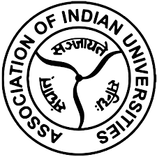
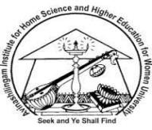
Avinashilingam Institute for Home Science and Higher Education for Women
Deemed to be University Estd. U/s 3 of UGC Act 1956, Category ‘A’ by MHRD(now MoE)
Re-accredited with ‘A++’ Grade by NAAC CGPA 3.65/4 Category, I by UGC
Coimbatore - 641 043, Tamil Nadu, India

7th Short-Term Capacity Building Programme for the year 2024 on
‘Digital Skills Training for Non-Teaching Staffs’
12th September 2024 – 14th September 2024

Online Mode

The AIU-AI-AADC (Association of Indian Universities -Avinashilingam Institute - Academic & Administrative Development Centre), organized the 7th Short-Term Capacity Building Program on Digital Skills Training for Non-Teaching Staffs for the year 2024 from 12th September 2024 – 14th September 2024.

The three-day digital skills training program focused on enhancing participants' ability to effectively use digital tools for professional tasks. Through interactive sessions and practical exercises, attendees learned how to effectively navigate the internet, assess information credibility, and utilize browsers for efficient research. They gained hands-on experience with email communication, mastering email etiquette, and using tools like cloud storage and project management software for collaboration. Additionally, participants were trained on essential cybersecurity practices, troubleshooting common digital issues, and leveraging social media platforms for professional growth. These practical skills helped to improve participants' digital literacy and boost their confidence in using technology in their professional and everyday tasks.
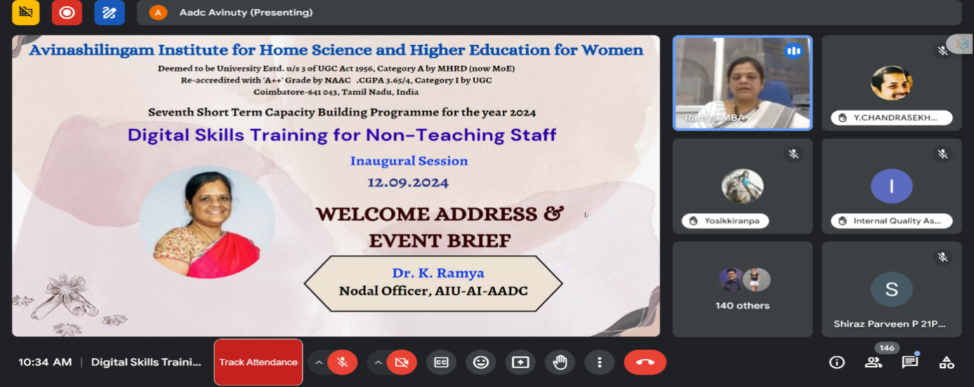

The program began with a prayer, followed by Dr. K. Ramya, Nodal Officer, AIU-AI-AADC, welcoming the gathering and briefing about the event. She explained the plan of action for the upcoming 3 days programme.
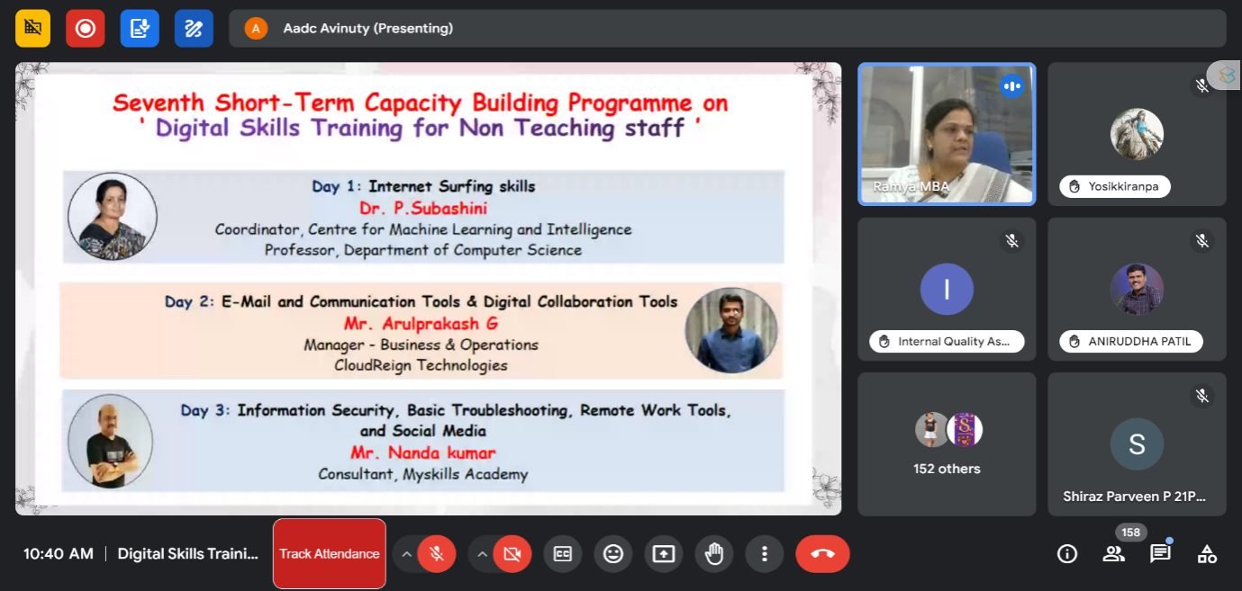
The presidential address was given by Dr. H. Indu, Registrar i/c of Avinashilingam Institute for Home Science and Higher Education for Women, who greeted the guest speakers and the participants. During her speech, she emphasized the importance of digital literacy, secure practices, and tools to help participants navigate modern digital workplaces efficiently and securely.
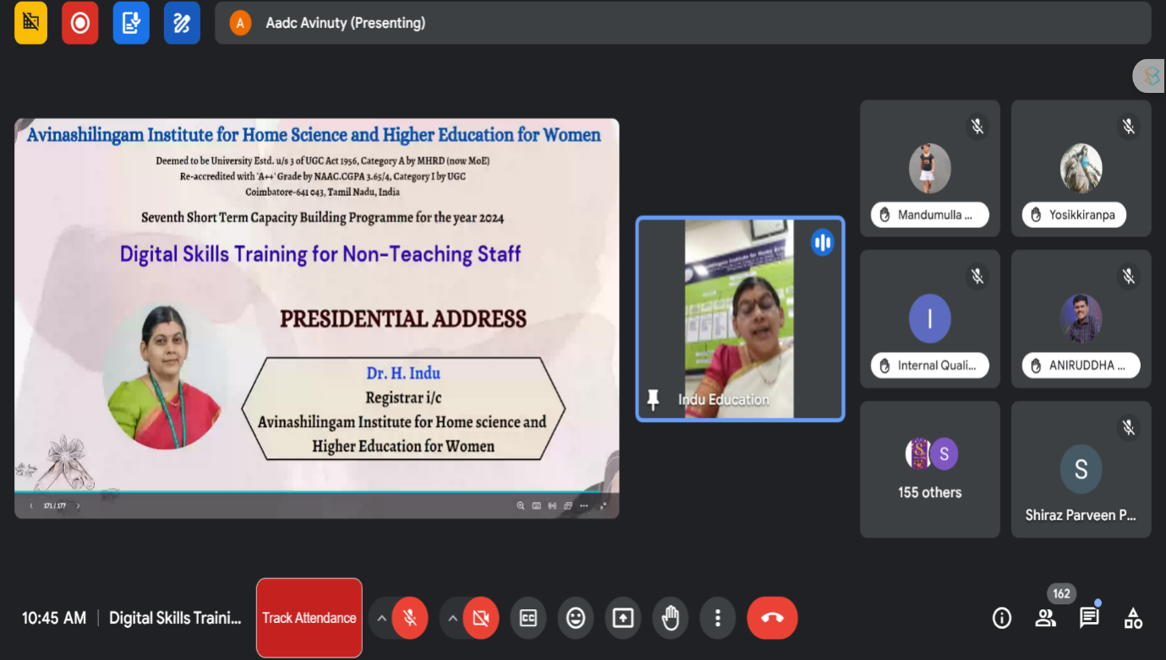

Day 1 Technical Sessions

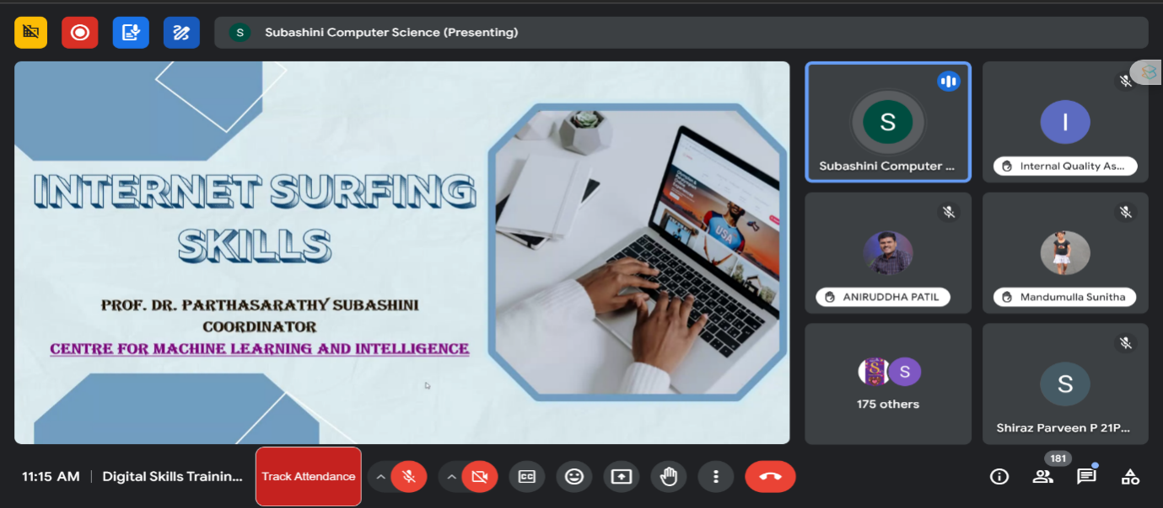The Technical Session of Day 1 was taken by Dr.Subashini Parthasarathy, Professor of Computer Science and Co-ordinator for the Centre for Machine Learning and Intelligence at Avinashilingam Institute for Home Science and Higher Education for Women, Coimbatore on the topic ‘Internet Surfing Skills training for non-teaching staffs’, where she explored the three most widely used browsers: Google Chrome, Mozilla Firefox, and Microsoft Edge. The session aimed to raise awareness about how to optimize browser use for better productivity and security.
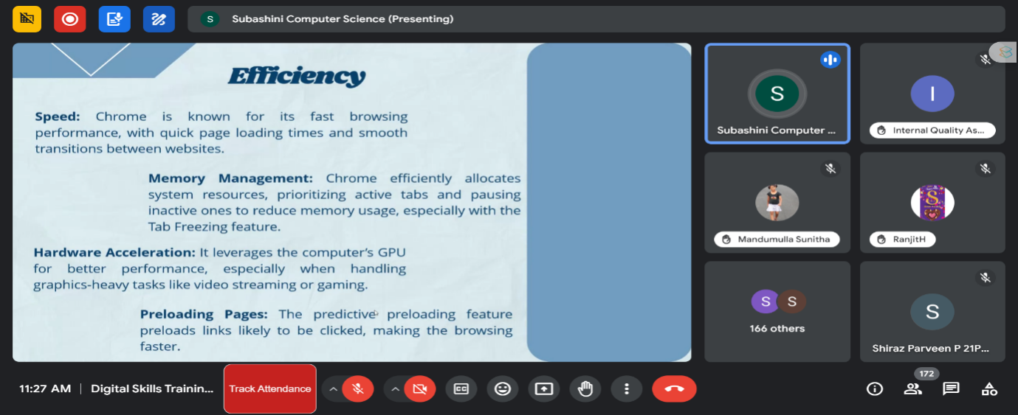
Google Chrome was highlighted for its speed, wide adoption, and integration with G Suite for education and collaboration. Mozilla Firefox, known for its strong privacy features and customizability, is a preferred choice for users concerned with data security. Microsoft Edge, built on the Chromium platform, offers compatibility with Microsoft services and is ideal for institutions using those ecosystems.
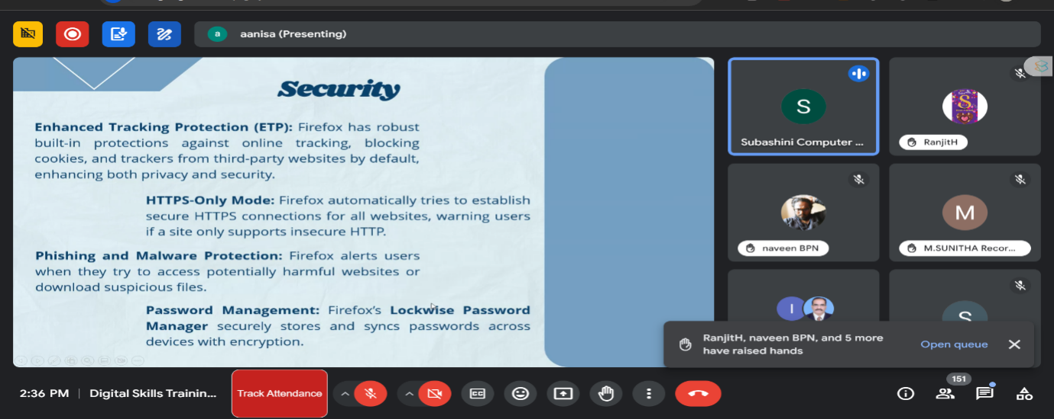
Dr. Subashini also addressed browser security, explaining features like Chrome’s sandboxing, automatic updates, and incognito mode for privacy. The session provided practical insights into secure browsing, managing cookies, and SSL certificates, empowering participants to enhance productivity and protect against online threats in their digital workspaces.

She also explained about customizing and enhancing browser productivity, focusing on Google Chrome. She highlighted Chrome’s ability to sync across devices, allowing users to customize themes, change font sizes, and manage tabs efficiently. The use of extensions, like ad blockers and productivity tools, was emphasized, particularly through the Chrome Web Store, which offers various extensions to enhance user experience and productivity.

She demonstrated organizing tabs by grouping them, assigning color codes, and naming groups, helping manage multiple tasks. The importance of bookmarks for efficient navigation was also stressed. Dr. Subashini explained features like Omnibox, which serves as a search bar and calculator, tab search for multitasking, and the password manager for secure browsing. The session concluded with a discussion on Chrome’s integration with tools like Gmail, Google Drive, and Google Docs, making it a collaborative and efficient tool for both personal and professional use.
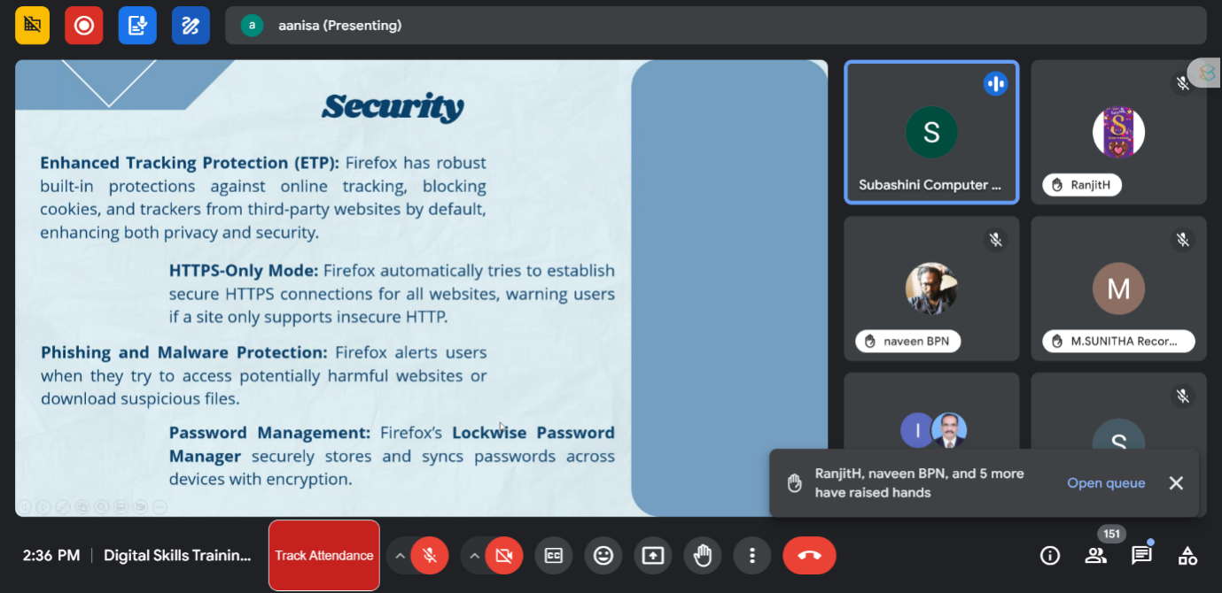
The afternoon session focused on the use of collaborative tools in Google and the security features of Firefox. Key points include managing multiple Google accounts and toggling between them, emphasizing the importance of keeping personal and official accounts separate. Additionally, Google's translation tools were discussed, which enable easy language translation for both documents and conversations.

Firefox was highlighted for its security and privacy features, including enhanced tracking protection, HTTPS-only mode, and phishing and malware alerts. Customization options in Firefox were also covered, such as themes, fonts, and browser layout adjustments, alongside tools like multi-account containers and screenshot capture. The session emphasized using these features to optimize productivity, ensuring a more secure and efficient browsing experience.

Dr. Subhashini also highlighted essential features such as the History tab in Firefox for easy navigation and the organization of bookmarks into containers. The discussion included Firefox's Reader Mode, which blocks distractions and allows text customization, enhancing focus on web content.
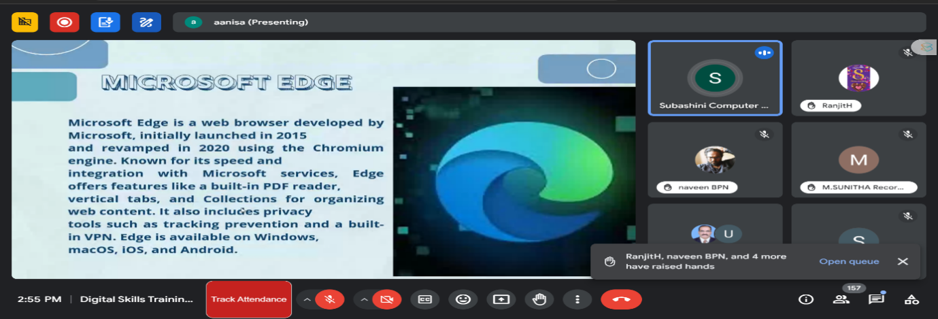
Dr. Subashini along with her assistant Ms. Anisha explained about Microsoft Edge, emphasizing its integration with Microsoft services, built-in PDF reader, and efficient memory usage. Security features like tracking prevention and Microsoft Defender SmartScreen were also covered.

Both speakers demonstrated how to customize toolbars and themes across the browsers, manage bookmarks, and utilize productivity tools like web capturing and immersive reading in Edge. Overall, the session effectively showcased the capabilities and unique features of each browser, emphasizing their utility for secure and efficient web browsing.

Key Takeaways
- The session focused on enhancing Internet surfing skills for non-teaching staff using Google Chrome, Mozilla Firefox, and Microsoft Edge.
- Google Chrome was praised for its speed, integration with G Suite, and advanced features like tab grouping, Omnibox, and password management.
- Mozilla Firefox was recommended for its strong privacy features, including enhanced tracking protection, HTTPS-only mode, and phishing and malware alerts.
- Microsoft Edge was highlighted for its integration with Microsoft services, built-in PDF reader, and tools like immersive reading and web capture.
- The session emphasized browser security, covering Chrome’s sandboxing and incognito mode, Firefox’s security features, and Edge’s tracking prevention and Microsoft Defender SmartScreen.
- Customization and productivity enhancements, such as using browser extensions, organizing bookmarks, and managing multiple accounts in all browsers, were explained.

Day 2 E-Mail Management and Organisation

The first session o555555n Day 2, the first session, led by Arul Kumar Prakash (Manager – Business &Operation) from CloudReign Technologies, the focus was on improving email management and communication practices. The session emphasized that emails serve not only as communication tools but also as essential documentation and proof of identity. He explained how to use email protocols like POP and IMAP and the importance of organizing emails through filters, folders, and labels to maintain a clutter-free inbox and enhance efficiency. The resource person also stressed the need for prompt email responses and regular inbox checks to prevent workflow delays.
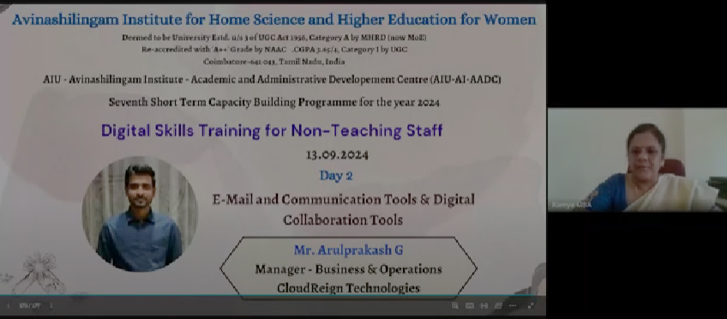

A significant part of the session was dedicated to identifying and managing spam and phishing emails. Resource person shared tips on recognizing suspicious emails by verifying sender information and using Gmail’s features, like viewing the source message, to spot phishing attempts. He also highlighted the importance of email security, urging caution when dealing with unknown senders, particularly when handling sensitive information.

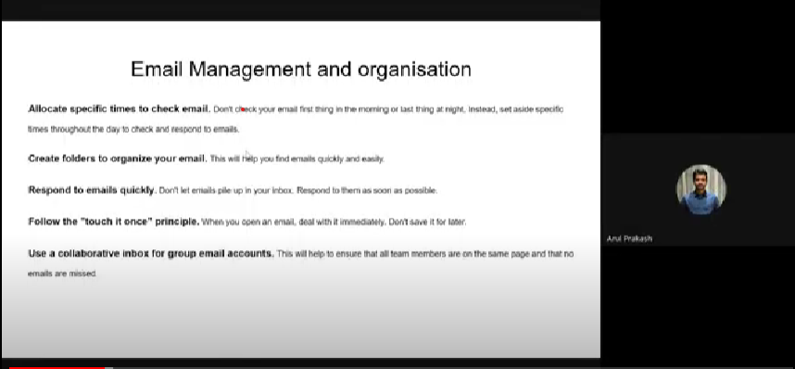
The session concluded with practical advice on automating email organization, prioritizing emails using starred features, and customizing inboxes for better workflow. He encouraged the use of third-party add-ons and the integration of tools like calendars and tasks within Google Workspace to streamline communication further and improve productivity. Participants found the session informative and helpful for improving email security and efficiency.

The second session, led by Ms.Shalini M G from CloudReign Technologies, focused on enhancing productivity and professionalism in email communication, and the resource person discussed the importance of crafting clear, concise, and professional emails and emphasized the significance of structuring emails effectively, using proper greetings, maintaining a respectful tone, and paying attention to details like subject lines and signatures to leave a positive impression on recipients. The session also covered best practices for using CC and BCC in emails to manage information flow while ensuring privacy when needed.
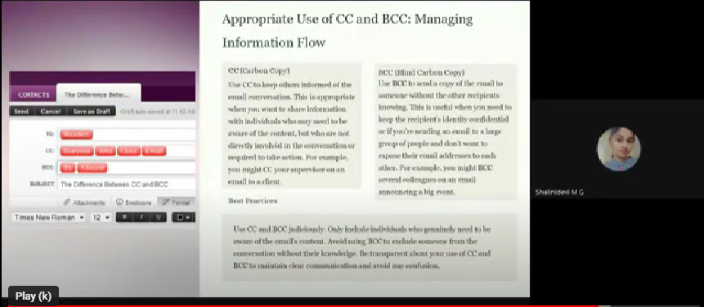
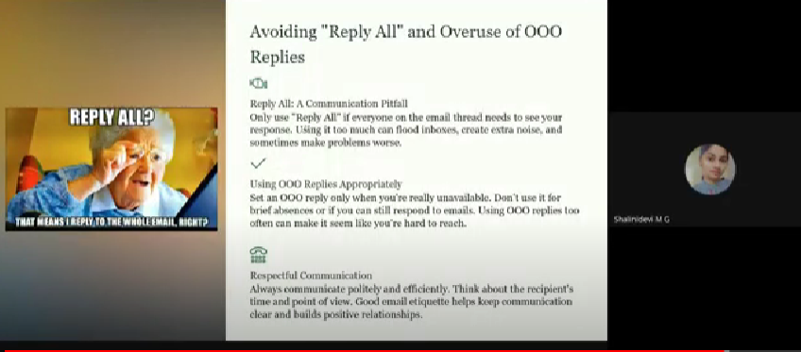
The session highlighted the importance of inbox management, encouraging participants to use folders, labels, and filters to stay organized. She also recommended scheduling emails for later delivery and using vacation responders when away from work. Additionally, she stressed the need to avoid unnecessary "Reply All" emails and advised participants to regularly clean up their inboxes by deleting promotional content and unsubscribing from irrelevant newsletters. Overall, the session provided practical tips for maintaining email productivity and ensuring clear, respectful communication in the workplace.

In the afternoon session, Ms. Rittika M from CloudReign Technologies delivered a comprehensive overview of Google’s digital collaboration tools. The session was meticulously designed to showcase how Google’s suite of applications, including Google Docs, Sheets, Slides, Forms, and Meet, can significantly enhance productivity and facilitate effective teamwork. Rittika's presentation highlighted the real-time collaboration features of these tools, demonstrating their ability to streamline work processes and improve communication across various professional and personal settings. The session began with an in-depth look at Google Docs, Sheets, and Slides. Resource Person demonstrated how these tools support simultaneous work on documents, spreadsheets, and presentations, enabling efficient teamwork and reducing the need for physical paperwork.
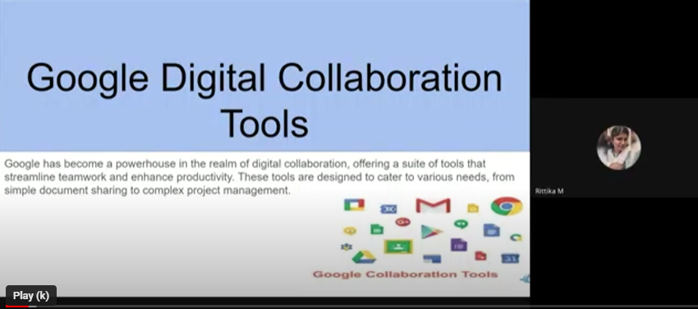
The capabilities of Google Keep were also highlighted during the session. Resource person introduced Keep as an effective note-taking app integrated with Google Workspace. Google Drive’s functionality was another key focus of the session. The resource person explained its features for file sharing, cloud storage, and collaborative editing. She stressed the importance of managing permissions and version control to maintain security and organization. Practical tips on optimizing storage were provided, including methods for deleting unnecessary files and adjusting storage allocations based on user needs.
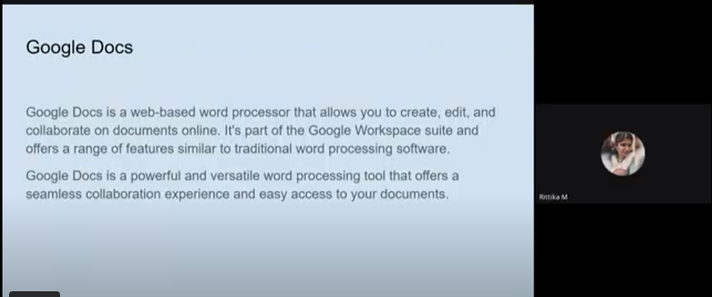

The session included practical demonstrations of Google Sheets and Docs, illustrating how to handle file sharing, document management, and the document approval process. It also showed how to request approvals, manage permissions, and use smart chips for automating tasks like meeting notes and email drafts. These demonstrations provided participants with hands-on experience in utilizing these tools effectively.

Overall, the sessions successfully illustrated how Google’s digital collaboration tools can enhance workflow efficiency, facilitate teamwork, and support effective communication, benefiting various professional and personal settings.

Key Takeaways
- Email Management was emphasized as crucial, with tips on using filters, folders, and labels to keep the inbox organized and clutter-free, ensuring better productivity.
- Email Security was highlighted, particularly recognizing phishing emails through sender verification, Gmail’s tools, and safe email practices to prevent data breaches.
- Prompt Responses and regular inbox checks were advised to prevent workflow delays, enhancing overall team efficiency.
- Spam and Phishing Identification techniques were discussed, focusing on using Gmail’s security features like source message viewing to detect suspicious emails.
- Automation and Prioritization of emails through tools like starred features, third-party add-ons, and integrated tools within Google Workspace were recommended to streamline communication and workflow management.
Day 3 Fundamentals of Information Security
The third day started vibrantly after two days of learning. Dr. K . Ramya, Nodal officer, AIU - Avinashilingam Institute- Academic & Administrative Development Centre (AIU-AI-AADC) gave a warm welcome to the participants and the chief guest. Resource person for the programme was Mr. Nanda Kumar, consultant, mySkills Academy. Chief guest started the session on the topic Fundamentals of Information Security. Guest informed that,
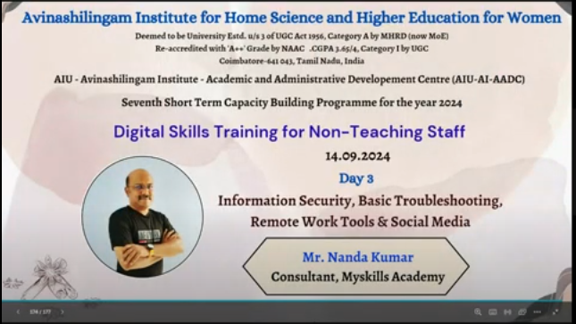

The speaker highlighted the significance of digital world in which safeguarding sensitive information has become a priority for individuals, businesses, and governments alike.
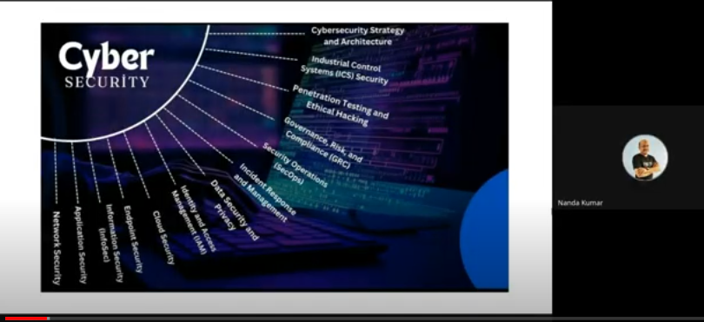
With cyber-attacks growing in frequency and sophistication, understanding the fundamentals of information security is crucial to protect personal data, corporate assets, and national security. He informed about Malware, Phishing, Insider Threats, Denial-of-Service (DoS) Attacks to the participants.
In the subsequent session on the topic Data Privacy and Protection, resource person added that data privacy refers to the rights and expectations individuals have regarding how their personal information is collected, used, and shared.
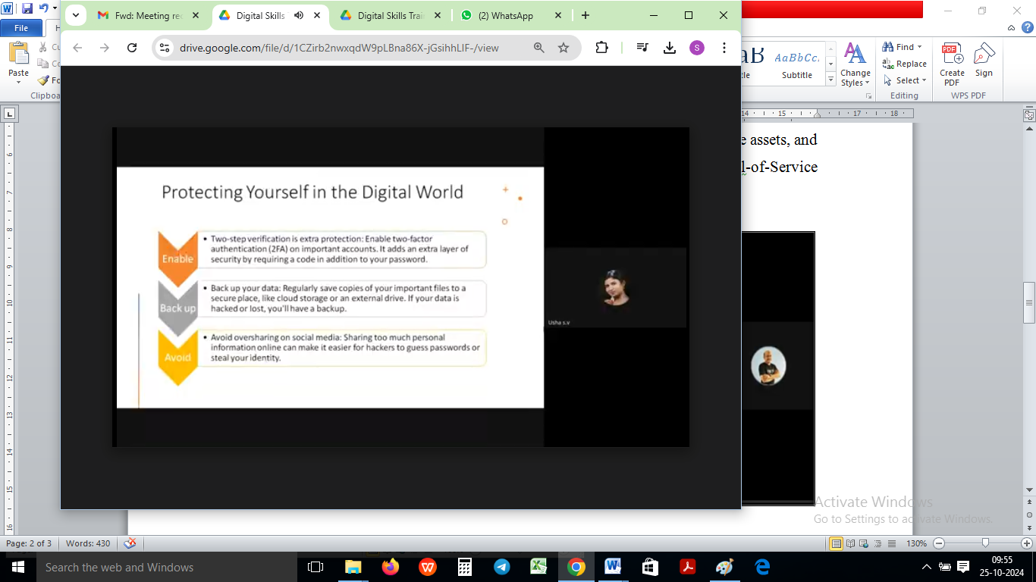
Resource person shared some personal steps to protect oneself from the digital world like Using Strong, Unique Passwords by avoiding simple or reused passwords can prevent unauthorized access to online accounts, being Cautious with Personal Information: Avoid sharing unnecessary information online or with unverified sources, Enabling Privacy Settings, Monitoring Data Access, Securing your devices and being cautious with downloads.
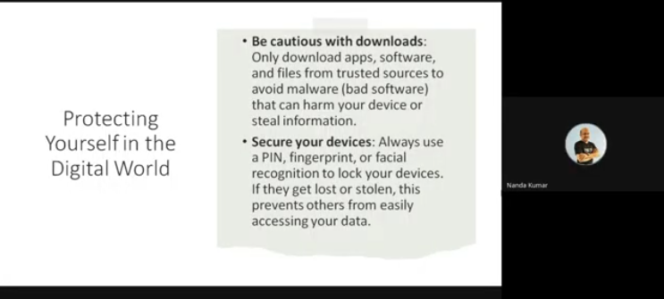
Post-lunch Session on the topic Basic Troubleshooting and IT Support was led by resource person, Mr. Nandakumar. Troubleshooting is an essential skill in IT support, allowing technicians to diagnose and resolve technical issues effectively.
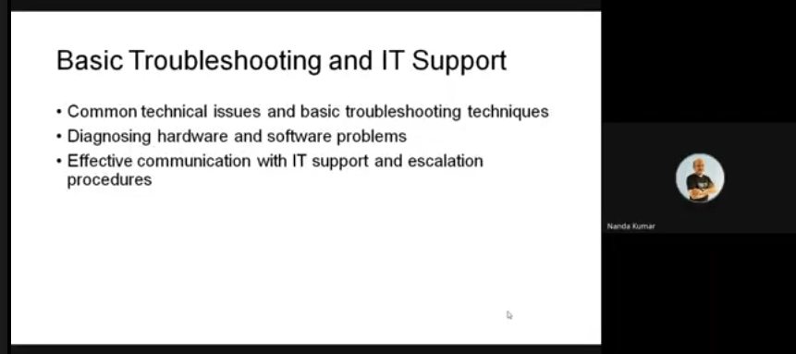
Basic troubleshooting and IT support, covering common problems and strategies to resolve them were discussed. Effective troubleshooting requires a logical and methodical approach to diagnosing and resolving technical problems.
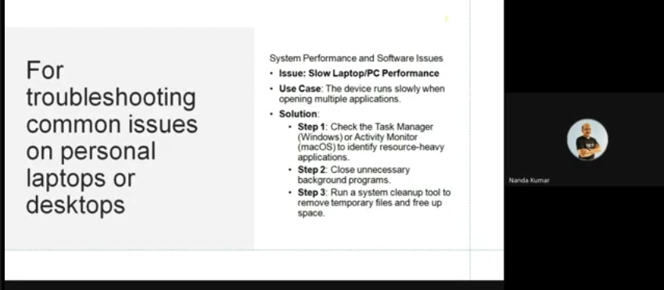
Resource person highlighted that IT troubleshooting involves diagnosing and solving hardware, software, and network problems in a systematic way.
Basic Troubleshooting Steps are Identify the problem, Recreate the issue, Check for simple solutions (restarting, checking connections), Use built-in diagnostic tools (like Task Manager or Event Viewer).
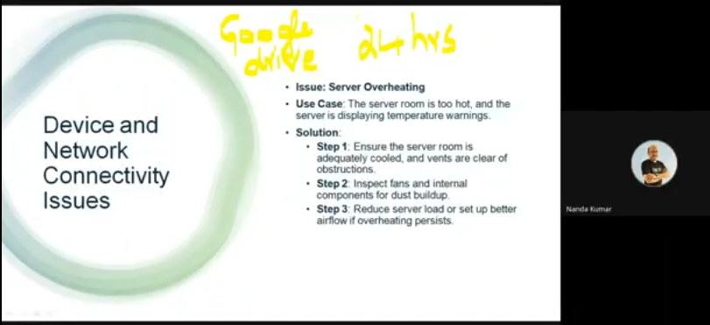
The final session was on the topic Remote Work Tools and Social Media Management. Reseource person Mr. Nandha Kumar explained how to use the work tools and explained clearly about how to manage the social media contents in an effective way.
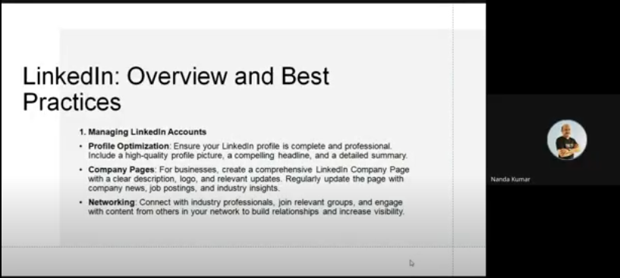

Social media management tools enable teams to schedule posts, track engagement, and analyze performance across platforms.

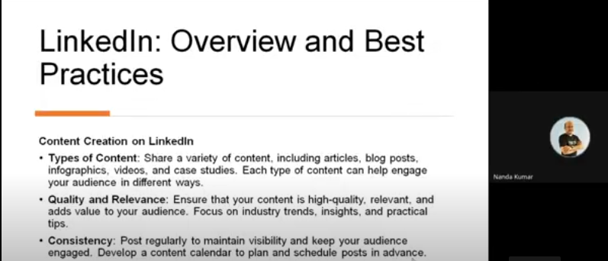

Social media management tools such as LinkedIn, X (Twitter), Instagram, Facebook are essential for businesses looking to maintain an active online presence and engage with their audience.
Key Takeaways
- Verify user identity and controlling access to systems or data based on privileges.
- Focus on safeguarding personal and organizational data from breaches and unauthorized access through encryption, firewalls, and secure access controls
- Fundamental troubleshooting steps involve identifying the problem, understanding the root cause, and applying a solution.
- Centralized tools make it easier to manage multiple social media accounts, saving time and ensuring consistency across platforms.
The event ended with a formal vote of thanks by the Nodal Officer of AADC to the resource persons, participants and all supporting staff for the conduct of the program. Overall, the program was successful in imparting digital skills required for the day-to-day activities of the non-teaching staff of higher education institutions.

Participants List

S.No | Name | Designation | Department | Institution/ Organisation Name
1 | rajani mvn | Librarian | Library | Vishnu Institute of Pharmaceutical Education & Research
2 | G KARTHIKEYAN | LAB TECHNICIAN | MECHATRONICS ENGINEERING | SONA COLLEGE OF TECHNOLOGY
3 | Ekta Chaudhary | Staff | Administration | Rajiv Gandhi Institute of Petroleum Technology
4 | P. Vasavi Viswanathan | Administrative Assistant | Department of Information Technology | Sona College of Technology
5 | N.P.Kumar | Lab Technician | Fashion Technology | Sona College of Technology
6 | Aniruddha Ashok Patil | Laboratory Assistant | Mechanical Engineering | Rajarambapu Institute of Technology, Rajaramnagar
7 | PANNEERSELVAM J | SYSTEM ADMINISTRATOR | COMPUTER SCIENCE ENGINEERING | SONA COLLEGE OF TECHNOLOGY
8 | AVINASH JAIN M | ASSISTANT INSTRUCTOR | CIVIL ENGINEERING | JNNCE,SHIVAMOGGA
9 | MADHAN RAMKUMAR K | Record Clerk | Administration | Providence college for women
10 | GOKULKUMAR S | TECHNICAL ASSISTANT | COMPUTER SCIENCE AND ENGINEERING | KONGU ENGINEERING COLLEGE (AUTONOMOUS)
11 | M.KANNAN | Lab Tech | Cse | Sona College of Technology
12 | M D Usha | Programmer | Mathematics | KSR College of Engineering
13 | RAVINDRANATH AVADUTA | Assistant Programmer | Emerging Technologies | Mahatma Gandhi Institute of Technology
14 | Sandeep Shettigar | Library Assistant | Central Library | St Joseph Engineering College
15 | T Karthik | Lab Technician | Electronics and Communication Engineering | Sona College of Technology
16 | S Suganya | Administration Assistant | Computer Science and Engineering | Sona College of Technology
17 | P N V VARALAXMI | Programmer | Information Technology | G Narayanamma Institute of Technology and Science
18 | SARAVANAKUMAR V | Net Admin | IT | Sona College of Technology
19 | Vishal Kumar Singh | ADMIN | FITCS | FITCS PARUL UNIVERSITY
20 | SHRIKANT SHARMA | SR. EXECUTIVE ASSISTANT | COMPUTER SCIENCE AND INFORMATION TECHNOLOGY | KIET GROUP OF INSTITUTIONS
21 | Shahina | Lab instructor | ECE | Sambhram institute of technology
22 | Vijay Akaram Patil | Lab Assistant | Electronics and Telecommunication Engineering | Rajarambapu Institute of Technology
23 | Pradeep mishra | Superintendent | Audit | RGIPT
24 | Kavitha | Office assistance | ECE | Nandha Engineering college
25 | VEEPURU SURENDRA | Assistant Programmer | Information Technology | Mahatma Gandhi Institute of Technology
26 | EDLINA THEREZA SALEMA | LOWER DIVISION CLERK | ADMINISTRATION | DON BOSCO COLLEGE OF ENGINEERING
27 | Lokender Kumar | Lab Instructor | CSIT | KIET GROUP OF INSTITUTIONS
28 | Thangavel P | Office Assistant | Civil Engineering | Kongu Engineering college
29 | SOUNDARYA P | PROGRAMMER | ECE | KSR Institute For Engineering And technology
30 | Preeti Bajpai | Adminstration Assistant | Dean, Faculty Affairs and Traning & Placement | RGIPT
31 | Kavita Amar Pashte | Technical Assistant | Artificial intelligence & Data Science | K. J. Somaiya Institute of Technology, Sion Mumbai-22
32 | Mohan v | Technical assistant | Electrical and Electronics Engineering | Kongu Engineering college
33 | SANGEET PAL | Office assistant | Registrar office | Kanpur institute of technology
34 | KV MAHESH KUMAR | Technician | ECE | Mahatmagandi Institute of technology
35 | P Mohammad Akram | System administrator | CSE | MITS
36 | B Satyanarayana | Technician | ECE | MGIT
37 | P RAVISHANKAR | Technician grIII | ECE | MGIT
38 | Mallela Kishore | Computer Operator | IT | Chaitanya Bharathi Institute of Technology
39 | KOKILAVANI V | TECHNICAL ASSISTANT | COMPUTER SCIENCE AND DESIGN | KONGU ENGINEERING COLLEGE
40 | K.Kokila | Technical Assistant | Computer Science and Design | Kongu Engineering College
41 | G.Yamunadevi | Technical Assistant | Computer Science and Design | Kongu Engineering College
42 | GOVINDHARAJ O K | DATA ENTRY OPERATOR | DEPARTMENT OF CIVIL ENGINEERING | KONGU ENGINEERING COLLEGE, PERUNDURAI
43 | Nikhil Malhotra | Technical Assistant (Computer) | Computer Science | University of Delhi, Bharati College
44 | Peddinti naga krishna chaitanya | Junior accountant | Sponsered research and industrial consultancy | INDIAN INSTITUTE OF TECHNOLOGY BHUBANESWAR
45 | G.Sivasakthi Arasu | Data Entry Operator | Computer Science and Design | Kongu Engineering College
46 | Priyajit Ray | Assistant Professor | Department of Commerce | Raja Peary Mohan College
47 | KATHIRVEL E | LAB TECHNICIAN | BME | SONA COLLEGE OF TECHNOLOGY
48 | TEEJUBI WALIKAR | JUNIOR ASSISTANT | ACADEMICS SECTION | NATIONAL INSTITUTE OF TECHNOLOGY GOA
49 | Dipak Kumar Sharma | Junior Accountant | SRIC | IIT Bhubaneshwar
50 | K S SUNIL KUMAR | System Administrator | Information Technology | Madanapalle Institute of Technology and Science
51 | P BANU PRIYA | Data Entry Operator | CT - UG | Kongu Engineering College
52 | Mrs. D Kavitha | Computer Lab Instructor | CSE | Panimalar Engineering College
53 | Sonu kumar goyal | Laboratory assistant | Smmme | IIT BHUBANESWAR
54 | Y Chandra Sekhar | Asst. Programmer | Information Technology | Chaitanya Bharathi Institute ofTechnology
55 | Menisha A | Lab Technician | Fashion Technology | SONA COLLEGE OF TECHNOLOGY
56 | HARJEET SINGH | Instructor (OMSP) | Administration | Aryabhatta College, University of Delhi
57 | B.P.NAVEEN | B.E Lab Institute | Ece | Nandha Engineering College
58 | R.Thangavel | Lab Instructor | ECE | Nandha Engineering College
59 | Anoosha J | Superintendent | Administration | NIT Puducherry
60 | Vithyasahar U | Junior Assistant | Administration | NIT Puducherry
61 | Deepak Ashok Khokade | Lab Assistant | E&TC | Rajarambapu Institute of Technology
62 | Veronica Maria Colaco e Fernandes | Assistant Registrar | Administration | Don Bosco College of Engineering
63 | Yogendra D | Foreman | Electrical and electronics engineering | PESCE MANDYA 571401
64 | GANESH SHAMRAO MADALE | Laboratory Assistant | Information Technology | Rajarambapu Institute of Technology, Rajaramnagar Islampur
65 | Jotiram S Jadhav | Lab Assistant | Department of E & TC Engineering | Rajarambapu Institute of Technology, Rajaramnagar
66 | veena A | Junior Assistant | Department of English and Foreign Languages | Alagappa University
67 | Mamitha U | Programmer | Computer Science and Engineering | St Joseph Engineering Collage
68 | Pavithra | Programmer | Computer Science and Engineering | St Joseph Engineering College Vamanjoor
69 | RAKSHITHA B S | PROGRAMMER | CSE | ST JOSEPH ENGINEERING COLLEGE
70 | RAVIKUMAR T | ASSISTANT REGISTRAR | ESTABLISHMENT SECTION | THE GANDHIGRAM RURAL INSTITUTE
71 | kanchan Honale | Office cum Lab Assistant | Computer Science and Engineering | SSGMCE,Shegaon
72 | ABRAHAM DANIEL M | IQAC - DATA ENTRY OPERATOR | IQAC (Internal Quality Assurance Cell) | ST JOSEPH'S UNIVERSITY
73 | SWATHI S NARAYAN | IQAC - SECRETARY | IQAC (Internal Quality Assurance Cell) | ST JOSEPH'S UNIVERSITY
74 | S.vimala | Assistant | EEE | Panimalar Engineering college
75 | Shravan Kumar | Programmer | Computer Science and Engineering | ST.Joseph Engineering College Vamanjoor
76 | Nikhitha Shetty | Programmer | Computer Science and Engineering | ST.Joseph Engineering College
77 | ROYENA BELINDA BARBOSA | L.D.C. | ADMINISTRATION | DON BOSCO COLLEGE OF ENGINEERING
78 | P.KRISHNAMOORTHI | LAB TECHNICIAN | ECE | SONA COLLEGE OF TECHNOLOGY
79 | D.DHANALAKSHMI | LAB TECHNICIAN | ECE | SONA COLLEGE OF TECHNOLOGY
80 | Shri Ram Kumawat | Technical Assistant | Electronics and Communication Engineering | National Institute of Technology Goa
81 | BADRISH K P | Instructor | ECE | JNN College Of Engineering Navule Shimoga
82 | ABIVIRUTHI S | TECHNICAL ASSISTANT | COMPUTER SCIENCE AND ENGINEERING | KSR COLLEGE OF ENGINEERING
83 | Karunakaran.K | Assistant Registrar (Finance)I/c | Account Section | Puducherry Technological University
84 | R. THANGAMUTHU | SYSTEM ADMINISTRATOR | COMPUTER SCIENCE AND ENGINEERING | KONGU ENGINEERING COLLEGE
85 | PRIYATHARSINI V C | DATA ENTRY OPERATOR | DEPARTMENT OF CSE | KONGU ENGINEERING COLLEGE
86 | K.T.ARUN | TECHNICAL ASSISTANT | DEPARTMENT OF INFORMATION TECHNOLOGY | KONGU ENGINEERING COLLEGE PERUNDURAI
87 | VISHALAANAND R S | TECHNICAL ASSISTANT | INFORMATION TECHNOLOGY | KONGU ENGINEERING COLLEGE . PERUNDURAI
88 | NANDHASRI | Lab technician | Biomedical engineering | Sona college of Technology
89 | ESAKKI RAMKUMAR T | Instructor | Electrical and Electronics Engineering | Sri Ramakrishna Engineering College
90 | P.SANKAR | TECHNICAL ASISTANT | COMPUTER SCIENCE ENGINEERING | KONGU ENGINEERING COLLEGE
91 | Mrs. Kavita Amar Pashte | Technical Assistant | AI-DS | K.J.Somaiya Institute of Technology,
92 | P Lakshmi Padmaja | Senior Assistant | Examinations Branch, CE's Office | University of Hyderabad
93 | V Velu | Lab technician | ECE | Sona college of technology
94 | M.V.Anjali Devi | Office Assistant | Examination Section, CE's Office | University of Hyderabad
95 | RITU RAMESH MALI | JUNIOR CLERK | ADMINISTRATION | MES GARWARE COLLEGE OF COMMERCE(AUTONOMOUS) ,PUNE
96 | Naik Preeti Suraj | Library Clerk | Commerce | MES Garware College of Commerce
97 | VASANTHKUMAR G | JUNIOR ASSISTANT | OFFICE | KSR COLLEGE OF ENGINEERING
98 | Sonkamble Pratiksha Suryakant | Peon | Office | MES GARWARE COLLEGE OF COMMERCE (AUTONOMOUS)
99 | NANDHINI G | PROGRAMMER | CSE | KSR COLLEGE OF ENGINEERING
100 | R. Mythili | OA | CSE | KEC
101 | A. Divya JYOTHI | Office Assistant | Controller of Examination' s Office | University of Hyderabad
102 | Ganesh Galugade | Laboratory Assistant | Information Technology | Rajarambapu Institute of Technology
103 | KANNAN S | UPS Incharge | CSE | SONA COLLEGE OF TECHNOLOGY
104 | Mohalatha | Programmer | Computer Science and Engineering | St Joseph Engineering College Vamanjoor
105 | Shreya | Programmer | Computer Science and Engineering | St Joseph Engineering College
106 | Preetham | Programmer | Computer Science | St Joseph Engineering College Mangaluru
107 | SANJEEV PRASANNA B | TECHNICIAN | EEE | SRI RAMAKRISHNA ENGINEERING COLLEGE
108 | R.SRINIVASAN | Sr.LAB TECHNICIAN | INFORMATION TECHNOLOGY | SONA COLLEGE OF TECHNOLOGY
109 | Komalavalli Ganeshan | Lab instructor | ECE | Nandha engineering college
110 | Yarramaneni Aravinda | Senior system Analyst | Controller of Examination | University of Hyderabad
111 | SELVAKUMAR.P | LABTECNICIAN | ECE | SONA COLLEGE OF TECHNOLOGY
112 | S. Bhaskar Rao | Sr. Assistant | Controller of Examination | University of Hyderabad
113 | Anshuman Gaikwad | Jr. Cleark | Office | Garware College Of Commerce
114 | Vivekb Dada Buchade | Head clerk | Office | MES.Garware College of Commerce
115 | Rajesh O. Bedre | Technical Lab. Assistant | Mechanical Engineering | Shri. Sant Gaganan Maharaj College of Engg.
116 | S.Ranjithkumar | Lab Assistant | Computer Science and Engineering | Kongu Engineering College
117 | M. Ramasamy | Proprietor | Textile | Sree vinayaga tex
118 | M.PARAMESWARAN | TECHNICAL ASSISTANT | CSE | KONGU ENGINEERING COLLEGE
119 | Deepashree | Programmer | computer science and engineering | ST.Joseph Engineering College,Vamanjoor
120 | Sandhya Rani | Asst System Admin | CSE | SJEC
121 | Suma | Programmer | Computer Science and Engineering | St Joseph Engineering College
122 | Nishmitha | Programmer | Computer science & engineering | St. Joseph Engineering College Mangaluru
123 | BALASO DHAVJI BABAR | Electician | Electrical engineering | Rajarambapu Institute of Technology Rajaram Nagar, Islampur
124 | Vasim Shafik Jamadar | Jr. Clerk | Deaprtment of Management Studies (MBA) | Rajarambapu Institute of Technology, Rajaramnagar
125 | S KIRUTHIKA | OFFICE ASSISTANT | COMPUTER SCIENCE AND DESIGN | KONGU ENGINEERING COLLEGE
126 | Ashwath A H | Instructior | CS&E | JNNCE
127 | Sri Pallavi Vinjamuri | Tr. Secretarial Assistant | MCA | Sona College of Technology
128 | L Prasath | Lab Technician | MCA | Sona College of Technology
129 | Sudhir N | Instructor | MCA | JNNCE,Shivamogga
130 | Sachin Balaso Gavali se | Electrician | Electrical Engineering | Rajarambapu institute of Technology Rajaramnagar Islampur
131 | Anandrao Narayan jadhav | Sr. Instructor | Electrical | Rajarambapu Institute of technology, rajaramnagar
132 | PRAVIN ASHOK KHOT | LAB ASSISTANT | MBA | RAJARAMBAPU INSTITUTE OF TECHNOLOGY
133 | Prachi Samir Phand | Assistant Librarian | Library | M.E.S.Garware College of Commerce
134 | Mrs.Sulbha kashid | Lab assistant | Electronic and computer science | Thakur college of engineering and technology
135 | NITHIYAMBAL | ASSISTANT ADMINISTRATION | ADMINISTRATION | SONA COLLEGE OF TECHNOLOGY
136 | Pramod v potedar | Lab Assistant | Electronics and communication | JNN college of Engineering
137 | Usha s v | Lab Assistant | ECE | JNN College of Engineering
138 | Maruti Santu Sonawane | Electrician | Electrical Engineering | Rajarambapu Institute of Technology, Rajaramnagar, Islampur
139 | Shriprasad Shivaji Kadam | Laboratory Assistant | Electrical engineering | Rajarambapu Institute of Technology Rajaramnagar Islampur
140 | Raghavendra k | Instructor | Information science and engineering | Jnnce
141 | MALI RAMESH HIRARAMJI | Laboratory Technician | Electronics and telecommunication | Singhad college of Engineering
142 | Swapna | Programmer | Computer science and engineering | Sjec
143 | Mariyappan D | Secretarial Asst | Mechatronics Engineering | Sona College of Technology
144 | HARINI S | PROGRAMMER | EXAM CELL | K S R INSTITUTE FOR ENGINEERING AND TECHNOLOGY
145 | Teena Mascarenhas Braganza | UDC | Examinations | Don Bosco College of Engineering
146 | NITHYA M | OFFICE ASSISTANT | EXAM CELL | K S R INSTITUTE FOR ENGINEERING AND TECHNOLOGY
147 | SUGANYA M | PROGRAMMER | EEE | K S R INSTITUTE FOR ENGINEERING AND TECHNOLOGY
148 | Pramod prakash patil | Wireman | Electrical | Rajarambapu institute of technology
149 | SAKTHIPRIYADHARSINI P | Project Associate | Sona Incubation Foundation | Sona College of Technology
150 | Shakthivel V | System manager | CSE | Kongu Engineering College
151 | Sunila G D | Mechnic | Civil Department | J N N college of engineering
152 | R.YUVARAJ | Lab Technician | ECE | Sona college of technology
153 | Saramekala karun kumar | Lab assistant | EEE | SASI
154 | E. Tamilarasi | Library Asst | Library | Sona College of Technology
155 | R.MANICKASUNDARAM | Sr. TECHNICAL ASSISTANT | CSE | Kongu Engineering College
156 | SHAILAJA | Lab Instructor | Electrical and Electronics Engineering | St Joseph Engineering College
157 | Anil Jagannath Kate | Laboratory Assistnat | Computer Science & Enginerring | Rajarambapu Institute of Technology,
158 | P.J. JESURAJ | Secretarial Assitant | MBA | SONA COLLEGE OF TECHNOLOGY
159 | Arati Tikare | Lab Instructor | CSE | JNNCE
160 | MAHESWARAN S | Technical Assistant | EIE | KONGU ENGINEERING COLLEGE
161 | R.THANGAMUTHU | SYSTEM ADMINISTRATOR | COMPUTER SCIENCE AND ENGINEERING | KONGU ENGINEERING COLLEGE
162 | Mr. Sandip Shahaji Patil | Lab Assistant | Automobile | Rajarambapu Institute of Technology, Islampur
163 | Raja Jayaraman | Network Engineer | Department of Computer Science and Engineering | Sona College of Technology
164 | Rajani.MVN | Librarian | Library | Vishnu Institute of Pharmaceutical Education and Research
165 | RAMACHANDRAN T | Technical assistant | Chemical engineering | Kongu Engineering college
166 | V.S. SAKTHIMURUGAN | LAB ASSISTANT | EEE | KONGU ENGINEERING COLLEGE
167 | Usha B | Instructor | ISE | JNNCE
168 | EPHSIBA M | Lab Assistant | Electrical And Electronics Engineering | Vel Tech Multi Tech Dr RR Dr SR Engineering College
169 | S.Nivas | Lab Technician | Civil | Sona College of technology
170 | Kiran Kumar N | Lab instructor | ECE | Sambhram institute of technology
171 | SUMAMMA BN | Lab instructor | ECE | Sambhram institute of technology
172 | Kiran Kumar N | Lab instructor | ECE | Sambhram institute of technology
173 | Sudha | Lab instructor | Electronics and communication engineering | Sambhram institute of technology
174 | sushil suresh vichare | Lab A. | computer engineering | Thakur College of Engineering and Technology
175 | Aniket Tanaji Patil | Lab Assistant | Science and Humanity's | Rajarambapu Institute of Technology
176 | Rushikesh Shivaji Patil | Lab assistant | Mechanical | Rajarambapu Institute of technology RajaramNagar
177 | Kalaiselvan S | Technical Assistant | EIE | Kongu Engineering College
178 | B.PNaveen | Lab Instructor | Ece | Nandha Engineering College
179 | R.Thangavel | Lab Instructor | ECE | NANDHA ENGINEERING COLLEGE
180 | Swapnil Shashikant Patil | Lab Assistant | Computer Engineering | Rajarambapu Institute of Technology, Rajaramnagar
181 | ANANDHAKUMAR K N | Technical assistant | Mechanical engineering | Kongu Engineering College
182 | M.PRAVEENKUMAR | TECHNICAL ASSISTANT | MECHANICAL | KONGU ENGINEERING COLLEGE
183 | Sriram | Technical assistance | Cse | Kongu engineering College perundurai
184 | Priya A | Lab Instructor | Electrical and Electronics Engineering | st.joseph engineering college
185 | Varsha S B | Lab instructor | CSE(cyber security) | Sambhram institute of technology
186 | SOUNDARYA P | PROGRAMMER | ECE | KSR Institute For Engineering And Technology
187 | Dhivya. R | Programmer | ECE | KSR Institute for Engineering And Technology
188 | A.S.GEETHA | Programmer | IQAC | K S R COLLEGE OF ENGINEERING
189 | Nandhasri | Lab technician | Biomedical engineering | Sona college of Technology
190 | S Renupriya | Lab Assistant | ECE | KSR institute for Engineering and Technology
191 | Geetha.N | Instructor | Electronics and Telecommunication | BMSIT
192 | SUPRIYA K | LAB INSTRUCTOR | Electronics and Communication Engineering | BMSIT&M
193 | Gunvant Dattu Chavan | Lab Assistant | Information Technology | Rajarambapu Institute of Technology, Rajaramnagar
194 | CHINNEGOWDA H S | INSTRUCTOR | Mechanical Engineering | P E S College of Engineering Mandya
195 | Murugesan .T | Instructor | EEE | Kongu Engineering college
196 | M. Sunitha | Record Asst | English | Chaitanya Bharathi institute of technology
197 | SENTHILKUMAR S | DATA ENTRY OPERATOR | IT | KONGU ENGINEERING COLLEGE
198 | R.SRINIVASAN | Sr.LAB TECHNICIAN | INFORMATION TECHNOLOGY | Sona college of Technology
199 | Dnyaneshwar Baldev Thakare | Clerk | Information Technology | Shri Sant Gajanan Maharaj College of Engineering Shegaon
200 | SARATHY V | Lab Technician | ECE | Sona College of Technology
201 | S.ANANDAN | Lab technician | Electronics communication engineering | KSR educational institutions
202 | A.Krishnamurthi | SystemAdministrator | CSE | Kongu Engineering College
203 | Yerroju s b Surya Prakash | Lab assistant | EEE | Sasi institute of technology and engineering college
204 | Padavala sri satya lavanya | Junior assistant(cop) | EEE | Sasi Institute of Technology&Engineering
205 | D SATHISHKUMARD | Computer Lab Assistant | COMPUTER TECHNOLOGY - PG | KONGU ENGINEERING COLLEGE - PERUNDURAI
206 | Prakash N Nikhade | IT Dept Assistant Teacher. | Information Technology Department. | Shri Sant Gajanan Maharaja College of Engg Shegaon IT Dept.

Sample Certificate

