Avinashilingam Institute for Home Science and Higher Education for Women
Deemed to be University Estd. u/s 3 of UGC Act 1956, Category A by MHRD (now MoE)
Re-accredited with 'A++' Grade by NAAC.CGPA 3.65/4, Category I by UGC
Coimbatore-641 043, Tamil Nadu, India
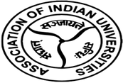

Report of the
Eighth Short Term Capacity Building Program on
AI for Engineers: Tools, Techniques, and Applications.

Jointly organised by
AIU – Avinashilingam Institute – Academic and Administrative Development Centre (AIU-AI-AADC)
&
School of Engineering
&
Centre for Machine Learning and Intelligence (CMLI)

14.10.2024 to 18.10.2024

Mode: Online

Avinashilingam Institute for Home Science and Higher Education for Women
Deemed to be University Estd. U/s 3 of UGC Act 1956, Category ‘A’ by MHRD
Re-accredited with 'A++' Grade by NAAC.CGPA 3.65/4, Category I by UGC. Coimbatore-641 043, Tamil Nadu, India

Report on Eighth Short Term Capacity Building Programme on
AI for Engineers: Tools, Techniques, and Applications.
The Avinashilingam Institute – Academic & Administrative Development Centre (AIU-AI-AADC), in collaboration with the School of Engineering and the Centre for Machine Learning and Intelligence, successfully organized the Eighth Short-Term Capacity Building Programme of 2024, titled AI for Engineers: Tools, Techniques, and Applications. Conducted online from 14th to 18th October 2024, the program aimed to explore the fundamentals and relevance of Artificial Intelligence (AI), understand its various applications in engineering and development, and facilitate its integration into research projects and teaching curricula. The sessions featured eminent speakers from across India, who provided participants with valuable insights and practical knowledge.

DAY 1: (14.10.2024 /Session I)
The inaugural session on Role of AI in health care started with prayer song and Dr.Ramya, Nodal Officer of the Academic and Administrative Development Centre at Avinashilingam Institute, welcomed the gathering.
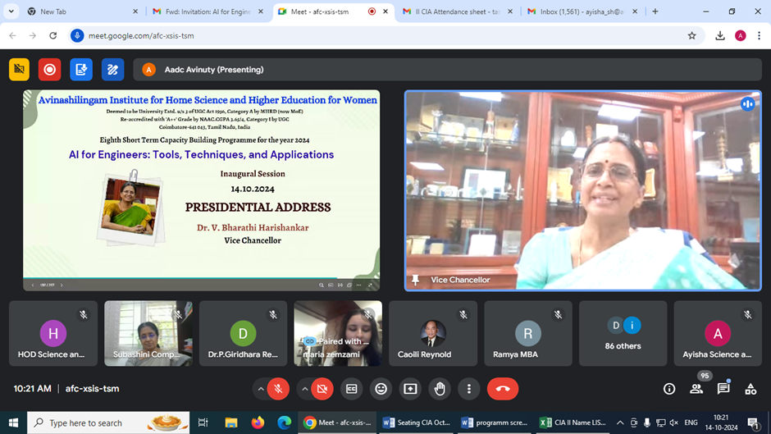
It was followed by the Presidential address delivered by Dr.V.Bharathi Harishankar, Vice- Chancellor, Avinashilingam Institute for Home Science and Higher Education for Women. During her presidential address, she insisted the participants to understand the contextual usage of AI and to strategize and apply AI to the local realities. She added that the AI and human intelligence will end up while choosing the right option.
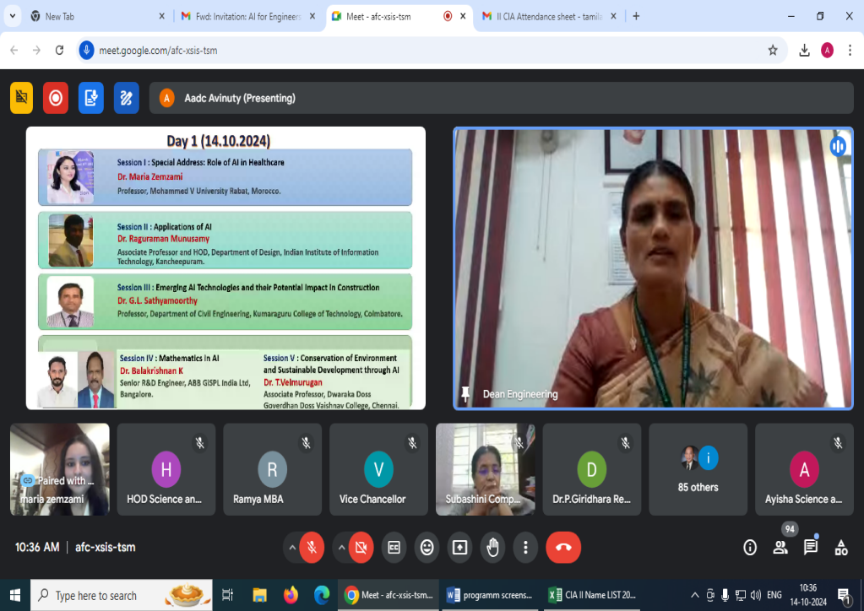
After the presidential address, Dr. B.Sargunam, Dean, School of Engineering briefed the contents of the five-day capacity building programme.

Dr.D.Sumitha, Associate Professor of Mathematics, School of Engineering introduced the chief guest Dr. Maria Zemzami, Professor, Mohammed V University, Rabat, Morocco to the forum.
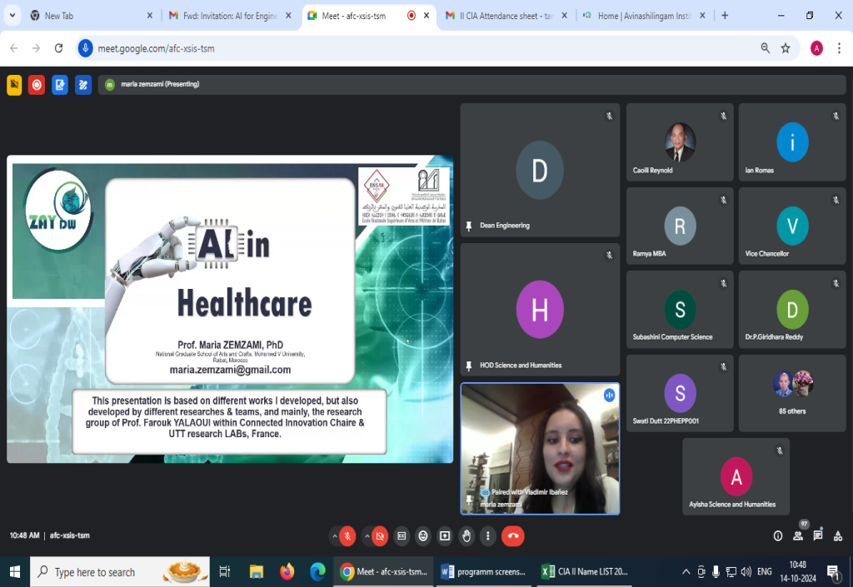

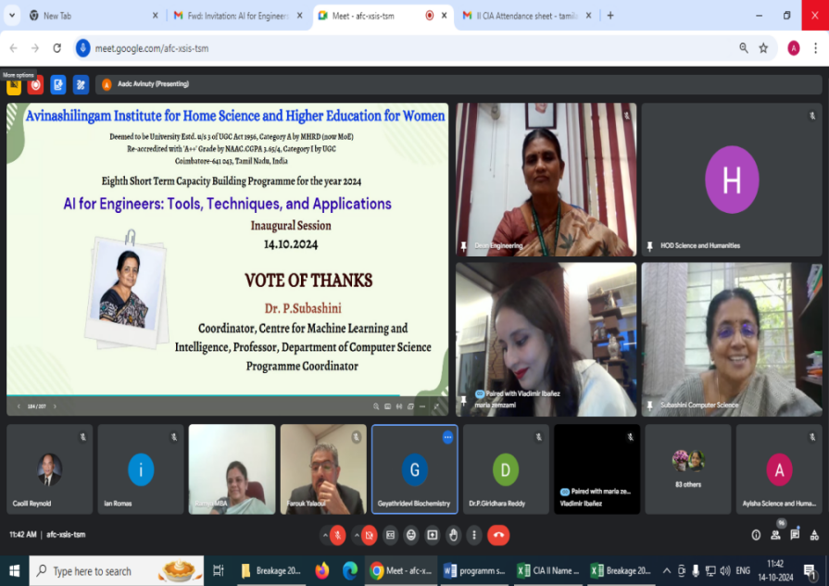
Dr. Maria Zemzami, Professor, Mohammed V University, Rabat, Morocco inaugurated the session through virtual mode and narrated the significant role of AI in Healthcare. During her inaugural address, she has started to explain the four main types of AI: reactive, limited memory, theory of mind and conscious of AI. Then she insisted the use of advanced technologies to restructure existing products and services and to support the speeds up operational efficiency and enterprise-wide growth in the Industry X.0- (4.0). The speaker shared the importance of the system interconnections along with the nine pillars of the industry 4.0. The speaker rightly pointed the importance of AI in Health care to save time/ efficiency, shortage of clinicians, improper patient outcome, Bio-data generation and robust algorithms etc. and the advantages and disadvantages. Finally, She explained the practical challenges related to data structures, real-time control, and the evolution of decision-making in the case of Smart EMR NG. The session came to an end with the vote of thanks proposed by Dr. P. Subashini, Coordinator of the Centre for Machine Learning and Intelligence and Professor of Computer Science.

DAY 1: (14.10.2024 /Session II)
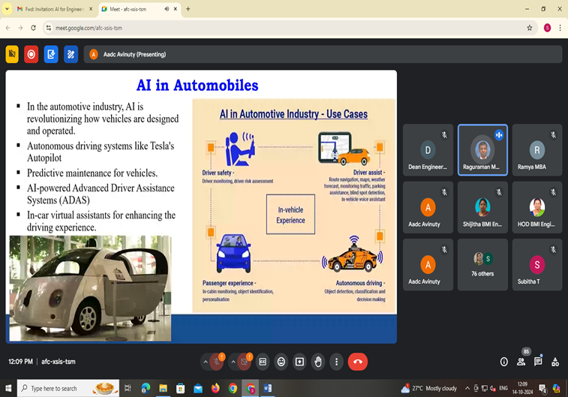
The second session on “Applications of AI” was handled by Dr. Raguraman Munusamy, Associate Professor and Head, Department of Design at the Indian Institute of Information Technology, Kancheepuram.

The session highlighted the diverse applications of Artificial Intelligence (AI) across various engineering disciplines, including healthcare, manufacturing, aerospace, and agriculture. Dr. Munusamy showcased videos demonstrating the transformative potential of AI and its profound impact on multiple sectors. He concluded the session by discussing the future of AI, emphasizing its vast potential to revolutionize industries. He predicted that AI would continue to evolve, becoming deeply integrated into everyday operations across sectors. He underscored the importance of engineers, healthcare professionals, and other industry experts staying informed and adapting to AI-driven advancements, as this technology shapes the future. The lecture offered valuable insights into both the current and emerging applications of AI, leaving participants with a deeper understanding of its significance and the opportunities it presents.
Key Takeaways from the Session:
- AI’s growing role in engineering.
- Applications of AI in automobiles, healthcare, and its impact on manufacturing.
- AI in aerospace and its future potential.

DAY 1: (14.10.2024 /Session III)
The third session, titled "Emerging AI Technologies and Their Potential Impact in Construction," was delivered by Dr. G.L. Sathyamoorthy, Professor in the Department of Civil Engineering at Kumaraguru College of Technology, Coimbatore. Dr. Sathyamoorthy provided a comprehensive overview of the transformative role of AI in the construction industry. He elaborated on how AI is being leveraged to optimize various phases of construction, such as design, project management, and safety monitoring.
The speaker highlighted that AI-powered systems are revolutionizing the industry by enabling the creation of more efficient building designs, automating repetitive tasks, and enhancing real-time, on-site decision-making.
At the same time, Dr. Sathyamoorthy addressed the challenges associated with AI adoption in the sector. These include the high initial implementation costs, a shortage of skilled professionals to manage AI technologies, and concerns surrounding data privacy.


Despite these challenges, Dr. Sathyamoorthy underscored the immense potential of AI to revolutionize the construction sector. He highlighted its ability to enable smarter project execution, lower costs, enhance safety measures, and improve overall efficiency in future construction projects.
Key Takeaways from the Session:
- The transformative potential of AI and its key applications.
- Efficiency and safety benefits driven by AI adoption.
- Challenges to adoption and the broader impact of AI on the construction industry.

DAY 1: (14.10.2024 /Session IV)

The fourth session, titled “Mathematics in AI,” was delivered by Dr. K. Balakrishnan, Senior Engineer, R&D, ABB GiSPL, Bangalore. He shared his valuable insights on how mathematics drives innovation in artificial intelligence.

Dr. Balakrishnan began by tracing the origins of AI to its inception in 1956, followed by the evolution of algorithms, the emergence of neural networks, and advancements in machine learning and deep learning. He highlighted the pivotal role of linear algebra in artificial intelligence, particularly its applications in developing machine learning models and algorithms for efficient data processing.

He further elaborated on the contribution of calculus in enhancing algorithms and improving the efficiency of AI systems. The session also underscored the importance of a strong understanding of statistical components, which fosters better decision-making and strategic planning in technology-driven domains.

Graph theory was discussed as a tool for analyzing complex relationships and patterns, thereby improving predictive models used in applications such as social network analysis and recommendation systems. Dr. Balakrishnan also explained Bayesian inference and its mathematical foundation for probabilistic reasoning, which enhances decision-making through data-driven insights across various fields.
In addition, he delved into key mathematical concepts underlying reinforcement learning (RL) and emphasized that understanding these principles is essential for implementing effective RL algorithms and optimizing outcomes. The session concluded with a detailed exploration of the intersection of mathematics, AI, and other disciplines.
Key Takeaways from the Session:
- Role of Mathematics in AI Innovation
- Significance of Statistical Components in Decision-Making
- Implementing and Optimizing Reinforcement Learning Algorithms

DAY 1: (14.10.2024 /Session V)
The fifth session, titled “Conservation of Environment and Sustainable Development through AI,” was led by Dr. T. Velmurugan, Associate Professor in the PG and Research Department of Computer Science and Applications at Dwaraka Doss Goverdhan Doss Vaishnav College, Chennai.
Dr. Velmurugan emphasized the transformative role of AI in advancing environmental sustainability. He discussed how AI can optimize energy efficiency, manage renewable energy systems, enhance smart grids, support agricultural sustainability, and improve waste and water management. Additionally, he highlighted AI's potential in mitigating climate change, preserving biodiversity, and aiding conservation efforts.
The session concluded with a compelling message on AI's capacity not only to drive environmental sustainability but also to shape a more balanced and resilient future.
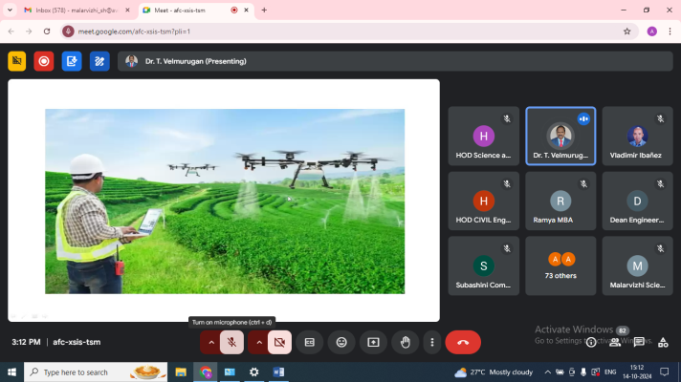

Key Takeaways from the Session:
- Practical Applications of AI in Sustainability
- Climate Modeling and Prediction
- Efficient Utilization of Renewable Energy

DAY 2: (15.10.2024 /Session I)
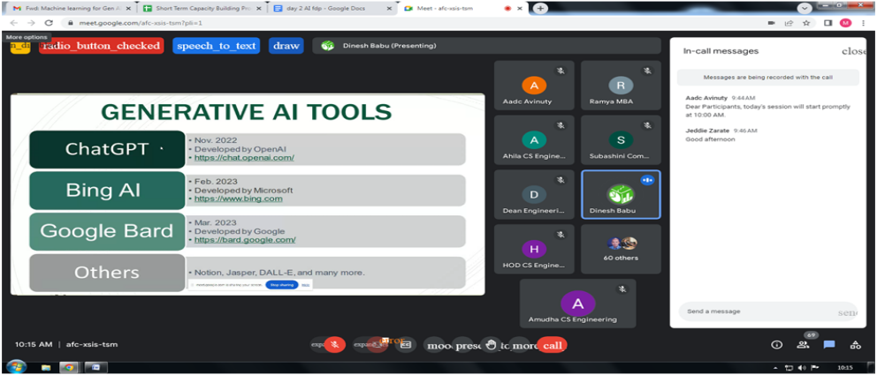

On the second day, the first session was conducted by Mr. R. Dinesh Babu, Managing Director of Brainswig Edutech Pvt. Ltd., Chennai, on the topic “Fundamentals of Generative AI and Responsible Generative AI.” He began by defining the basic concept of Generative AI, highlighting its economic potential, benefits, and practical applications.

Mr. Dinesh Babu explained in detail the steps involved in how Generative AI functions, using a real-time example to enhance understanding. He further elaborated on the capabilities, limitations, and ethical considerations of Generative AI, emphasizing its responsible use, particularly in classroom environments. Additionally, he introduced popular Generative AI tools such as ChatGPT, Bing AI, and Google Bard, offering insights into their functionalities.

He provided a comprehensive explanation of the working process of ChatGPT, strategies for building responsible Generative AI systems, and best practices for using AI responsibly within organizations. His presentation also covered the implementation of Generative AI with Large Language Models (LLMs) and the critical role of Natural Language Processing (NLP) in AI applications.

As a practical demonstration, Mr. Dinesh Babu showcased the use of Power BI to create interactive dashboards. He demonstrated how prompts can be used to visualize data, presenting an example of sales distribution across countries.

Key Takeaways from the Session:
- Fundamentals of Generative AI and Responsible Generative AI
- Overview of Generative AI tools and their limitations
- Practical demonstration of handling input data using tools like Power BI

DAY 2: (15.10.2024 /Session II)
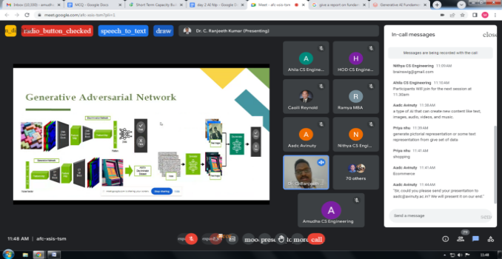

Dr. C. Ranjeeth Kumar, Professor, Department of CSE, Ashoka Women’s Engineering College, Kurnool, Andhra Pradesh, conducted the second session on “Machine Learning for Generative AI (GenAI).”
During his presentation, he provided an overview of GenAI, emphasizing its ability to generate new content in various forms, including text, images, audio, and code. He discussed the practical applications of GenAI, such as chatbots and virtual assistants, and elaborated on the process of training machine learning models for GenAI using supervised learning, unsupervised learning, and reinforcement learning, supported by illustrative examples.
Dr. Ranjeeth Kumar also highlighted the distinctions between GPT and ChatGPT, along with the different versions of ChatGPT. He delved into the two primary components of GenAI:
- Multi-head attention, which enables models to capture complex relationships and produce accurate and meaningful outputs such as text, images, or other content, and
- Self-attention mechanisms, which enhance the model's ability to focus on key elements within the input data, improving both accuracy and coherence.
The session concluded with an insightful discussion on the energy consumption, ethical considerations, and key challenges associated with the implementation of GenAI.
Key Takeaways:
- Machine Learning for GenAI
- Comparison of training data types and their quality
- Key components of GenAI: Multi-head attention

DAY 2: (15.10.2024 /Session III)
The third session, titled Generative AI – Cyber Security, was led by Dr. G. Ramsundar, Assistant Professor (Sl.Gr.), Department of Information Technology, Sri Ramakrishna Engineering College, Coimbatore.

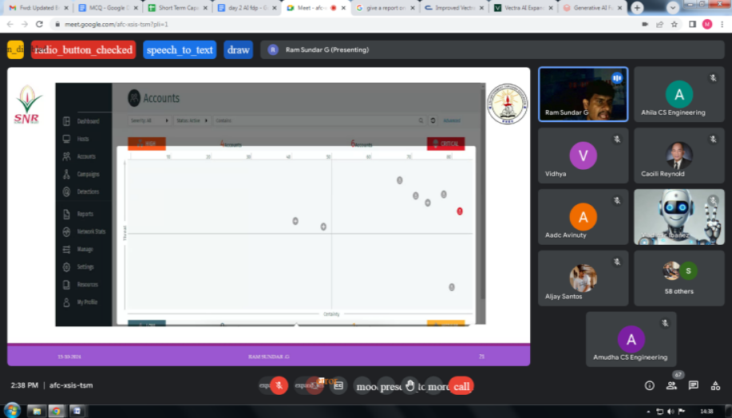

Dr. Ramsundar provided an in-depth explanation of cutting-edge AI tools, focusing on Microsoft Copilot and the Vectra AI platform, which introduces advanced threat detection and response capabilities to address generative AI threats. He detailed the operational steps of Vectra AI, including data collection, AI-driven analysis, real-time threat detection, and priority setting.

Highlighting its growing adoption, Dr. Ramsundar noted that over 40% of Vectra AI's identity clients have integrated Microsoft Copilot for M365 into their operations. He elaborated on how the Vectra AI platform supports Security Operation Centers (SOC) in safeguarding identities and preventing attackers from exploiting generative AI tools.

The session also shed light on the distinctions between Vectra AI and traditional security solutions. Dr. Ramsundar presented two key components of the Vectra Cognito platform—Cognito Recall and Cognito Detect—which play a vital role in post-event investigations and forensics. He emphasized how senior security analysts can utilize Cognito Recall to retrospectively identify threats using high-quality threat intelligence derived from third-party security alerts.

Additionally, he discussed the benefits of Vectra AI, including its speed, accuracy, scalability, and efficiency. A demonstration of the Darktrace tool followed, showcasing its significance in cybersecurity. Dr. Ramsundar demonstrated how network administrators could access comprehensive device protection insights through a single dashboard.

The session concluded with a compelling real-time case study on leveraging Vectra AI to combat ransomware within a business setting.

Key Takeaways:
- AI Tools: Microsoft Copilot
- Differences between Vectra AI and traditional security solutions
- Darktrace tool and its significance

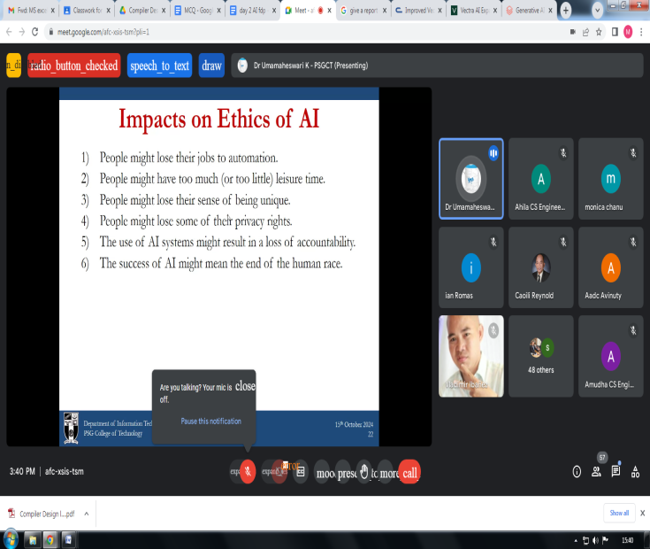
DAY 2: (15.10.2024 /Session IV)

The fourth session, titled Ethical Considerations in GenAI, was conducted by Dr. K. Uma Maheswari, Professor & Head of Information Technology, PSG College of Technology, Coimbatore.
Dr. Uma Maheswari provided an insightful overview of Generative AI models, including OpenAI, Google Gemini, and various versions of ChatGPT, while also addressing their limitations. She emphasized the principles of AI ethics, the significance of ethical decision-making in AI, and the associated risks and challenges.
The session highlighted best practices for using GenAI responsibly and explored its applications across different scenarios, underscoring the ethical guidelines that must be followed. Dr. Uma Maheswari delved into critical topics such as robotics legislation, safety considerations, and the ethical risks associated with technological advancements. She also elaborated on the various forms of ethics in computer science and technology.
Additionally, she addressed the societal impacts of automation, particularly focusing on employment displacement and privacy concerns, offering a well-rounded perspective on the ethical dilemmas posed by GenAI.

Key Takeaways:
- Ethical considerations in Generative AI
- Impacts of AI on ethics and society

DAY 3: (16.10.2024 /Session I)
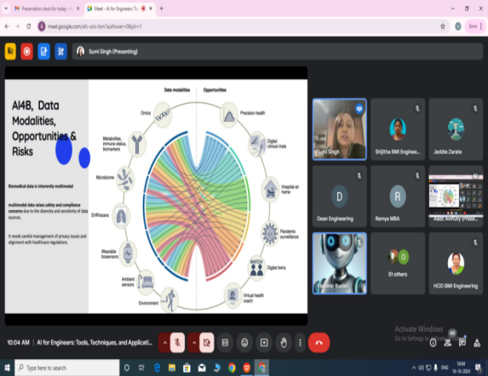

he third day commenced with a session led by Dr. Sumi Singh, Founder and Principal of Generative AI Labs, USA, which focused on designing machine learning systems for biomedical applications. Dr. Singh highlighted the importance of balancing innovation with safety and regulatory compliance. She discussed how to responsibly integrate AI into healthcare systems, ensuring technological advancements are paired with robust ethical and regulatory frameworks. The session concluded with an emphasis on AI's transformative potential in the biomedical field, particularly in research, diagnostics, and patient care. Dr. Singh also stressed the need for continuous monitoring and ethical considerations, including bias mitigation and user privacy protection, in AI deployment. This balanced approach between innovation and regulatory adherence is vital to integrating AI into healthcare systems while enhancing outcomes and preserving patient trust.
Takeaways from the session:
- Practical guidelines for designing AI systems that meet safety standards.
- Exploration of diverse AI applications in healthcare.

DAY 3: (16.10.2024 /Session II)


The second session, led by Mr. Varadharaj Krishnan, an Independent Researcher from Washington, USA, delved into the integration of Generative AI and Cybersecurity. The discussion provided a comprehensive analysis of the opportunities generative AI brings to cybersecurity, along with the increasing risks it introduces. With the rapid advancement of AI-driven cyber threats, Mr. Krishnan emphasized AI’s dual role: as both a potent tool for strengthening cybersecurity and a prime target for cybercriminals. He concluded by asserting that integrating generative AI into cybersecurity is no longer optional but essential in the face of evolving threats. Organizations that embrace these technologies will not only bolster their security frameworks but also enhance their ability to proactively counter emerging cyber risks.
Key Takeaways from the Session:
- Understanding how organizations can harness AI to strengthen their cybersecurity.
- Strategies for enhancing defenses and safeguarding against AI-driven cyber-attacks.

DAY 3: (16.10.2024 /Session III)


This session highlighted the powerful capabilities of MATLAB in developing AI applications, with a particular focus on biomedical engineering. Participants gained a comprehensive understanding of how MATLAB's AI tools are leveraged for biomedical signal processing, data simulation, model training, and system deployment, especially within the medical and healthcare sectors.
The session emphasized MATLAB’s robust support for biomedical engineering applications, offering a full spectrum of tools that span the entire AI pipeline, from data preparation to deployment. With its capabilities in machine learning and deep learning, MATLAB proves to be an invaluable asset for tackling complex challenges in both academic research and industrial settings.
Key Takeaways from the Session:
- Practical knowledge of implementing AI applications in healthcare using MATLAB.
- Understanding how MATLAB’s AI tools can address complex biomedical engineering challenges, from data processing to system deployment.


DAY 3: (16.10.2024 /Session IV)

In this session, Mr. Visweswaran J. introduced the rapidly advancing fields of Augmented Reality (AR), Virtual Reality (VR), and Mixed Reality (MR), collectively referred to as Immersive Technologies.
He discussed their growing integration across diverse industries, emphasizing their transformative potential in fields such as biomedical engineering and education. The session also highlighted the relevance of Industry 4.0 technologies and the pivotal role immersive technologies play in reshaping professional environments. Mr. Visweswaran showcased how immersive technologies, including VR, AR, MR, and XR, are revolutionizing industries by providing interactive, engaging, and immersive experiences. These technologies enable professionals and students to visualize complex processes and engage with digital content in innovative ways.
Key Takeaways from the Session:
- Application of immersive technologies in complex biomedical signal processing workflows and AI model training.
- Practical use of MATLAB’s AI tools in biomedical engineering scenarios.

DAY 3: (16.10.2024 /Session V)
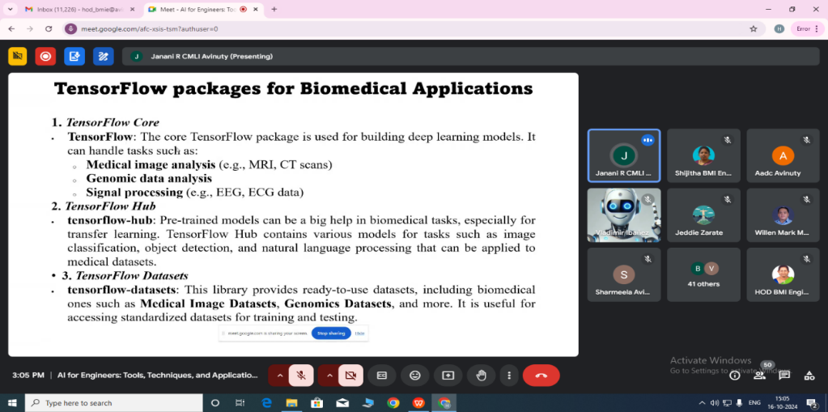

In this session, Ms. Janani delved into the use of open-source AI tools in the biomedical field, with a particular focus on how platforms like TensorFlow can be leveraged to address complex biomedical challenges. She discussed the advantages of open-source tools, highlighted the challenges faced by researchers, and provided practical insights into implementing these tools across a range of biomedical applications.
The session emphasized how open-source AI tools, especially TensorFlow, can be applied effectively to biomedical domains, from medical imaging to genomics. These tools provide scalable and adaptable solutions to tackle intricate problems, empowering researchers and healthcare professionals to develop cutting-edge AI models that drive progress in medical research and healthcare. Key features such as automatic differentiation, TPU support, and cross-platform deployment enable the creation of powerful models.
Key takeaways from the session:
- In-depth exploration of open-source AI tools
- Practical guidance on integrating these technologies into various biomedical fields

DAY 4: (16.10.2024 /Session I)


The session began with a brief introduction of the guest, Dr. N. Sathish Kumar, Professor, Department of ECE, Sri Ramakrishna Engineering College, Coimbatore. The first session, titled “AI-Based Technologies for Next-Generation Mobile Communication,” focused on the role of AI in the communication domain. Dr. Sathish Kumar provided an overview of mobile communication networks and discussed the penetration of AI across various sectors within this field. He highlighted that future research areas in next-generation mobile communication will include Terahertz communication, Photonics, and Visible communication, with AI-enabled 6G technology poised to revolutionize the communication landscape.
The key topics covered during the session included AI in network optimization and management, fault prediction within networks, resource utilization, and telecom maintenance. Dr. Sathish Kumar also explained the application of AI algorithms and models in communication systems, concluding with a discussion on AI’s transformative potential and the need for thoughtful development to enhance network systems. The session was followed by an engaging discussion with participants.
Key Takeaways from the Session:
- AI will dominate future communication channels.
- Detailed insights into AI and IoT integration in wireless data communication systems.

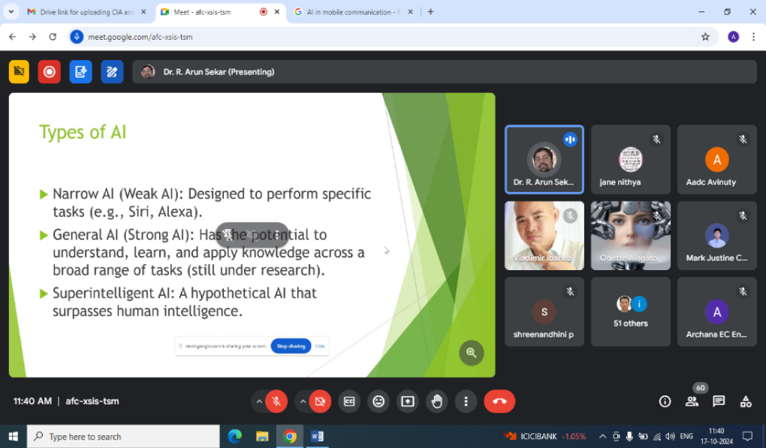
DAY 4: (16.10.2024 /Session II)

Dr. Arun Sekar Rajasekaran began the session by exploring the different types of Artificial Intelligence (AI) and its key components. The discussion then shifted to Blockchain technology, where the speaker covered its history, architecture, and overall block diagram in detail. Real-time Blockchain platforms and the potential applications that can be developed using them were highlighted. The integration of AI with Blockchain was examined, with emphasis on how it can enhance data security, improve efficiency, boost data analytics, support data integration, and prevent fraudulent transactions. The session concluded with a discussion on the real-world applications of AI-Blockchain integration and the future trends and potential development areas in this domain.
Key Takeaways from the Session:
- AI integration with Blockchain enhances data security.
- Future trends and potential development areas of AI-Blockchain integration were discussed.

DAY 4: (16.10.2024 /Session III& Session IV)

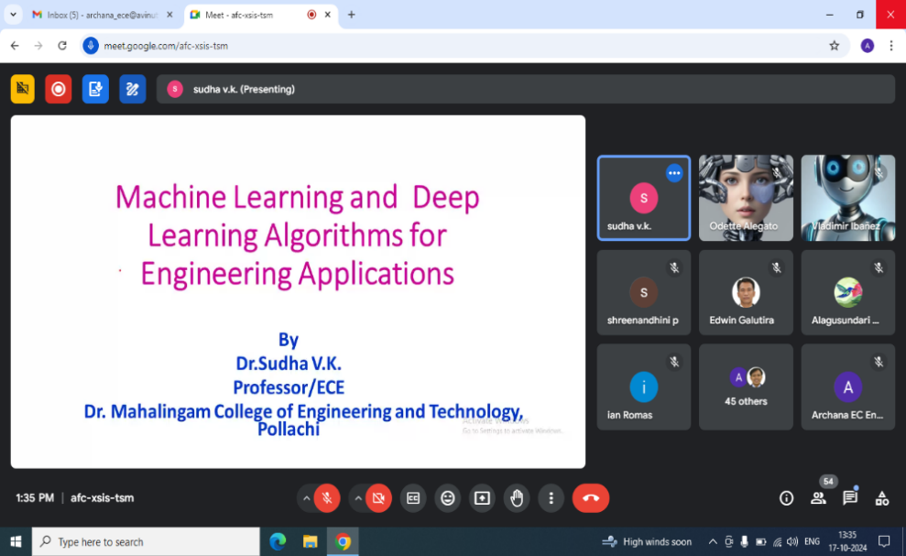
The third and fourth sessions were conducted by Dr. Sudha V.K., Professor, Department of ECE, Dr. Mahalingam College of Engineering and Technology, Coimbatore. The topic of the sessions was "Deep Learning and Machine Learning Algorithms for Engineering Applications."
Dr. Sudha began by introducing the fundamentals of Machine Learning and Deep Learning, emphasizing their key differences. She provided a clear and concise presentation on the various categories and classifications within Machine Learning, followed by an in-depth exploration of methods such as classification, regression, and clustering. She then proceeded to outline the Machine Learning workflow and demonstrated its wide-ranging applications using algorithms like linear regression, logistic regression, KNN, and SVM.
The latter part of the session focused on Artificial Neural Networks and Deep Learning algorithms. Dr. Sudha explained the operation of a single neuron and provided insights into various activation functions, including ReLU, Sigmoid, and others. The session also covered neural network models such as the perceptron and multi-layer perceptron.
Key Takeaways from the Session:
- Introduction to the fundamentals of Machine Learning and Deep Learning.
- In-depth analysis of Artificial Neural Networks and Deep Learning algorithms.

DAY 5: (18.10.2024 /Session I)

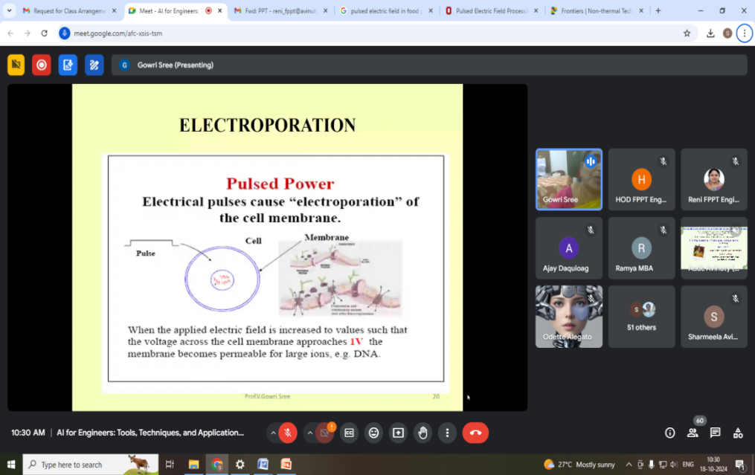

The first session of the fifth day was on “Novel Technologies in Food Preservation,” presented by Dr. V. Gowri Sree, Professor in the Division of High Voltage Engineering, Department of Electrical and Electronics Engineering, College of Engineering, Anna University, Chennai.

Dr. Gowri Sree began by discussing the importance of food quality, which is a critical concern in the food preservation process. He then introduced Pulsed Electric Field (PEF) processing, a novel food pasteurization technique that uses short bursts of high-voltage electric fields to achieve microbial inactivation or modification of food structure. PEF processing involves applying high voltage pulses (20–80 kV/cm) lasting milliseconds to microseconds to liquid foods placed between two electrodes. The electric field may be applied using various pulse types—exponentially decaying, square wave, bipolar, or oscillatory pulses—at ambient, sub-ambient, or slightly elevated temperatures. The pulses are applied at high repetition rates (up to 3,000 pulses per second) to ensure the entire food sample is treated.
Key takeaways from the session:
- Overview of food processing and preservation technologies.
- Advantages and disadvantages of PEF processing.

DAY 5: (18.10.2024 /Session II)

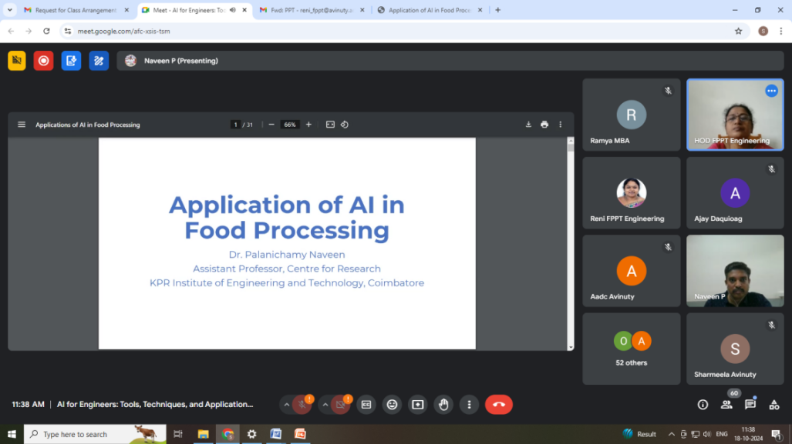

Dr. Naveen highlighted how Artificial Intelligence (AI) is revolutionizing various industries, and the food sector is no exception. AI is transforming the food industry by enhancing efficiency, creativity, and sustainability. It is a game-changer, improving customer service and food safety.

The speaker discussed various AI applications within the food industry, such as food production automation through robotics, which boosts efficiency, precision, and safety. AI helps streamline operations, increase productivity, improve product quality, and reduce labor costs. He also emphasized the importance of proper training to fully leverage these advancements.

Dr. Naveen explained how AI is shaping the future of food production, processing, and distribution, with AI-powered tools optimizing supply chains, enabling accurate demand forecasting, and reducing overproduction and underproduction. Moreover, AI has elevated food safety by detecting contaminants and offering personalized nutrition plans. The potential of AI and futuristic technologies in the food industry promises a more sustainable, healthier, and secure future.

Key Takeaways from the Session:
- Diverse applications of AI in the food industry
- Future trends and predictions for AI in food processing

DAY 5: (18.10.2024 /Session III)
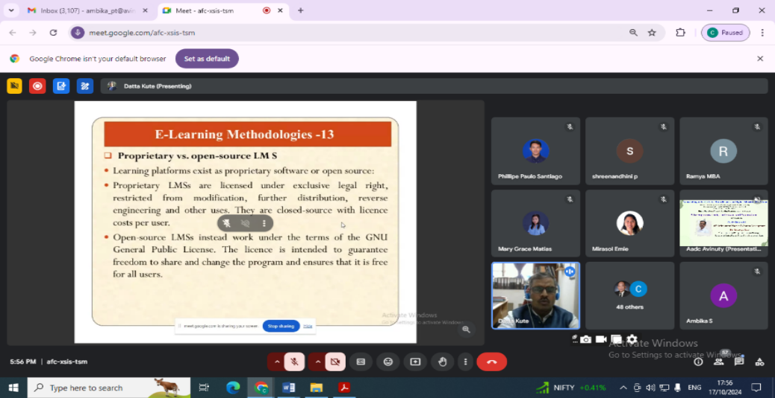

Presented by Dr. Dattatraya Kute, Chairman of the Printing Machinery Sectional Committee MED 25, Manager at University Press, and Officer on Special Duty at the Examination Department, Savitribai Phule Pune University, Pune.
This session delved into the transformative impact of technology-enabled learning, focusing on the National Mission on Education through ICT. Dr. Kute emphasized the objectives of the Educational Multimedia Research Centre and the evolution of e-learning methodologies. He discussed the future potential of Artificial Intelligence (AI) in shaping e-content development and highlighted its role in areas such as content creation, personalization, editing, optimization, data analysis, accessibility, interactive experiences, and content curation.
Dr. Kute concluded by stressing the continuous advancement of AI technology and the integration of AI in e-content development, which will likely lead to even more innovative and effective learning approaches.
Key Takeaways from the Session:
- Automation in e-learning through AI
- Delivering personalized education with AI
- Adaptive learning technologies
- Personalized content recommendations
- Enhancing learning outcomes with intelligent algorithms

DAY 5: (18.10.2024 /Session IV)
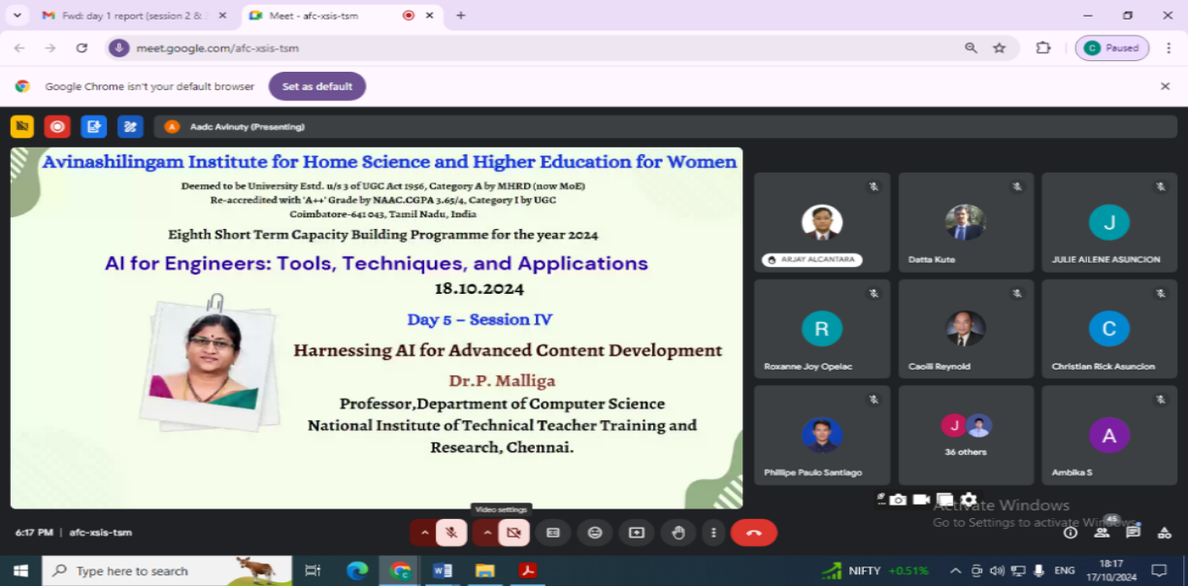
The final session of our 5-day online capacity-building program focused on “Harnessing AI for Advanced Content Development,” delivered by Dr. P. Malliga, Professor of CSE and Head of the Department of Educational Media and Technology at NITTTR, Chennai. Dr. Malliga provided a comprehensive overview of how AI can be leveraged in content development, emphasizing its applications in automated content generation, video production, image creation, and content optimization.
She showcased various practical AI tools such as Deep Dream, Adobe Sensei, Pebbley, Lumen5, and DALL-E, all of which enhance the creative process by automating repetitive tasks and assisting in idea generation, research, writing, editing, and content optimization. These tools enable content creators to produce high-quality work more quickly and efficiently. Additionally, she highlighted the importance of AI tools for improving grammar, style, and even fact-checking, thereby elevating the overall quality of content.
Dr. Malliga concluded the session with a crucial point: AI should not replace human creativity and judgment but should instead complement these qualities. The most effective outcomes will be achieved when AI is used as an augmentative tool to enhance the skills and expertise of content creators. With thoughtful integration and usage, AI can become a valuable ally in the pursuit of excellence in content creation.
Key Takeaways:
- Methods for developing e-content
- Tools for improving content development
- The impact of AI on creative writing

The program concluded with formal vote of thanks to the resource persons, participants and the organising committee for the successful conduct of the program.

Participants List
S.No. | Name | Designation | Department | Institution/ Organisation Name
1 | Mrs. Anasuya Mani MP | Assistant Professor | Pharmacology | Jain School of Allied Healthcare and Sciences
2 | Mrs. Sangeetha Gandhi S | Assistant Professor | Biotechnology | Rajalakshmi Engineering College
3 | Ms. Christy Jacqueline | Assistant Professor | Computer Science | Sacred Heart College
4 | Dr.K.L.Shunmuganathan | Dean | Information Technology | Rajalakshmi Engineering College
5 | Dr. Shobha Shankar | Professor | E&EE | Vidyavardhaka College of Engineering
6 | Dr. N Sandya Rani | Professor | CSE | Jaya Engineering College
7 | Mrs. Bhuvanapriya.S | Assistant Professor | CSE | Dhaanish Ahmed College of Engineering
8 | Ms. Minnuja Shelly | Assistant Professor | Computer Science and Engineering | Sahrdaya College Of Engineering & Technology Kodakara,Thrissur.
9 | Mrs. Sreedevi R Krishnan | Assistant Professor | Computer Science and Engineering | Adi Shankara Institute of Engineering and Technology
10 | Mrs.Meenalochini. M | Assistant Professor | Computer Science and Design | Kongu Engineering College
11 | Mrs. Amitha Mathew | Assistant Professor | CSE | Rajagiri School of Engineering and Technology
12 | Mrs.LISHA KURIAN | Research scholar | Computer Science Engineering | Avinashilingam University
13 | Ms. Dhakshu Sivan | Research Scholar | Computer Science and Engineering | Avinashilingham university
14 | Ms. Nimmi M K | Assistant Professor | Artificial Intelligence and Data Science | Muthoot Institute of Technology and Science
15 | Mrs. Archana Devi D | Lecturer | Electrical and Electronics Engineering | Mohamed Sathak Polytechnic College, Kilakarai
16 | Mrs.Nighila Ashok K | Assistant Professor | CSE | Universal Engineering College
17 | Mrs.Jasmy Davies | Assistant professor | Computer science and engineering | Sahrdaya college of engineering and technology
18 | Mr. M.Manoj Kumar | Teaching Assistant | DDU-KK (B.Voc - Farm Equipments Operation & Maintenance) | The Gandhigram Rural Institute (Deemed to be University), Gandhigram.
19 | Mrs. Mahalakshmi | Research Scholar | Biomedical Instrumentation Engineering | Avinashilingam Institute for Home Science and Higher Education for Women
20 | Mrs. K PRIYA | Research Scholar | Computer Science | Annai College of Arts & Science, Kovilacheri
21 | Mrs. Hemalatha | Research Scholar | Computer Science | Annai College of arts and science, kovilacherry
22 | Mrs. Seethala Devi V | PhD Research Scholar | Computer Science | Annai College of Arts and Science
23 | Mrs.Madhura Mahajan | Research Scholar | Printing Technology | Avinashilingam University
24 | Ms. Sheethal M S | Research Scholar | Computer Science and Engineering | Avinashilingam Institute for Home Science and Higher Education for Women
25 | Dr. Naneetha R | Assistant Professor | Journalism and Mass Communication | SRM University
26 | Ms. Ayshwarya P | Ph.d Research Scholar | Computer Science | Annai College of Arts & Science
27 | Mrs. Swati Dutt | Scholar | Printing Technology | Avinashilingam Institute for Home Science & Higher Education
28 | Mrs.S. Shanmugapriya | Assistant Professor | Artificial Intelligence and Data science | Nehru Institute of Engineering and Technology
29 | Mrs.Alagusundari | Assistant Professor | Computer Science and Engineering | Sri RamaKrishna Engineering College
30 | Mrs.Arthi D | Assistant Professor | Artificial Intelligence and Data Science | KCG College of Technology
31 | Dr.N.Nandakumar | Professor | Mechanical Engineering | Government College of Technology
32 | Mrs.S. Bhuvaneswari | Safety officer | Printing Technology | SCM garments pvt ltd
33 | Ms. Jencia.J | Assistant Professor | Biomedical Engineering | Karunya Institute of Technology and Sciences
34 | Mrs. Hepsiba D | Assistant Professor | Biomedical Engineering | Karunya Institute of Technology and Sciences
35 | Ms. Shree Nandhini.p | Assistant Professor | Emerging Technologies | Sree Sakthi Engineering College
36 | Ms.J.Paruvathavardhini | Research Scholar | Electronics and Communication Engineering | School of Engineering, Avinashilingam University
37 | Ms. K Santhiya Lakshmi | Research scholar | ECE | Avinashi lingam engineering campus
38 | Ms. Vijitha G | Asst.Professor | Electronics and Communication | Jawaharlal college of engineering and technology
39 | Mrs. S.Nandhini | Research scholar | Civil Engineering Department | Avinashilingam institute for Home Science and Higher Education for women
40 | Mrs. Minarva Devi | Assistant professor | ECE | Sri Raaja Raajan College of Engineering and Technology
41 | Ms. Khumukcham Monica Chanu | Research scholar | Electronics and Communication Engineering | Manipur Institute of Technology
42 | Mrs.V.Devi | Assistant Professor | Artificial Intelligence and Machine Learning | Hindusthan College of Engineering and Technology
43 | Mrs.Blessy Rapheal M | Associate professor | ECE | Rajadhani Institute of science and Technology
44 | Mrs.J.karpagam | Research scholar | Civil engineering | Avinashilingam school of engineering
45 | Ms. Suja Paulose | Research Scholar | Electronics and Communication Engineering | Avinashilingam institute of Home Science and Higher Education for Women Coimbatore
46 | Mrs.Gokilavani A | Associate Professor | CSE | Jai Shriram Engineering College
47 | Mrs.Vanitha.G | Assistant Profrssor | CSE | SNS College of Technology
48 | Mrs.Anju Aravind | Part time Research Scholar | ECE | Avinashilingum Institute for Home Science and Higher Education for Women
49 | Ms. Sharmeela R | Assistant professor | FPPT | Avinashilingam institute
50 | Ms. Muneebahmdhyiddeen | Research Scholar | Computer Science and Engineering | Avinashilingam Institute for home science and higher education for women
51 | Mr. S. Sunilkumar | Software Developer | Computer Science | Kittle Pvt. Ltd
52 | Ms. K.Jane Nithya | Assistant Professor | Computer Science | Ethiraj College for Women
53 | Mrs. C. T.Vidhya | Assistant Professor | CSE | Avinashilingam Institute for Home Science and Higher Education for Women
54 | Mrs. C. Janani | Assistant Professor | CSE | Avinashilingam Institute for Home Science and Higher Education for Women
55 | Mrs.Nimmi Vijayan | Ph.D Scholar | Electronics and Communication Engineering | Avinashilingam Institute for Home Science and Higher Education for Women
56 | Ms.Winnie Ann Thomas | Assistant Professor | Electronics & Biomedical Engineering | Adi Shankara Institute of Engineering & Technology
57 | Mrs.J.Rama | Research Scholar | Computer science | Annai college of arts and science
58 | Mrs G. Gokilavani | Teaching Assistant | CSE | Avinashilingam Institute for Home Science and Higher Education for Women
59 | Engr. Abegail E. Ruiz | Assistant Professor | Electronics Engineering | Mariano Marcos State University, Philippines.
60 | Engr. Christian Philip M. Austria | Instructor | Electronics Engineering | Mariano Marcos State University, Philippines.
61 | Engr. Lovina Sciechrist T. Agbayani | Instructor | Computer Engineering | Mariano Marcos State University, Philippines.
62 | Garcia, Julie Ailene A. | Instructor | Electronics Engineering | Mariano Marcos State University, Philippines.
63 | Engr. Meynard C. Nicolas | Instructor | Electronics Engineering | Mariano Marcos State University, Philippines.
64 | Engr. Maria Fregie Gaile R. Pagador | Instructor | Electronics Engineering | Mariano Marcos State University, Philippines.
65 | Engr. Ajay A. Daquioag | Instructor | Computer Engineering | Mariano Marcos State University, Philippines.
66 | Engr. Willen Mark D. Manzanas | Program Chair, PSMREE | Computer Engineering | Mariano Marcos State University, Philippines.
67 | Engr. Aljay B. Santos | Assistant Professor | Computer Engineering | Mariano Marcos State University, Philippines.
68 | Engr. Diana Rose A.Tambogon | Instructor | Computer Engineering | Mariano Marcos State University, Philippines.
69 | Engr. Vladimir P. Ibanez | Department Chairman, CpE | Computer Engineering | Mariano Marcos State University, Philippines.
70 | Engr. Engelbert T. Carino | Instructor | Computer Engineering | Mariano Marcos State University, Philippines.
71 | Dr.Sharona Q. Barroga | Dean, College of Engineering | Chemical Engineering | Mariano Marcos State University, Philippines.
72 | Engr. Phillipe Paulo B. Santiago | Instructor | Computer Engineering | Mariano Marcos State University, Philippines.
73 | Engr. Alennie M. Fagaragan | Instructor  Department Chairman | Agricultural and Biosystems Engineering | Mariano Marcos State University, Philippines.
74 | Dr. Reynold M. Caoili | Instructor | Agricultural and Biosystems Engineering | Mariano Marcos State University, Philippines.
75 | Engr.Edwin F.Galutira | Instructor | Computer Engineering | Mariano Marcos State University, Philippines.
76 | Engr. Ashier Dave M Calulot | Instructor | Mechanical Engineering | Mariano Marcos State University, Philippines.
77 | Engr. Roxanne Joy O. Antonio | Instructor | Agricultural and Biosystems Engineering | Mariano Marcos State University, Philippines.
78 | Dr. Bethany Grace S. Calixto | Associate Professor | Agricultural and Biosystems Engineering | Mariano Marcos State University, Philippines.
79 | Engr. Arjay C Alcantara | Instructor | Mechanical Engineering | Mariano Marcos State University, Philippines.
80 | Engr. Peter Joenel A.Pelayo | Instructor | Mechanical Engineering | Mariano Marcos State University, Philippines.
81 | Ruguian, Arlene Mia G. | Department Chair | Materials Science and Engineering | Mariano Marcos State University, Philippines.
82 | Engr. Odette R. Alegato | Department Chair | Mechanical Engineering | Mariano Marcos State University, Philippines.
83 | Engr. Ian V. Romas | Instructor | Mechanical Engineering | Mariano Marcos State University, Philippines.
84 | Mary Grace D.Matias | Instructor | Computer Engineering | Mariano Marcos State University, Philippines.
85 | Mark Justine S.Cudapas | Instructor | Computer Engineering | Mariano Marcos State University, Philippines.
86 | Engr. Rafael C. Domingo | Instructor | Mechanical Engineering | Mariano Marcos State University, Philippines.
87 | Engr. Marifaye Flores | Instructor | Computer Engineering | Mariano Marcos State University, Philippines.
88 | Engr. Christian Rick C. Asuncion | Instructor | Computer Engineering | Mariano Marcos State University, Philippines.
89 | Engr. Kendrick Cyrus A. Acidera | Instructor | Mechanical Engineering | Mariano Marcos State University, Philippines.
90 | Dr. Cristina S. Decano-Valentin | Associate Professor | Agricultural and Biosystems Engineering | Mariano Marcos State University, Philippines.
91 | Engr. Neal Janus R. Pacis | Instructor | Mechanical Engineering | Mariano Marcos State University, Philippines.
92 | Engr. Jan Leiton S. Palaspas. | Instructor | Mechanical Engineering | Mariano Marcos State University, Philippines.
93 | Engr. Joseph Allan S. Gamiao | Instructor | Ceramic Engineering | Mariano Marcos State University, Philippines.
94 | Engr. Shaira Camille M. Santos | Instructor | Agricultural and Biosystems Engineering | Mariano Marcos State University, Philippines.
95 | Engr. Louvie John M. Ruguian | Instructor | Ceramic Engineering | Mariano Marcos State University, Philippines.
96 | Engr. Emie S. Mirasol | Associate Professor III | Ceramic Engineering | Mariano Marcos State University, Philippines.

Sample Certificate

