A report on the Workshop on Advanced in Artificial Intelligence for Social
Sciences Research Level II Workshop

Date: 16th - 20th April, 2024

School of Arts Humanities and Social Sciences Hall, Chhatrapati Shahu Ji Maharaj University, Kanpur

ORGANISED BY

Association of Indian Universities, Chhatrapati Shahuji Maharaj University, Academic and Administrative Development Center sponsored by the Association of Indian Universities

(AIU-CSJMU-AADC)

16/04/2024,

Time- 10:30 am to 12:30 pm

Opening ceremony/ Inaugural Session:

A workshop was conducted on Tuesday at Chhatrapati Shahu Ji Maharaj University, Kanpur. The topic of which was ‘‘Artificial Intelligence for Social Science Level II workshop’’. The goal of the workshop was to give attendees an understanding of the many ways that artificial intelligence (AI) is being applied in many disciplines by examining its sociological, legal, intellectual, and cultural aspects. The seminars will focus on data visualisation, sophisticated AI tools, and the possible effects of AI on humanities, with a particular emphasis on how AI may influence future professions and society.

This workshop was inaugurated by Dr. Brishti Mitra, Dean Academics and Dr. Anuradha Kalani, Dean Research and Development CSJMU, Kanpur. Director of School of Arts Humanities and Social Sciences Dr. Kiran Jha, Assistant Prof. Dr. Anshu Singh, Dr. Mayuri Singh, Assistant Prof. Dr. Pooja Singh and other teachers and students of the department were present in the program. Dr. Brishti Mitra noted that these kinds of programmes have gained popularity in the science and engineering fields, but to talk about AI and advanced technologies in a social science department is an exceptional feat. She urged students to take advantage of this opportunity and learn as much as possible about the new technologies. Dr. Anshu Singh in her welcoming speech pointed out the importance of such programmes. She also informed the audience that all programmes of School of Arts, Humanities and Social Sciences at CSJMU, Kanpur now have a paper of advanced technologies which may be opted by the students. She also talked about the new diploma course in Digital Humanities being offered for the students.
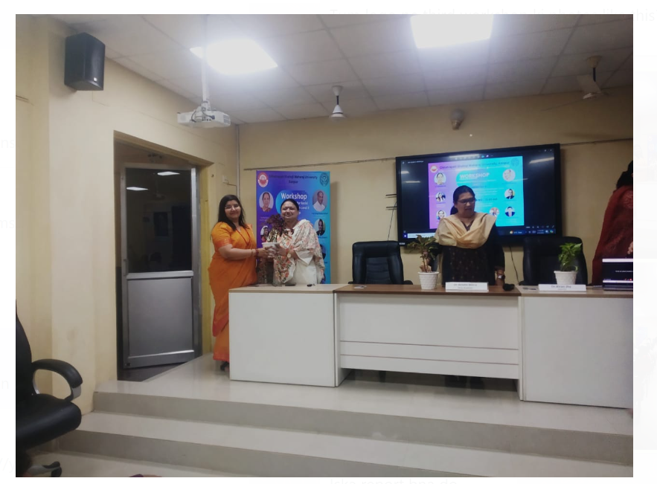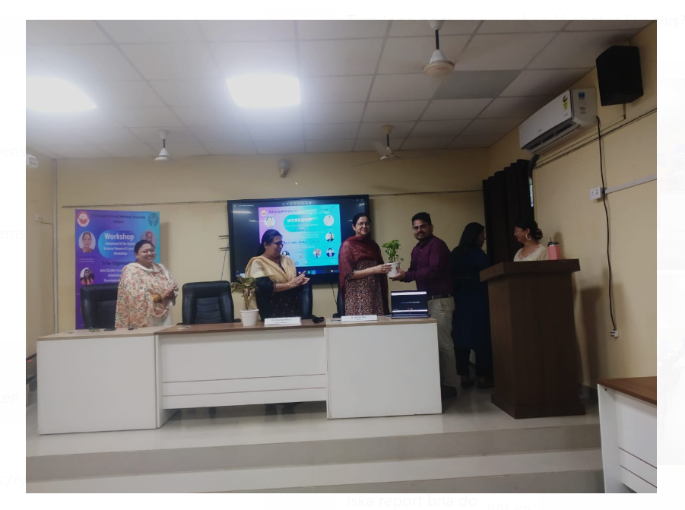

Session 2: 1:30 pm - 3.30 pm
Advanced AI Tools and Data Visualization Speaker: Amritanshu Pandey, Brhat

Dr. Amritantanshu Pandey gave an overview of cutting-edge artificial intelligence techniques Data visualization's significance in AI Practical workshop on utilizing AI tools for data visualization. Students indulged in real time practice of AI tools where they focused on the reception of prompts. Students asked specific questions related to their fields of interest where they tried to use art as an expression of their disciplinary backgrounds.

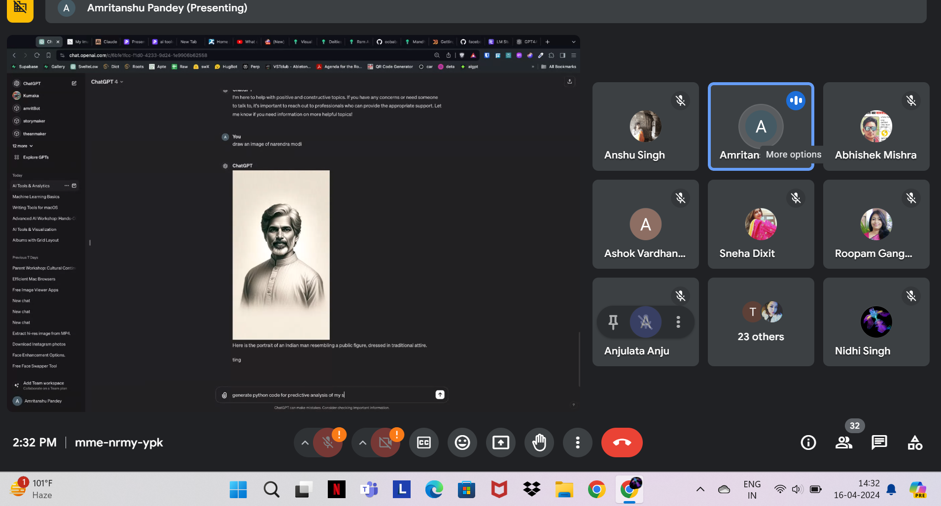

DAY 2: 17th April, 2024
Session 3: 10:30 AM to 12.30 PM
Culture and AI, Culture Mapping, and Digital Humanities Speaker: Dr. Anurag Shukla, Brhat
Dr. Anurag Shukla, has discussed the relationship between AI and culture Methodologies and techniques for AI-assisted culture mapping, Artificial Intelligence in Digital Humanities. He talked about various tools that are currently in use like Pixler, Freepik, and Gencraft. He mentioned that the production of art is a subjective process where the people can use their perspectives on various types of cultural ideas and turn them into art or writing. Dr. Anurag was dedicated to the cultural production of stories, symbols, and various other artefacts related to the local ideas of Indian roots.

Session 4: 1:30 PM to 3.30 PM
Academic Writing in Humanities Speaker: Dr. Anshu Singh, CSJMU

Dr. Anshu Singh, CSJMU discussed AI tools for improving humanities study and writing, AI integration in academic writing, Some pointers for efficient academic writing in the modern digital world. Students had hands-on practice and learnt LATEX for their academic writings. All the participants used latex with the instructions. All students were asked to share their respective screens so that the trainer might be able to see their progress. All the students were informed that they need to produce a LATEX document about their work progress in the workshop as the final assignment for their final assessment.
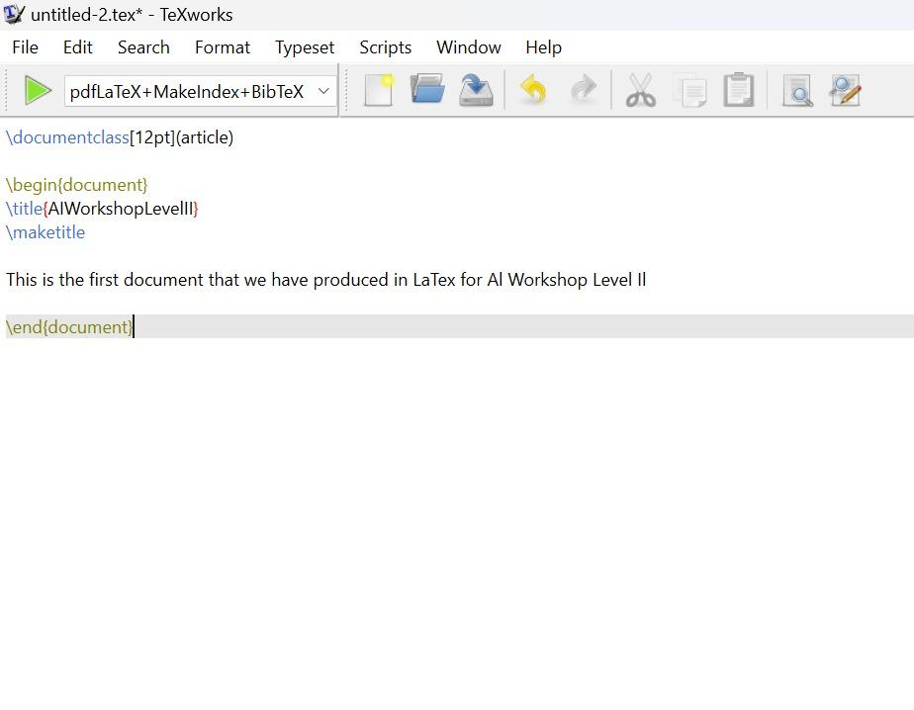
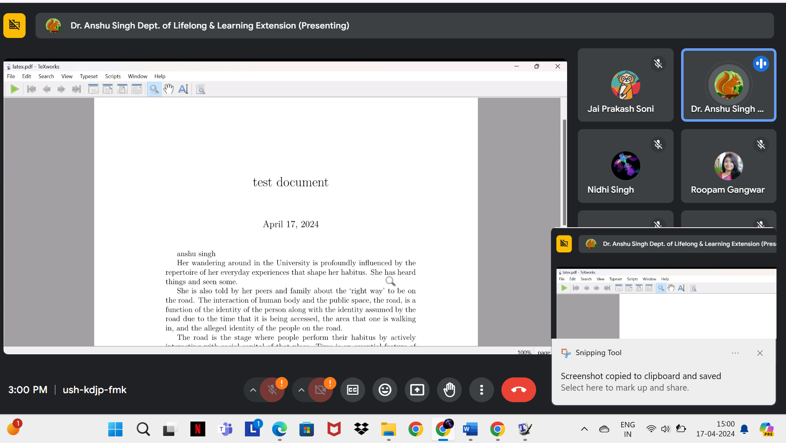

DAY 3: 18th April, 2024
Session 5: 10:30 AM to 12:30 PM
Artificial Intelligence and Sociological Thinking in the Digital Age
Speaker: Mayurakshi Chaudhari, FLAME UNIVERSITY

AI has the capacity to make already-existing societal injustices worse. Algorithms frequently reproduce the prejudices found in the data that they are trained on, producing biassed results in regards to loan approvals, hiring practices, and law enforcement. Sociologists are studying the ways in which these prejudices appear and the steps that might be taken to lessen them. Important considerations in this regard are algorithmic bias and equity and access.

Session 6:
SPECIAL LECTURE: 04:00 PM
Adapting to Change: Navigating Career Opportunities in the AI Landscape

Speaker: Dr. Jyothi Kumar, Program Coordinator for a Ph.D. training program funded by the National Science Foundation (NSF) at Michigan State University.

Dr. Jyothi Kumar, Program Coordinator for a Ph.D. training program funded by the National Science Foundation (NSF) at Michigan State University, has described the most recent developments in vocations relating to AI, perceptions on how artificial intelligence will develop in business and academics, Advice on how to get ready for a profession in artificial intelligence.
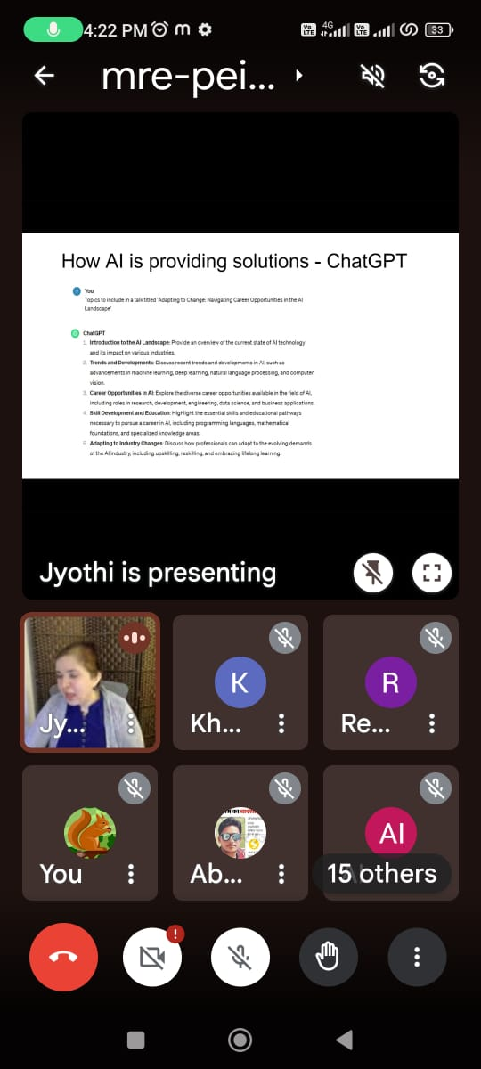

DAY 4: 19th April, 2024

Session 7: 10:30 AM to 12:30 PM
AI for Bharat: Unpacking what AI means for India through a systems perspective
Speaker: Titiksha Vashist, Pranava Institute

Titiksha Vashist, Pranava Institute has discussed What Is AI? How can we interpret the excitement and promise surrounding this new technology? Considering India's development trajectory in particular, what are the potential and problems presented by AI systems? How can we use this technology to further our careers and create new fields such as AI for Indian languages and Indigenous AI?

Session 8: 1:30 PM to 3:30 PM

AI for Social Impact Speaker: Nirmal Patel, PLAYPOWER LABS
Nirmal Patel, PLAYPOWER LABS, Talked about how AI can be used to address societal issues, Exhibition of social impact AI projects and activities, Techniques for utilising AI to bring about constructive social change. He talked about his experience as a social activist who works in the spaces where only the internet has its reach. This has helped him immensely in designing his programmes through AI for the good of people.
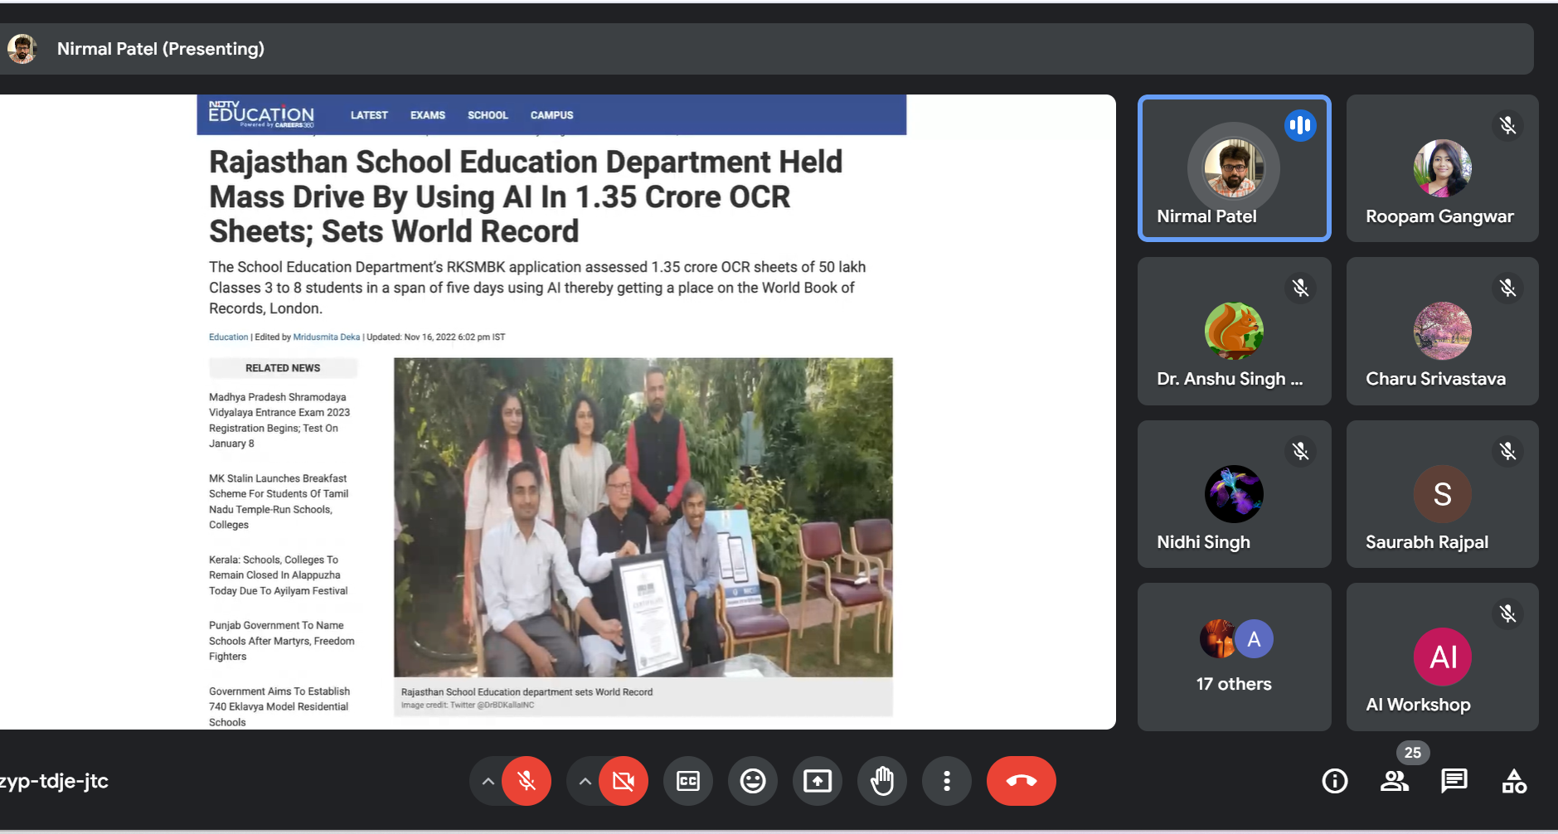

Session 9: Valedictory Session.
As an assessment assignment all the participants were asked to prepare a LATEX document on their feedback for the whole workshop. This assignment along with daily assessment forms were formed as a basis for the certification of the participants: a sample of the document is attached below.
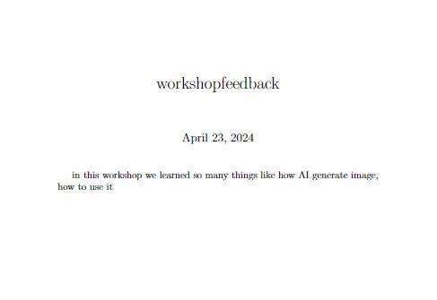
Networking and Valedictory Session: After the training, there was a networking session where attendees connect with one another and the speakers, ask questions, and engage in conversation. The Valedictory session was attended by Dean Research and Development, Dr. Anuradha Kalani, Dr. Soni Gupta (SAAST), Ms. Mayuri Singh (ABVSLS), Mr. Sushant Gangoli (Braht), Dr. Anurag Shukla (Braht), Dr. Anshu Singh (AIU-CSJMU-AADC), along with all the participants, and scholars. It was a very intense session where participants shared their experience of the workshop. Participants were mesmerised by the background of the speakers who came from different academic backgrounds to inform them about the utility of the advanced technologies in various disciplines of Social Sciences.
Participants talked in detail about the new things that they have learnt, they were especially in praise for the learning about new tools and techniques. A formal vote of thanks was delivered by the Dean Research and Development for the team who managed the whole programme. Dr. Anshu Singh gave a brief overview of the workshop, she thanked the participants, and AIU for their constant support throughout the programme.
