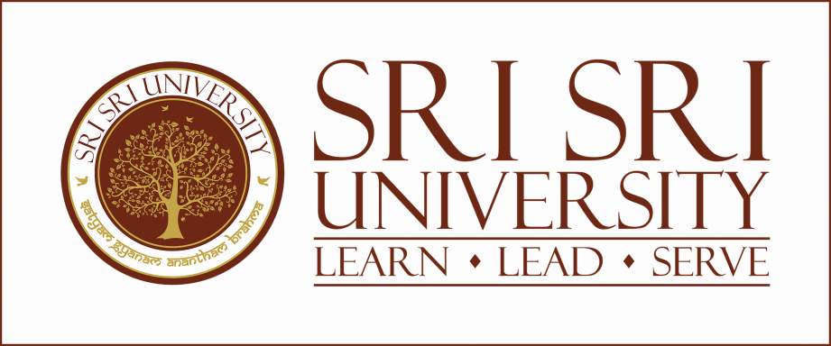
AIU-SSU-AADC Report
30 March, 2024
- Inauguration of SSU-AADC at Sri Sri University, Cuttack, Odisha
On the 9th of November 2023, a significant milestone was achieved as Sri Sri University (SSU), located in Cuttack, Odisha, entered into a Memorandum of Understanding (MoU) with the Association of Indian Universities (AIU) to establish the AIU Academic and Administrative Development Centre (AIU-AADC) on its campus. This event marked a notable collaboration between SSU and AIU, solidifying their commitment to advancing academic and administrative excellence in the higher education sector.

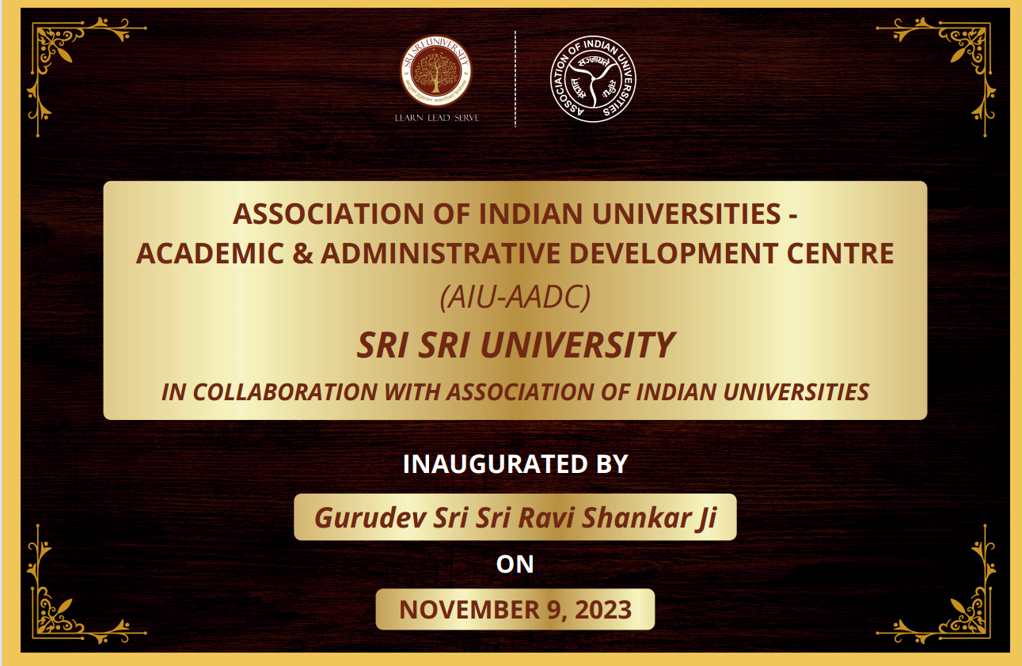

The AIU, established in 1925, holds the distinction of being the second oldest university association globally. With 921 member institutions in India, including 14 foreign universities, AIU serves as an apex inter-university representative body. The newly inaugurated AIU-AADC at SSU is a testament to the commitment of both institutions to continuous capacity building and the integration of technology in higher education.
The objectives of Association of Indian Universities – Sri Sri University – Academic and Administrative Development Centre, (AIU-SSU-AADC) align with the evolving landscape of higher education. The center aims to provide faculty members with continuous knowledge and skill enhancement, enabling them to navigate the dynamic higher education environment effectively. Additionally, AIU-AADC seeks to equip administrative staff with the necessary skills to adapt to emerging information technologies. The center will also play a crucial role in preparing library professionals and technical staff to meet global demands and local needs in research and knowledge resources. Importantly, it will introduce research scholars to the principles of academic integrity and professional ethics.
The inauguration of AIU-AADC at SSU was a momentous occasion attended by dignitaries from AIU, including Dr. Amarendra Pani, Joint Director, Dr. Rama Devi Pani, Deputy Director, and Dr. Usha Rai Negi, Assistant Director. The ceremony was graced by the presence of Gurudev Sri Sri Ravi Shankar, who officially inaugurated the center. Despite the physical distance, AIU dignitaries participated in the event online.

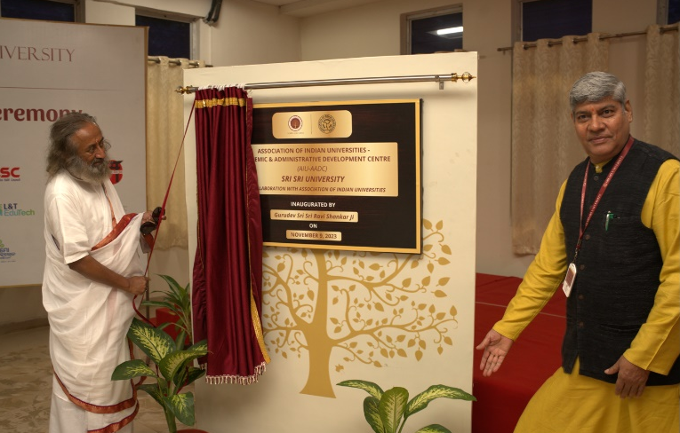

This collaboration marks a prestigious step for Sri Sri University, reflecting its commitment to offering a unique and holistic education that combines the best of both Eastern wisdom and Western innovation. The establishment of AIU-AADC at SSU signifies a shared vision to foster academic growth, technological advancement, and ethical values in higher education. Dr. Vijaya Lakshmi Mohanty is working as a Director-AADC at SSU.
About Sri Sri University, Cuttack, Odisha

Sri Sri University is enacted by Government of Odisha under Sri Sri University Act, 2009.It has started its academic year 2012 and is emerging as a centre for premium education in India, aimed at blending the “Best of East & West”. This University is uniquely placed in offering education that combines Western innovation with the Eastern values and wisdom. The University has approximately 2000 students from 28 states of India and 7 countries of the world in 43 courses and nine streams. The three pillars on which the edifice of Sri Sri Sri University is built is learn, lead and serve. Founded by world renowned Humanitarian and Spiritual Leader Gurudev Sri Sri Ravi Shankar, the University vouches for uplifting moral values among its students.
The mission of the University is to create centres of excellence in knowledge and research across the fields of study in order to equip students to achieve the highest levels of professional ability in a smoke-free, alcohol-free, vegetarian campus. It fosters human values to serve the needs of local, national and global economies.
Sri Sri University, Cuttack, Odisha, India has been awarded for its unique Campus and Academic Excellence. Some of the recent recognitions and awards are as follows:
- Accredited with NAAC ‘A’ in 2023.
- Times Higher Education Impact Ranking (601-800) in 2022.
- Times Higher Education Impact Ranking (801-1000) in 2021.
- Rank 1st in Odisha, 7th in India & 304th in the World in UI Green Metric World University rankings 2020.
- Listed in TOP 25 young University list by Outlook-ICARE India University Ranking

- Administrative Development Programmme (ADP) on Smart Office Automation with Integration of Excel with Mysql
Date: 5-11 February, 2024
Programme code: AIU/SSU/AADC/2023-24/01
Number of Participants: 56

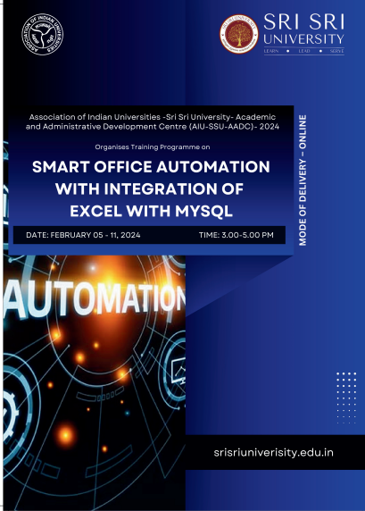
Smart Office Automation with Integration of Excel with Mysql- The online ADP promises to empower the teaching faculty, researchers and administrative staff of HEIs with the latest tools, techniques, and insights that transcend traditional research boundaries. The ADP aims to provide participants a comprehensive understanding of advanced techniques on Smart Office Automation with Integration of Excel with Mysql. The ADP will be facilitated by experts in the said domains and participants receive personalized guidance and mentorship throughout the programme.
Programme will start on 5th February 2024 and will end on 11th February 2024. Dr. Sudhir Kumar Mohapatra, Director, IQAC, Sri Sri University is scheduled to impart the training who is an accomplished trainer in the field.

Sri Sri University is pleased to announce a significant opportunity for Higher Education Institutions worldwide. An online Administrative Development Program (ADP) focusing on 'Smart Office Automation with Integration of Excel and MySQL' is scheduled from 5th to 11th February 2024. The training sessions will be conducted from 3 pm to 5 pm online. This program is designed to empower faculty members, researchers, and administrative functionaries of Higher Education Institutions (HEIs) with cutting-edge tools, techniques, and insights that go beyond traditional research boundaries.

On the inaugural day of the online program, Prof. Mrs. Rajita Kulkarni, President, Sri Sri University, thanked AIU for considering the University to establish AIU-AADC which is privileged to be one of the 10 selected centers. Prof. B. R. Sharma, Vice-Chancellor, commended the initiative of the team members of SSU and AIU and congratulated the Center. Dr. Amarendra Pani, Joint Director of the Association of Indian Universities, emphasized the importance of technology in the proposed programs for both teaching and non-teaching faculty of HEIs. He expressed his pleasure over the commitment shown by Sri Sri University to best utilise the opportunity for strengthening HEIs of India. Dr. Vijaya Lakshmi Mohanty, Director of HRDC and Nodal Officer of AIU-SSU-AADC, provided detailed insights into the centre’s plans. Dr. Deepa Vinay, Executive Registrar, and Swami Satya Chaitanya, Director of Operations, Sri Sri University spoke about the importance of the center and the tech-based programme that it will offer.
The ADP aims to offer participants a comprehensive understanding of advanced techniques in Smart Office Automation with the Integration of Excel and MySQL. It will be facilitated by experts in the field, providing personalized guidance and mentorship throughout the program. The program is a joint certification from the Association of Indian Universities and Sri Sri University. 56 participants have enrolled the Programme.
This initiative promises to empower faculty members, researchers, and administrative functionaries of Higher Education Institutions with the latest tools, techniques, and insights that transcend traditional research boundaries. The program will cover topics such as creating and maintaining databases, tables, and SQL, conceptualizing and implementing MySQL courses, importing, updating, and deleting records from tables (MYSQL), analysing relational and logical operators, applying operators to data, and using string matching with the like operator in SQL (MYSQL). The program targets faculty members, researchers, and administrative functionaries of Higher Education Institutions.
The organizing committee includes patrons viz., Prof. Pankaj Mittal, Secretary General, Association of Indian Universities, New Delhi. The inauguration was attended by Dr. Usha Rai Negi, Assistant Director, Research, AIU, Ms. Sonali Das, Coordinator- PR, and Mr. Kapil Rajwani, Technical Officer, SSU among others.

- Faculty Development Programme on Translation Studies from Global South
Date: 19 February 2024 – 5 March, 2024
Programme code: AIU/SSU/AADC/2023-24/01
Number of Participants: 125

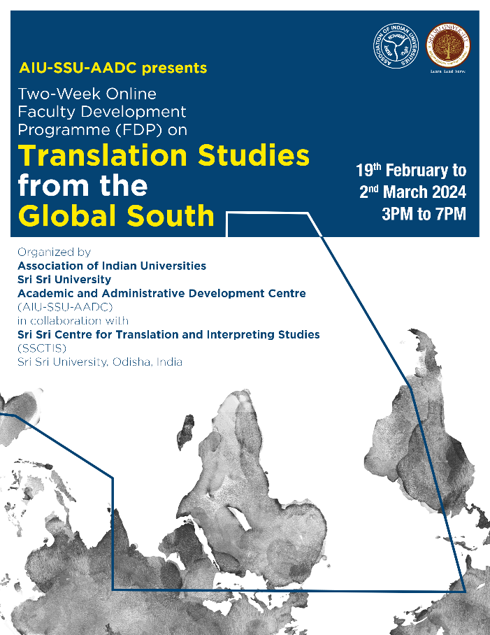
Association of Indian Universities–Sri Sri University–Academic and Administrative Development Centre (AIU-SSU-AADC) in Collaboration with Sri Sri Centre for Translation and Interpreting Studies conducted a two-week Faculty Development Programme titled, “Translation Studies from the Global South” from 19th February to 5th March 2024.
The Association of Indian Universities–Sri Sri University–Academic and Administrative Development Centre (AIU-SSU-AADC) in collaboration with Sri Sri Centre for Translation and Interpreting Studies conducted a two-week Faculty Development Programme titled, “Translation Studies from the Global South” from 19th February to 5th March 2024. The FDP proved to be a great success with the presence of 125 participants from India and abroad.
The event commenced with the welcoming remarks delivered by Dr Vijaya Lakshmi Mohanty, Director of SSU HRDC and Nodal Officer of AIU-SSU-AADC, where she outlined the detailed concept note of the programme stressing on the role of AIU-SSU-AADC in empowering faculties across India with cutting edge research. Dr. Pankaj Mittal, Secretary General, Association of Indian Universities elaborated on the different collaborations with wide range of universities, State, Central, Private, Open, Deemed to be and Institute of National Importance as well as universities outside India, thereby becoming the largest association of universities in the world. Prof. Rajita Kulkarni, President of Sri Sri University emphasized on the importance of Translation and Interpretation in a plurilingual country thereby opening the first interpreting studies centre in India. Prof. B.R. Sharma, Vice Chancellor underlined on the importance of understanding culture in the act of translation. Dr. Deepa Vinay, Executive Registrar outlined the significance of technology in the translation industry. Dr. Rindon Kundu, Director of Sri Sri Centre for Translation and Interpreting Studies, explained the significance of organising this FDP by underlining the need to decolonize the field of translation studies by empowering the theories and practices of translation from the Global South especially from India.

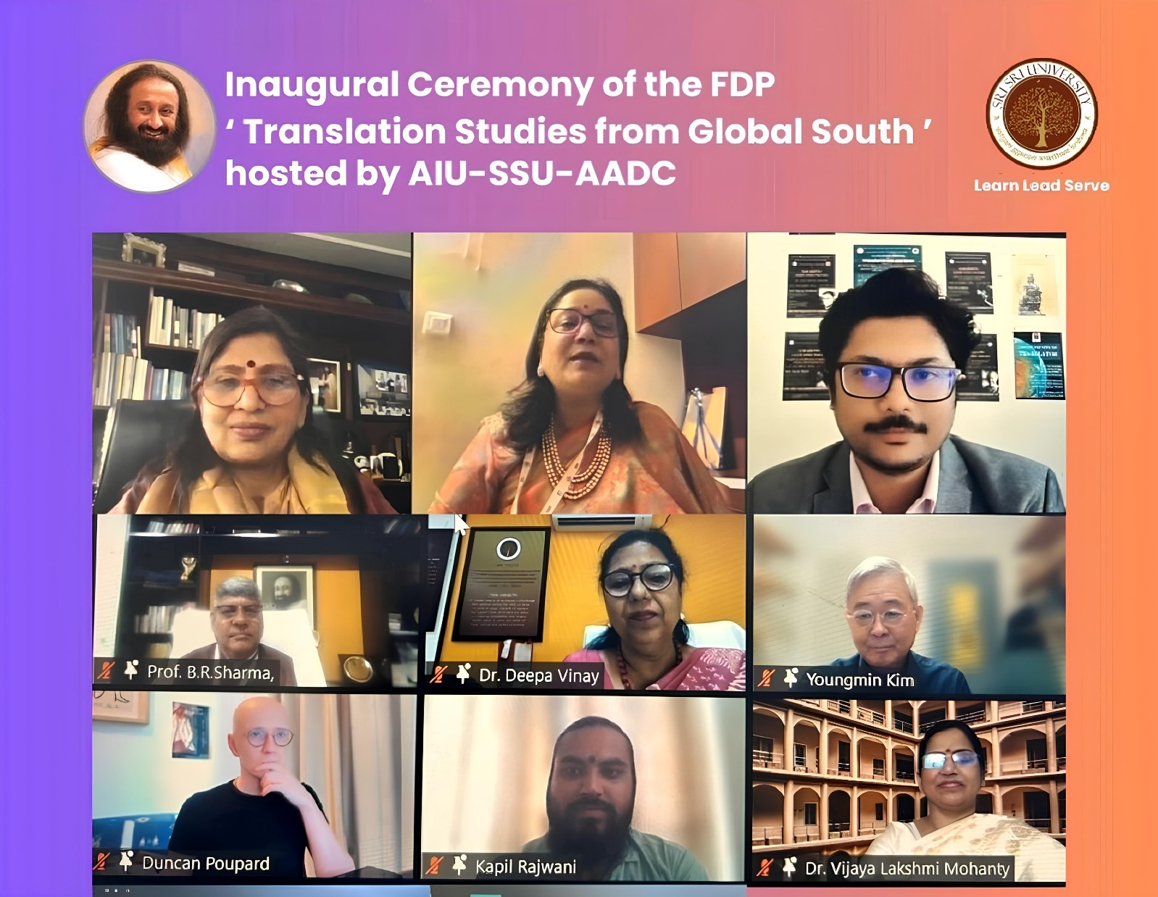
The 16 resource persons were drawn from 9 countries. Over the course of 14 days, scholars and esteemed professors from around the world i.e., Prof. Jatin Nayak, Professor Emeritus, Kalinga Institute of Social Sciences (Deemed to be University), Odisha; Prof. John Milton, Distinguished Professor, University of São Paulo, Brazil; Prof. Youngmin Kim, Professor Emeritus, Dongguk University, South Korea; Prof. Rita Kothari, Professor and Co-Director, Centre for Translation, Ashoka University, New Delhi; Prof. Defeng Li, Director of Centre for Studies of Translation, Interpreting and Cognition, University of Macau, Macau; Prof. Ilse Feinauer, Ton and Anet Vosloo Chair in Afrikaans Language Practice, Stellenbosch University, South Africa; Prof. Chandrani Chatterjee, Professor of English, Savitribai Phule Pune University, Maharashtra; Prof. Duncan Large, Executive Director, British Centre for Literary Translation, University of East Anglia, United Kingdom; Prof. Sayantan Dasgupta, Co-ordinator, Centre for Translation of Indian Literatures, Department of Comparative Literature, Jadavpur University, West Bengal; Prof. Hephzibah Israel, Director of Impact and Knowledge Exchange, University of Edinburgh, UK; Prof. Duncan Poupard, Associate Professor, the Chinese University of Hong Kong, Hong Kong; Dr Annie Rachel Royson, Assistant Professor, Pandit Deendayal Energy University, Gujarat; Dr Uchenna Oyali, Lecturer, University of Abuja, Nigeria; and Dr Sohomjit Ray, Assistant Professor, College of Staten Island, the City University of New York, USA and Dr Saswati Saha, Assistant Professor, Sikkim University, Sikkim, acted as resource persons in the extremely thought provoking Faculty Development Programme.
This two-week Faculty Development Programme brought together 125 participants from different parts of India (one participant from Yemen) to discuss current issues in translation studies, share ideas, and create new models and theories. Over the course of two weeks, this FDP looked at the ideas and disciplinary paths of translation studies in peripheral regions, such as Asia, Africa, and Latin America, with an eye towards understanding how these fields were developed and expanded outside the Global North. It engaged faculty on how the Global South might become a focus for new features in Translation Studies. Faculty members had the opportunity to present their research towards decolonising the field of Translation Studies thereby learnt how different fields might impact and advance Translation. This Faculty Development Programme attempted to deconstruct the “universal” concept of translation by investigating diverse discursive practices in “marginal spaces” and bringing together alternate perspectives and methods of translation from around the world. It is to be noted that amongst the faculties who participated in this FDP, 7% are Professors, 9% are Associate Professors, and 67% are Assistant Professors. 70% of the enrolled candidates are PhD degree holders and 12% are with MPhil degree as well as 70% of the participants are Female faculties. All these figures prove the diversity of the programme.
The valedictory session witnessed Dr. Amarendra Pani, Joint Director, Association of Indian Universities, who interacted with the participants and learnt how successful and beneficial the FDP was for their academic career. Dr. Usha Rai, Assistant Director, AIU offered her wishes for the completion of a quality FDP. Guru Ratikant Mahapatra, Dean, Faculty of Arts Communication and Indic Studies, Sri Sri University congratulated Dr Rindon Kundu, Director of SSCTIS, for meticulously organizing the FDP. The Faculty Development Programme, which has done more than just increase the visibility of translation studies in India and abroad; it has also elevated Odisha's academic institutions to the forefront of the field.
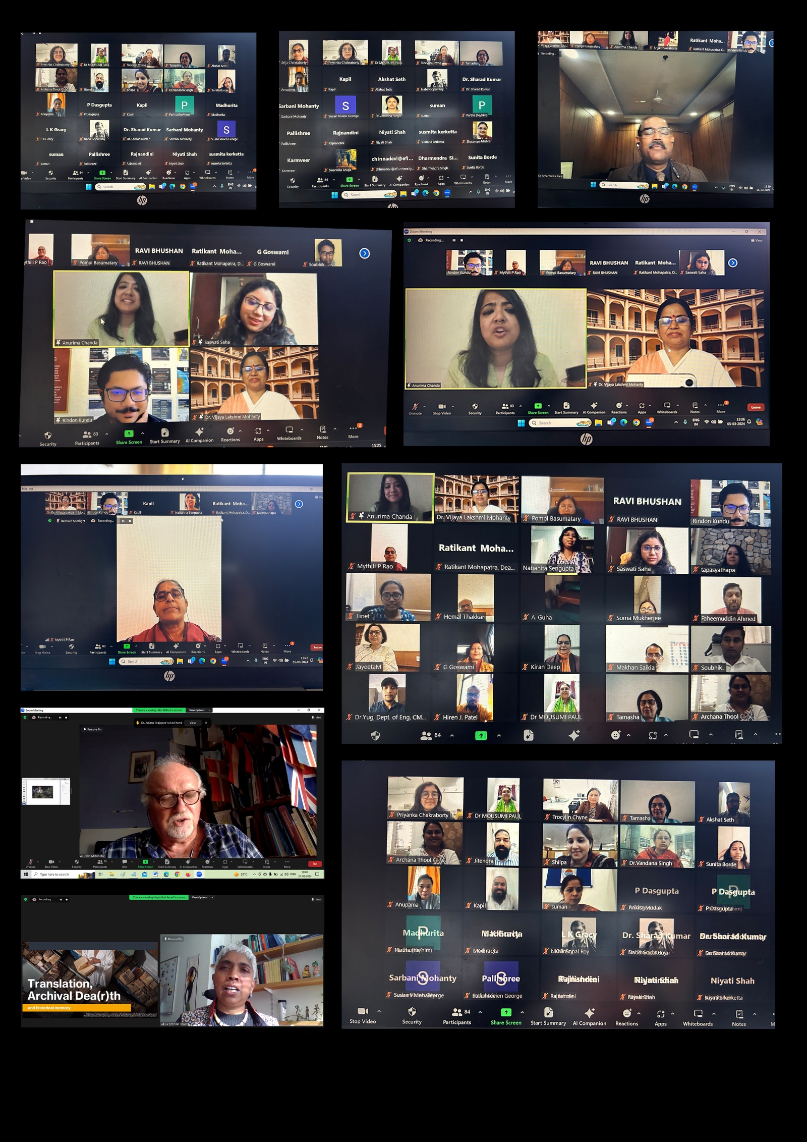
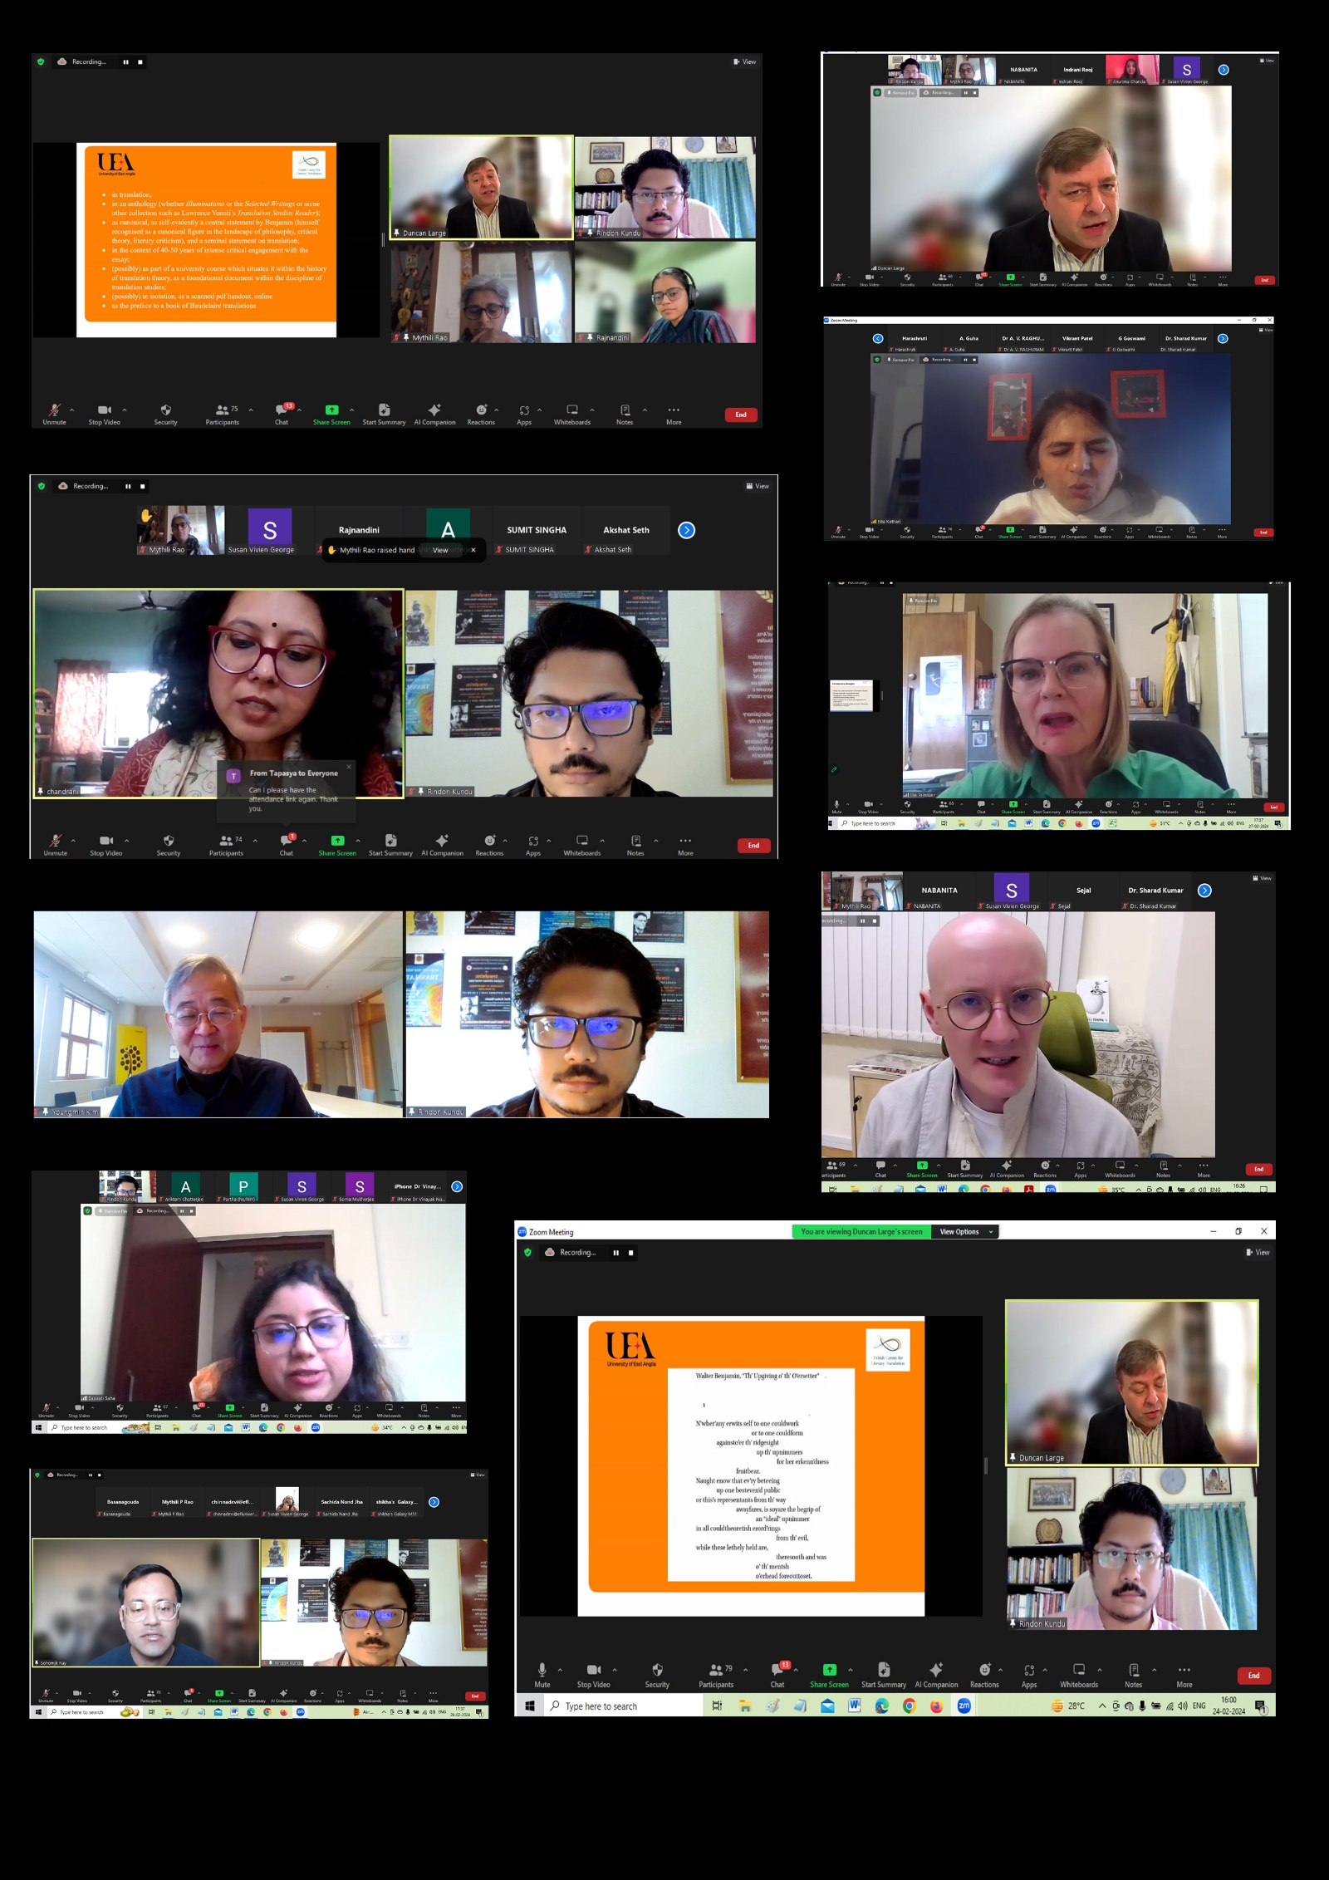
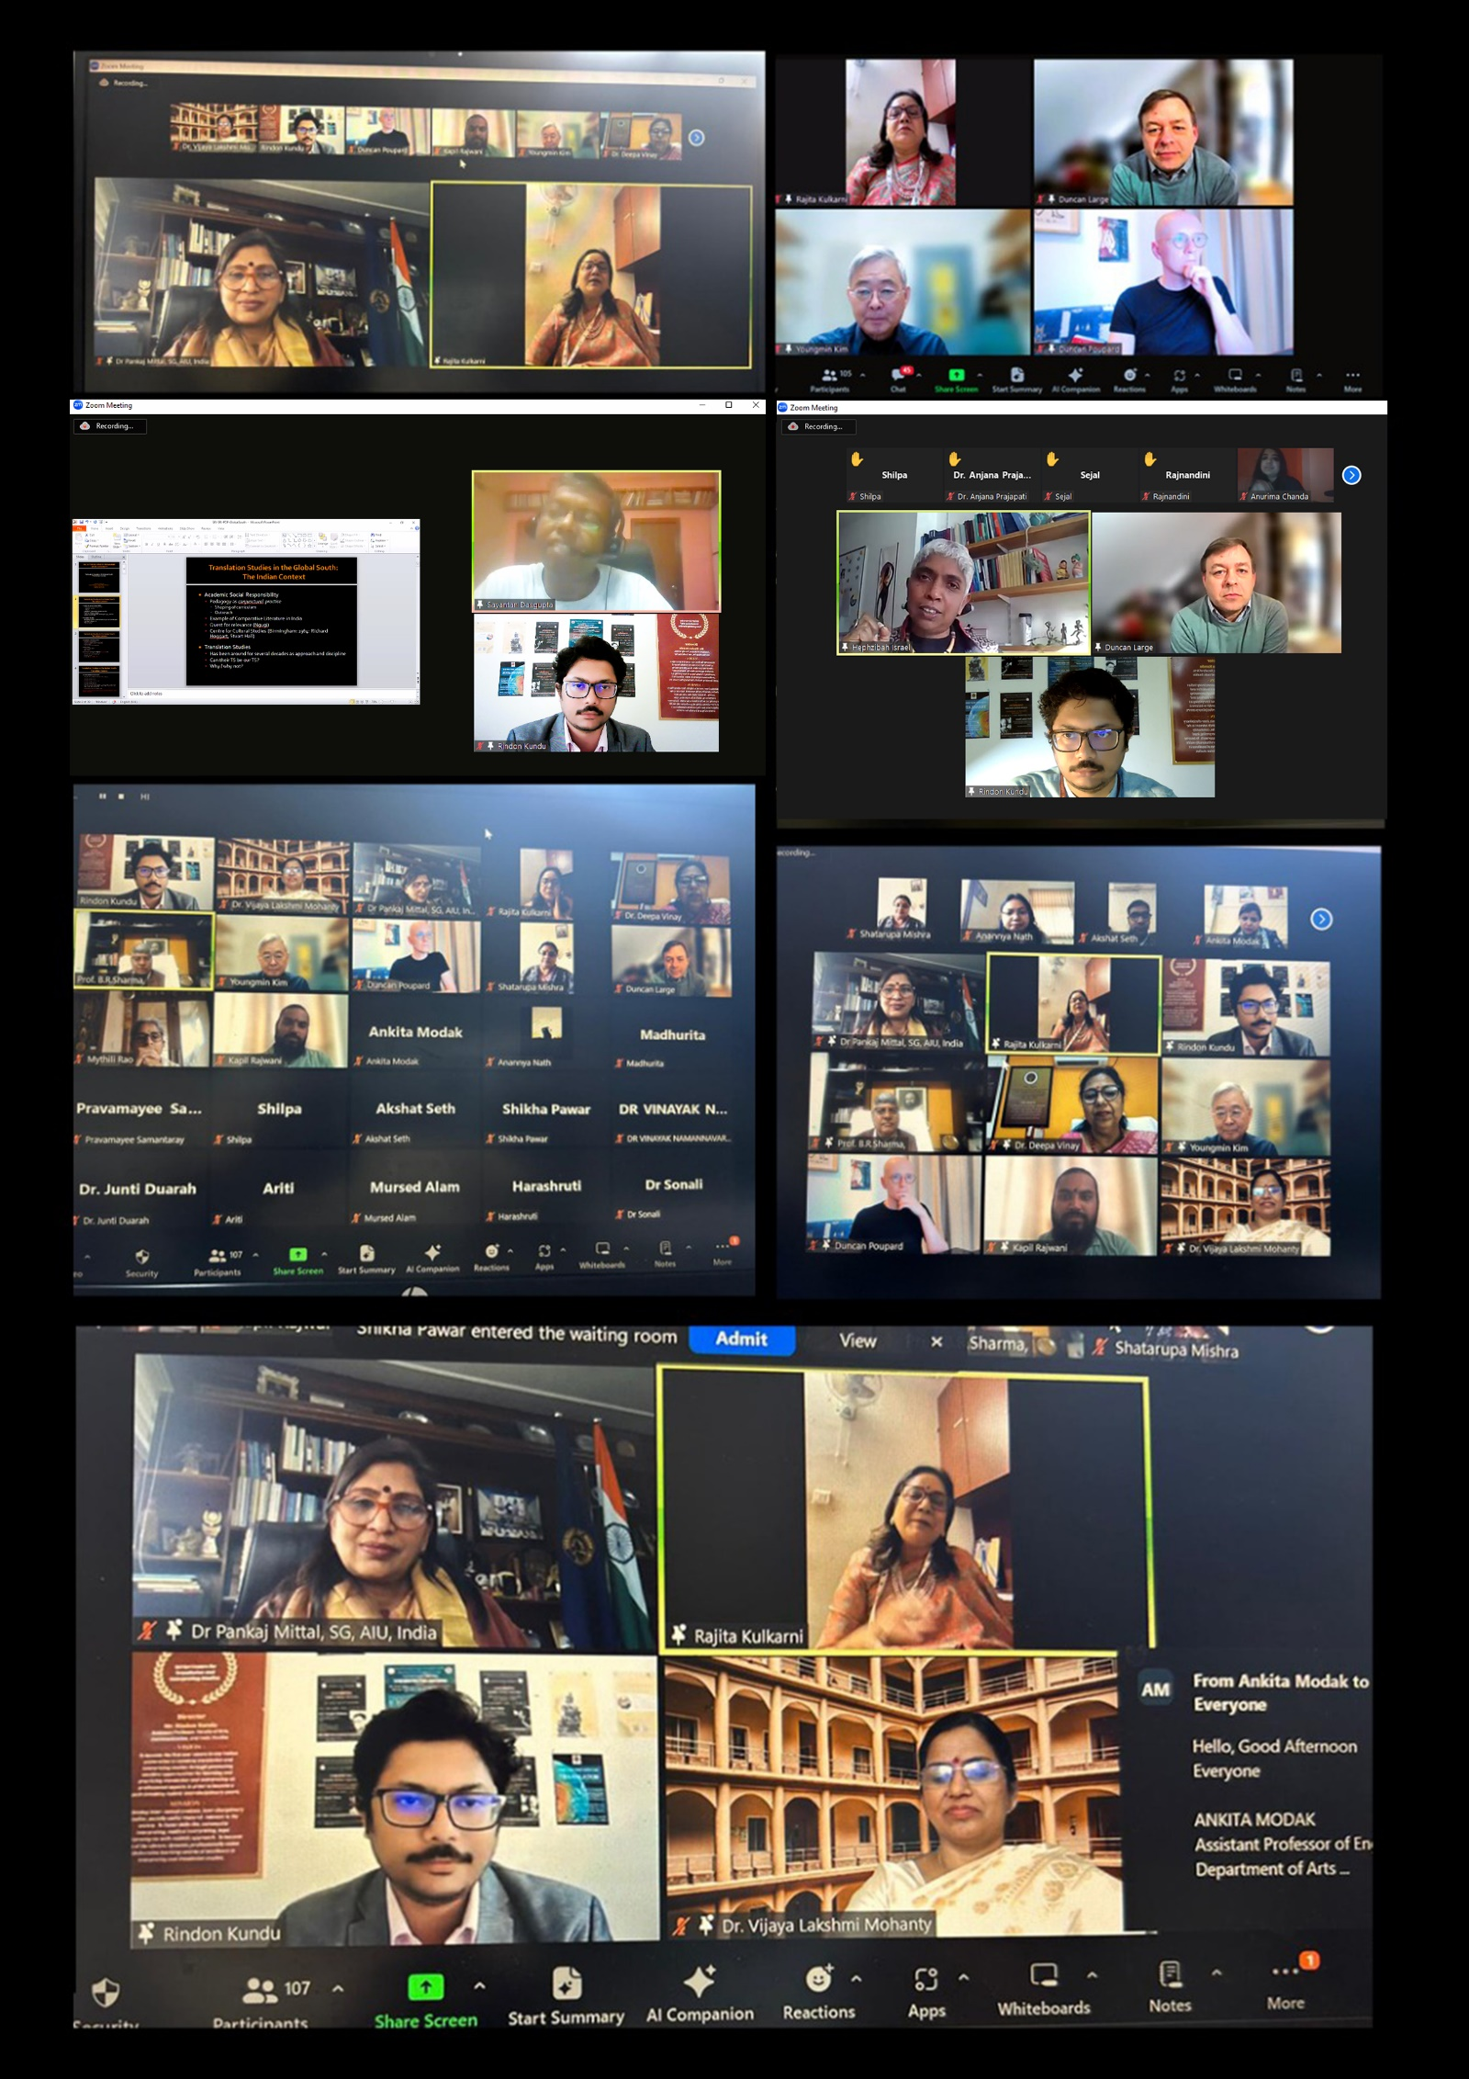
- One -week Faculty Development Programme (FDP) on “Use of Artificial Intelligence and emerging technologies in HEIs”
Date: 3-12 April, 2024
Programme code: AIU/SSU/AADC/2023-24/03

The Faculty Development Programme (FDP) titled 'Use of Artificial Intelligence and other Emerging Technologies in Higher Education Institutions' aligns with the National Education Policy (NEP) - 2020, highlighting the transformative impact of technology on education. This week-long online training, conducted by AIU-SSU-AADC, focuses on empowering teaching and non-teaching faculty in Higher Education Institutions (HEIs) to effectively integrate artificial intelligence, machine learning, blockchain, cyber security and other advanced educational technologies. The objective is to equip participants with the necessary knowledge and skills to navigate and harness the potential of these technologies in the evolving landscape of higher education.
Objective of the FDP 'Use of Artificial Intelligence and other emerging technologies in HEIs:
Through a combination of interactive lectures and practical trainings, the FDP will enable faculty members to learn the following:
- Policy perspectives on Artificial Intelligence (AI) in education
- Basics of Artificial Intelligence (AI)
- Use of Artificial Intelligence (AI) in MS office 365
- Use of AI and ChatGPT in reporting
- Role of Artificial Intelligence (AI) in Education
- Use of Artificial Intelligence in cyber safety and security
- Use of social media to leverage professionally
The rapid advancements in Artificial Intelligence (AI) and emerging technologies have revolutionized various sectors, including higher education. Recognizing the need to equip faculty members with the necessary knowledge and skills to harness these technologies effectively, the Association of Indian Universities – Sri Sri University- Academic and Administrative Development Centre (AIU-SSU-AADC) organized a One-Week Online Faculty Development Programme (FDP) on "Use of Artificial Intelligence and Emerging Technologies in Higher Educational Institutions" from 3rd April 2024 to 12th April 2024.
Inaugural Ceremony (03rd April 2024): The FDP commenced with an auspicious inaugural ceremony, graced by esteemed dignitaries and experts in the field. Prof. (Dr.) Vijaya Lakshmi Mohanty, Director, HRDC, Director and Nodal Officer, AIU-SSU-AADC, Sri Sri University, delivered the welcome address, highlighting the significance of integrating AI and emerging technologies in higher education. The FDP Coordinator, Mr. Satyajeet Arya, Assistant Professor, Faculty of Science, Sri Sri University, provided an insightful overview of "Artificial Intelligence for Education." The Chief Guest, Prof. (Dr.) Deepa Vinay, Executive Registrar, Sri Sri University, addressed the gathering, emphasizing the university's commitment to fostering innovation and embracing technological advancements in education. The ceremony concluded with a vote of thanks by Mr. Satyajeet Arya.
- Day-wise Programme Highlights:
- Day 1 (03rd April 2024): The inaugural day focused on "Artificial Intelligence for Education: Policy Perspectives." Eminent guests, organizing team members, and participants engaged in thought-provoking discussions on the current policies, regulations, and guidelines governing the implementation of AI in educational institutions.
- Day 2 (04th April 2024): Mr. Jayakar Sodagiri, Assistant Professor at Delhi University, conducted an informative session on "Use of AI tools in Chat GPT in reporting." Participants gained hands-on experience in utilizing AI-powered chatbots for various reporting tasks, enhancing their efficiency and productivity.
- Day 3 (05th April 2024): Dr. K. S. Sowmiya Rani, a renowned Professional Editor with a substantial LinkedIn following (33K), shared her expertise on "AI tools in academic institutions." The session explored the potential applications of AI in academic settings, such as grading, personalized learning, and administrative tasks, while also addressing the associated challenges and best practices.
- Day 4 (06th April 2024): Mr. Arvind Singh Chandel, an accomplished AI expert from Accenture with a rich background in academia and industry, conducted a session on "Problem solving with AI." Participants learned about various AI-based problem-solving techniques, including machine learning algorithms, deep learning models, and their practical applications in addressing complex challenges in education and research.
- Day 5 (08th April 2024): Mr. Satyajeet Arya, Assistant Professor at Sri Sri University, delivered an enlightening session on "Basics of Artificial Intelligence (AI) in Daily Use." The session focused on the integration of AI in everyday life, highlighting its implications and impact on various aspects, including education, healthcare, transportation, and communication.
- Day 6 (09th April 2024): Mr. Satyajeet Arya conducted an assignment session, allowing participants to apply their learnings from the previous sessions. Participants were tasked with developing practical solutions or case studies involving the integration of AI in educational settings, fostering critical thinking and problem-solving skills.
- Day 7 (10th April 2024): Dr. Narayan Jena, Assistant Professor at FACIS, Sri Sri University, Cuttack, conducted an insightful session on "Ethical communication and Information Integrity in the age of Artificial Intelligence." The session explored the ethical considerations and challenges associated with AI-driven communication and information dissemination, emphasizing the importance of maintaining transparency, accountability, and responsible use of AI technologies.
- Subsequently, Dr. Nirmalaya Kumar Mohanty, a distinguished Data Scientist and Researcher with a Ph.D. in Numerical Optimization and Mathematics from IIIT, Bhubaneswar, delivered a thought-provoking session on "How secure we are in this world of information." The session delved into the security and privacy implications of AI-driven technologies in the digital age, highlighting the potential risks and mitigation strategies to ensure data protection and cyber security.
- Day 8 (12th April 2024): The FDP culminated with a Valedictory Programme, where guests, organizing team members, and participants reflected on the learnings and experiences gained throughout the programme. Participants shared their insights, feedback, and proposed future directions for integrating AI and emerging technologies in higher education institutions.
- Conclusion
- The One-Week Online Faculty Development Programme on "Use of Artificial Intelligence and Emerging Technologies in Higher Educational Institutions" was appreciated widely among the teaching faculty for its pragmatic approach and hands on tool for enabling a smart professional. Participants had the opportunity to interact with renowned experts, gain valuable insights into AI and emerging technologies, and explore their applications in enhancing teaching, learning, and research processes. The programme facilitated discussions on the challenges, opportunities, and best practices associated with the integration of AI in academic institutions, equipping faculty members with the necessary knowledge and skills to embrace the digital transformation in higher education effectively.
Feedback and analysis
Based on the feedback provided by the participants, it is evident that the One-Week Online Faculty Development Programme (FDP) on "Use of Artificial Intelligence and Emerging Technologies in Higher Educational Institutions" was a resounding success. The participants expressed their overwhelming appreciation for the informative and insightful sessions, which provided them with valuable knowledge and practical applications of AI tools in the field of education.
The feedback highlights the following key points:
- Enlightening and Informative Sessions: Participants consistently praised the sessions as being "enlightening," "informative," and "knowledgeable." They appreciated the in-depth analysis and comprehensive coverage of AI tools, automation, and research applications presented by the resource persons.
- Practical and Hands-on Learning: Several participants commended the inclusion of hands-on exercises and practical training during the sessions. This approach allowed them to gain firsthand experience in utilizing various AI tools and platforms, enhancing their understanding and enabling them to apply the learnings effectively in their academic and research endeavours.
- Relevant and Innovative Content: The content of the FDP was deemed "innovative," "creative," and "relevant" by the participants. They appreciated the focus on cutting-edge technologies and their potential applications in higher education, equipping them with the necessary skills to embrace the digital transformation in the field.
- Excellent Organization and Delivery: Participants praised the organizers for their "dedicated efforts" in arranging and conducting the FDP in a "professional manner." The resource persons were lauded for their expertise and resourcefulness, contributing to an enriching learning experience.
- Desire for More Such Programs: Many participants expressed their enthusiasm for attending more FDPs on specialized topics, research methodologies, software tools, and advanced techniques related to AI and emerging technologies. This reflects their eagerness to continue learning and expanding their knowledge in this rapidly evolving field.
Photographs:
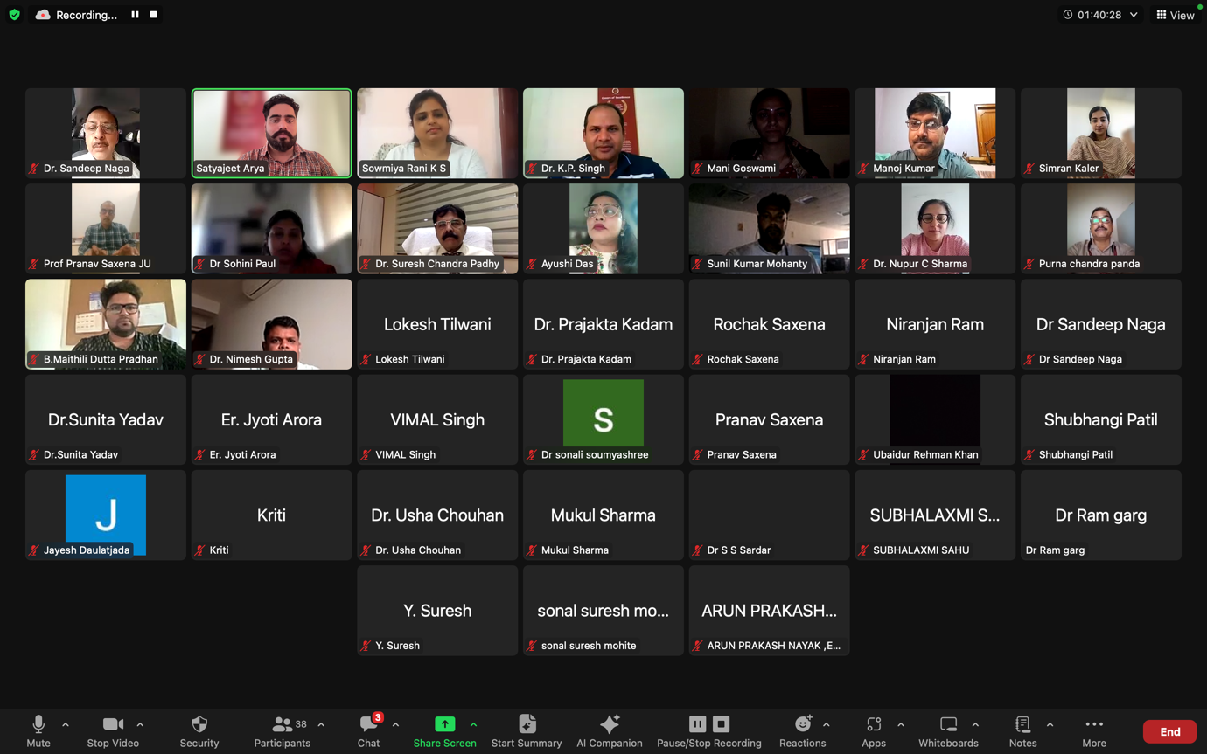

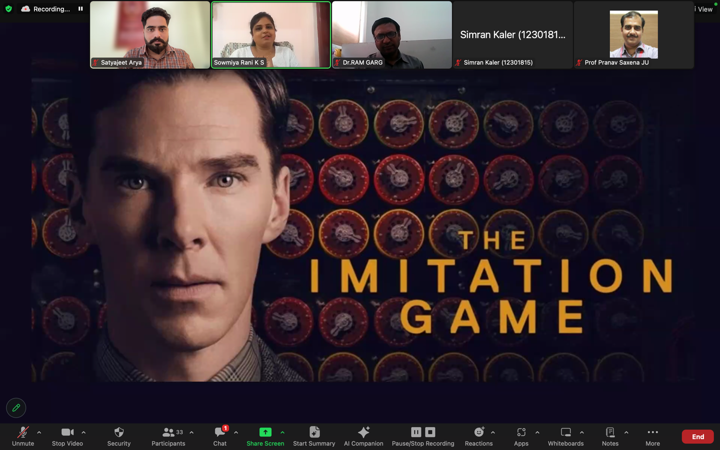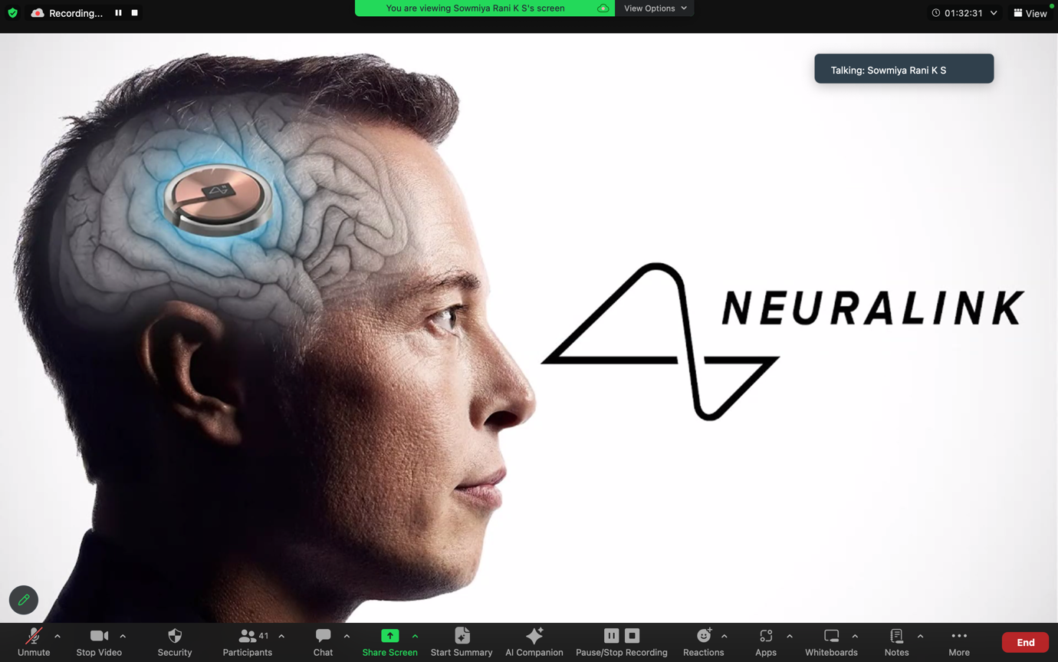

Media Coverage of AIU-SSU-AADC:

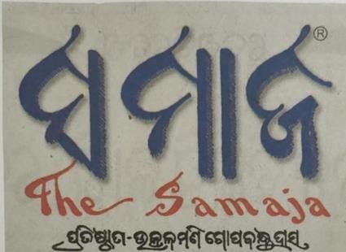

07.02.2024
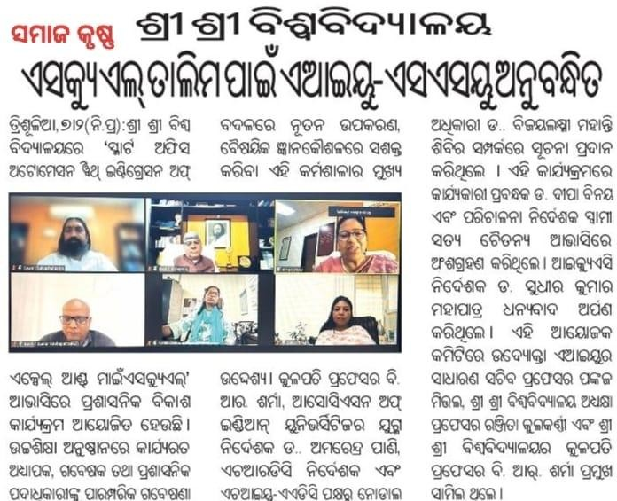


7 Feb 2024
Sri Sri University Announces Online Administrative Development Program
Sri Sri University is conducting an online Administrative Development Program titled 'Smart Office Automation with Integration of Excel and MySQL' from 5th to 11th February 2024. The program aims to enhance the administrative capabilities of faculty, researchers, and staff of Higher Education Institutions with advanced techniques and tools. The program, jointly certified by AIU and SSU, was inaugurated by several dignitaries, including Gurudev Sri Sri Ravi Shankar.

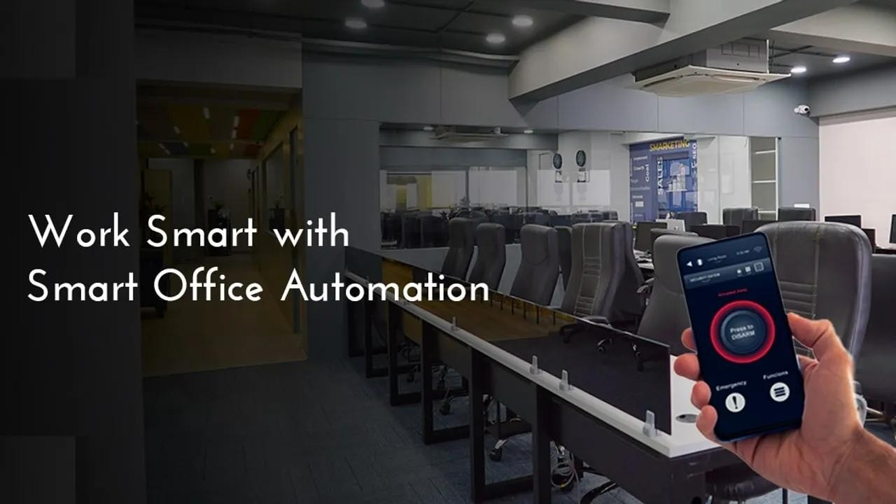

Sri Sri University Announces Online Administrative Development Program

In a bid to advance administrative capabilities in Higher Education Institutions (HEIs), the Sri Sri University (SSU) in Cuttack, Odisha, is set to conduct an online Administrative Development Program (ADP).
Titled 'Smart Office Automation with Integration of Excel and MySQL', the program is slated to run from 5th to 11th February 2024.

Empowering HEIs with Advanced Tools
Targeted at faculty members, researchers, and administrative functionaries, the initiative aims to arm these professionals with advanced techniques and tools pivotal to office automation and database management. Encompassing areas such as creating and maintaining databases, tables, SQL, and data operations, the program seeks to instill proficiency in emerging tools among academic administrators.

Joint Certification by AIU and SSU
The program is a product of joint certification from the Association of Indian Universities (AIU) and SSU, with 56 participants currently enrolled. This collaborative effort signifies a shared commitment to enhancing the professional capabilities of faculty and administrative staff in HEIs.

Inauguration Attended by Dignitaries
The inauguration of the program witnessed an array of notable personalities in attendance. Among those present were Prof. Mrs. Rajita Kulkarni, President of SSU, Prof. B. R. Sharma, Vice-Chancellor, and Dr.
Amarendra Pani, Joint Director of AIU. The center, inaugurated
by Gurudev Sri Sri Ravi Shankar on 9th November 2023, was commended for being chosen as one of 10 centers for AIU-AADC.

Link:https://bnnbreaking.com/breaking-news/education/sri-sri-university-announces- online-administrative-development-program


February 7, 2024

AIU-SSU-AADC offers Tech-based ADP in its first offering
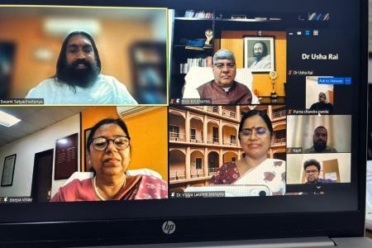
· SSU is privileged to become one of the 10 centres- Prof. Kulkarni

Cuttack: Sri Sri University, Cuttack, Odisha is pleased to announce a significant opportunity for Higher Education Institutions worldwide. An online Administrative Development Program (ADP) focusing on ‘Smart Office Automation with Integration of Excel and MySQL’ is scheduled from 5th to 11th February 2024. The training sessions will be conducted from 3 pm to 5 pm online. This program is designed to empower faculty members, researchers, and administrative functionaries of Higher Education Institutions (HEIs) with cutting-edge tools, techniques, and insights that go beyond traditional research boundaries.
On the inaugural day of the online program, Prof. Mrs. Rajita Kulkarni, President, Sri Sri University, thanked AIU for considering the University to establish AIU-AADC which is privileged to be one of the 10 selected centers. Prof. B. R. Sharma, Vice-Chancellor, commended the initiative of the team members of SSU and AIU and congratulated the Center. Dr. Amarendra Pani, Joint Director of the Association of Indian Universities, emphasized the importance of technology in the proposed programs for both teaching and non-teaching faculty of HEIs. He expressed his pleasure over the commitment shown by Sri

Sri University to best utilize the opportunity for strengthening HEIs of India. Dr. Vijaya Lakshmi Mohanty, Director of HRDC and Nodal Officer of AIU-SSU-AADC, provided detailed insights into the center’s plans. Dr. Deepa Vinay, Executive Registrar, and Swami Satya Chaitanya, Director of Operations, Sri Sri University spoke about the importance of the center and the tech-based programme that it will offer. Dr. Sudhir Kumar Mohapatra, Director, IQAC has offered vote of thanks. He is also the resource person and curator of the 7-day online workshop.
The ADP aims to offer participants a comprehensive understanding of advanced techniques in Smart Office Automation with the Integration of Excel and MySQL. It will be facilitated by experts in the field, providing personalized guidance and mentorship throughout the program. The program is a joint certification from the Association of Indian Universities and Sri Sri University. 56 participants have enrolled in the Programme.

This initiative promises to empower faculty members, researchers, and administrative functionaries of Higher Education Institutions with the latest tools, techniques, and insights that transcend traditional research boundaries. The program will cover topics such as creating and maintaining databases, tables, and SQL, conceptualizing and implementing MySQL courses, importing, updating, and deleting records from tables (MYSQL), analyzing relational and logical operators, applying operators to data, and using string matching with the like operator in SQL (MYSQL). The program targets faculty members, researchers, and administrative functionaries of Higher Education Institutions.

The organizing committee includes patrons viz., Prof. Pankaj Mittal, Secretary General, Association of Indian Universities, New Delhi. The inauguration was attended by Dr. Usha Rai Negi, Assistant Director, Research, AIU, Ms. Sonali Das, Coordinator- PR, and Mr. Kapil Rajwani, Technical Officer, SSU among others.

Gurudev Sri Sri Ravi Shankar, founder and Lifetime President of Sri Sri University, inaugurated AIU-SSU-AADC on 9th November 2023. This center promises to make faculty and academic administrators in emerging tools to make their work smarter, better and establish themselves as valued professionals in HEIs.

Link:https://orissadiary.com/aiu-ssu-aadc-offers-tech-based-adp-in-its-first- offering/amp/

https://www.thequiver.in/team-orion-and-dance-clubs-spectacular-performance-in-the-mini-marathon-was-a-highlight/
https://bnnbreaking.com/breaking-news/education/sri-sri-university-announces-online-administrative-development-program
https://orissadiary.com/aiu-ssu-aadc-offers-tech-based-adp-in-its-first-offering/amp/

Sri Sri University
AIU-SSU-AADC
Association of Indian Universities- Sri Sri University-Academic &Administrative Development Centre
FDP and ADPs
Programme No. | Title | Mode | From | To | Duration | No. of Participants  (Academic) | No. of Participants  (Administrative) | Total Participants
1 | Smart Office Automation with Integration of Excel with Mysql- | Online | 5th February | 11th February | 7 Days | 29 | 27 | 56
2 | FDP on Translation Studies from Global South | Online | 19th February | 5th March | 14 Days | 125 |  | 125
3 | “Use of Artificial Intelligence and  emerging technologies in HEIs” | Online | 3rd April | 12th April | 7 Days | 32 | 20 | 52
4 | AI Evolution: from foundation to generative AI | Online | 3rd June | 10th June | 7 days | 91 | 91 | 91
5 | SHIKSHA-3.0 “Unleashing the latent potential of an educator in HEIs”(Continuing) | Online | 24th  june | 18th  July | 21 Days | 37 | 37 | 37

Total Number of academic professionals – 314
Total Number of administrative professionals – 47
Total Participants – 361

AIU-SSU-AADC Financials and Number of participants:

AIU -SSU-AADC
FINANCE and number of participants Feb-April 2024
SL. NO. | DETAILS of Training and Grants |  | Revenue income in INR | No. of Participants
1 | Amount received from AIU |  | 1,00,000/-
2 | ADP on MySql |  | 12,000/- | 56
3 | FDP on Translation Studies |  | 1,87,500/- | 125
4 | FDP on AI |  | 11,000/- | 52
5 | Amount received from AIU |  | 1,00,000/-
6 | AI Evolution: from foundation to generative AI |  |  | 91
7 | SHIKSHA-3.0 “Unleashing the latent potential of an educator in HEIs” (Continuing) |  |  | 37
 | Total |  | 4,10,500/- | 361

