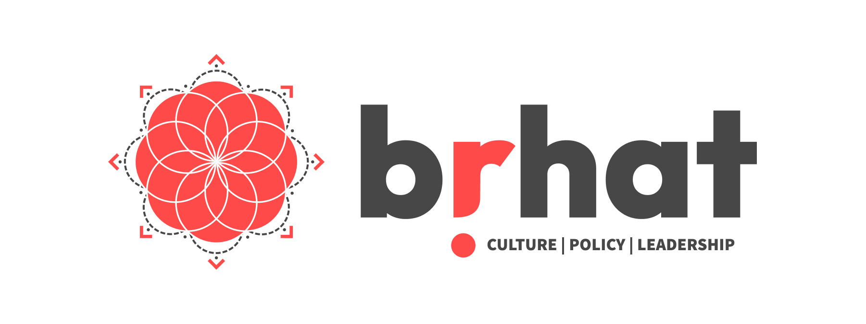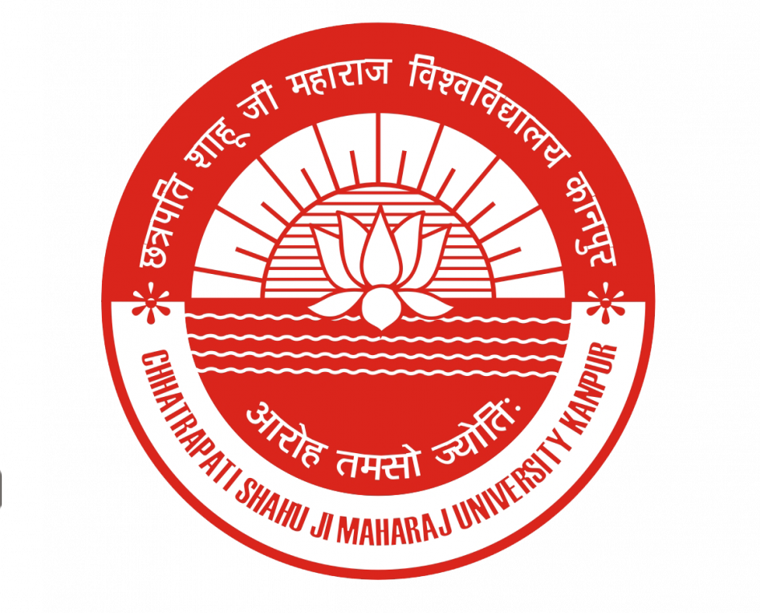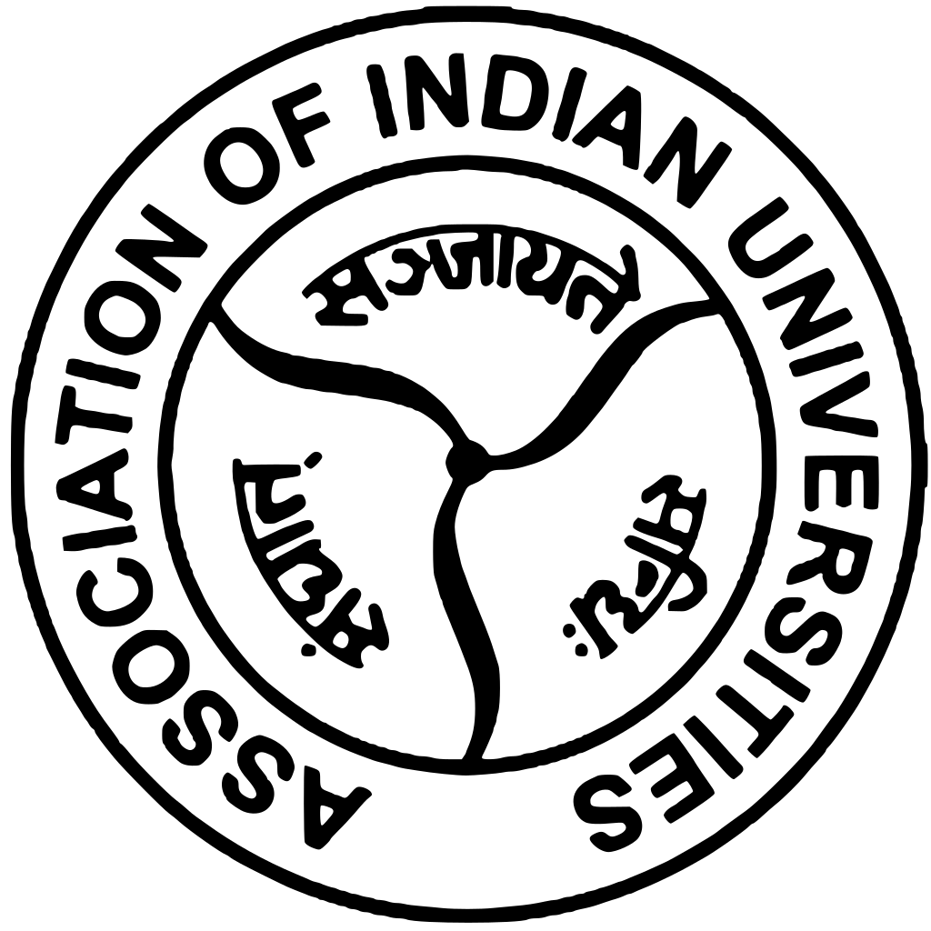

A Report on
Civilizational Public Policy: A Technological Perspective

19 Oct 2024 - 19 Jan 2025 [12 weeks]
72 hours (36 sessions, weekends only)

Fri : 7 to 9 PM IST | Sat-Sun : 10 AM to 12 PM IST

ORGANISED BY

Association of Indian Universities, Chhatrapati Shahuji Maharaj University, Academic and Administrative Development Center sponsored by the Association of Indian Universities.

(AIU-CSJMU-AADC)

IN COLLABORATION WITH
Bṛhat

Introduction
The fourth workshop under AIU_CSJMU_AADC in collaboration braht was an online certificate program in public policy, was conducted from October 2024 to January 2025. This workshop explores both Eastern and Western philosophical traditions, demonstrating how these have shaped governance over time. At its core, the program integrates foundational concepts from Dharma and the Arthaśāstra, providing participants with a deeply Indic perspective on statecraft, leadership, and governance.

Profile of the participants.
This workshop was attended by 36 participants from diverse academic backgrounds, including political science, law, economics, international relations, engineering, philosophy, and life sciences policy. Their expertise spans disciplines such as public administration, urban planning, literature, environmental humanities, and digital finance, ensuring that governance is examined from multiple perspectives. By integrating scientific inquiry, economic reasoning, and civilizational thought, the cohort engages with policymaking through a deeply interdisciplinary lens.
Professionally, the cohort represents a wide array of sectors, including public policy, governance, technology, law, education, infrastructure, and social impact consulting. Participants are actively engaged in policy advisory, economic strategy, political consulting, media law practice, software product management, and sustainable urban development. Others bring expertise in biochemistry, emerging technology policy, financial inclusion, and Indic research, adding depth to discussions on governance and statecraft. This intellectually diverse group brings a rich synthesis of ideas and practical experience, making this workshop a truly transformative learning environment.
Inaugural Session: Anugraha Sambhashanam and Program Orientation
In an online inaugral session Shri Ramachandra Roddam, talked about governance. He introduced the idea that policy-making must not be viewed as a mechanical or bureaucratic process but as a dynamic and living force that derives legitimacy and strength from its civilizational roots. Governance, he argued, should propel meaningful transformation, ensuring that policies are not merely transactional but deeply transformative. This perspective reframed governance as a moral and social responsibility rather than a technical function, urging a reconsideration of how societies structure their administrative and political frameworks.

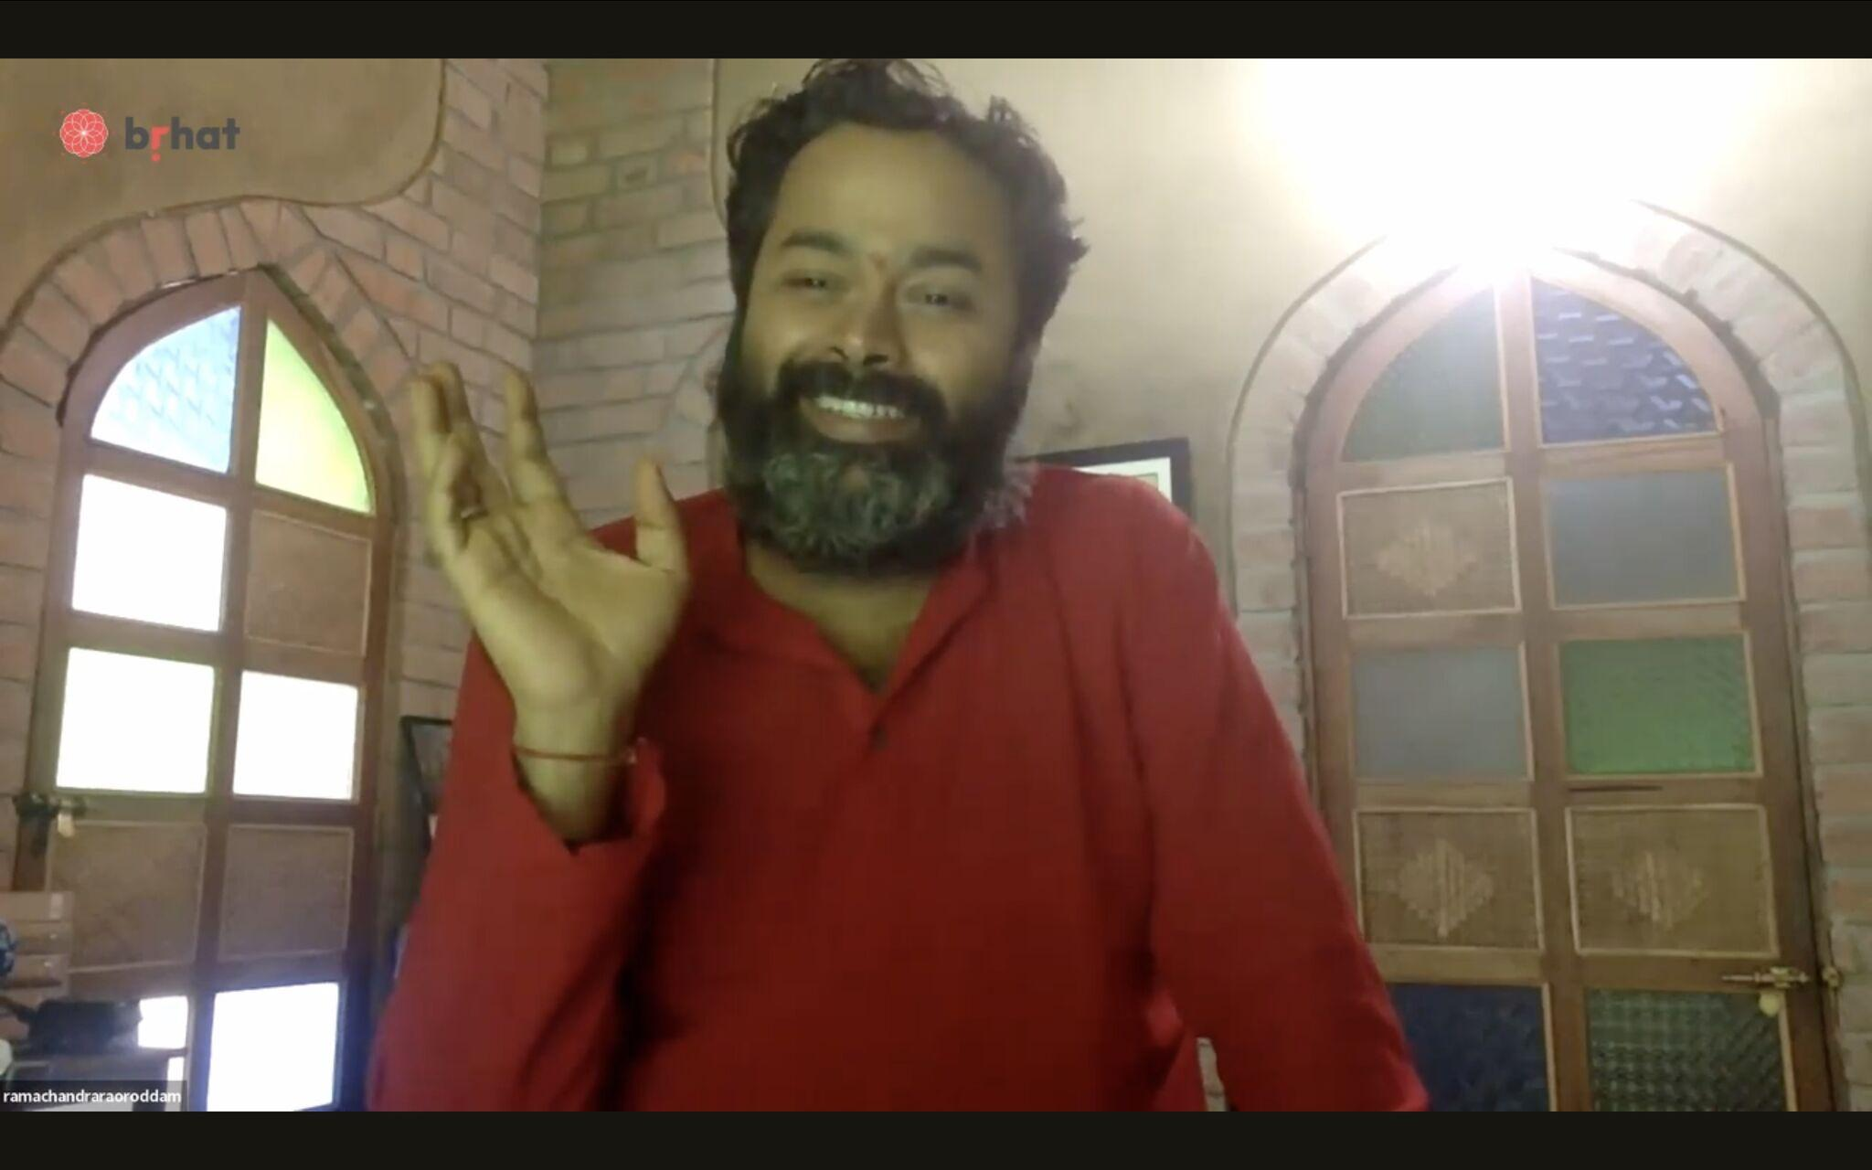

Week 1
Introduction to leadership styles based on Pandava Mandala
The study of governance was further enriched by Shri Rajeev N., who introduced the Pandava Mandala as a model for leadership. Drawing from the Mahābhārata, he illustrated how different leadership archetypes contribute to governance. Yudhishthira’s wisdom, Bhima’s strength, Arjuna’s clarity, Nakula’s resilience, and Sahadeva’s foresight were explored as distinct yet complementary leadership styles that together ensure the stability and adaptability of governance. By mapping these qualities to contemporary organizational and policy challenges, the session highlighted how governance requires a balance between different leadership attributes, rather than a monolithic approach. Participants were encouraged to introspect on their own leadership styles and understand the necessity of diverse leadership traits in policy-making.
How to Build a Civilization?
A crucial inquiry into civilizational sustainability was led by Shri Amritanshu Pandey, who posed the fundamental question: How do you build a civilization? Through historical and philosophical insights, he examined the factors that lead to civilizational continuity and decline. He argued that governance and policy must be understood as long-term civilizational projects rather than short-term administrative solutions. Institutions, cultural frameworks, and knowledge systems were presented as the pillars of civilizational endurance, with a focus on how policy-making must integrate historical awareness and cultural depth to remain effective. This perspective urged a departure from policy as an isolated tool and repositioned it as a means of sustaining and nurturing a civilization across generations.

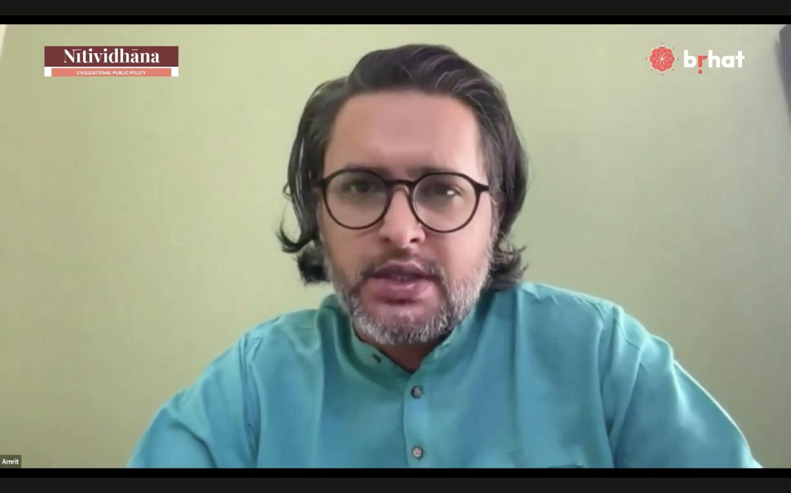
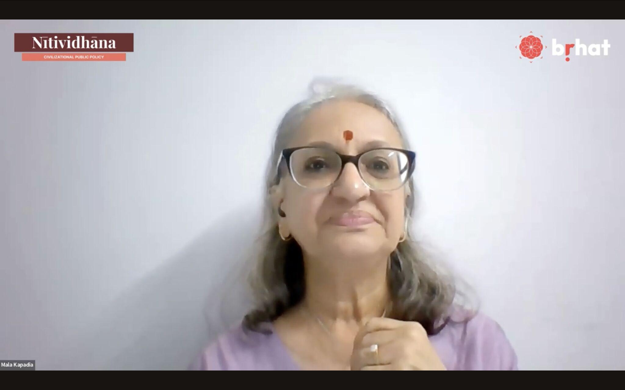

Week 2
Introduction to Public Policy and advance techniques of governance:
The discussion on public policy was led by Shri Anurag Shukla, who expanded on the idea that policy is not merely a set of regulations but a reflection of a society’s values and evolving needs. He introduced policy-making as a dynamic process, shaped by societal attitudes, cultural narratives, and ethical considerations which brings in the need of advanced technological methods like AI to the fore. The interplay between historical governance models and contemporary policy challenges was examined, highlighting the need for a proactive rather than reactive approach. The session prompted an exploration of how governance structures can be both adaptable to modern challenges and rooted in traditional wisdom, reinforcing the idea that public policy should be an organic evolution rather than a forced imposition.
Economic Reasoning
A critical dimension of governance was introduced by Shri Indradeep Ghosh, who engaged participants in understanding economic reasoning within policy-making. He stressed that strategic economic thinking is essential for creating policies that are both effective and equitable. His session examined the delicate balance between market-driven policies and state intervention, highlighting the importance of aligning economic policies with ethical considerations. Through case studies, he demonstrated the real-world impact of economic policies on societies, encouraging a deeper analysis of how economic models shape governance and long-term civilizational sustainability.

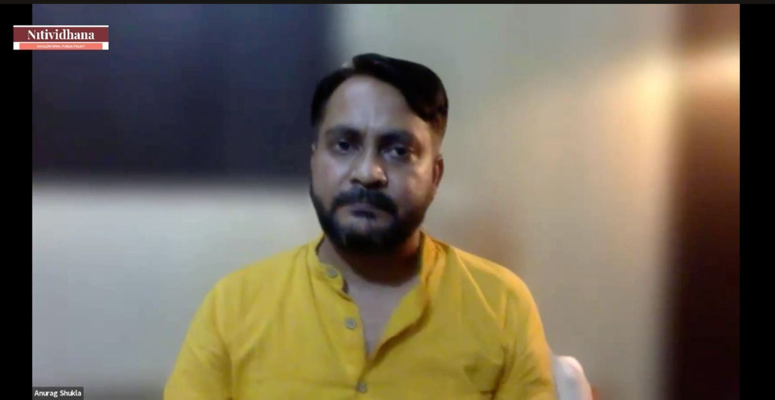
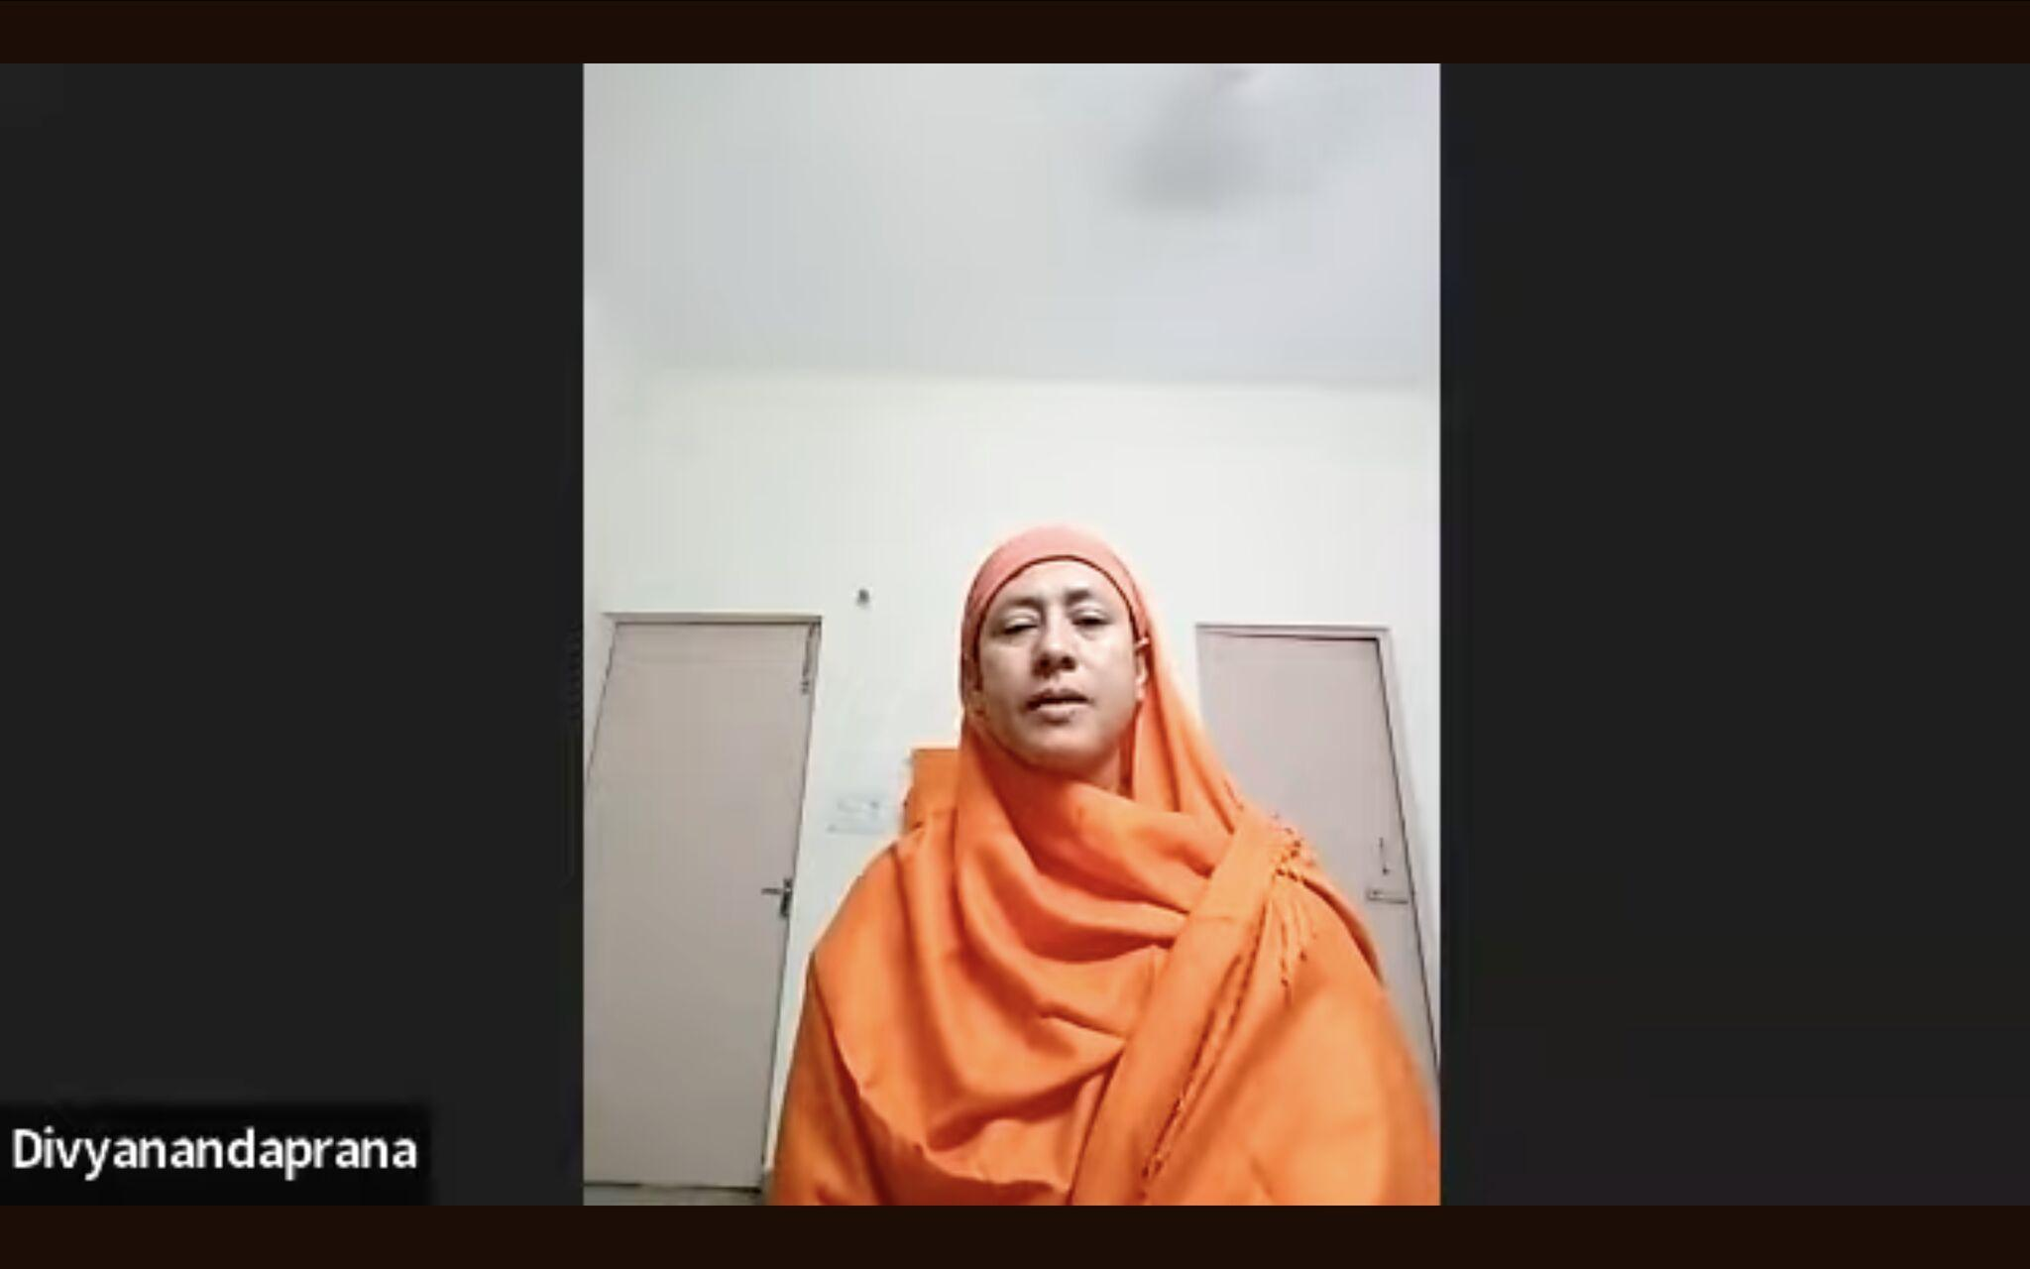

Week 3
The Future of Economics
Smt. Smita S. introduced a groundbreaking perspective on economic reasoning in her session The Future of Economics. Moving beyond conventional economic models, she integrated Nyāya, the classical Indian system of logic, into policy analysis, redefining how economic decisions can be made with greater transparency and coherence. She demonstrated how structured logic—rooted in systematic reasoning—could refine economic hypotheses, making policy analysis both inductive and deductive. The session illustrated how Indian epistemological traditions offer powerful tools for governance, providing frameworks that ensure policies are not just data-driven but also logically sound. This dialogue encouraged participants to rethink economic analysis as a structured discipline that balances empirical evidence with philosophical depth, ensuring that economic policies are not just technically proficient but also intellectually robust.
Theory and Practice of Dharma in Governance
Dr. Mohan Raghavan’s sessions brought the lens of Dharma into governance, guiding participants through its principles as a foundational element for ethical and sustainable policies. The discourse challenged modern policy paradigms that often prioritize short-term gains over ethical responsibility, urging participants to explore governance as a Dharmic duty rather than a bureaucratic exercise. This session served as a crucial bridge between philosophical thought and real-world governance, illustrating how ethical considerations can and must inform public policy.
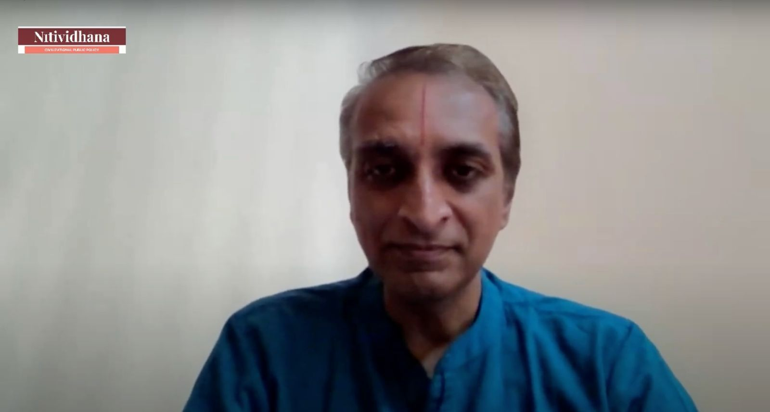

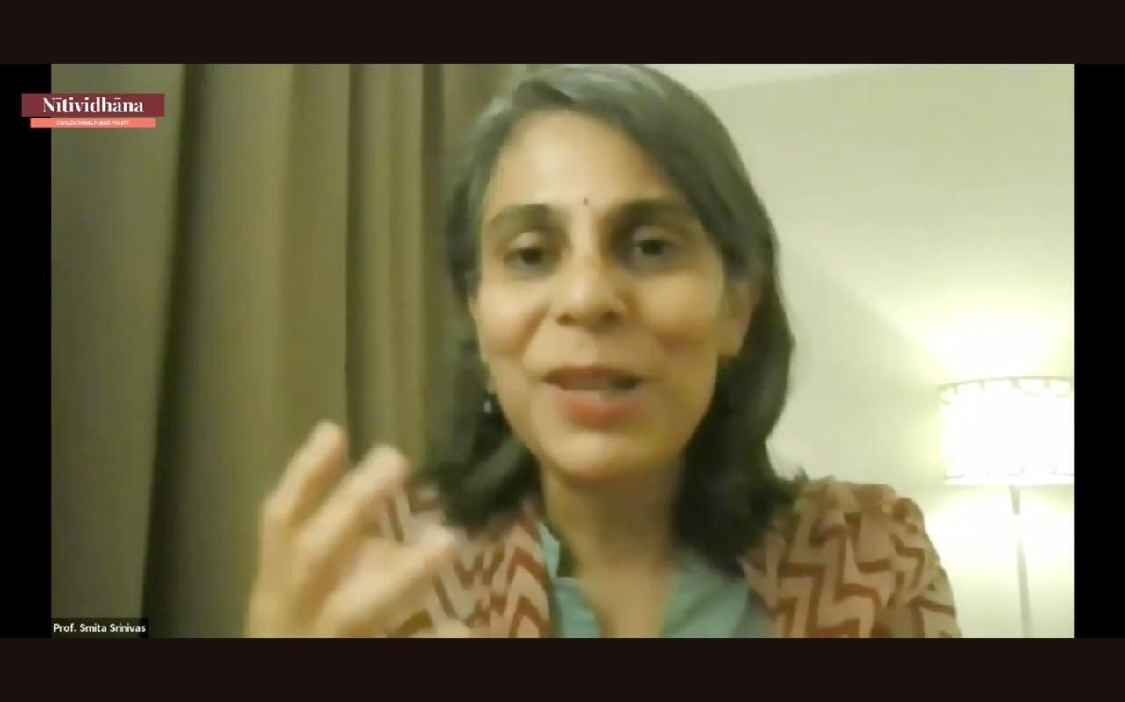

Week 4
Policy Writing Workshop and Synthesis Session
The transition from theoretical discourse to practical application was facilitated through the Policy Writing Workshop led by Shri Anurag Shukla. This session provided an immersive learning experience where participants engaged in structuring arguments, drafting policies, and refining their analytical approaches. With his extensive experience in public policy and education, Anurag Ji emphasized that effective policymaking is not just about ideas but about the ability to translate those ideas into well-articulated documents that reflect both analytical rigor and societal needs. Participants gained hands-on experience in crafting policy documents that were logical, persuasive, and implementable, reinforcing the importance of clear, well-structured communication in governance.

Week 5
Governance and Global Futures
Shri Raghava Krishna’s session, Governance and Global Futures, expanded the discourse beyond national governance to examine India’s role in shaping global policy through the lens of Indian Knowledge Systems. He illustrated how ancient Indian philosophies—rooted in sustainability, holistic well-being, and ethical governance—are deeply relevant in addressing contemporary crises such as climate change, economic inequality, and technological disruptions. Drawing from disciplines such as Ayurveda, Vedanta, and Arthashastra, he demonstrated that Indian traditions offer not just historical insights but also practical frameworks that can inform global governance models today. By engaging with IKS from a solutions-oriented perspective, the discussion underscored that India’s intellectual heritage is not just for academic study but has the potential to shape meaningful policy interventions on a global scale.
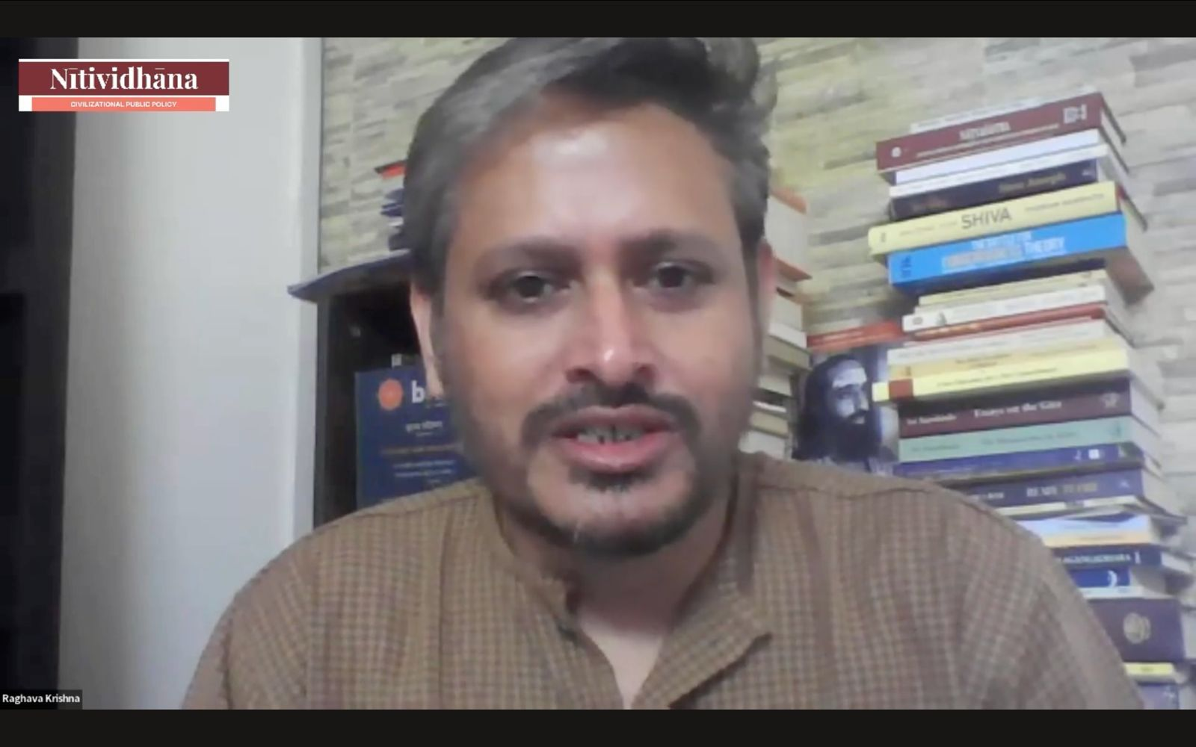

Week 6
Indian Knowledge Systems - An Overview
Shri Mathighatta Chaitra’s session on Indian Knowledge Systems – An Overview provided a panoramic understanding of India’s intellectual traditions. He examined the vast corpus of traditional knowledge, from Ayurveda to Vedic sciences, highlighting their applicability in contemporary governance and policy-making. A central theme of the discussion was the disconnect between IKS and modern academic and policy frameworks, a gap that has led to the sidelining of indigenous knowledge in favor of Western paradigms. He called for a reevaluation of IKS, stressing its potential to offer holistic and sustainable solutions to societal challenges. The session sparked critical reflections on how India could reclaim and integrate its civilizational knowledge into the modern governance discourse, moving beyond passive appreciation to active implementation.
Historical and Cultural Influence on India's International Relations
Shri Sanjay Pulipaka’s session on Historical and Cultural Influence on India’s International Relations reframed diplomacy through a civilizational lens. He demonstrated how India’s values, historical narratives, and cultural frameworks shape its global engagements. By analyzing India’s historical role in fostering trade, knowledge exchange, and diplomatic ties, he illustrated how its international relations have always been rooted in a civilizational ethos rather than mere realpolitik. The discussion underscored the importance of crafting foreign policy that remains authentic to India’s civilizational identity while navigating contemporary geopolitical realities. The session urged participants to consider how India could assert its soft power through cultural diplomacy, historical continuity, and strategic alignments that reflect its traditional worldview.
Development: a mixed perspective
The concept of development and its underlying assumptions were critically examined by Shri Rahul Goswami. His session traced global influences on India’s development paradigms, highlighting the tensions between indigenous models and externally imposed frameworks. He questioned conventional indicators of progress, arguing that India's trajectory must be assessed through its own civilizational lens rather than borrowed economic models. The discussion unpacked the limitations of GDP-centric growth, emphasizing the need for Niti (policy) that aligns with cultural and societal aspirations. By drawing from historical governance models, he encouraged participants to rethink sustainability, proposing an alternative paradigm that integrates economic growth with ethical and cultural continuity.

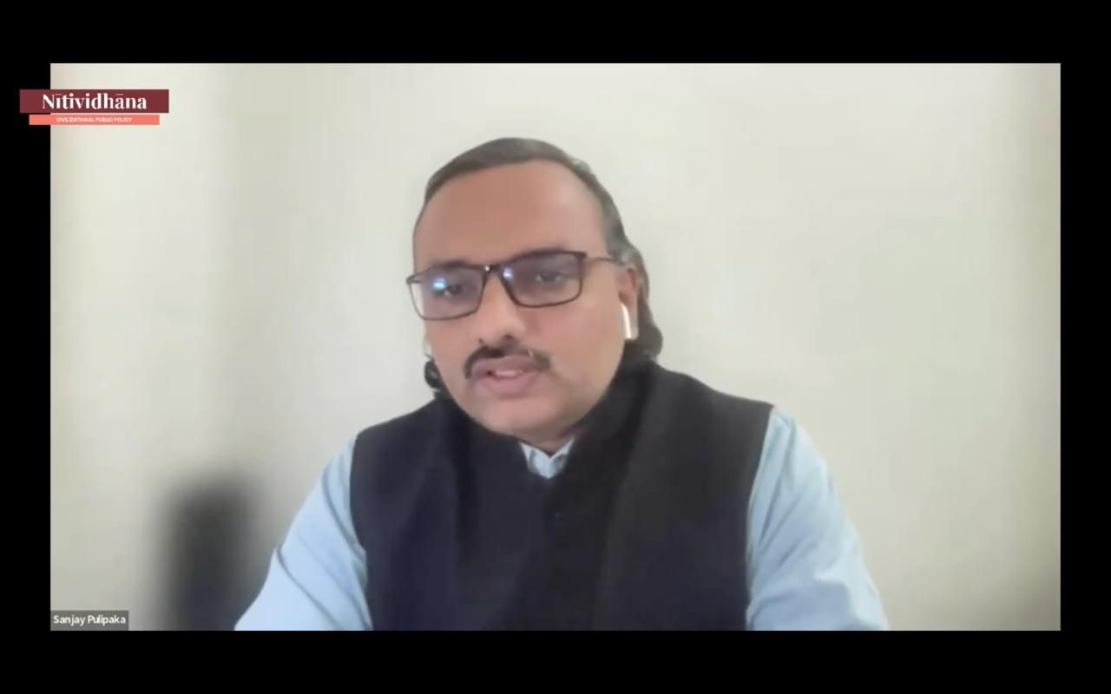

Week 7
Policy and Planning
Smt. Smita S. offered an insightful session on Planning and Policy, emphasizing the distinction between the two and their respective roles in governance. She stressed the critical importance of context in policy design, demonstrating how effective governance requires an understanding of mental models, institutional rules, and societal expectations. Drawing from her extensive experience in international development and public policy, Smita Ji illustrated how governance frameworks differ across cultures and how India’s civilizational ethos must shape its policy-making approaches. The session provided the cohort with a nuanced understanding of how well-designed policies are not static but dynamic, evolving in response to cultural, economic, and geopolitical shifts. This perspective encouraged participants to think beyond rigid policy structures and to develop governance models that are both flexible and rooted in civilizational wisdom.
India's Strategic National Interest and Challenges
Shri Pankaj Saxena’s session on India’s Strategic National Interest and Challenges delved into the complexities of maintaining India’s cultural and civilizational identity in a rapidly shifting global landscape. Drawing from his extensive research on Hindu temples, arts, and literature, he illustrated how India’s rich civilizational heritage is both a source of strength and a challenge in the modern geopolitical arena. His discussion highlighted the pressing need to safeguard India’s cultural essence against external influences while ensuring that its civilizational identity remains relevant in contemporary strategic discourses. The session invited critical reflections on how India can position itself as a global leader without compromising its indigenous knowledge systems and traditions. The session reinforced the idea that strategic interests are not just about military or economic considerations but also about protecting the intellectual and cultural capital that defines a civilization’s continuity.
Dharmanomics
Shri Sriram Balasubramanian’s discussion on Kautilyan Dharmic Capitalism examined the role of Srenis (guilds) and the Dharmic ecosystem in shaping India’s historical economic policies. Unlike Western economic models that often prioritize short-term gains, Dharmanomics emphasizes balance—between wealth creation and ethical responsibility, between individual prosperity and societal harmony. He demonstrated how ancient Bharatiya economic policies were not merely transactional but deeply embedded in ethical considerations, ensuring that commerce served the greater good rather than being driven solely by market forces. The session shed light on the continuity of Indic economic principles and their relevance in addressing modern economic challenges.

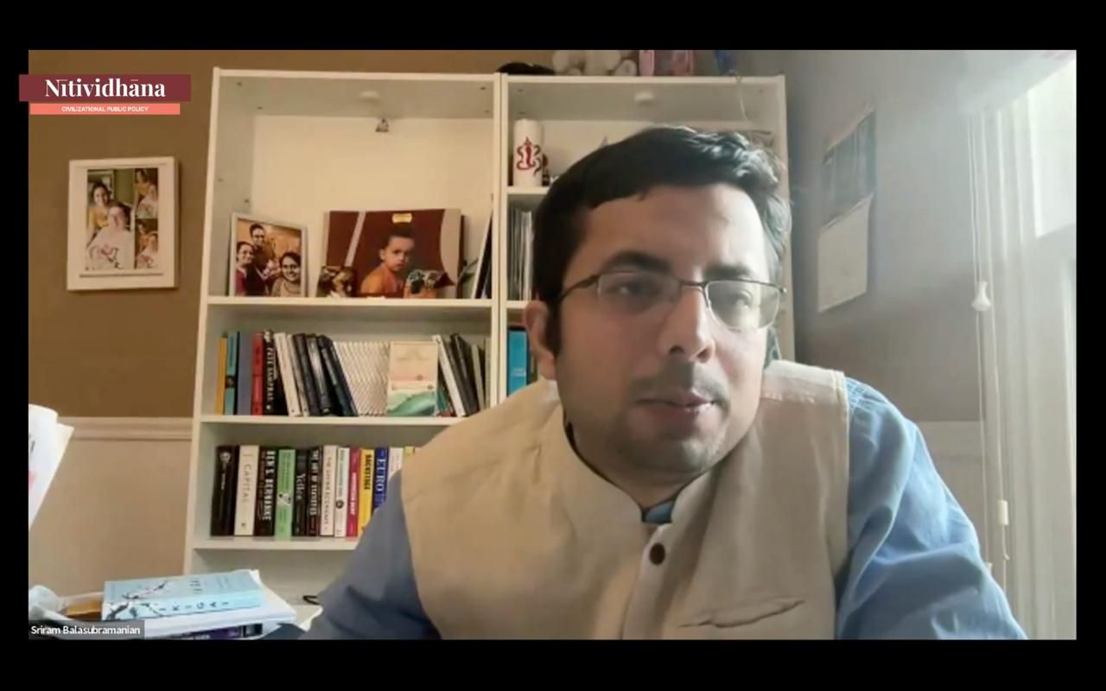

Week 8
Digital Humanities - Application
Dr. Anshu Singh’s session on Applications of Digital Humanities introduced participants to the transformative potential of Machine Learning (ML) in addressing policy challenges. She provided a critique of current AI and ML frameworks, identifying key limitations—such as bias in algorithms and data homogenization—that restrict their applicability to diverse societies like India. By reframing Indian Knowledge Systems (IKS) as valuable data repositories, she demonstrated how ML can be leveraged to analyze, preserve, and revive traditional knowledge.
Indian Economy and the Supranational Complex
Shri Rahul Goswami’s sessions on Indian Economy and the Supranational Complex provided a critical lens on global governance frameworks and their implications for national policy. He dissected the influence of supranational entities on local governance, economic structures, and cultural homogenization, highlighting how these institutions often dictate policy directions that may not align with India’s long-term interests. His discussion urged the cohort to critically examine international regulatory bodies, development agencies, and financial institutions, ensuring that India’s participation in global governance remains sovereign and values-driven rather than externally dictated.
Principles of Arthashastra - Economics and State Craft
Dr. Kajari Kamal’s session on Principles of Arthaśāstra – Economics and Statecraft introduced the cohort to Kauṭilya’s foundational ideas, emphasizing their relevance in contemporary governance. She illustrated how Arthaśāstra remains an unparalleled guide for policymaking, resource management, and geopolitical strategy in a rapidly evolving multipolar world. Participants explored how Kauṭilyan principles can inform modern governance, from managing state resources to securing national interests.
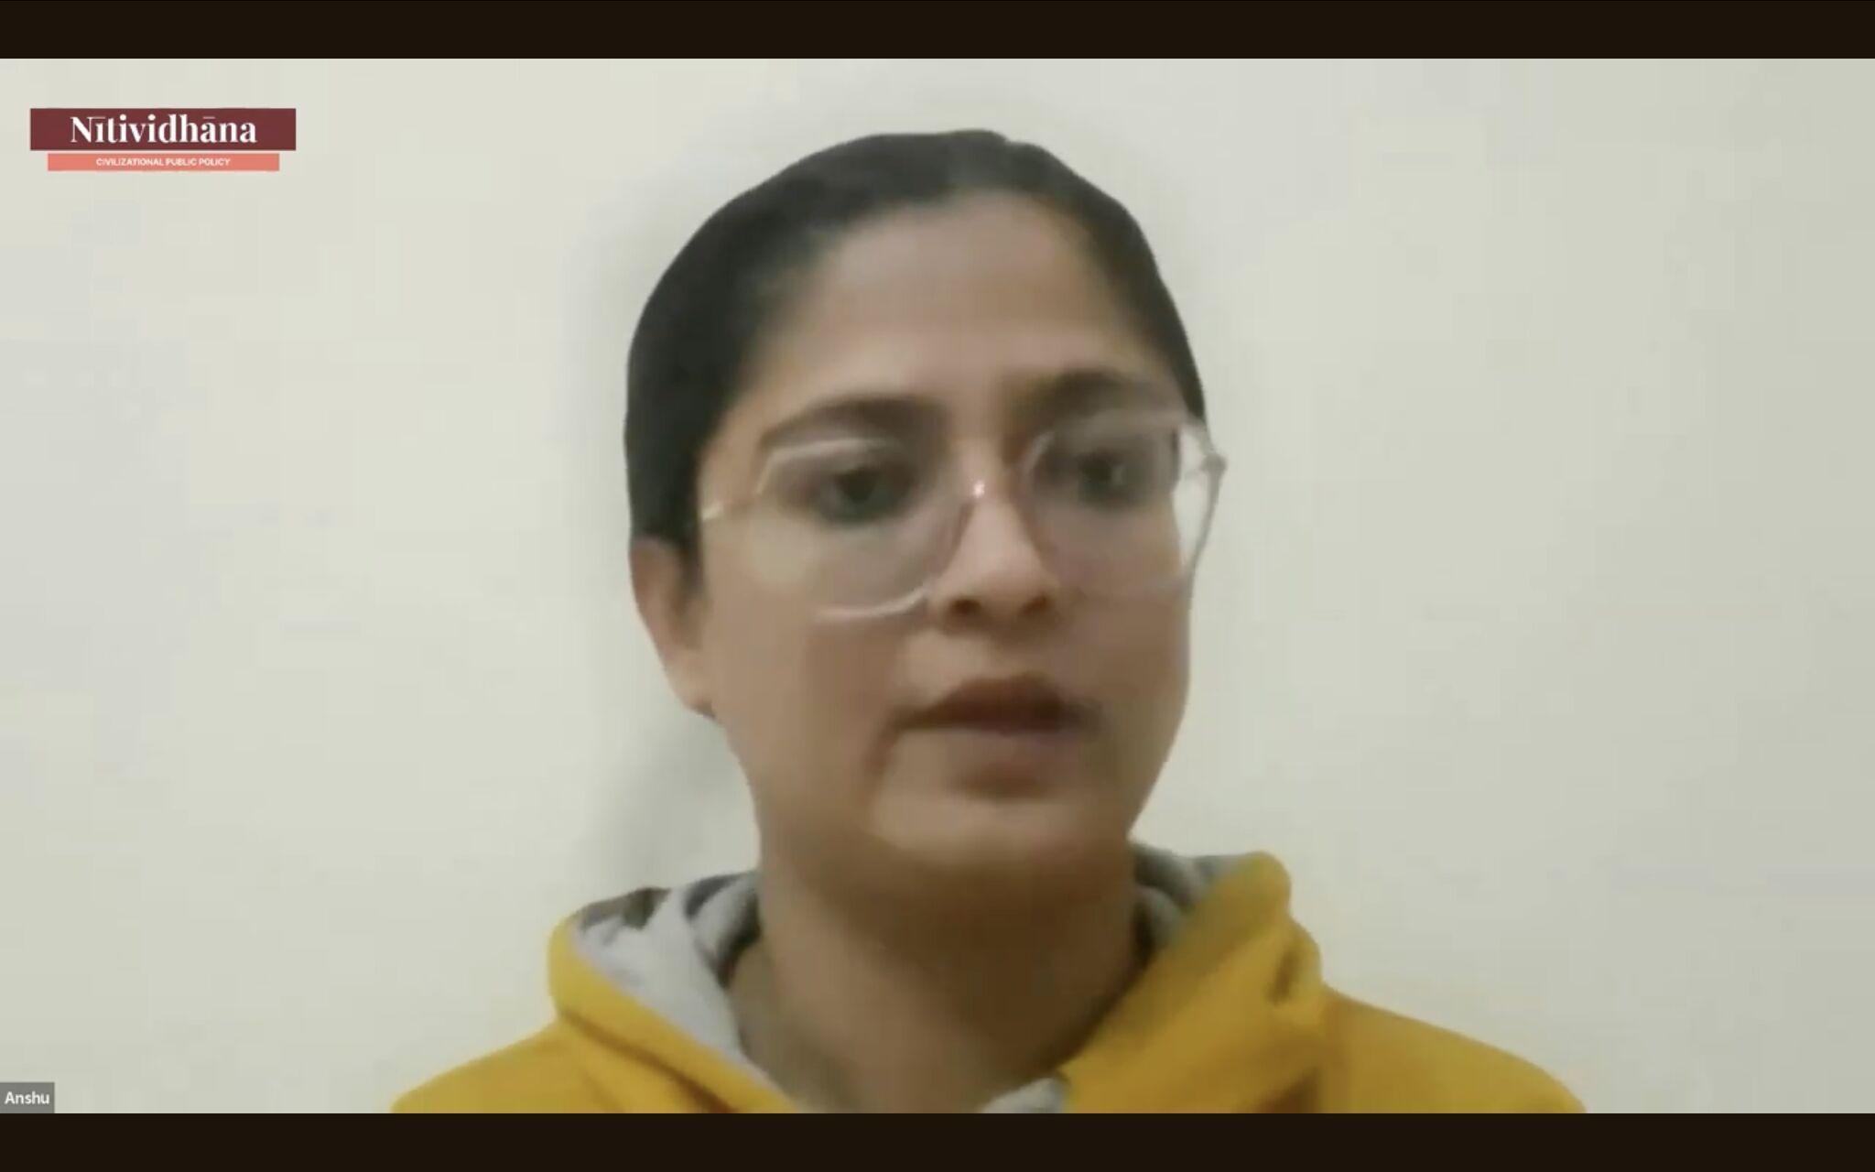

Week 9
Policy Writing Workshop
Shri Anurag Shukla’s Policy Writing sessions emphasized the art of effective policy communication. He guided participants through the process of structuring arguments, ensuring that policies are both analytically rigorous and accessible to diverse stakeholders. His sessions covered best practices in policy design, stakeholder engagement, and the application of Design Thinking alongside Civilizational Frameworks. His insights provided the cohort with a nuanced understanding of crafting impactful policies that connect effectively with both the public and policymakers.
Principles of Arthashastra
Building upon this, Shri Sriram Balasubramanian’s session on Principles of Arthaśāstra provided a deep dive into Kauṭilyan economic thought. He outlined key principles such as targeted redistribution, flexible minimum wages, and labor contracts that safeguard workers’ rights—demonstrating how economic policies must serve both individual prosperity and collective well-being. By drawing parallels between ancient economic structures and today’s financial systems, he showcased the viability of Dharmic capitalism—an approach that integrates wealth creation with ethical governance. His insights reinforced the need for India to reassert its own economic paradigms rather than conforming to Western models that often prioritize profit over sustainability and social harmony.
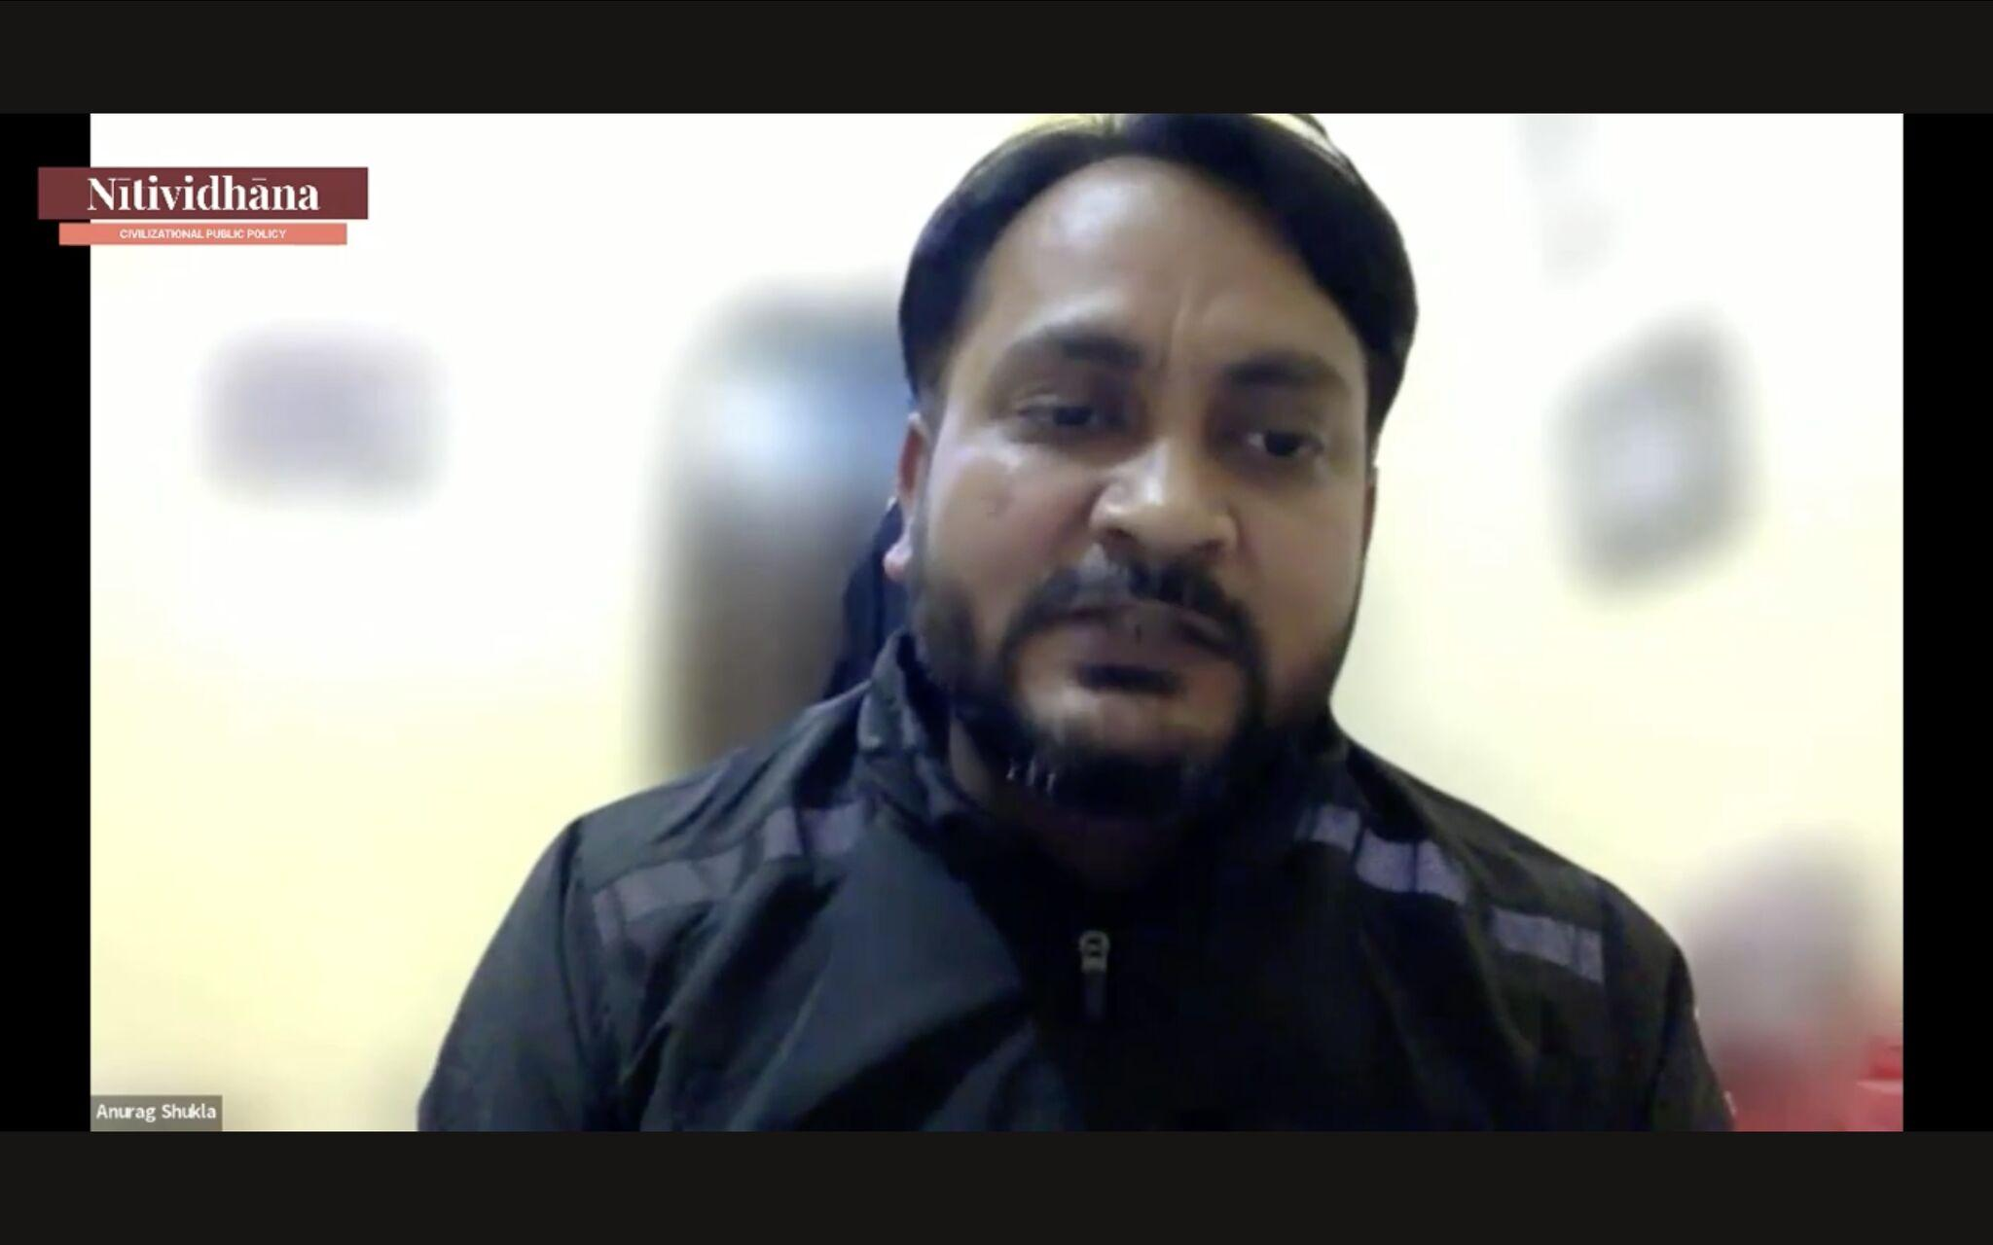

Week 10
Field Work Discussions - Pancha Kosha Model in Governance
Shri DK Hari and Smt. Hema Hari took participants on an introspective journey through the Pancha Kosha model, redefining governance as a citizen-driven and deeply human process. Rather than limiting governance to bureaucratic structures, they painted a vision where societal harmony (Samajam), citizen aspirations, and historical management practices shape policy and administration. With the precision of scholars and the clarity of storytellers, they unfolded governance as a layered phenomenon—one that transcends policies and institutions to encompass cultural consciousness, ethical leadership, and community-driven progress.
Field Orientation Module 1 - Education Policy and Governance
Shri Muneet Dhiman transported participants into the world of Vidyakshetra—an educational framework where tradition isn’t a relic but a living guide. His session was a departure from conventional policy discussions, offering instead a Jeevan Drishti—a worldview that connects knowledge to life. By integrating Bharatiya values into teacher training, mentorship, and student development, Vidyakshetra seeks to revive education as a holistic, value-based endeavor. Shri Dhiman’s insights illuminated the need to reorient pedagogy, ensuring that education nurtures not just intellect but character, preparing students to be responsible contributors to society.
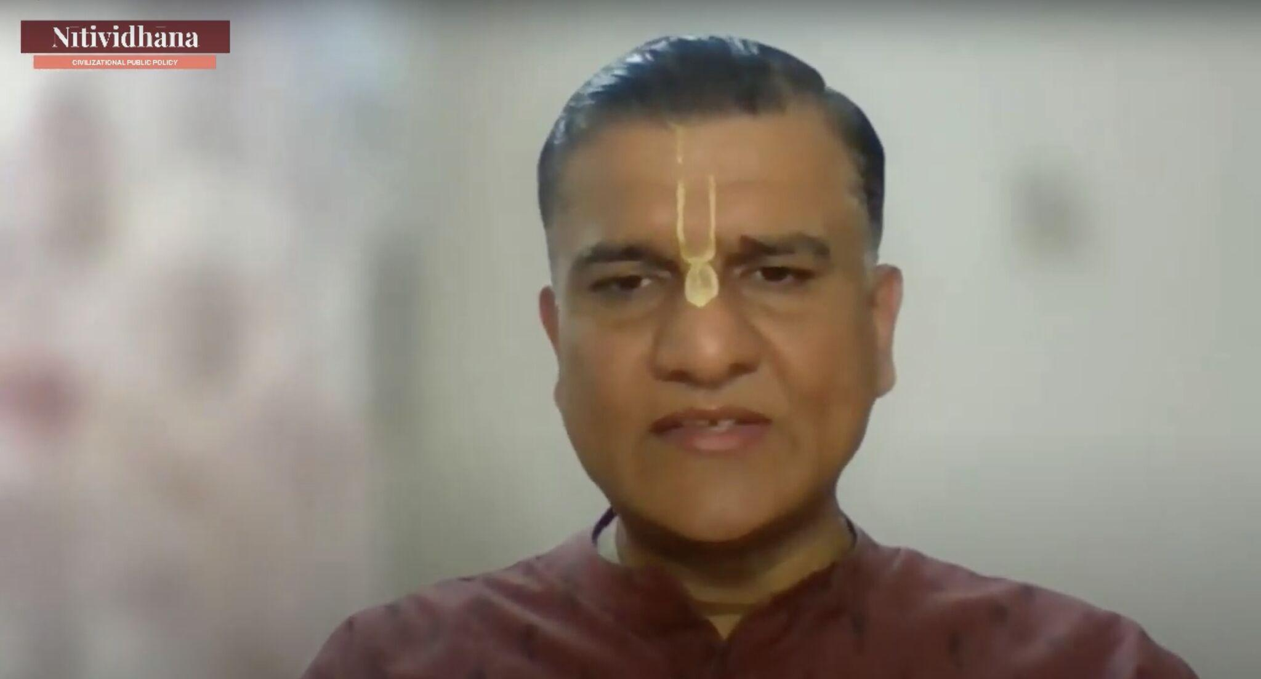
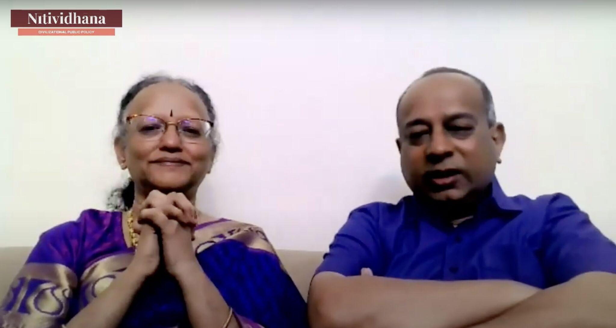

Week 11
Field Orientation Module 1 - Education Policy and Governance
Shri Ashok Pandey’s session offered a compelling journey through India’s education policies, from their philosophical roots to their present-day challenges. He decoded the guiding principles of NEP 2020, emphasizing the urgent need for decolonizing India’s educational systems. However, this was not just an analysis of policy frameworks; it was a vision for the future. He shared the vision of Bharat in 2047—where education is not just functional but deeply cultural, shaping not only intellect but also character.
Field Orientation Module 2 - Public Administration
Shri Manoj Srivastava’s session was a masterclass in bridging policy and reality. With decades of experience in administration, he unraveled the complexities of governance, emphasizing that administration is not just about rules and regulations but about ethics, courage, and cultural sensitivity. He explored how traditional knowledge systems can shape urban policy frameworks, making governance more ethical and people-centric. His practical insights underscored that good governance is not just about efficiency but about aligning policies with the lived experiences of people.
IKS Careers: Charting New Pathways
Bringing the focus back to the participants themselves, Shri Amritanshu Pandey addressed one of the most pressing concerns—career pathways in Indian Knowledge Systems (IKS) and public policy. Unlike conventional career choices, this field demands deep introspection, resilience, and a commitment to civilizational values. He also discussed challenges such as the lack of targeted data and the importance of self-awareness in policy careers. His session was both empowering and practical, reminding participants that the future of public policy is not just shaped in large offices but in small, meaningful actions driven by authenticity and purpose.
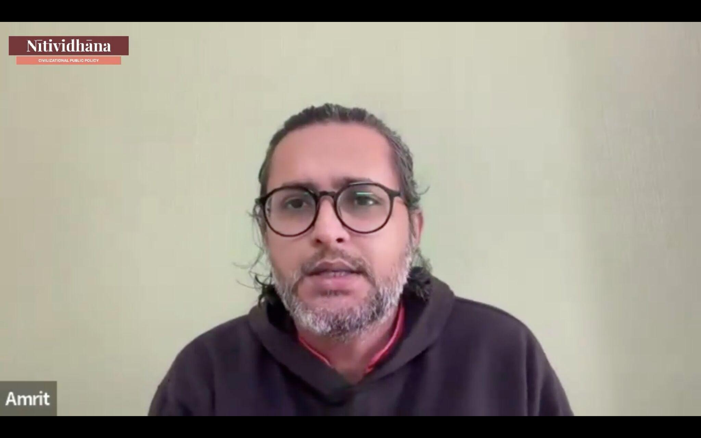

Week 12
Emerging Technology Design and Governance
Shyam Krishna Kumar, co-founder of The Pranava Institute, led a thought-provoking session on the intersection of technology, public policy, and society within the Indian context. Addressing key issues such as India’s digital transformation, regulatory frameworks, cybersecurity, and technology ethics, the discussion underscored the need for a dharmic approach to innovation. Participants engaged in a dialogue on the philosophical foundation required to navigate the complex relationship between technology and cultural values. The session emphasized that while emerging technologies present unprecedented opportunities, they must be governed by ethical frameworks rooted in Dharma.
Field Orientation Module 3 - Health Policy and Governance
Aarti Kumar, CEO of the Community Empowerment Lab, led a thought-provoking session on health policy and governance with a specific focus on childbirth experiences in India. Her session explored the physiological, cultural, and policy dimensions of maternal health, highlighting the gaps between traditional childbirth methods and evidence-based care. One of the most pressing issues she addressed was the decline of social knowledge surrounding breastfeeding and maternal care, largely due to rapid societal changes. This shift has led to a growing need for formal instruction and policy frameworks that integrate both traditional and scientific approaches.
Field Orientation Module 4 - Environmental Policy and Governance
Praveena Sridhar’s session on Environmental Policy and Governance highlighted her journey from corporate life to grassroots activism, offering firsthand insights into sustainable policymaking. She outlined effective methods for engaging with government entities, advocating for environmental policies that prioritize long-term ecological balance. Her discussion on the Save Soil movement and the Rally for Rivers initiative showcased successful models of policy engagement, where grassroots activism led to significant government funding for river rejuvenation. She also addressed critical policy hurdles in sustainable farming, such as regulatory challenges in tree felling and transportation. Her session reinforced the need for proactive environmental governance that bridges policy frameworks with community-driven solutions.
Master Synthesis Session
Raghava Krishna Ji’s Master Synthesis Session provided a reflective close to the discussions, emphasizing critical thinking and lifelong learning in public policy. His insights touched on the role of empathy in political leadership, the challenges of judicial reforms, and the need for a multi-disciplinary approach to policy design. He encouraged participants to cultivate a habit of reflective practice, framing public issues in a way that accounts for both cultural depth and real-world pragmatism. By linking technology, ethics, and civilizational values, his session urged participants to remain inquisitive and proactive in shaping governance. The discussions underscored that policy is not just about solving immediate problems but about designing long-term frameworks that uphold India’s civilizational continuity while addressing contemporary challenges.
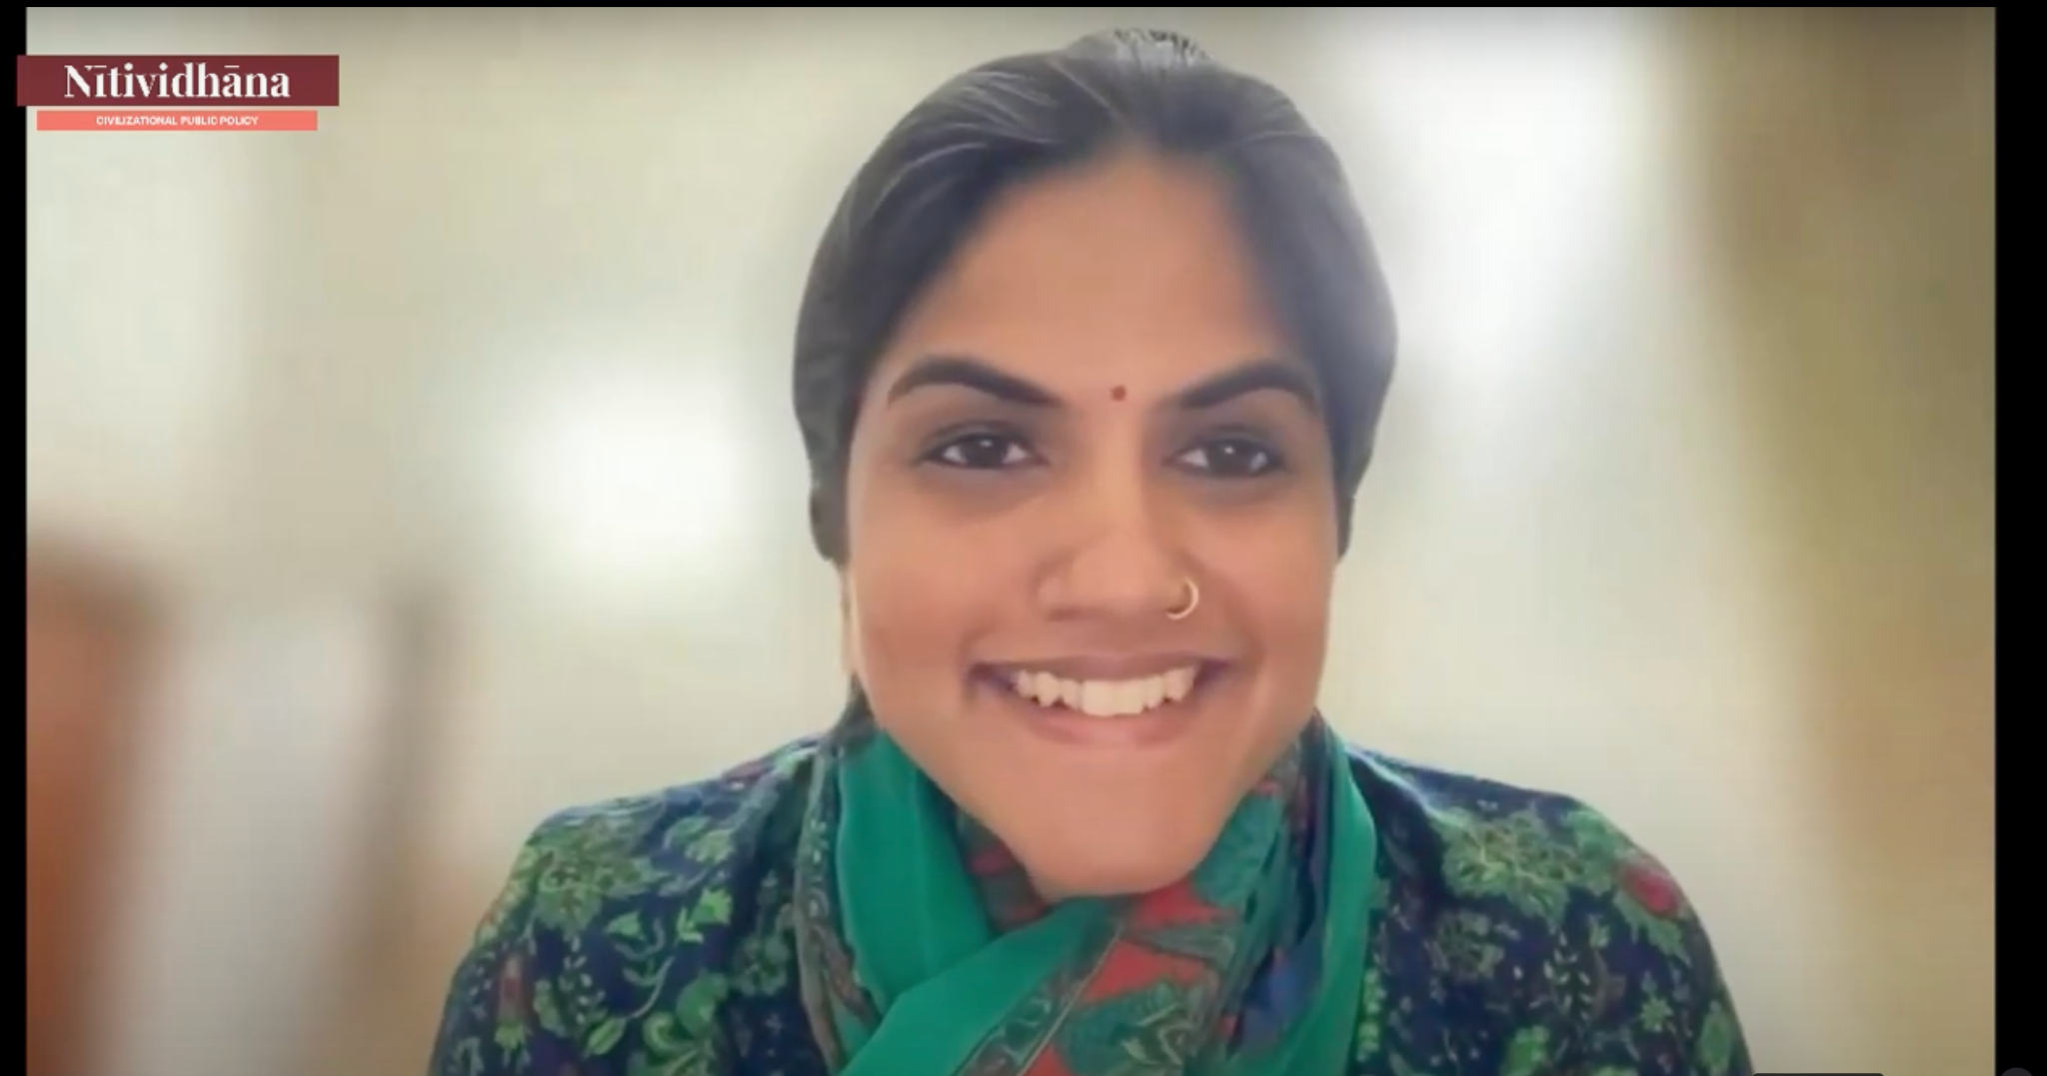

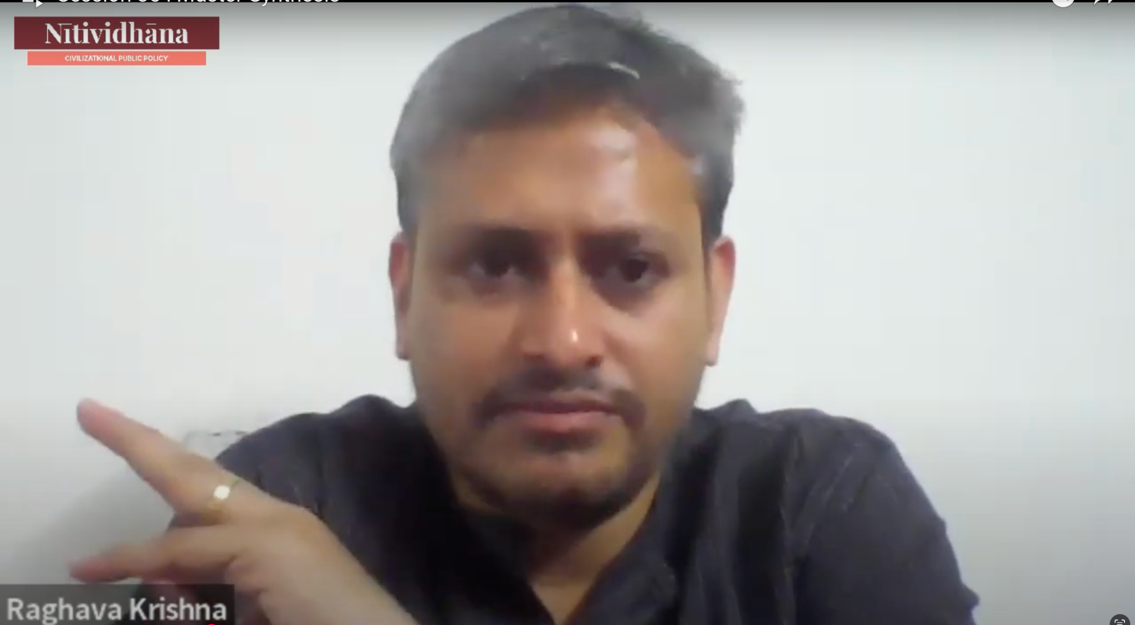

Group Presentations
As the Nītividhāna cohort moved towards the culmination of their learning journey, participants showcased their insights through thought-provoking group presentations. Under the guidance of expert mentors, each team explored contemporary policy challenges through an Indic perspective, offering original ideas that blended traditional wisdom with modern governance frameworks.
These presentations reflected a deep engagement with civilizational thought, proving that India’s ancient principles remain profoundly relevant in addressing today’s pressing issues.

Presentation Topics:
- Applications of Kauṭilya’s Dharma Drishti to the Technology Race in Today’s Geopolitical Context
- Reclaiming Harmony: Integrating Indic Perspectives in Environmental Policy Design
- Dharmic Curriculum for Primary and Secondary Schools
- Empowering Underprivileged Children in Urban Slums: A Civilizational Perspective
- An Indic Lens on India's Cybersecurity Policy
- Digital Dharma: Bharat's Digital Public Infrastructure in the Spirit of Vasudhaiva Kutumbakam
