COL-CEMCA and AIU organise Five-day FDP on Technology Enabled and Blended Learning at The NorthCap University in Haryana, India
The Commonwealth of Learning's regional centre, Commonwealth Educational Media Centre for Asia (COL-CEMCA) and the Association of Indian Universities (AIU) successfully conducted a five-day hybrid Faculty Development Programme (FDP) on Technology-enabled and Blended Learning from 6-10 January 2025 at The NorthCap University (NCU), Gurugram, Haryana. The initiative aligns with the National Education Policy 2020 (NEP 2020), which advocates continuous professional development for educators to enhance teaching practices and institutional capabilities.
The programme aimed to equip the faculty members, and administrative staff at NCU with the knowledge and tools necessary to integrate technology and blended learning into higher education effectively. Apart from sensitising them on NEP 2020, Open Educational Resources (OER), the Graduate Employability Framework, it also included a comprehensive session on the Institutional Blended Learning Policy (IBLP) template created by COL-CEMCA, and its implementation strategies. The FDP was attended by more than 50 educators and staff from NCU. Adopting a participatory approach with group discussions and interactive activities, the programme also included baseline and feedback surveys to assess its impact on participants.
The inaugural session featured addresses by eminent persons, including Prof. Nupur Prakash, Vice-Chancellor, NCU; Dr. Pankaj Mittal, Secretary General, AIU; Dr. B. Shadrach, Director, COL-CEMCA; and Prof. Anjali Garg, Director, Centre for Distance and Online Education, NCU.
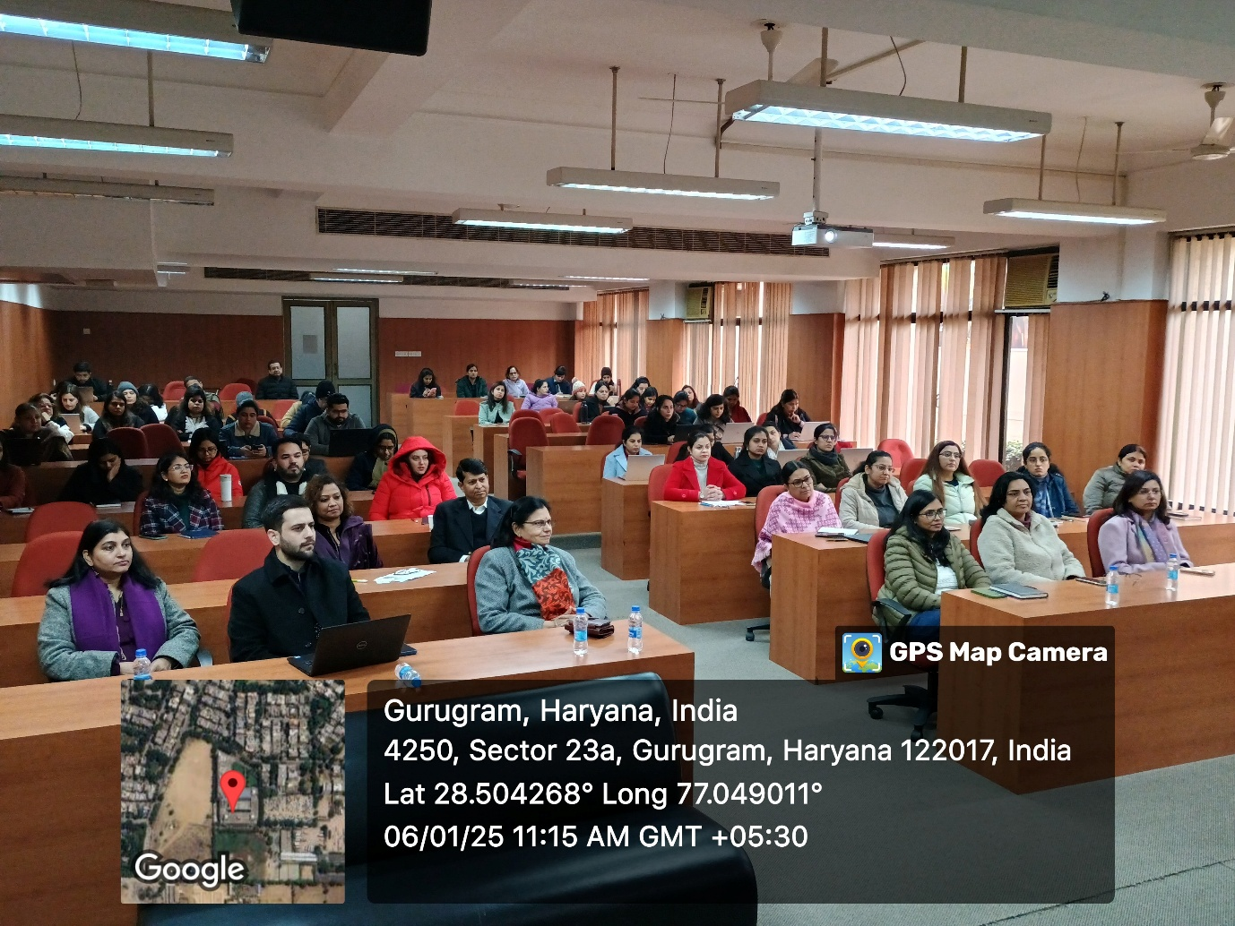
Dr. Shadrach highlighted the programme’s alignment with NEP 2020 reforms, which emphasise multidisciplinary education, enhanced research, leveraging technology, and granting autonomy to high-performing institutions. He noted, “AIU and COL-CEMCA wish to see you perform, innovate, and enhance your research capabilities, engage in multi-disciplinary education that offers flexibility and, above all, achieve these by leveraging technology for education including Artificial Intelligence.”
The five-day programme included COL-CEMCA expert-led sessions with Dr. Santosh Panda, Former Director, STRIDE, Indira Gandhi National Open University (IGNOU), New Delhi, providing insights into the scope and role of Technology-enabled Learning (TEL) and its integration with blended learning. Ms. Sheriya Sareen, Ph. D Scholar, IIT Jammu, introduced the Institutional Blended Learning Policy (IBLP) template. Dr. Barnali Roy Choudhury from Netaji Subhas Open University explored the use of OER, MOOCs, and Learning Management Systems (LMS) in education, and Dr. Ashish Kumar Awadhiya from IGNOU, discussed skilling and graduate employability in India.
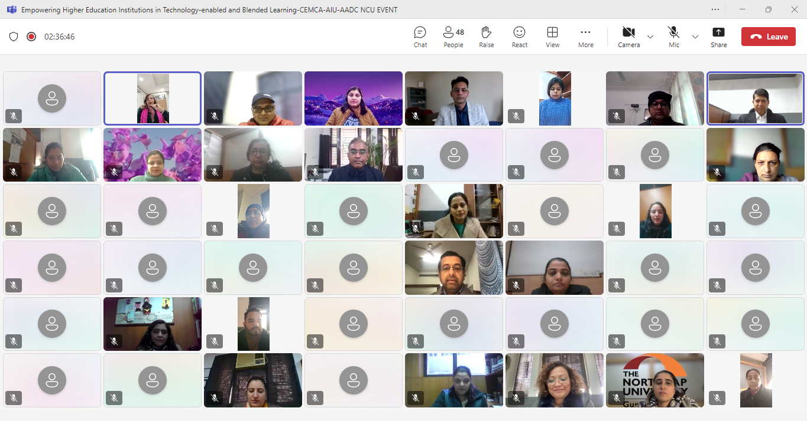
The FDP was ably coordinated by Dr Satnam Singh, Coordinator, AADC-NCU, Dr Ranjana Parihar, Joint Secretary, AIU and Dr B Shadrach, Ms Monica Sharma, and Mr Aflaq Shah from COL-CEMCA.
The event underscored COL-CEMCA and AIU’s commitment to fostering transformative learning experiences, enabling institutions like NCU to excel in delivering innovative, technology-enabled education.

