COL-CEMCA and AIU organise an online five-day FDP on Technology Enabled and Blended Learning at Panjab University, Chandigarh, India
The Commonwealth Educational Media Centre for Asia (COL-CEMCA) and the Association of Indian Universities (AIU), hosted a Faculty Development Programme (FDP) on "Empowering Higher Education Institutions in Technology-Enabled Learning (TEL) and Blended Learning" at AIU affiliated AADC -Panjab University, Chandigarh from 24 February to 1 March 2025. The programme equipped the over 70 educators with the skills and knowledge to integrate TEL and blended learning into their teaching practices, with a focus on institutional policy development and the creation of open educational resources (OERs). This initiative sought to harness technology for transformative educational experiences, aligning with the goals of the National Education Policy (NEP) 2020.
Professor Renu Vig, Vice Chancellor, Panjab University, expressed gratitude to COL-CEMCA and AIU for organising this significant FDP. Underscoring the transformative potential of digital platforms in education, she mentioned that universities can now offer 40 percent of their courses through MOOCs, with students being able to earn up to 20 percent of their credits via these platforms. Panjab University has been a leader in this initiative, with its faculty serving as SWAYAM coordinators and creating courses accessed by over 90,000 students. Professor Vig emphasised the need for educators to stay ahead in leveraging artificial intelligence (AI) to ensure quality learning.
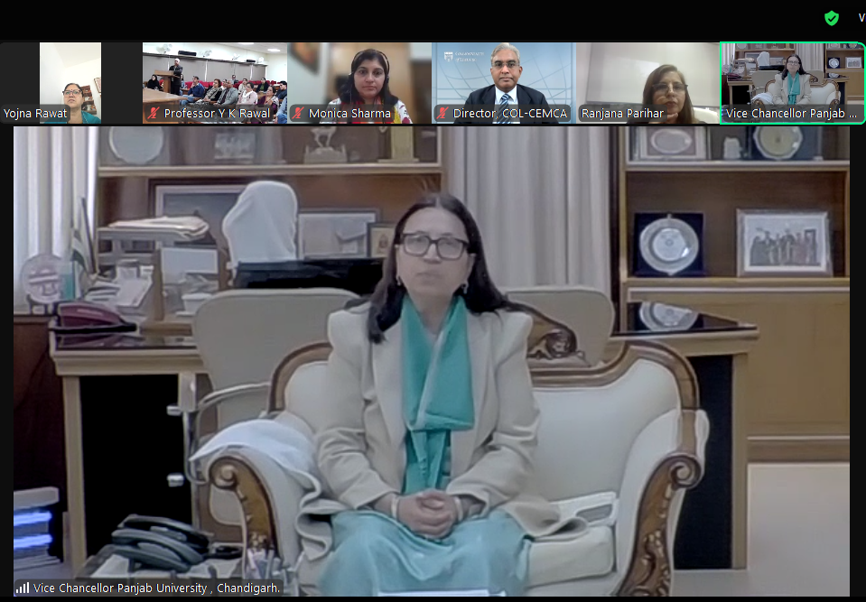
Dr B. Shadrach, Director of COL-CEMCA, emphasised the importance of open learning initiatives, noting that Panjab University was one of 12 institutions selected for this year’s FDP. He stressed the programme’s role in helping universities implement NEP 2020 and develop institutional-level blended learning policies. Dr Shadrach also highlighted the potential for educators to create courses for their own LMS, which can be shared across universities, reaching millions of learners.
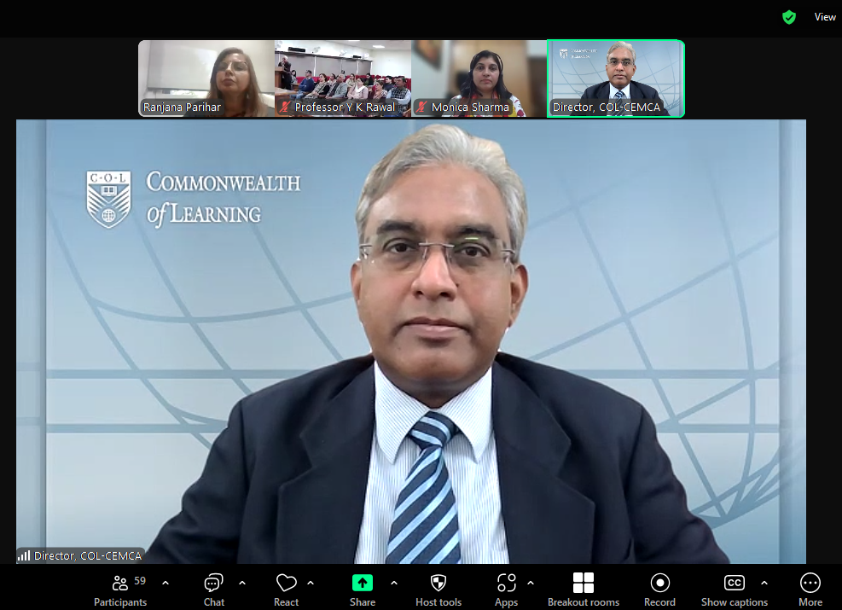
Professor YK Rawal, Coordinator of the Academic and Administrative Development Centre (AADC) at Panjab University, acknowledged the growing role of technology in education. Dr Yojna Rawat, Director of the Research and Development Cell, emphasised the irreplaceable role of educators while advocating for equipping them with technological skills to enhance teaching and learning outcomes. Ms. Ranjana Parihar, Joint Secretary of AIU, praised Panjab University for hosting the initiative, which aligns with AIU’s mission of strengthening technology-enabled teaching practices.
Dr. Ranjana Parihar, Joint Secretary, in her address, expressed gratitude to CEMCA for the collaboration and highlighted the crucial role of AIU-AADCs in providing practical training to faculty members of Higher Education Institutions (HEIs). She emphasized the significance of technology-enabled learning and blended learning in keeping pace with the rapidly evolving educational landscape.
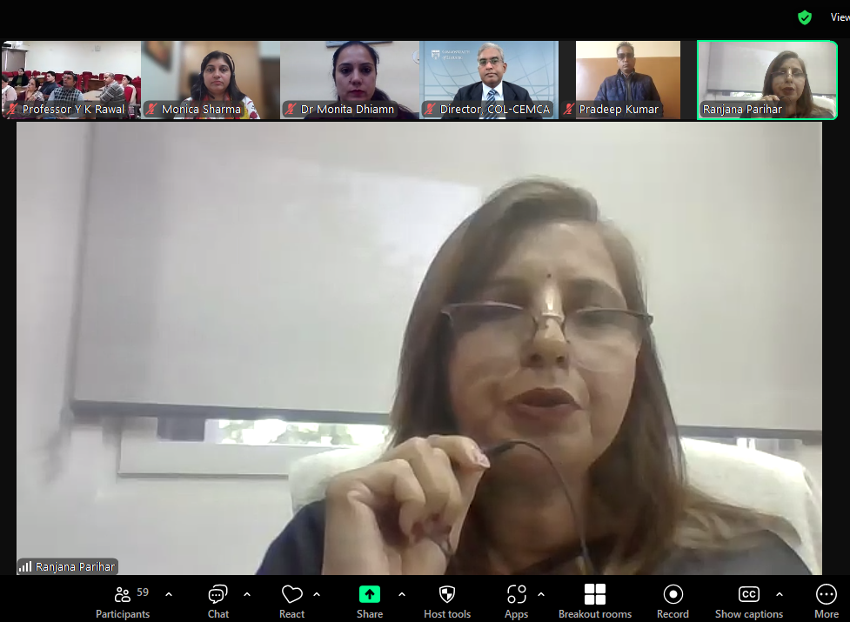
The FDP featured sessions by distinguished COL-CEMCA consultants, including Dr Ajith Kumar C, who discussed the concept and scope of TEL, and Ms. Sheriya Sareen, who guided participants in developing and implementing the Institutional Blended Learning Policy (IBLP) template. Dr Papiya Upadhyay elaborated on the use of OERs, MOOCs, and LMS, while Ms Ojasvi Goyal shared insights on skilling and employability.
Together, these sessions provided a comprehensive understanding of innovative educational practices, reinforcing Panjab University’s commitment to embracing technology and enhancing learning experiences for educators and students alike.
The FDP was ably coordinated by Dr YK Rawal, Coordinator, AADC-PU, Dr Ranjana Parihar, Joint Secretary, AIU and Dr B Shadrach, Ms Monica Sharma, and Mr Aflaq Shah from COL-CEMCA.

