AIU-VGU-AADC: Faculty Development Programme: “Pravaah”
FDP-III: "Empowering Higher Education: Understanding & Integrating National Education Policy 2020"
Report
The Association of Indian Universities (AIU), in collaboration with Vivekananda Global University (VGU) and its Academic and Administrative Development Centre (AADC), organized a transformative five-day Faculty Development Program (FDP) from May 13 to May 17, 2024. Themed "Empowering Higher Education: Understanding & Integrating National Education Policy 2020," the FDP aimed to provide educators with a comprehensive understanding of the National Education Policy (NEP) 2020 and its implications for the higher education landscape.
The program commenced on May 13, 2024, with an inaugural ceremony. Mr. Aseem Purohit, Head of the Department of Management Studies at VGU, welcomed the participants and introduced the objectives of the FDP. Prof. Santosh Kumar, Acting President of VGU, delivered the welcome address, setting the stage for the discussions ahead. Dr. Boola Choudhary, Coordinator of AIU-VGU-AADC, provided an overview of the FDP, emphasizing its significance in aligning educational practices with the NEP 2020. Prof. D.V.S. Bhagvanulu, Pro-President (RA) of VGU, shared his insights on the necessity of integrating NEP 2020 into higher education. The highlight of the inaugural session was an address by the Chief Guest, Er. Onkar Bagaria, CEO of VGU, who underscored the importance of adopting application-based teaching methodologies, fostering interactive classroom environments, and instilling Indian values in educational practices. The inaugural session concluded with a vote of thanks by Prof. Praveen Chaudhary, Registrar of VGU. Around 30 faculty members participated in the FDP.
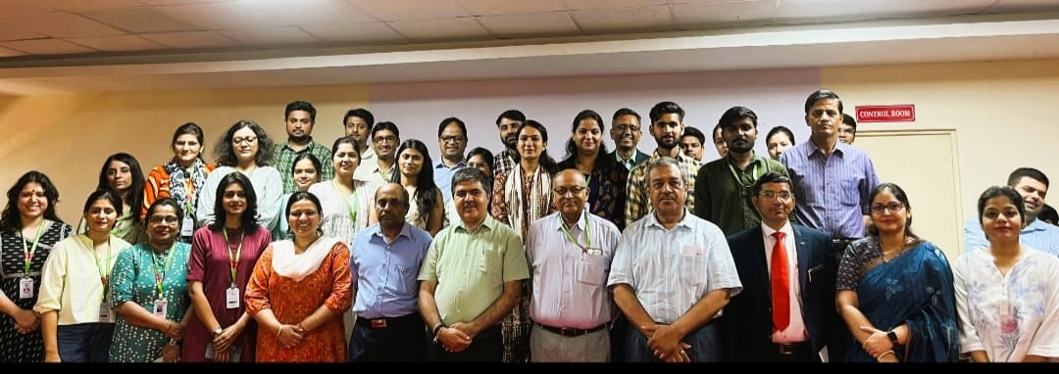
The first technical session, held later on the same day, was led by Prof. D.V.S. Bhagvanulu, who delved into the objectives of the National Research Foundation (NRF) and the critical importance of research ethics. Prof. Bhagvanulu discussed the NRF's role in promoting high-quality research and innovation in Indian higher education. He highlighted the need for adherence to ethical standards in research to ensure integrity and credibility in academic work. The session provided participants with a clear understanding of how the NRF aims to support and enhance the research ecosystem in India, aligning with the broader goals of NEP 2020.
On the second day, Dr. Ritika Mahajan, Assistant Professor in the Department of Management Studies at MNIT Jaipur, led a session on "Indian Ethos & Culture: NEP 2020." Dr. Mahajan emphasized the significance of integrating Indian cultural values and ethos into the educational framework, as outlined in the NEP 2020. She discussed how the policy aims to promote a sense of national pride and cultural awareness among students. Dr. Mahajan highlighted various pedagogical approaches that educators can adopt to embed Indian ethos in their teaching practices, thus fostering a holistic learning environment that respects and celebrates India's rich cultural heritage. Participants engaged in lively discussions, exploring practical ways to incorporate these values into their curricula.
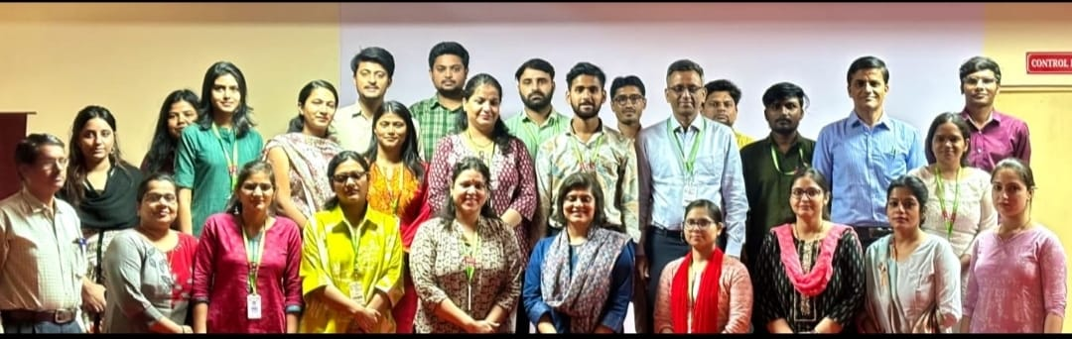
The third day focused on "Multidisciplinary Education & Holistic Development," with Dr. Dipti Sharma, Associate Professor in the Department of Humanities and Social Sciences at MNIT Jaipur, leading the session. Dr. Sharma discussed the NEP 2020's emphasis on multidisciplinary education, which aims to break down silos between different fields of study and promote a more integrated and holistic approach to learning. She explained how this approach can help students develop a well-rounded skill set, better preparing them for the complexities of the modern world. Dr. Sharma also shared examples of successful multidisciplinary programs and initiatives, encouraging participants to think creatively about how they can implement similar strategies in their institutions. The session provided valuable insights into fostering an educational environment that nurtures intellectual curiosity and holistic development.
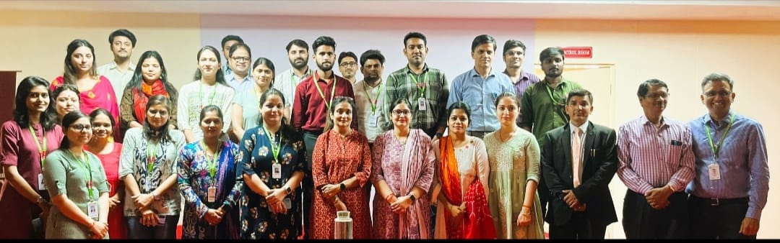
On the fourth day, the focus shifted to "Technology and Education with Reference to NEP," with Dr. Dilip P. Barad, Dean, Professor, and Head of the Department of English at Maharaja Krishna Kumar Singhji Bhavnagar University, Gujarat, leading the discussion. Dr. Barad highlighted the pivotal role of technology in modern education, as envisioned by NEP 2020. He discussed various technological tools and platforms that can enhance teaching and learning experiences, making education more accessible and engaging for students. Dr. Barad also addressed the challenges and opportunities associated with integrating technology into the classroom, including issues of digital literacy and equitable access. He encouraged educators to embrace technological innovations while being mindful of their pedagogical implications. The session sparked a dynamic exchange of ideas on leveraging technology to achieve educational excellence.
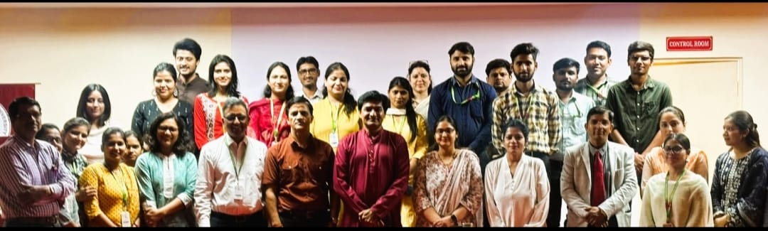
The final day of the FDP featured a session on "NEP 2020 & Innovation in Teaching Practices," led by Dr. Vinod Shanwal, Professor and Head of the Department of Education and Training at Gautam Buddha University, Greater Noida, Uttar Pradesh. Dr. Shanwal emphasized the need for continuous innovation in teaching practices to meet the evolving demands of higher education. He discussed various innovative pedagogical strategies that align with the objectives of NEP 2020, such as experiential learning, project-based learning, and the use of digital tools to facilitate interactive and student-centred learning environments. Dr. Shanwal shared case studies and examples of innovative teaching practices that have proven effective in enhancing student engagement and learning outcomes. Participants were encouraged to reflect on their teaching methods and consider how they can incorporate innovative practices into their own classrooms.
The FDP concluded with a valedictory ceremony, featuring an address by Prof. Meeta Mathur from the University of Rajasthan, Jaipur. Prof. Mathur highlighted the critical role of educators in transforming the educational landscape in line with NEP 2020. She emphasized the importance of continuous professional development and the adoption of innovative teaching practices to ensure that educators are well-equipped to meet the evolving needs of students. Prof. Mathur's address underscored the need for a collaborative and forward-thinking approach to education, inspiring participants to take an active role in driving positive change in their institutions. The ceremony included a report on the FDP by Dr. Boola Choudhary, addresses by Prof. Santosh Kumar and Prof. D.V.S. Bhagvanulu, and a vote of thanks by Ms. Malvika Dudi Bagaria, Director of the Faculty of Management at VGU.
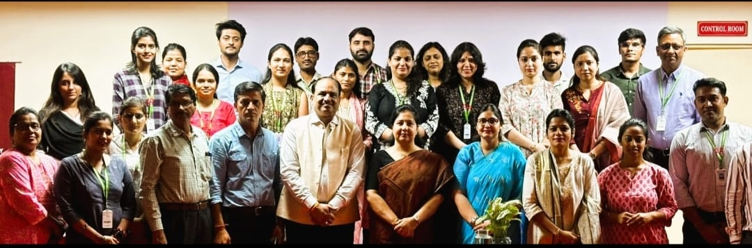

The five-day FDP was a significant step toward equipping educators with the knowledge and skills necessary to implement the NEP 2020 effectively. The program fostered a collaborative environment for sharing insights and strategies to enhance the quality of higher education. The active participation and expert-led sessions provided valuable learning experiences for all attendees, contributing to the overarching goal of empowering higher education in India. The program's success highlights the importance of continuous professional development and the adoption of innovative approaches to teaching and learning, paving the way for a transformative educational landscape in India.

