COL-CEMCA, AIU and SVU Organise Online FDP on TEL and Blended Learning
The Commonwealth Educational Media Centre (COL-CEMCA), Commonwealth of Learning (COL)’s Asian regional centre, and the Association of Indian Universities (AIU) collaborated to conduct Faculty Development Programmes (FDPs) on Technology-enabled Learning (TEL), and Blended Learning in AIU’s Academic and Administrative Development Centres (AADCs) hosted by member higher education institutions (HEIs) across India. The was the second FDP in this series hosted by the Faculty and Staff Development Centre (FSDC) at Somaiya Vidyavihar University (SVU) in Mumbai, Maharashtra, from 13 to 17 January 2025.
This landmark FDP focused on empowering the SVU faculty members to adopt TEL and blended learning to enrich their teaching and learning practices. The FDP was inaugurated on 13 January 2025 by eminent dignitaries from COL-CEMCA, AIU, and SVU, with more than 70 participants attending the session on Day 1. The event highlighted the increasing importance of these approaches in line with the National Education Policy (NEP) 2020, which was underlined by all the speakers on this occasion.
Appreciating this initiative, Professor Rajasekharan Pillai, Vice Chancellor, SVU, emphasised the importance of educators’ capacity building in specific technologies to ensure effective adoption of TEL and blended learning. Professor Pillai expressed his gratitude to COL-CEMCA for its support, envisioning this partnership as the foundation for many more future innovations and collaborations.
Dr B. Shadrach, Director, COL-CEMCA, provided a detailed programme overview, highlighting the five key transformations advocated by NEP 2020, i. e., multi-disciplinary education and flexibility, increased focus on research, leveraging technology for education, and greater autonomy for HEIs performing well. He lauded SVU’s innovative efforts under the leadership of Professor Pillai to become one of the best HEIs in delivering education face-to-face, online and in open and distance mode.
Dr Pankaj Mittal, Secretary General, AIU, in her remarks, expressed gratitude to SVU and CEMCA for organising the programme, especially during AIU's centenary celebrations. She discussed AIU’s efforts in teacher training, including creating e-content and incorporating AI into teaching-learning practices. Dr Mittal elaborated on the prospects of technology in revolutionising problem-solving and personalised learning in education.
In her observations, Dr Ranjana Parihar, AIU, commended the visionary approach of the programme, made possible by CEMCA’s generous support. She emphasised its potential to equip participants with a deeper understanding of TEL and blended learning practices.
The inaugural session was anchored by Dr Preeti Rawat, Ms. Shreya Nair from FSDC-SVU. In her remarks, Dr Rawat emphasised the critical need for TEL and blended learning in modern education. She shared insights into the role of FSDC in advancing faculty capacity building and commended the programme for addressing these emerging needs.
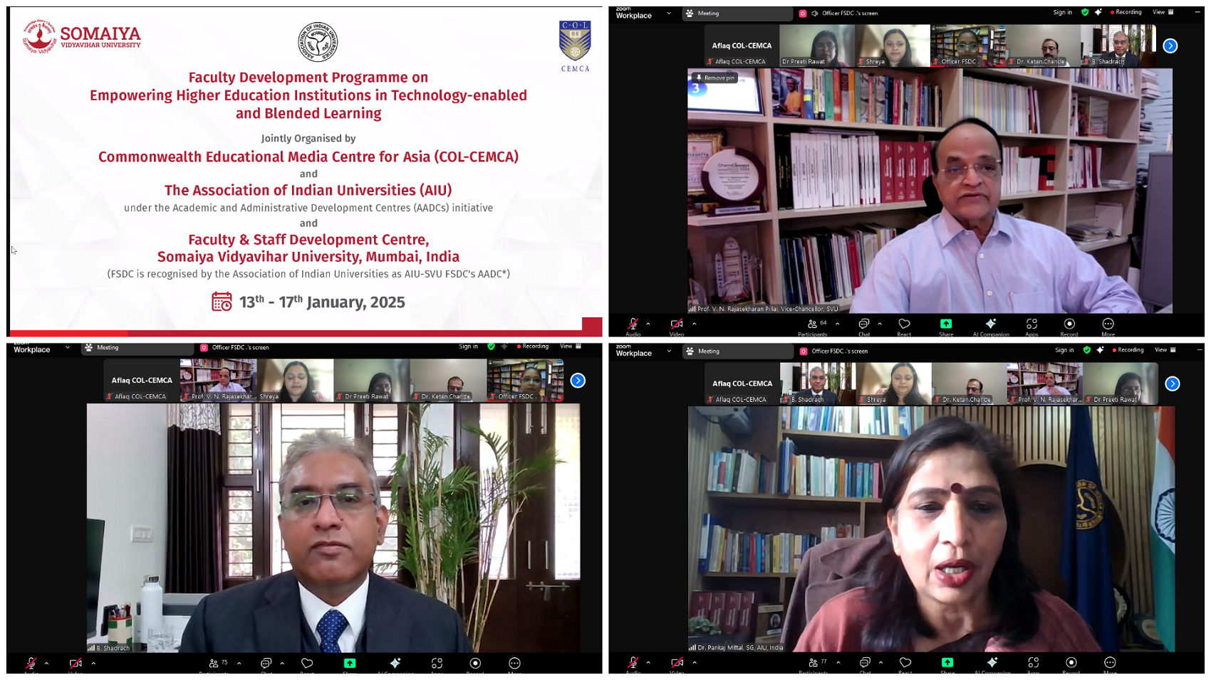
The five-day workshop featured a rich array of sessions delivered by distinguished experts. On the first day, the participants explored the features of NEP 2020, while on the second day, Professor (Dr) Santosh Panda, Former Director, STRIDE, Indira Gandhi National Open University (IGNOU), New Delhi, led an insightful session on effective implementation of TEL. This was followed by a presentation by Professor Jeetendra Pande from Uttarakhand Open University, who discussed the advantages of OERs and their integration into blended learning environments. Dr. Ashish Kumar Awadhiya from IGNOU conducted a session on graduate employability offering participants valuable insights and practical tools, while Sheriya Sareen from IIT, Jammu, introduced the IBLP template on the final day.
On the conclusion of the FDP, Dr B. Shadrach, Director of COL-CEMCA, thanked SVU and its Faculty and Staff Development Centre (FSDC) team for their efforts in making the programme a success. “We are privileged to partner with SVU. This initiative not only equips educators with critical skills but also lays the foundation for further collaboration,” he remarked. Dr Shadrach also introduced resources offered by COL-CEMCA, including templates for IBLP, OER, and TEL policies, as well as future initiative around developing an institutional policy template on Artificial Intelligence (AI) and Generative AI to streamline its adoption by educational institutions.
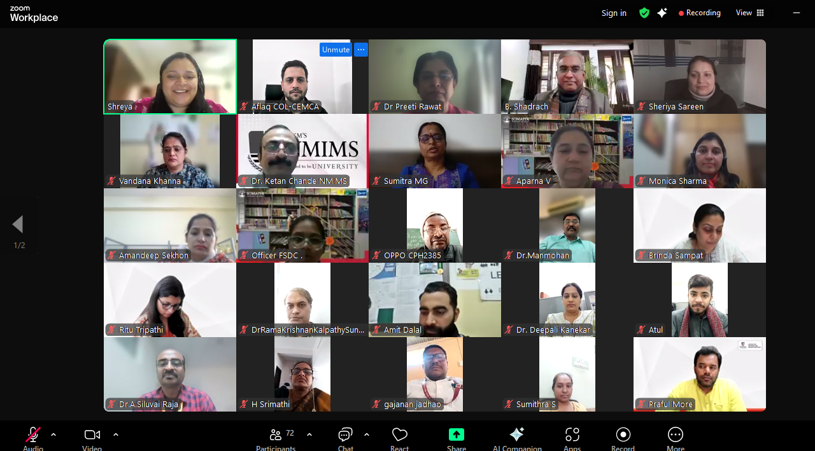
In her concluding remarks, Dr Preeti Rawat from FSDC, SVU, emphasised the significance of such programmes, highlighting their alignment with the vision of India’s National Education Policy (NEP) 2020, particularly in promoting Blended Learning. Dr Rawat expressed gratitude to COL-CEMCA for providing engaging and resourceful sessions, which were enhanced through interactive activities in breakout rooms.

