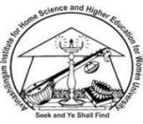
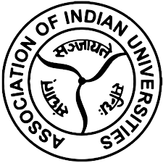

AVINASHILINGAM INSTITUTE FOR HOME SCIENCE AND HIGHER EDUCATION FOR WOMEN
(Deemed to be university under category ‘A’ by MHRD,Estd. u/s 3 of UGC Act 1956)
Re-accredited with ‘A++’ Grade by NAAC, Recognized by UGC under section 12B Coimbatore-641 043, Tamil Nadu, India
Report on Second Short-Term Capacity Building Program for the year 2025
“Transforming Visual Communication Education with Artificial Intelligence”
Organized By
The AIU-AI-AADC
(Association of Indian Universities - Avinashilingam Institute Academic & Administrative Development Centre)
&
Centre for Machine Learning and Intelligence
&
Department of Visual Communication
School of Arts and Social Sciences

17.03.2025 - 21.03.2025

AIU-AI-AADC
Report on Second Short-Term Capacity Building Program
“Transforming Visual Communication Education with Artificial Intelligence”
17.03.2025 - 21.03.2025
The AIU-AI-AADC (Association of Indian Universities - Avinashilingam Institute - Academic & Administrative Development Centre), Centre for Machine Learning and Intelligence and Department of Visual Communication jointly organized its Second Short-Term Capacity Building Program on “Transforming Visual Communication Education with Artificial Intelligence” for 2025 from 17th March to 21st March 2025.
The program aimed to provide a comprehensive understanding of AI concepts and their applications in visual communication. The participants were provided an overview of contemporary AI tools and techniques relevant to visual communication education. The programme enabled the participants to understand the various AI practices in the fields of designing, newsrooms and other audio-visual media. They were given hands-on experience with AI-powered design and teaching and research tools to promote innovative and collaborative teaching and research strategies for visual communication.
Thirty-two participants from diverse institutions attended online sessions, focusing on integration of Visual Communication education and artificial intelligence.
The inaugural programme started with a prayer song. The welcome address was given by Dr. K. Ramya, Coordinator of Academic and Administrative Development Centre. The overview of the sessions in the programme was given by Dr. V. Jayashree, Headi/c, Department of Visual Communication. The presidential address was given by Dr. Shobhana Kokkadan, Dean, School of Arts and Social Sciences. The inaugural address was given by Mr. Trotsky Marudhu and the Vote of Thanks was given by Dr. P. Subashini, Coordinator, Centre for Machine Learning and Intelligence.
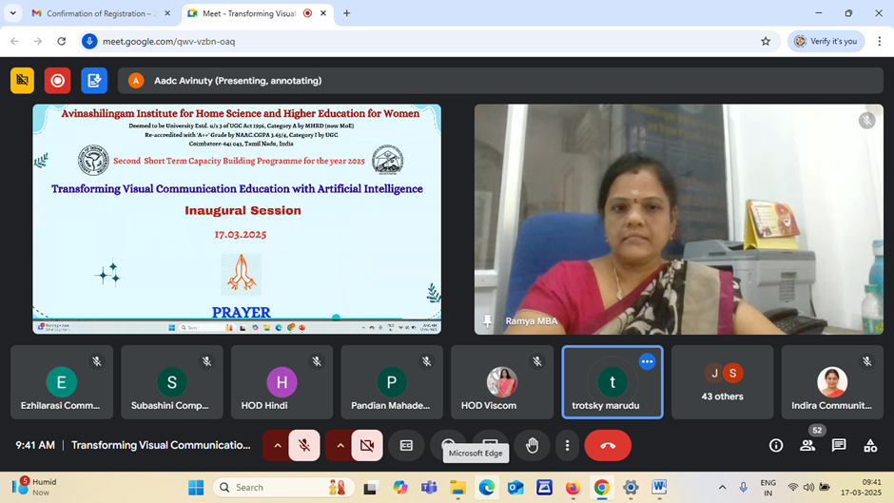
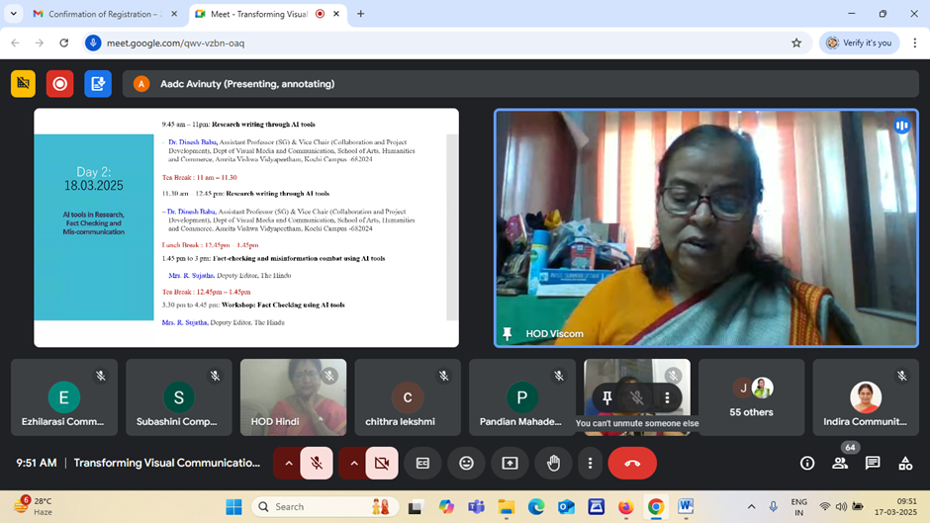

Session I & II – 17.03.2025
Overview of AI tools for Creative Industries
Resource Person : Mr. M.Trotsky Marudu
Presidents, Dr. MGR Institute of Film and Television Technology, Chennai

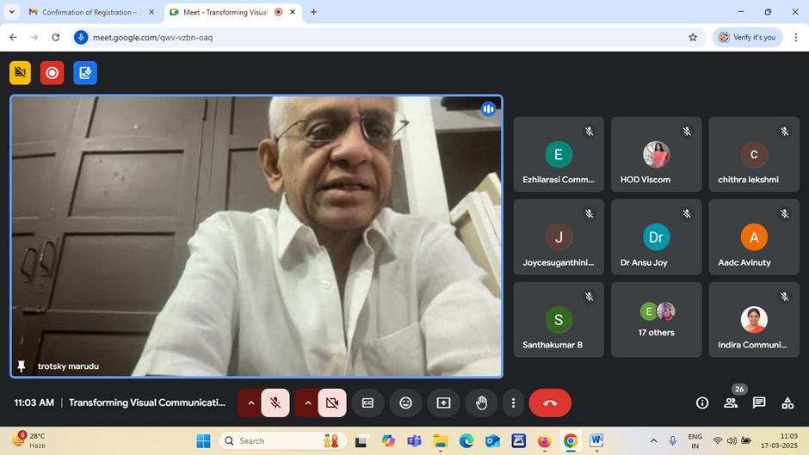
Mr. Marudu spoke about the evolution of various forms of communication from print to internet. He stated that he was amused by the classical literature printed in the form of comic books in his early childhood. He said the camera was first used by an artist and as many lenses had evolved it had taken shape into an instrument of photography. As he studied in the College of Fine arts in the sixties, the vicinity of Moore Market near the college got them access to filmmaking styles of Sam Pekinpa and Ridley Scott through books. The Disney comics and several other comic books were available at that time. But the comic books did not carry the violence portrayed by the above said directors. Hence the cartoons where there is an array of images telling stories in consecutive frames inspired him to get in to animation.
He stated that around ten artists had to work for three months to animate a sequence that was easily compiled by an AI app. He added the AI illustrations had grown in multitudes in Chinese and Japanese art including that of Manga. But then the regional cultural aesthetics (for example being Tamil) is missed by the chat GPT prompts. At the end of his talk while answering the questions he said they are trying to establish a center for digital excellence in MGR Institute for Film and Technology which will host Visual Communication students and will conduct camps for young artists and students.
17th March 2025 - Day 1: Session III and IV
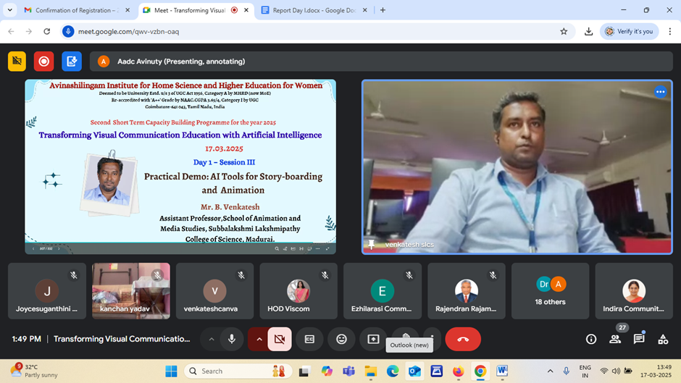
The second session was on the topic “AI Tools for storyboarding and animation” by Mr.Venkatesh, Assistant Professor, School of Animation Media Studies, Subbalakshimipathy college of Science, Madurai. The main objectives of the session were to introduce the participant to various AI tools in storytelling frame by frame by explaining through practical’s.
Mr.Venkatesh started his topic by explaining the history of animation that how AI is being used to generate new forms of content from interactive narratives to immersive experience. How to convert the storyboard by using AI tools, chat gpt,l eonardo davinci app, canva.Research and experiment with different tools to find the best fit out of it also the customization options are essentials generating the content to fit their specific needs and styles were discussed.
The presentation successfully highlighted how AI technologies can act as powerful assistants in the field of storyboarding and in the academic activities, enhancing productivity and creativity. Participants gained valuable knowledge on how to leverage AI by storytelling through animation; it enhanced the presentation creation with AI tools. The session concluded with a Q&A session where participants clarified their doubts regarding the AI tools for telling the story.

18th March 2025 Day 2: Session I and II
Research writing through AI tools and Hands on workshop -
Resource Person: Dr. Dinesh Babu
Assistant Professor, Department of Visual Media and Communication
Amritha Vishwa Vidhyapeetham, Kochi Campus.

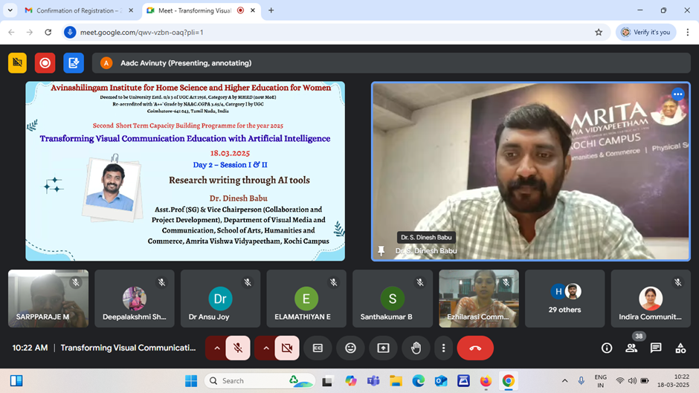
The first session was on the topic “Research Writing through AI Tools” by Mr. Dinesh Babu, Assistant Professor at the Department of Visual Media and Communication at Amritha Vishwa Vidhyapeetham, Kochi Campus. The objective of the session was to introduce the participants to various AI-driven research writing tools that can streamline the research writing process, enhance research productivity, and assist in creative tasks such as presentations and audio content creation.
Mr. Dinesh Babu provided an in-depth overview of the latest advancements in AI technologies in the research landscape and demonstrated practical applications of these tools across different stages of research. Mr. Dinesh Babu introduced various AI tools specifically tailored for research purposes like Elicit, Scispace, connected papers, consensus, Litmaps for Literature review, Research Rabbit, R Discovery, Ask R Discovery for research paper discovery, Answer this ai and Answer the public for finding the most searched item online which may help us find the research gap or research idea.Hemingway.com and Quilbot, writefull.com for paraphrasing the content, Datatab and Jenni.ai. for statistical analysis of the data, paperpile.com, mendeley, zotero for reference management, ethos.bl.uk,zenodo and bielefeld academic search engines to access thesis around the world. Sir also briefed upon the various presentation tools like gamma ai. Tools like Beatoven.ai,II Eleven labs.io, Runaway.ml.com, Deepmotion, NotebookLLM was also demonstrated for animation,photo,video and sound editing purposes. The session successfully highlighted how AI technologies can act as powerful assistants in research and academic activities, enhancing productivity and creativity. Participants gained valuable knowledge on how to leverage AI tools to simplify literature reviews, perform data analysis,enhance presentation creation with AI-driven tools,and integrate professional-level audio content into their research projects. The session concluded with a Q&A session where participants clarified their doubts regarding the usage and integration of these tools in their research works.
Day 2: 18th March 2025: Session III and IV
Fact-checking and misinformation combat using AI tools and Workshop on Ethical considerations when using AI in journalism
Resource person: Mrs. R. Sujatha, Deputy Editor, The Hindu
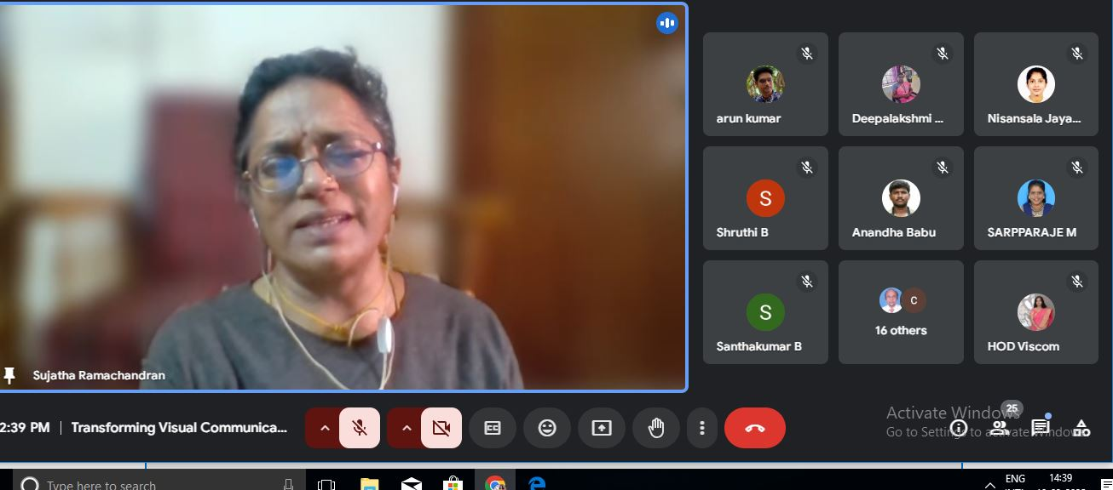

The resource person for the afternoon’s session was Mrs. Sujatha Ramachandran, Deputy Editor, The Hindu. The resource person was introduced by Dr. V. Jayashree, Assistant Professor and HoD, Department of Visual Communication. She elaborated on several case histories where the journalist has to come across. She dealt with the following questions:
What kind of information am I encountering? Who wrote it? Who published it? When was it published? Why was it written? To inform, entertain, or persuade? Is this information appropriate for the context of how I am using it? Is the information complete? Are there events, facts, or viewpoints missing? Who or what are the sources? Are they believable? Could the source know what they claim to know? What evidence is presented, and how was it tested? When was the data gathered?
Session Four: Fact Checking and mis-information combat using AI tools
In session IV, she dealt with finding out facts through various Government authenticated websites such as Press Bureau of Information, Government of India. She gave the following topics to explore and fact check as a takeaway.
- The Growing Popularity of STEM Degrees in Tamil Nadu
- Exploring the Challenges and Opportunities of Higher Education in Tamil Nadu
- The Impact of Government Policies on Higher Education in Tamil Nadu
- The Role of Education Technology in Enhancing Learning in Tamil Nadu
- How Student Loans are Affecting Higher Education in Tamil Nadu
- The State of Graduate Schools in Tamil Nadu
- The Impact of Digital Learning Technologies in Tamil Nadu
- Exploring Innovative Solutions to Add

The session ended with questions posted by participants which were addressed by the resource person.

19.03.2025 Day 3: Session I -Artificial Intelligence for Sound Engineering
Resource Person - Dr. Subhashini P, Co-ordinator
Centre for Machine Learning and Artificial Intelligence, Avinashilingam Institute

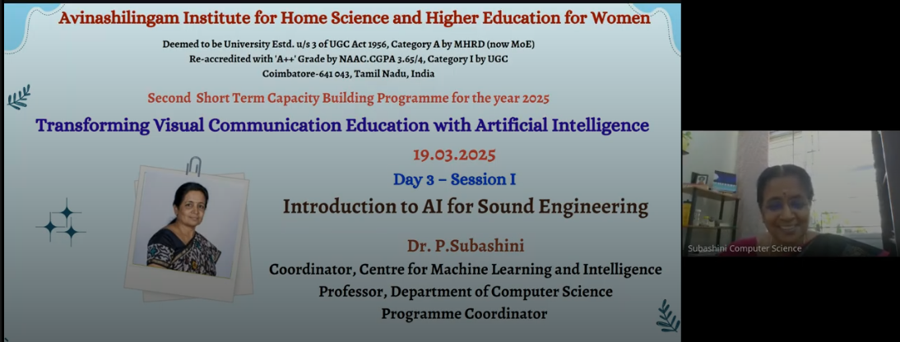
The session was led by Professor Dr. Subhashini P, Co-Ordinator, Centre for Machine Learning and Artificial Intelligence, and a prominent expert in the field of Artificial Intelligence on the topic “Artificial Intelligence for Sound Engineering”. The event aimed to provide research scholars and professionals with a comprehensive understanding of how artificial intelligence is transforming modern sound engineering practices. Professor Dr. Subhashini P began the session by giving an overview of the evolution of sound engineering, highlighting the integration of artificial intelligence as a game-changer in the digital age. Key AI technologies were introduced, explaining their relevance and application in various aspects of sound processing, music production, and audio analysis. Dr. Subhashini demonstrated how TTS AI tools convert written text into natural-sounding human speech. The demonstration included practical examples using popular TTS APIs. The session showcased real-time voice modulation and customization features available in modern TTS systems. The speaker highlighted the role of deep learning models in enhancing speech recognition, especially in noisy environments. Professor Subhashini introduced GANs, explaining the concept of generator and discriminator networks. Applications of GANs in sound engineering, such as creating new sound textures, voice synthesis, and audio style transfer, were explored.
The participants engaged enthusiastically, asking for clarification and gain insights into AI's role in sound engineering. The event successfully highlighted the impact of artificial intelligence on sound engineering. Through practical demonstrations and expert insights where attendees gained valuable knowledge on how emerging AI tools like TTS, STT, and GANs are shaping the future of audio production and processing.

19.03.2025 Day 3: Session II -Generative AI in Visual Content Creation
Resource Person: Dr. Linda Sherin, Assistant Professor,
Centre for Machine Learning and Artificial Intelligence, Avinashilingam Institute

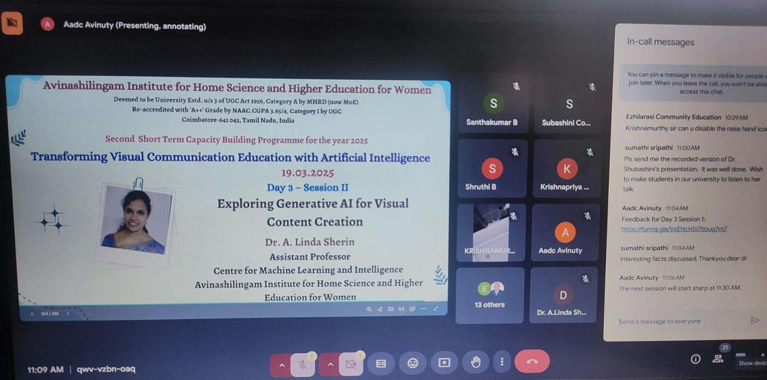
Mrs. Linda Sherin, Assistant Professor, Centre for Machine Learning and Artificial Intelligence delivered an insightful session on the transformative role of “Generative AI in visual content creation”. She began by highlighting key applications in the AI scenario, notably OpenAI and NVIDIA. OpenAI’s advancements, particularly with models like DALL·E, which have revolutionized the ability to generate realistic and creative images from textual prompts. NVIDIA, on the other hand, is leading in the development of powerful AI hardware and software platforms that accelerate visual content creation, making high-quality graphics and visuals more accessible to designers and marketers. Mrs. Linda emphasized the growing importance of visual content in marketing, explaining how brands use AI-generated images and videos to create engaging, personalized campaigns, reducing time and cost while enhancing creativity.
Furthermore, she delved into specific technologies driving this revolution, such as Stable Diffusion and Runway ML. Stable Diffusion, allows for the generation of highly detailed images with extra control and customization. Runway ML was introduced as a user-friendly platform that gives access to advanced AI models for creators without deep technical expertise. Mrs. Linda also explained the critical role of diffusion models in AI image generation, describing how they filter and refine noisy data into high-quality visuals. Overall, her talk provided a comprehensive overview of how these advanced tools and models are shaping the future of content creation, empowering industries to innovate rapidly and effectively.

Day 3: 19.03.2025 : III and IV - "UI/UX for Next Gen Powered by AI" Mr. Dhanushwaran, Faculty, Image Creative Education, Coimbatore.
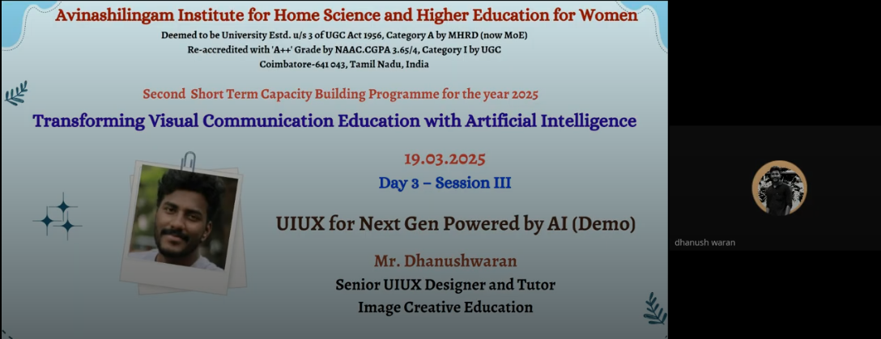
Mr. Dhanuswaran, Faculty at Image Creative Education was the resource person for the 3rd and 4th session of day 3 who gave an excellent demonstration on the topic "UI/UX for Next Gen Powered by AI". The session focused on the integration of AI tools in enhancing UI/UX design. Mr. Dhanuswaran introduced participants to Figma software, explaining its key features and how it can be used to design interactive user interfaces efficiently. He demonstrated how to animate photos effortlessly and how to enhance existing web pages by utilizing AI-powered tools like ChatGPT through effective prompt engineering. This allowed participants to understand how AI can assist in generating creative design ideas and content enhancements.
Additionally, Mr. Dhanuswaran covered the usage of Canva, emphasizing its user-friendly interface and how it supports designers in creating visually appealing content. The highlight of the workshop was the live demo sessions, where the tools were showcased in real-time, providing practical insights into their functionalities. Participants found the demonstrations highly beneficial, gaining hands-on experience and a clear understanding of how to apply these tools in real-world UI/UX projects. Overall, the session was interactive, informative, and empowered participants with modern design techniques powered by AI.

Day 4: 20.03.2025 I and II Session
Resource Person: Mr. Jerry Wilson
Developing AI- Generated Visual Projects & Workshop:Developing AI Generated Visual
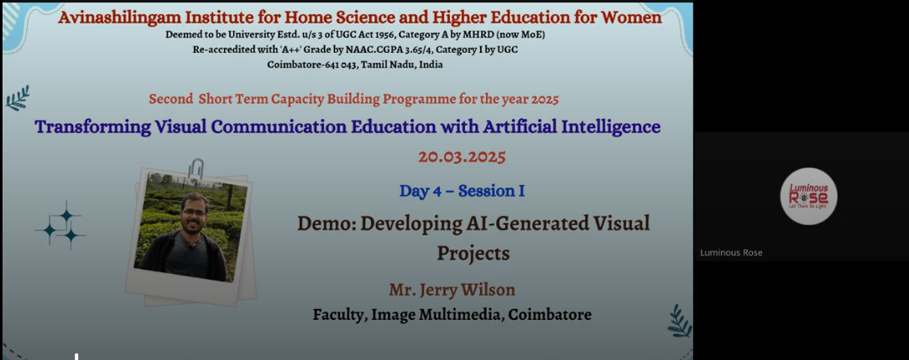
The session was started by Jerry Wilson, trainer and a freelancer in the field of Video Editing, Photography and software’s like Adobe Photoshop, After effects Adobe Premiere, Final cut pro, Auto desk Maya, blender. The session started with the history of AI technology and the beneficiation of it. How AI has started to text images in a realistic way. The speaker started explaining through practical way also stating the different software usage with paid version and free version. The software’s like Chat GPT, Prompts, adobe express. The Participants were engaged by asking him doubts and got clarified through practical demonstration. The session was insightful, and it has been an enriching experience to learn about the powerful tools that bring creativity to life. The demonstration of how AI seamlessly transforms images using advanced algorithms has opened new doors for creativity in digital media. The takeaway from this session is let us continue to experiment, innovate and push the boundaries of digital art. images. Finally, the session ended with Questions & Answers.

Day 4 III and IV Session
Dr. Umesh Arya, Former Dean of GJ University, Hisar
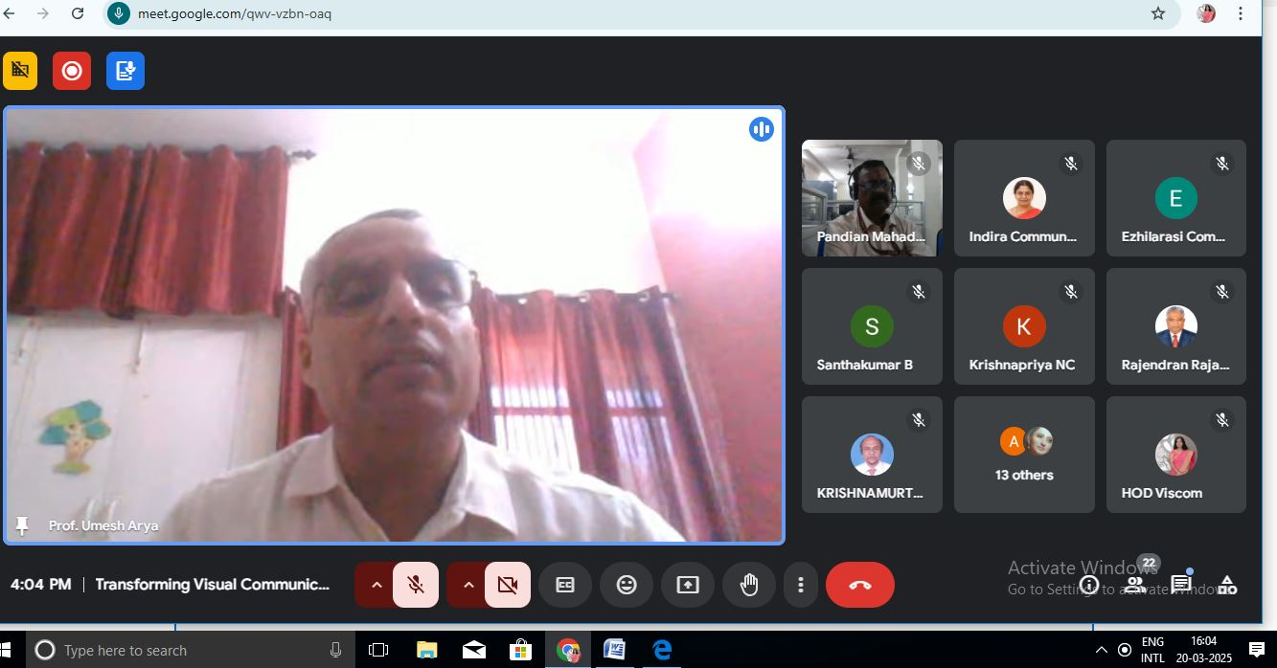
Dr. Umesh elaborated on AI in content generation for newsrooms and Ethical considerations when using AI in journalism. He said that the newsrooms of various media uses both Generic AI tools as well as customise Captiv tools based on their own requirements. He emphasized on how Prompt Engineering is vital in navigation of the AI tools to get relevant and authentic information. He further stressed on how time management has become more effective with the advent of AI tools.

In session IV he spoke about the relevance of ethical considerations in the use of AI tools in journalism. He said that there is no well agreed code of conduct in this regard, and it is very subjective. In his speech, he mentioned synthetic data, algorithms of oppression, principles of unconscious psychology and other concepts which were related to the use of AI tools in journalism.

Day 5: Session I and II
Emerging Trends in AI for Media and Communication Research.
Dr. Uma Shankar Pandey, Associate Professor and Head
Surendranath College for Women, Kolkata

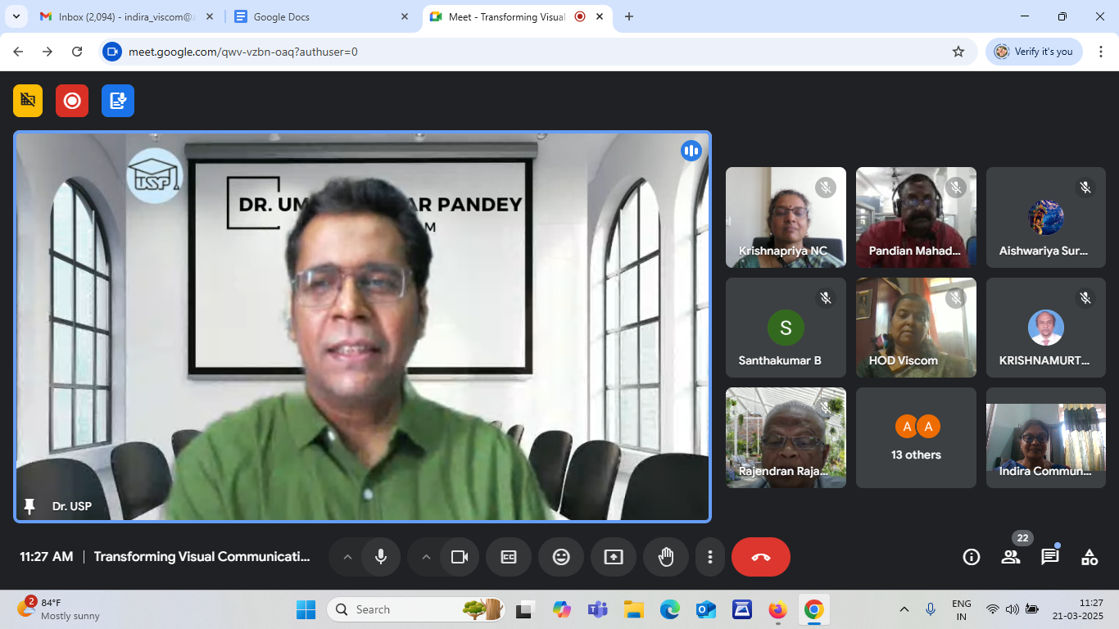

Dr. Uma Shankar Pandey, Associate Professor and Head at Surendranath College for Women, Kolkata spoke about Emerging Trends in AI for Media and Communication Research. While explaining the various tools available for all stages he explained how Natural Language Processing and Language Learning Models work to give us the data or content we look for.
He also demonstrated the use of various AI tools that can be used for research and also in our teaching learning process. He emphasized that usage of AI tools cannot be ignored or considered unethical as the future lies with Artificial Intelligence.

Day 5: Session III
“Facilitating Review of Literature through AI tools”.
Dr. Aditya Kumar Shukla, Associate Professor and Officiating Head,
Amity School of Communication, Amity University, Madhya Pradesh

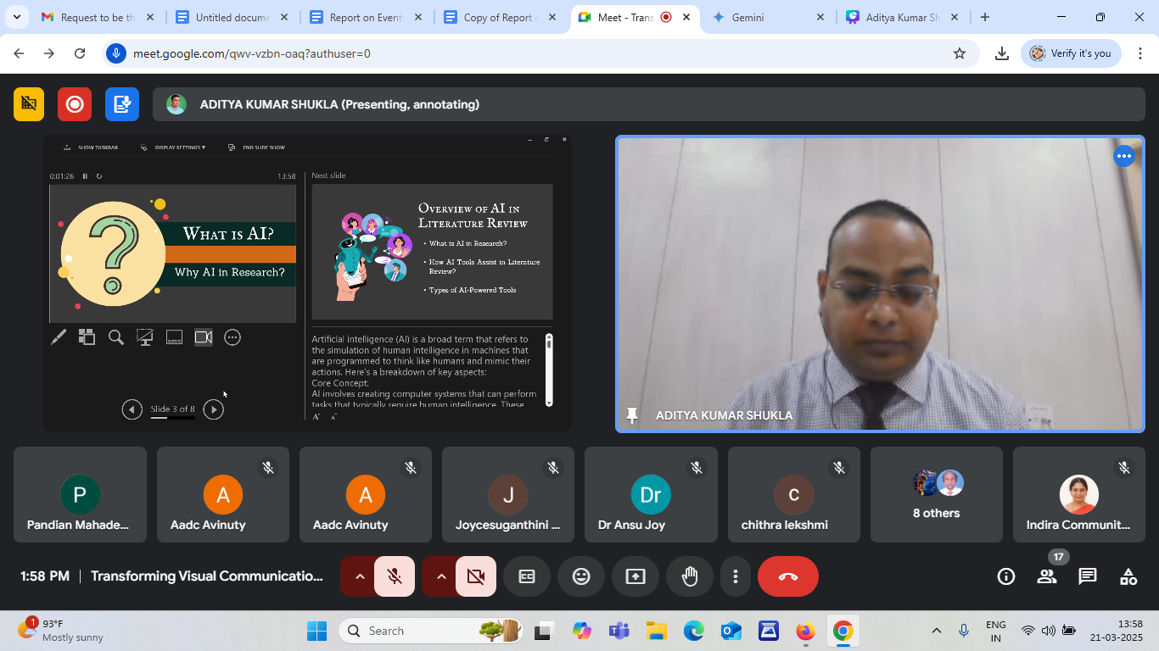

Dr. Aditya Kumar Shukla, Associate Professor and Associate Professor and Officiating Head, Amity School of Communication, Amity University Madhya Pradesh spoke on the topic “ Facilitating Review of Literature through AI tools”. He discussed the various tools available for review of literature and shared his experiences on how to effectively use these tools. In his deliberations he emphasized on the importance of evaluating the AI sources for credibility and relevance and ethical considerations regarding plagiarism and data privacy. He also instructed not to completely rely on one single tool and recommended combining AI tools with traditional tools for effective research.
Day 5: Session IV - Valedictory Session
The Valedictory function of this capacity building programme started with a prayer song, and welcome address by Dr. Subhashini, Coordinator of Centre for Machine Learning and and Intelligence. The report of the five-day programme was given by Dr. E. Indira, Assistant Professor, Department of Visual Communication. The valedictory address was given by Dr. M. Sri Hari, Associate Professor and Head of the Department of Communication and Media Studies, Bharathiar University, Coimbatore. In his address he emphasized the importance and need for the use of AI tools in academic and research activities. He shared his experiences on the use of AI tools and how it resulted in effective outcomes. However he stressed that caution and originality of work should be given priority. Several participants shared their feedback about the programme. The surprising part of the feedback session was that the participants had used the AI tools recommended in the programme for preparing their feedback. Dr. V. Jayashree thanked the authorities, coordinators of the AADC centre and CMLI centre for giving an opportunity to organise such a programme. She also thanked the participants for making this programme a successful one.
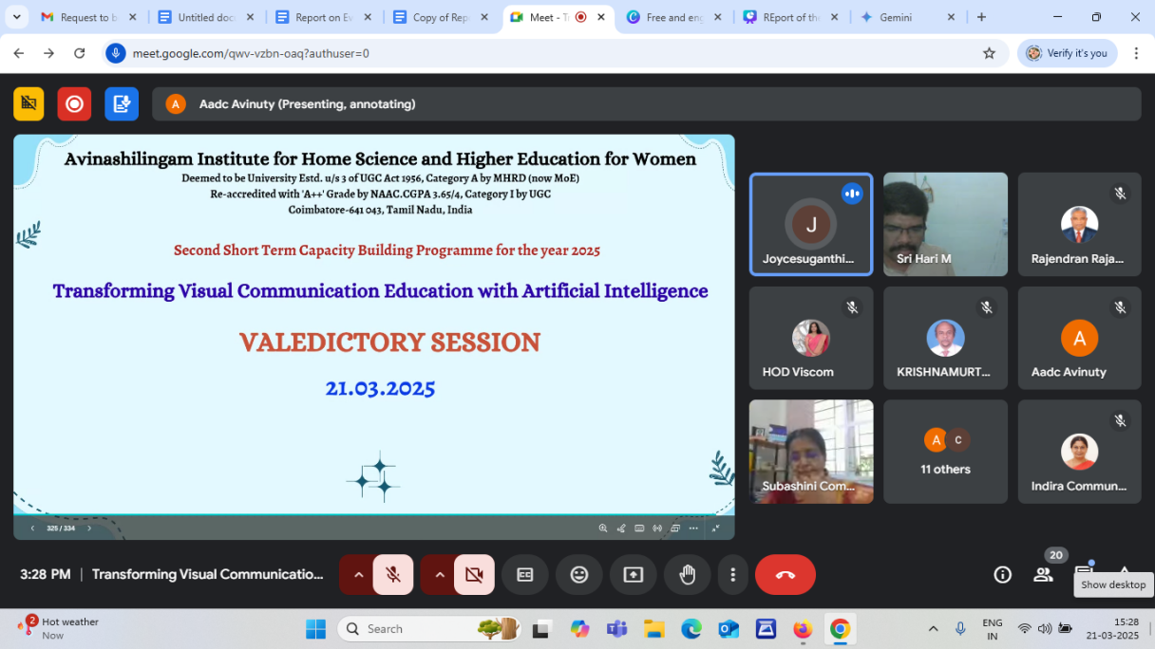

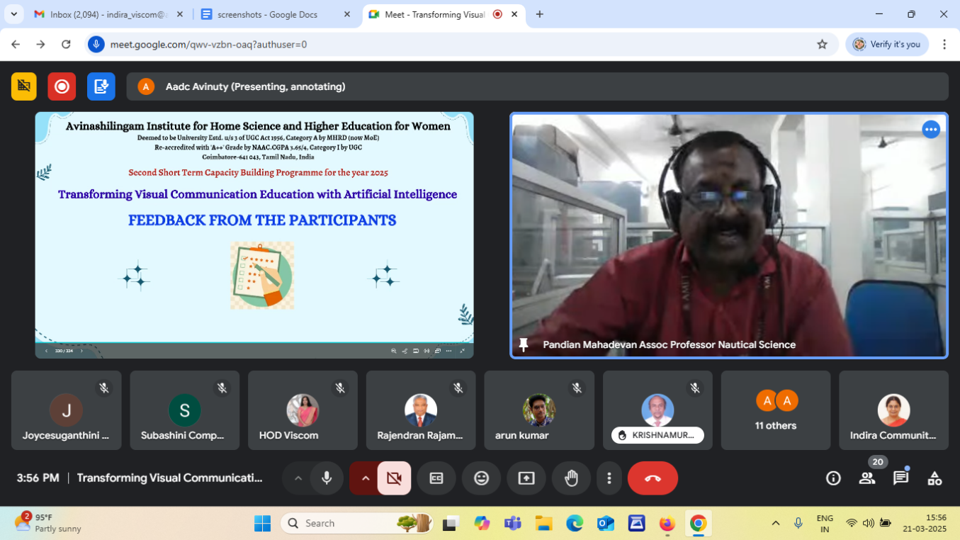
Participants List
S.No | Name | Designation | Institution/ Organisation Name
1 | Dr. M. Sarppa Raje | Assistant Professor | Thiagarajar College of Engineering, Madurai.
2 | Mr. Captain Pandian Mahadevan | Associate Professor | Academy of Maritime Education and Training, Chennai.
3 | Mr. Colapancheri Rajendran | Associate Professor | Academy of Maritime Education and Training, Chennai.
4 | Ms. Shivani V. | Research Scholar | Thiagarajar College of Engineering, Madurai.
5 | Dr. Deepalakshmi S | Assistant Professor | Faculty of Science and Humanities, SRM Institute of Science and Technology, Chengalpattu.
6 | Dr. Elamathiyan E | Assistant Professor | SRM Institute of science and Technology, Chennai.
7 | Mr. Capt.Santhakumar Baskaramoorthy | Associate Professor | AMET University, Chennai
8 | Dr.Sumathi.K.Sripathi | Associate Professor | DMI – St. Eugene University,Chibombo, Lusaka.
9 | Dr. Ansu Elsa Joy | Assistant Professor | SRM Institute of Science and Technology, Chennai.
10 | Dr. M.Lakshmipriya | Assistant Professor | SRM Institute of Science and technology, Kattankulathur, Chennai.
11 | Dr. Deepa Makesh | Assistant Professor | Sastra University Chennai campus.
12 | Dr. Padmanabhan. T | Assistant Professor and Head | Faculty of Science and Humanities, SRM Institute of Science and Technology, Chengalpattu.
13 | Ms. Chithra Lekshmi K S | Research Scholar (Communication)& Assistant Professor | PSG College of Arts & Science, Coimbatore.
14 | Dr. E.Indira | Assistant Professor | Avinashilingam Institute for Home Science and Higher Education for Women, Coimbatore.
15 | Dr Kanchan Yadav | Assistant Professor | Graphic Era Deemed to be University, Dehradun, Uttarakhand.
16 | Mrs. K.G.L.A.N.S.Jayawardhana | PhD Scholar | Bharathiar University, Coimbatore.
17 | Dr.V.Jayashree | Assistant Professor and Head, | Avinashilingam Institute for Home Science and Higher Education for Women, Coimbatore.
18 | Dr. Poarkodi Natarajan | Assistant Professor | SRMIST, Kattankulathur, Chennai.
19 | Mr. Arunkumar C | AR/VR developer, Content creator | Ekalaivan, Salem.
20 | Mrs. V.Ezhilarasi | Assistant Professor | Avinashilingam Institute for Home Science and Higher Education for Women, Coimbatore.
21 | Ms. Aiswariya S S | Assistant Professor | PSG College of Arts & Science,Coimbatore.
22 | Dr. Devika P | Assistant Professor | Kumaraguru College of Liberal Arts and Science, Coimbatore.
23 | Ms. Shruthi B | Research Scholar | Bharathiar University, Coimbatore.
24 | Mr. Aswin V | Research Scholar | Bharathiar University, Coimbatore.
25 | Dr. Rohini Sreekumar | Assistant Professor | St. Joseph's College (Autonomous), Devagiri.
26 | Dr. Paul T Benziker | Assistant Professor and Head | Nehru Arts and science college, Coimbatore.
27 | Mrs. Joyce Suganthini D.T | Assistant Professor | Avinashilingam Institute for Home Science and Higher Education for Women, Coimbatore.
28 | Mr.P. Anandhababu | Assistant Professor | Vels University, Chennai.
29 | Dr. Krishnapriya. N.C | Assistant Professor | SASTRA University, Chennai.
30 | Mr. R. Krishnamurthy Kumar | Associate Professor | AMET University, Chennai.
31 | Dr. Harie Karthikeyan | Assistant Professor | SRM Institute of Science and Technology, Chennai.
32 | Ms. Deepthi VV | Assistant Professor | Madras Christian College, Chennai.

Sample Certificate

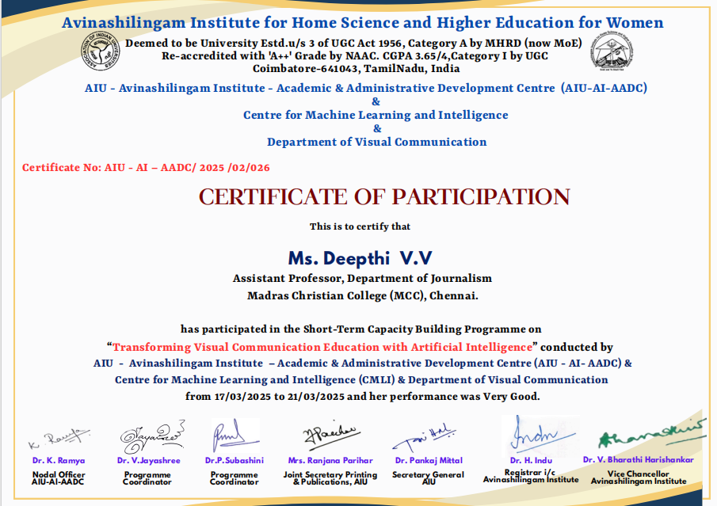

Feedback from the Participants

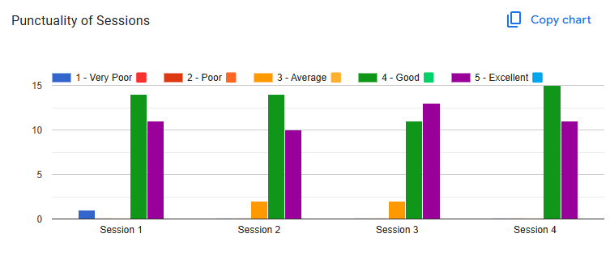

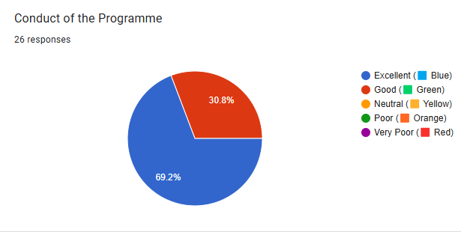

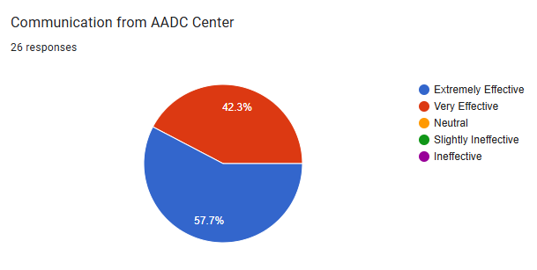

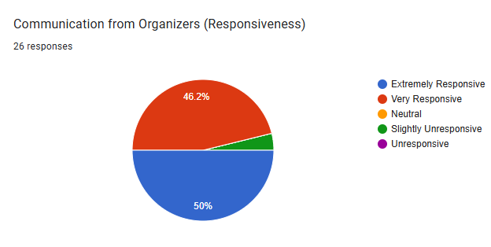

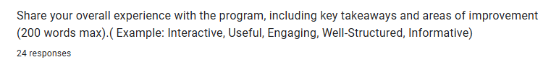
Useful engaging sessions
It is a wonderful days of learning and I learned new concepts. Please provide recorded sessions as reference
Good , engaging ,usefull
Good. Can have one feedback form a day
It was a well organised program tailored for Visual Communication discipline covering most aspects like usage of AI in design, animation, research, visual content creation and in news production. Very informative sessions. Now feel satisfied that I am not left out with all this updates after attending this capacity building program.
Was interactive and useful
Informative
Wonderful programme. Each of the sessions were extremely useful for researchers and educators.
Good
All 5 days were very informative as it was a new perspective
A very useful, engaging and informative capacity building programme. Also the programme was well structured with necessary interactive and hands-on training sessions. The sessions were conducted by knowledgeable and experienced resource persons. I personally feel this course gives an insight into the vast world of AI. Also various AI tools discussed during the sessions will help me to integrate AI in imparting training of my students. Good effort by Avinashilingam university.
Well-structured, topically relevant, engaging and very informative
Well organized, hard to go about with tamil interaction...couldn't understand much, yet a good one
Good programme. Could be conducted in a more convenient time other than office hours. Feedback could be taken once in a day or overall.
Well structured and excellent but it will be good
Well organized
Thank to AIU for conducting this workshop. I learnt a lot about visual communication using artificial intelligence. It was very useful, well structured and informative. I am sure I will improvise on teaching skills using visual communication . Thank all in AIU for organising this workshop and structuring it very well and organizing all the best persons for rendering the lecture and workshop.
Dear organizing team it was wonderful initiative arranged in a grand manner all the expertise were good delivery of content also very good overall program was wonderful
Overall, it is useful
Excellent
All session very useful and gathering new information and idea
This 5-day session was insightful and well-structured, providing a comprehensive understanding of how AI is revolutionizing visual communication education. The sessions effectively balanced theoretical concepts with practical applications, making AI tools more accessible and relevant for educators and students alike. The hands-on demonstrations and real-world case studies were particularly engaging, showcasing AI’s potential in design, storytelling, and content creation. The discussions on ethical considerations and future trends added depth to the learning experience. A few more interactive activities or industry expert sessions could further enhance engagement. Overall, a highly valuable and thought-provoking program that equips participants with the knowledge and skills to integrate AI into visual communication effectively. Looking forward to future sessions!
Informative and inline with recent developments in media scape
It was an intractive resourceful session. The knowledge imparted was unique in its application. Some of the resource speakers were extraordinary. Most of all, all of them were excellent in their expressive discourse. Surprised to hear the explanations in Tamil, well-structured.

