Report on
Online Faculty Development Program on

Digital Transformation, AI Integration, and E-Governance in Higher Education

held
From 04/05/2026 to 08/05/2026



Organized By

Academic and Administrative Development Centre (AADC) Poornima University, Jaipur

NOTICE/CIRCULAR OF THE EVENT
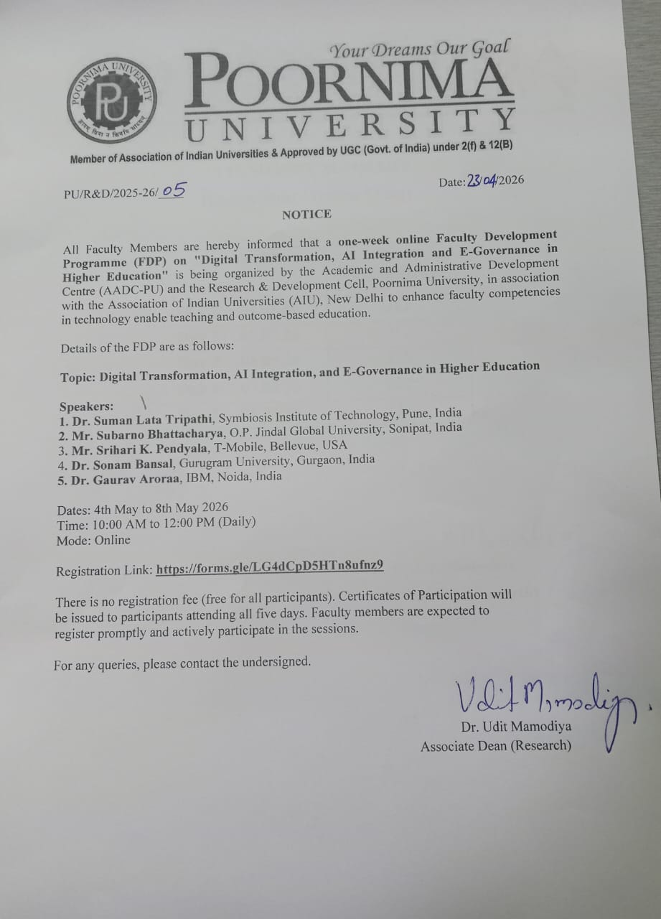

FLYER/BROCHURE OF THE EVENT

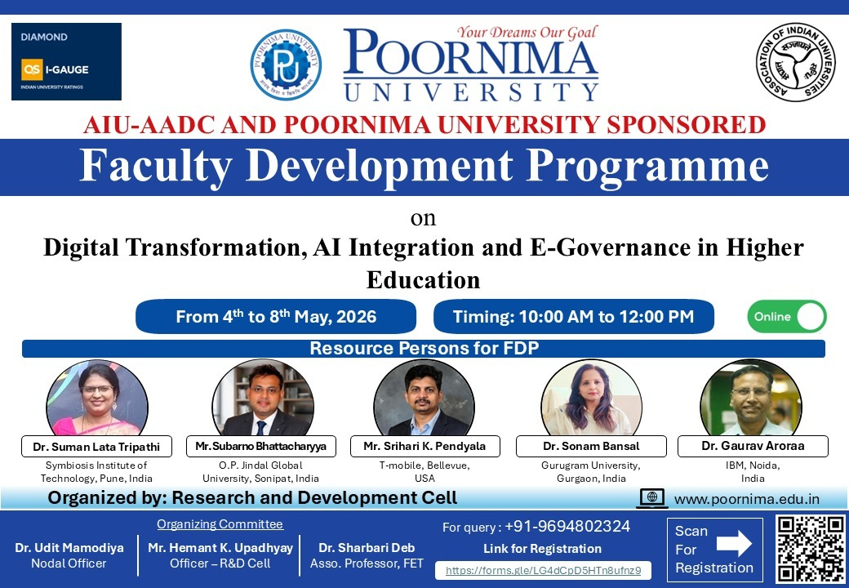

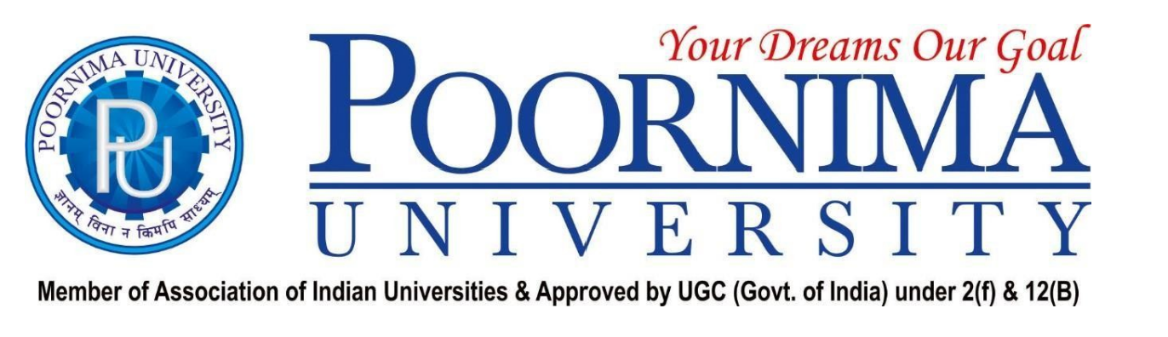

BRIEF BIO OF THE SPEAKER(S)

Day 1 (04.05.2026)

Dr. Suman Lata Tripathi is a Professor at the Symbiosis Institute of Technology, Symbiosis International (Deemed University), Pune, with extensive experience in teaching, research, and academic leadership in Electronics and Communication Engineering. Her core expertise lies in VLSI design, nanoelectronic devices, and advanced semiconductor technologies, and she has authored numerous high-impact publications, patents, and book chapters in these domains.

Recognized in global researcher rankings, she has supervised several research scholars and contributed to funded projects while mentoring faculty on outcome-based education and the integration of emerging technologies in engineering curricula. In this FDP, she offers foundational perspectives on digital transformation in higher education and the critical role of robust electronic and computing infrastructures in enabling AI integration and e-governance.

Day 2 (05.05.2026)

Mr. Subarno Bhattacharyya is Assistant Director – Program Development and Academic Operations at O.P. Jindal Global University, Sonipat, where he leads initiatives in digital learning, academic governance, and higher education transformation. His work focuses on conceiving and implementing AI-enabled, interdisciplinary, and sustainability-oriented academic programs, strengthening online education ecosystems, and aligning institutional practices with global quality, accreditation, and SDG frameworks.

He regularly contributes to policy discussions, workshops, and publications on digital transformation, responsible innovation, and e-governance in universities, engaging with diverse stakeholders. Through this FDP, he brings a future-oriented, policy-linked perspective on how AI integration and digital platforms can reshape teaching–learning, student support, and institutional decision-making in Indian higher education.

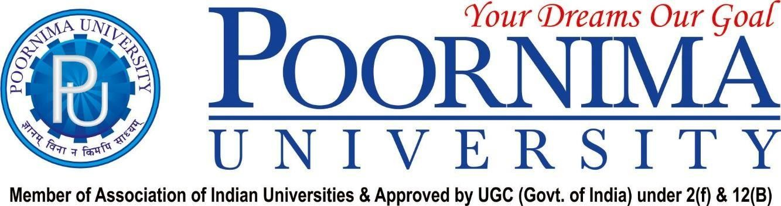

Day 3 (06.05.2026)

Mr. Srihari K. Pendyala is an industry professional at T-Mobile in Bellevue, USA, with a rich background in telecom networks, large-scale digital infrastructure, and data-driven systems engineering. Working with one of the world’s leading 5G and wireless service providers, he has been engaged in initiatives related to network modernization, high-speed connectivity solutions, and cloud-based platforms that support advanced digital services and customer experiences.
His practical experience covers performance optimization, reliability engineering, and the deployment of next-generation communication architectures. In this FDP, he connects industry-grade perspectives on connectivity, 5G ecosystems, and secure enterprise operations with the requirements of universities, helping participants appreciate how robust network backbones enable AI adoption, e-governance platforms, and scalable online academic delivery.

Day 4 (07.05.2026)
Dr. Sonam Bansal is Professor and Chairperson in the Department of Education at Gurugram University and has around two decades of experience in teacher education, educational research, and innovative pedagogy. Her academic and professional interests span competency-based education, digital literacy, inclusive and experiential learning, guidance and counseling, and AI-integrated teaching–learning practices.
She has developed international MOOCs under UNESCO’s Open Education for a Better World initiative, trained large numbers of educators in the use of digital tools, and conducted several capacity-building programs across online and offline modes. An active researcher and editor, she frequently serves as a resource person in national and international forums. In this FDP, she emphasizes learner-centric, technology-enabled, and NEP-2020-aligned approaches to digital transformation and e-governance in higher education institutions.

Day 5 (08.05.2026)

Dr. Gaurav Arora is associated with IBM and brings expertise in analytics, AI-driven solutions, and digital consulting for enterprises and academic institutions. With a strong academic and industry background, he has contributed to projects and professional forums that apply advanced analytics, cloud technologies, and intelligent systems to complex, real-world decision-making contexts. His work involves collaborating with multidisciplinary teams to design scalable, secure, and data-informed digital ecosystems and services. In this FDP, he shares perspectives on AI, data analytics, and cognitive tools for higher education, highlighting how universities can leverage enterprise-class platforms for learning analytics, institutional decision support, and future-ready e-governance. His inputs encourage faculty to conceptualize long-term, analytics-enabled digital strategies aligned with institutional vision.

SCREENSHOTS OF EVENT (DAY 1)

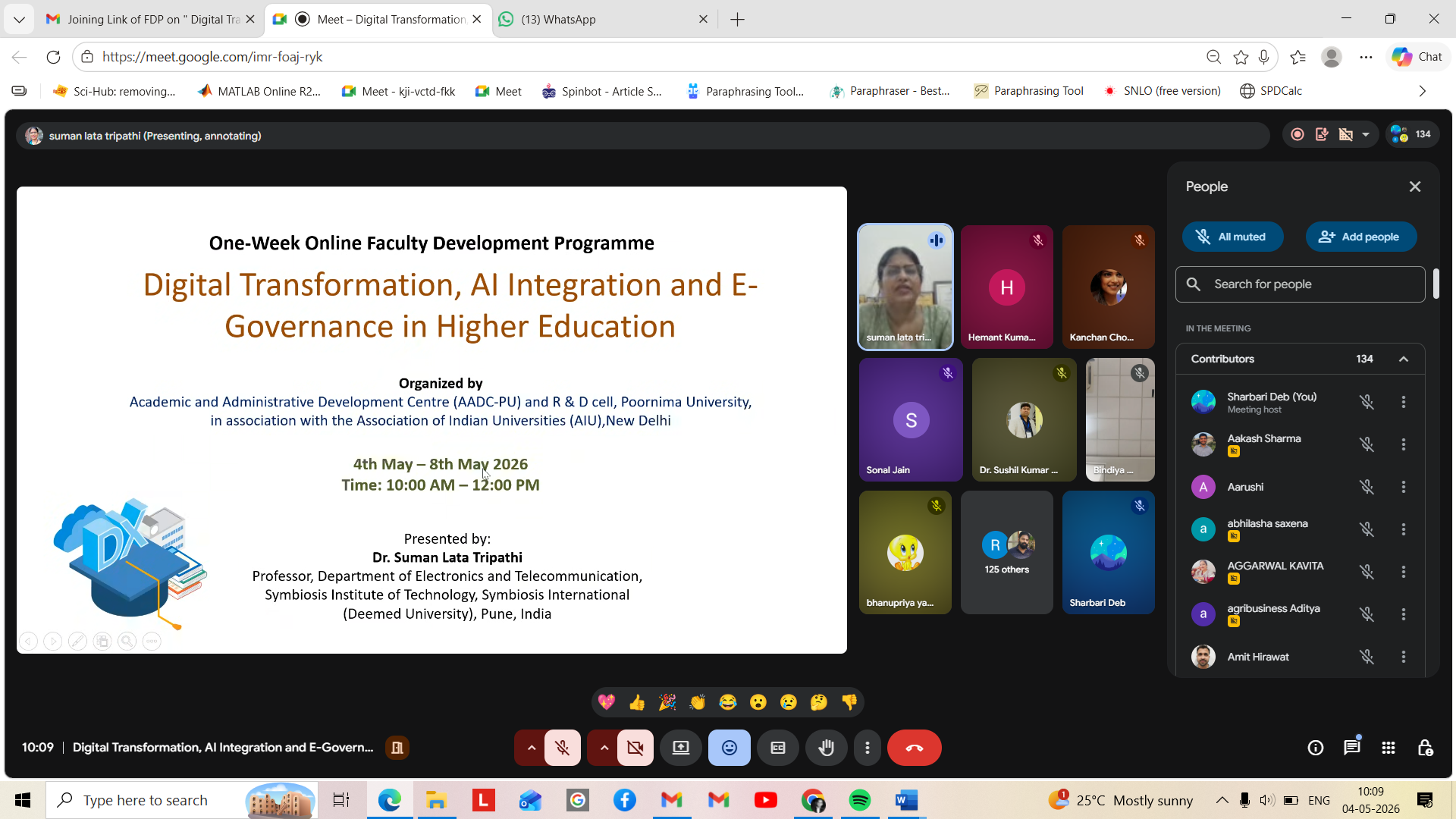

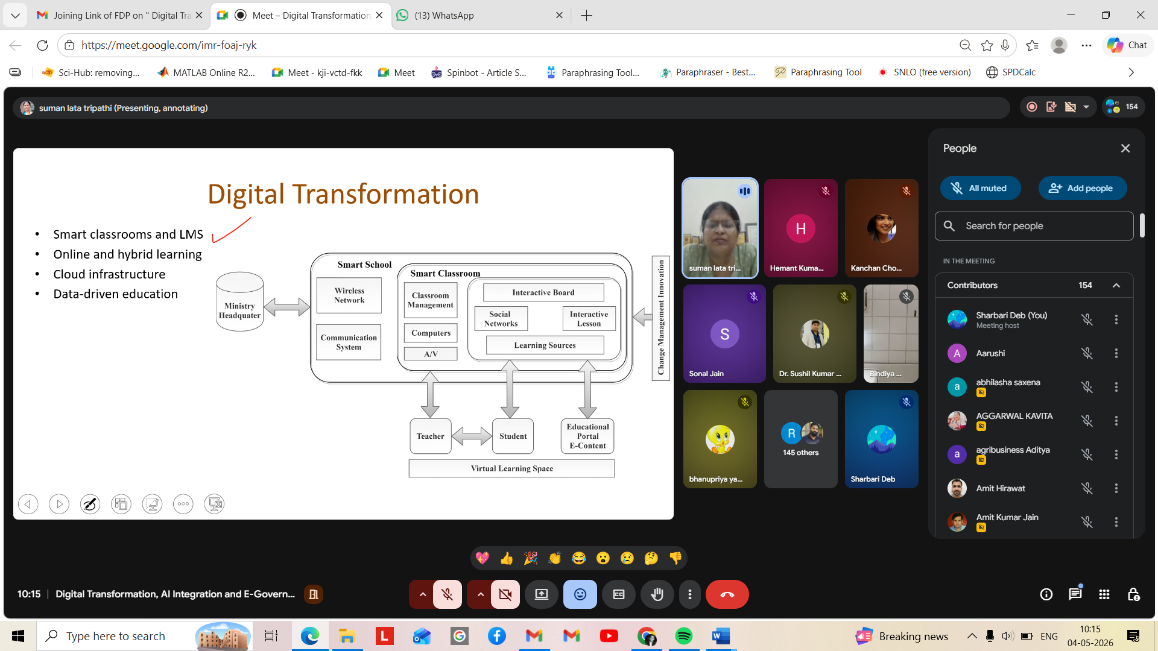

SCREENSHOTS OF EVENT (DAY 2)

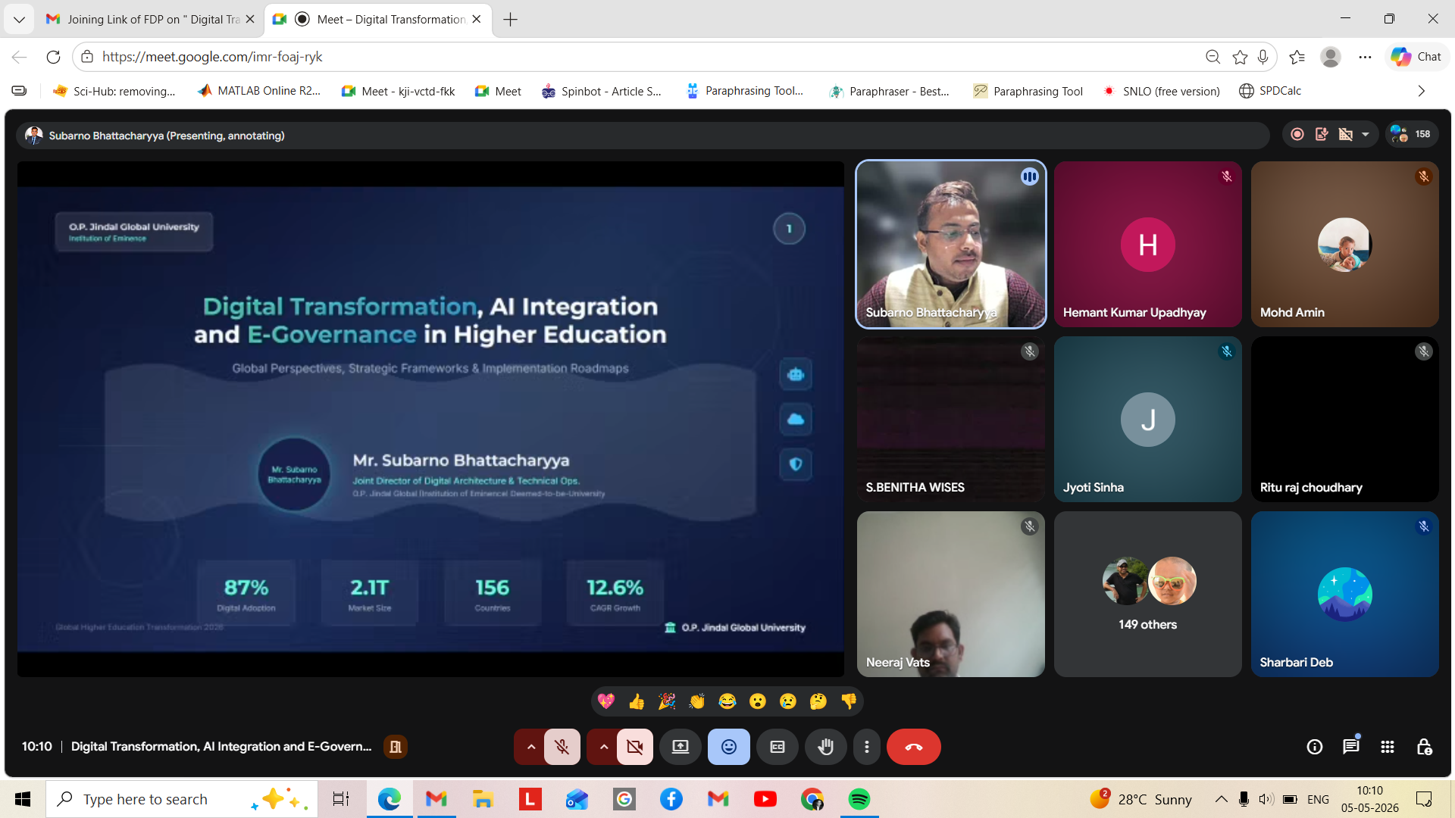

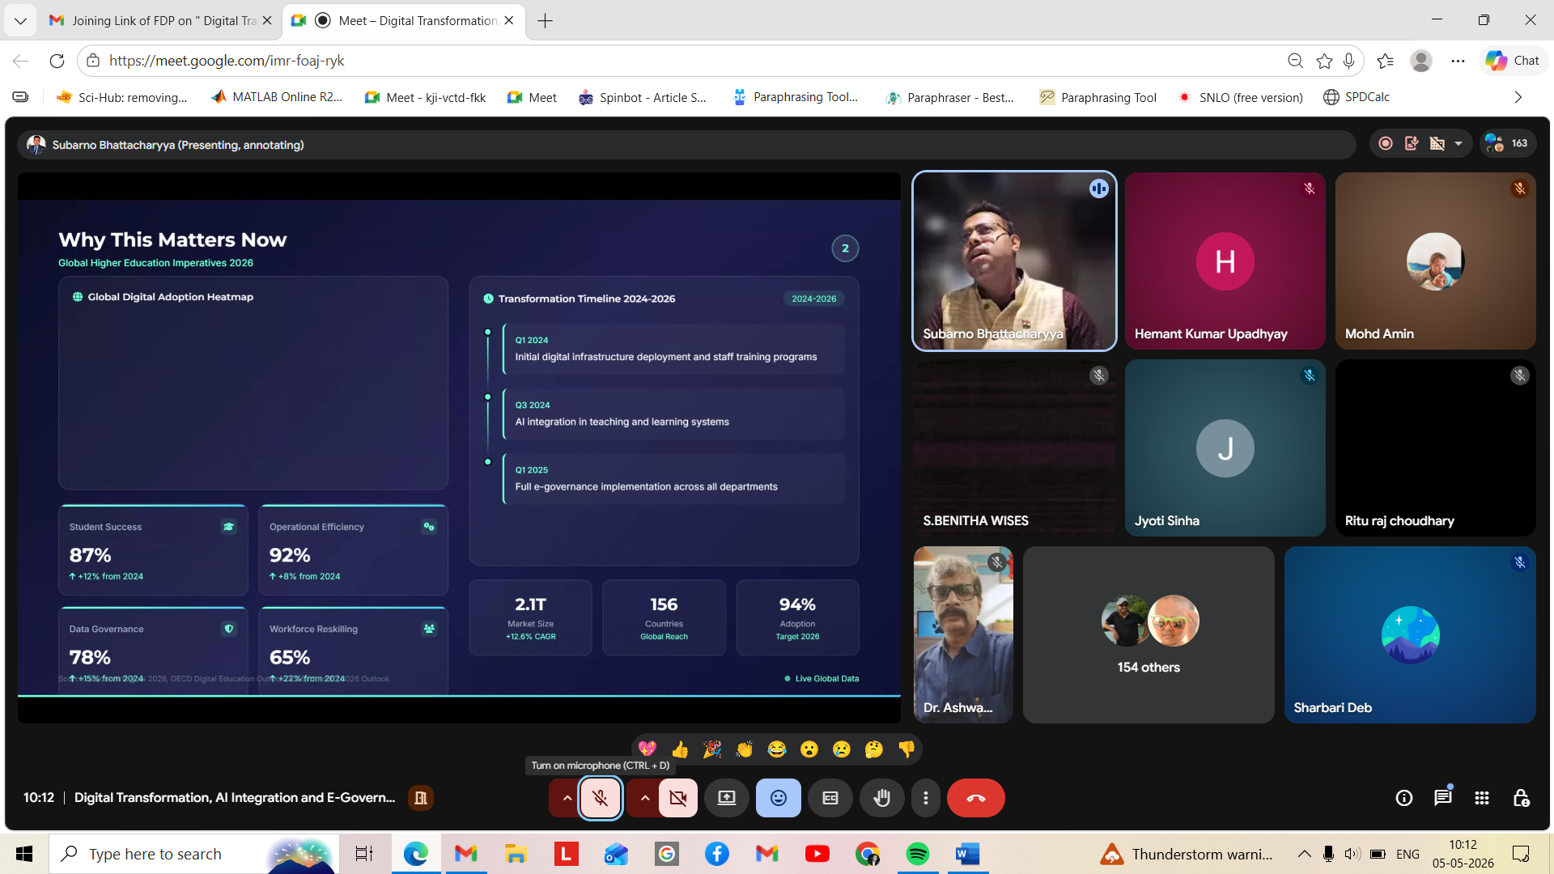

SCREENSHOTS OF EVENT (DAY 3)

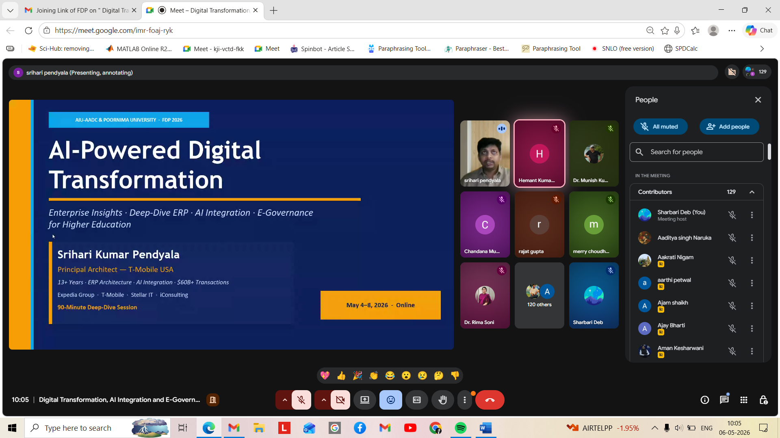

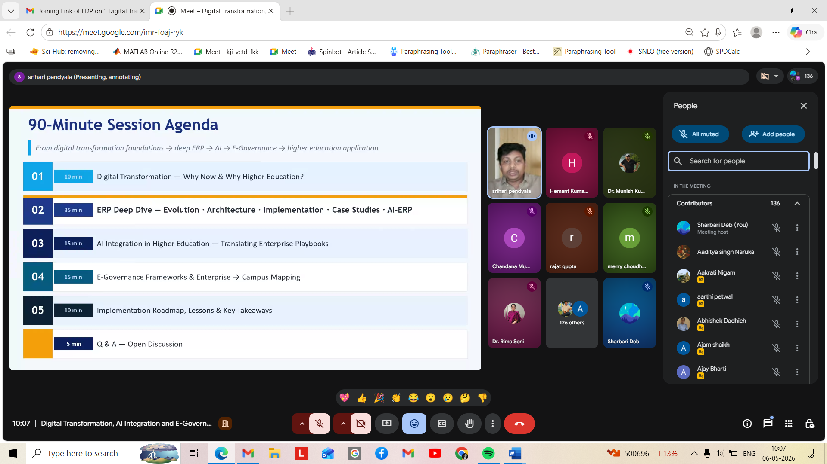

SCREENSHOTS OF EVENT (DAY 4)

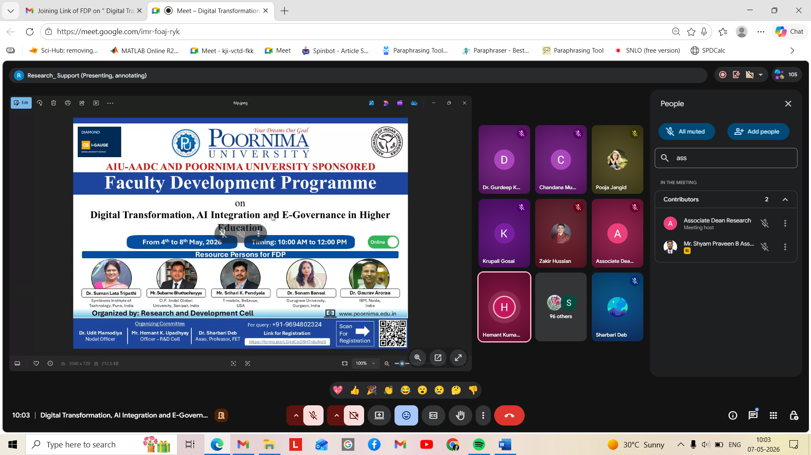

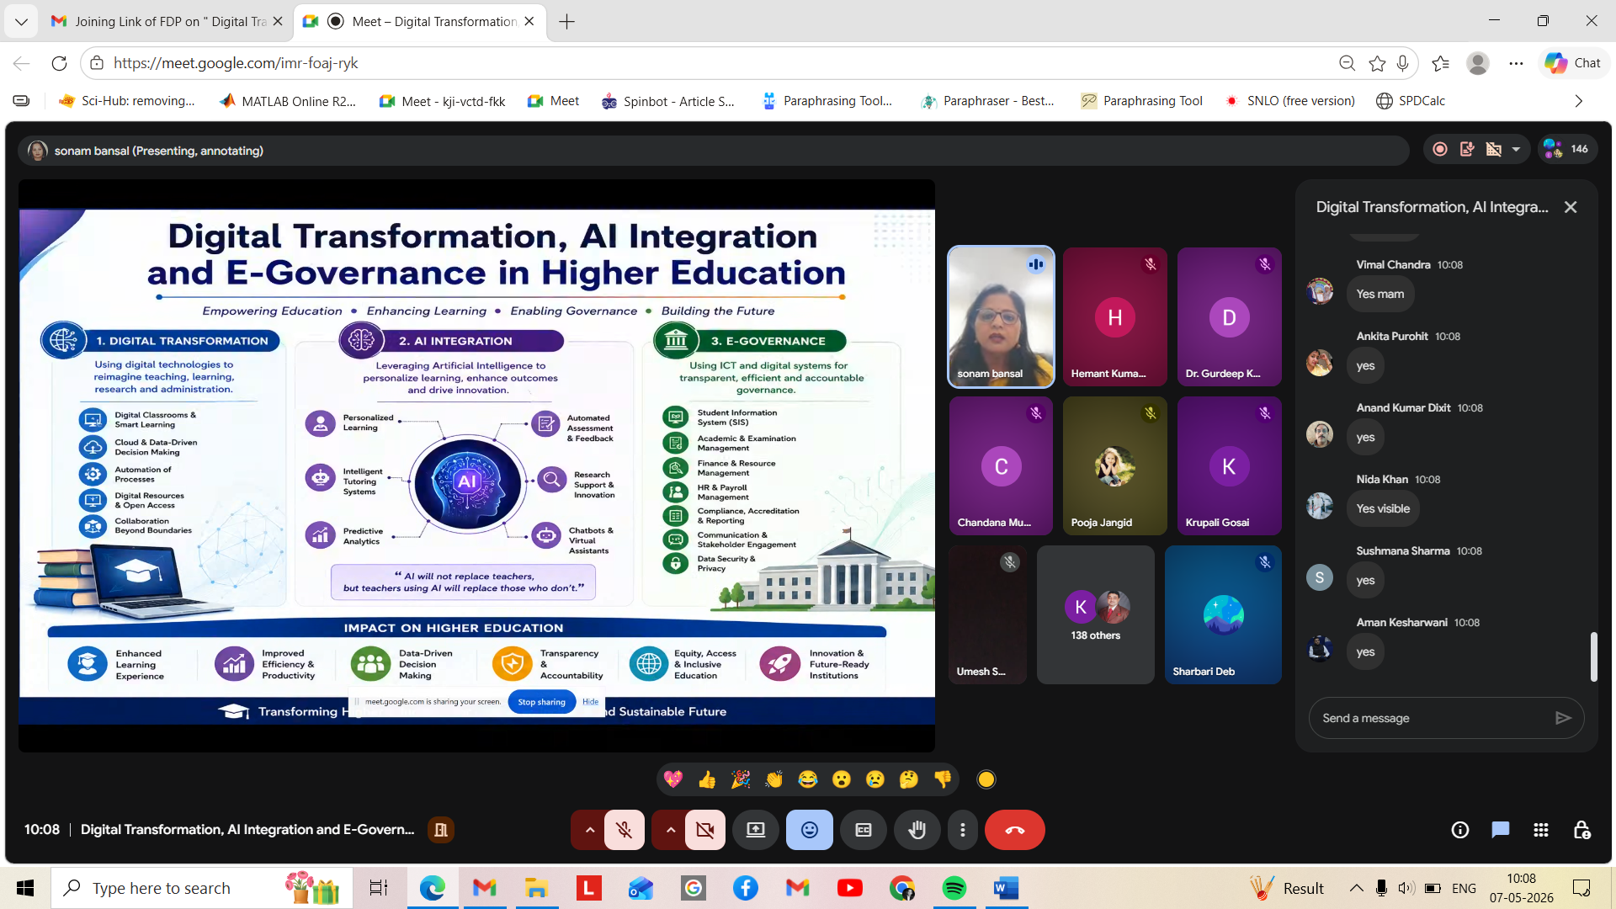

SCREENSHOTS OF EVENT (DAY 5)

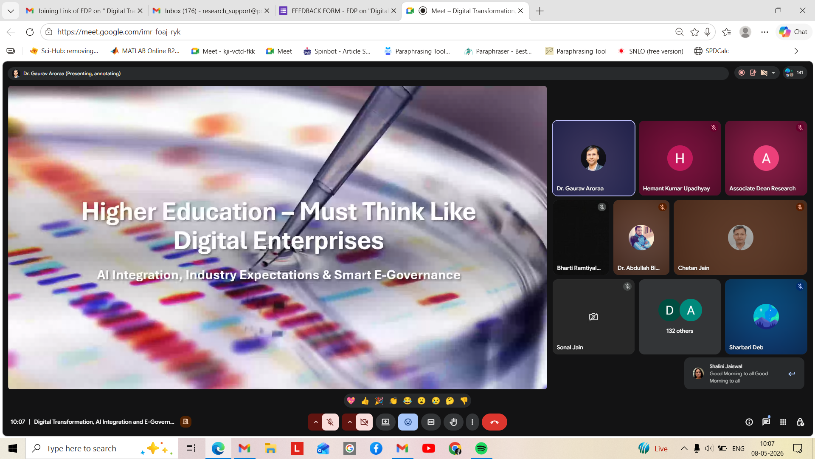

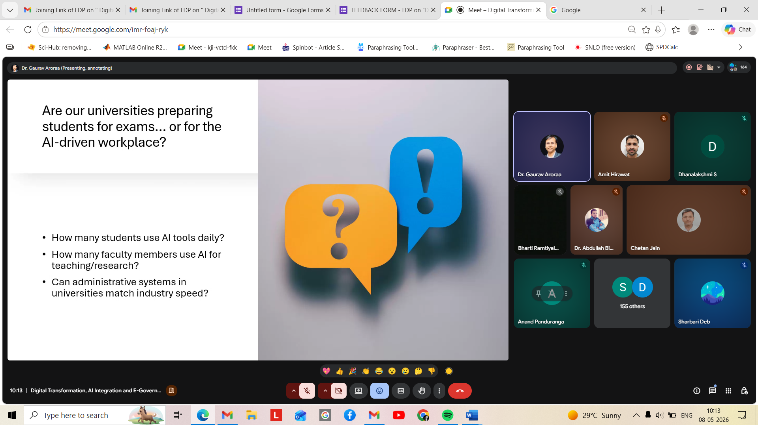

SWOT ANALYSIS

Strengths
- Focuses on emerging areas like AI, digital transformation, and e-governance.
- Enhances faculty skills in technology-enabled teaching and learning.
- Promotes innovative pedagogical practices and blended learning approaches.
- Improves awareness of AI-based assessment and analytics tools.

Weaknesses
- Varying levels of digital literacy among participants.
- Dependence on stable internet and technical infrastructure.

Opportunities
- Development of AI-enabled smart classrooms and digital campuses.
- Strengthening online and blended education systems.
- Enhancing research and innovation using AI tools.
- Building institutional e-governance frameworks.

Threats
- Ethical issues related to AI usage in academics.
- Overdependence on technology in teaching-learning processes.
- Financial limitations for implementing digital infrastructure.

ANALYSIS OF FEEDBACK FROM THE ATTENDEES

Online Faculty Development Program on
“Digital Transformation, AI Integration, and E-Governance in Higher Education.”
 |  | No. of Participants
Linguistic Scale | Points out of 10 | Day 1 | Day 2 | Day 3 | Day 4 | Day 5
Below expectations | 1 | 0 | 0 | 0 | 0 | 0
Very Poor | 2 | 0 | 1 | 0 | 0 | 0
Poor | 3 | 0 | 0 | 0 | 0 | 0
Unsatisfactory | 4 | 3 | 1 | 2 | 5 | 1
Needs improvement | 5 | 6 | 5 | 10 | 3 | 7
Average | 6 | 8 | 11 | 12 | 10 | 9
Satisfactory | 7 | 18 | 28 | 21 | 21 | 33
Good | 8 | 100 | 94 | 92 | 81 | 74
Very good | 9 | 134 | 147 | 145 | 143 | 143
Excellent | 10 | 258 | 240 | 245 | 264 | 260

